Job Profile comprising Job Description and Person Specification
Job Description

Job Title:  FM Operations Assistant | Grade:  Scale 3
Section:  Property Services – FM Operations | Directorate:  Housing & Regeneration
Responsible to following manager:  Assistant Operations Manager | Responsible for following staff:  N/A
Post Number/s: | Last review date:

Working for the Richmond/Wandsworth Shared Staffing Arrangement

This role is employed under the Shared Staffing Arrangement between Richmond and Wandsworth Councils. The overall purpose of the Shared Staffing Arrangement is to provide the highest quality of service at the lowest attainable cost.

Staff are expected to deliver high quality and responsive services wherever they are based, as well as having the ability to adapt to sometimes differing processes and expectations.

The Shared Staffing Arrangement aims to be at the forefront of innovation in local government and the organisation will invest in the development of its staff and ensure the opportunities for progression that only a large organisation can provide.

Job Purpose

Assist in the provision of an SSA wide full document and production support service, working to ensure all courier, confidential waste, document delivery, Printing and postal duties are completed in accordance with established procedures to audit and security regulations within prescribed deadlines and priorities.

Specific Duties and Responsibilities

- Provide the day-to-day postal services including the sorting. Opening, and recording of Special items including all items received from courier companies
- Collect and delivers postal items including bulk mailings and specifically quoted tasks.
- Complete all postal related duties in accordance with financial, security and audit regulations.
- Oversees the monitoring and secure collection and processing of all confidential waste.
- Ensuring all tasks are completed in an organised, efficient way paying attention to detail and accuracy
- To fulfil meeting room services for the provision of refreshments managing stock levels and replenishment.
- Assists in managing access to Town Hall complex for staff/visitors/contractors, providing access cards, keys and controlling car park barriers.
- To work as part of a team, but also at times to work alone without close supervision for long periods, including flexible working.
- To be a responsible vehicle Driver for the operations service
- To deliver an excellent customer experience by providing advice, support and general assistance in all areas of the FM service
- To Support Evening meetings, Committees and Council Meetings
- To provide support and to undertake Matrix working as required to ensure the professional delivery of the FM Operations Services.

Generic Duties and Responsibilities

- To contribute to the continuous improvement of the services of the Boroughs of Wandsworth and Richmond.

- To comply with relevant Codes of Practice, including the Code of Conduct and policies concerning data protection and health and safety.

- To adhere to security controls and requirements as mandated by the SSA’s policies, procedures and local risk assessments to maintain confidentiality, integrity, availability and legal compliance of information and systems

- To promote equality, diversity, and inclusion, maintaining an awareness of the equality and diversity protocol/policy and working to create and maintain a safe, supportive and welcoming environment where all people are treated with dignity and their identity and culture are valued and respected.

- To understand both Councils’ duties and responsibilities for safeguarding children, young people and adults as they apply to the role within the council.

- The Shared Staffing Arrangement will keep its structures under continual review and as a result the post holder should expect to carry out any other reasonable duties within the overall function, commensurate with the level of the post.
Additional Information
- To provide support outside of usual working hours
- To work across the SSA, in both LB Richmond and Wandsworth BC as needed

Team structure
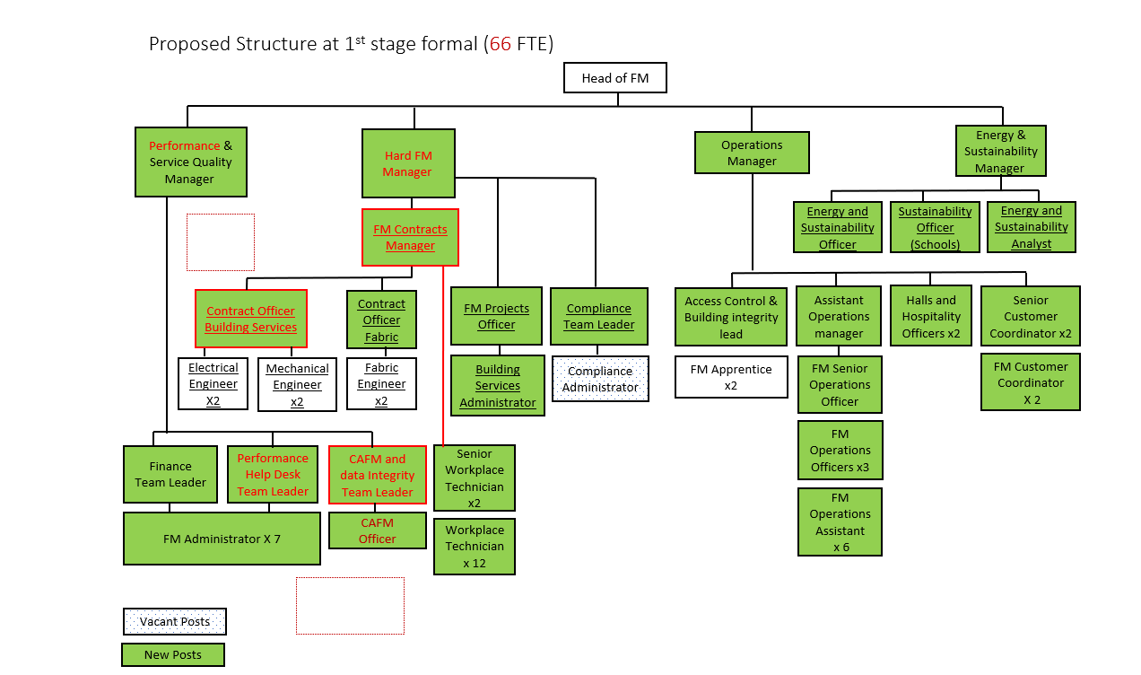

Person Specification

Job Title:  FM Operations Assistant | Grade: Scale 3
Section:  Property Services - FM Operations | Directorate:  Housing & Regeneration
Responsible to:  Assistant Operations Manager | Responsible for:  N/A
Post Number/s: | Last Review Date:

Our Values and Behaviours

The values and behaviours we seek from our staff draw on the high standards of the two boroughs, and we prize these qualities in particular:

Being open. This means we share our views openly, honestly and in a thoughtful way. We encourage new ideas and ways of doing things. We appreciate and listen to feedback from each other.

Being supportive. This means we drive the success of the organisation by making sure that our colleagues are successful. We encourage others and take account of the challenges they face. We help each other to do our jobs.

Being positive. Being positive and helpful means we keep our goals in mind and look for ways to achieve them. We listen constructively and help others see opportunities and the way forward. We have a ‘can do’ attitude and are continuously looking for ways to help each other improve.

Person Specification Requirements | Assessed by  A  & I/ T/ C (see below for explanation)
Knowledge
knowledge of the operational requirements of a complete postal and  courier service | A & I
Knowledge of good practice relating to manual handling and service provision. | A & I
Operational requirements of a complete Document & Delivery Service and associated machinery (scanners, folders) | A & I
Experience
Working to changing deadlines and priorities
Working in a fast moving, multi-tasking team environment
Skills
Good communication skills both written and verbal
Ability to work independently and as an effective team member using
own initiative and adapting to changing priorities
Good IT user skills
To have a full Driving licence
Qualifications
.

A – Application form / CV
I – Interview
T – Test
C - Certificate

