Job Profile comprising Job Description and Person Specification

Provisional Job Title:  Project Manager | Grade:  PO3 – PO6
Section:  Corporate IT | Directorate:  Resources
Responsible to:  IT Senior Project Manager | Responsible for:  No staff line management applicable
Post Number/s: | Date: January 2022

Working for the Richmond/ Wandsworth Shared Staffing Arrangement

This role is employed under the Shared Staffing Arrangement between Richmond and Wandsworth Borough Councils. The overall purpose of the Shared Staffing Arrangement is to provide the highest quality of service at the lowest attainable cost.

Staff are expected to deliver high quality and responsive services wherever they are based, as well as having the ability to adapt to sometimes differing processes and expectations.

The Shared Staffing Arrangement aims to be at the forefront innovation in local government and the organisation will invest in your development and ensure the opportunities for progression that only a large organisation can provide.

Job Purpose:

To plan, manage and deliver business and IT projects ranging from simple to complex, ensuring that these projects are formally managed in accordance with SSA’s chosen project management methodology and contribute to improved SSA operations and performance in line with the SSA IT Strategy.

Specific Duties and Responsibilities:

- Take responsibility for the detailed definition, documentation, delivery and success of a range of projects - tailoring the approach to the context; directing and counselling project team members; and advising clients/users as necessary on all phases.
- Lead on interacting with and influencing project stakeholders, SSA IT staff, the business and suppliers to manage project scope and expectations.
- Liaise with Business Development Managers within the IT SSA function on project start-up and initiation activities and the development / refinement of project brief and business case documents.
- Recommend and implement appropriate project governance arrangements and ensure that respective governance roles are clearly articulated and understood.
- Lead project teams; allocating and monitoring tasks, motivating staff and appraising individual performance; contribute to the development, training and appraisal of project staff.
- Prepare and maintain pragmatic and realistic project, quality, and risk plans, including plans incorporating sub-projects; and monitor team performance against plans, providing reports to project boards and SSA IT management as required.
- Monitor and control allocated project resources and budget; assess the effect of any project changes on costs, timescale and/or resource needs; and reports these to the project board.
- Evaluate and make recommendations/decisions on business and technical options as appropriate.
- Ensure projects are formally closed out; handed over to ‘business-as-usual’ arrangements; subsequently reviewed where appropriate; and that lessons learned are captured and actioned. Produce appropriate documentation to support these processes
- Assist the Projects and Programmes Manager in continuous project improvement and organisational development

Progression Criteria

PO3 Working mainly on tactical projects, be able to perform the duties of the post with appropriate support from management and senior team colleagues. A basic level of knowledge and experience in relation to the post’s duties and responsibilities.

PO4 Having achieved Prince2 Practitioner status and working on larger departmental projects, be able to perform the full duties of the post with minimal input from team colleagues and management. A moderate level of knowledge and experience in relation to the post’s duties and responsibilities.

PO5 Experienced in the project management of both larger tactical and corporate projects. Comprehensive knowledge and demonstrable track-record of experience in relation to the post’s duties and responsibilities.

PO6 Having achieved MSP Practitioner status, fully experienced in the management of more complex and enterprise-scale projects (either standalone or as part of a programme) and programmes contributing to significant organisational transformation. Expert knowledge and demonstrable track-record of achievement in relation to the duties and responsibilities of the post.

Generic Duties and Responsibilities

- To contribute to the continuous improvement of the Borough’s of Wandsworth and Richmond services.

- To comply with relevant Codes of Practice, including the Code of Conduct, and policies concerning data protection and health and safety.

- To adhere to security controls and requirements as mandated by the SSA’s policies, procedures and local risk assessments to maintain confidentiality, integrity, availability and legal compliance of information and systems

- To promote equality, diversity, and inclusion, maintaining an awareness of the equality and diversity protocol/policy and work to create and maintain a safe, supportive and welcoming environment where all people are treated with dignity and their identity and culture are valued and respected.

- To understand the both Council’s duties and responsibilities for safeguarding children, young people and adults as they apply to your role within the council.

- The Shared Staffing Arrangement will keep its structures under continual review and as a result the post holder should expect to carry out any other reasonable duties within the overall function, commensurate with the level of the post.

Additional Information
Posts Managed: N/A

Current team structure

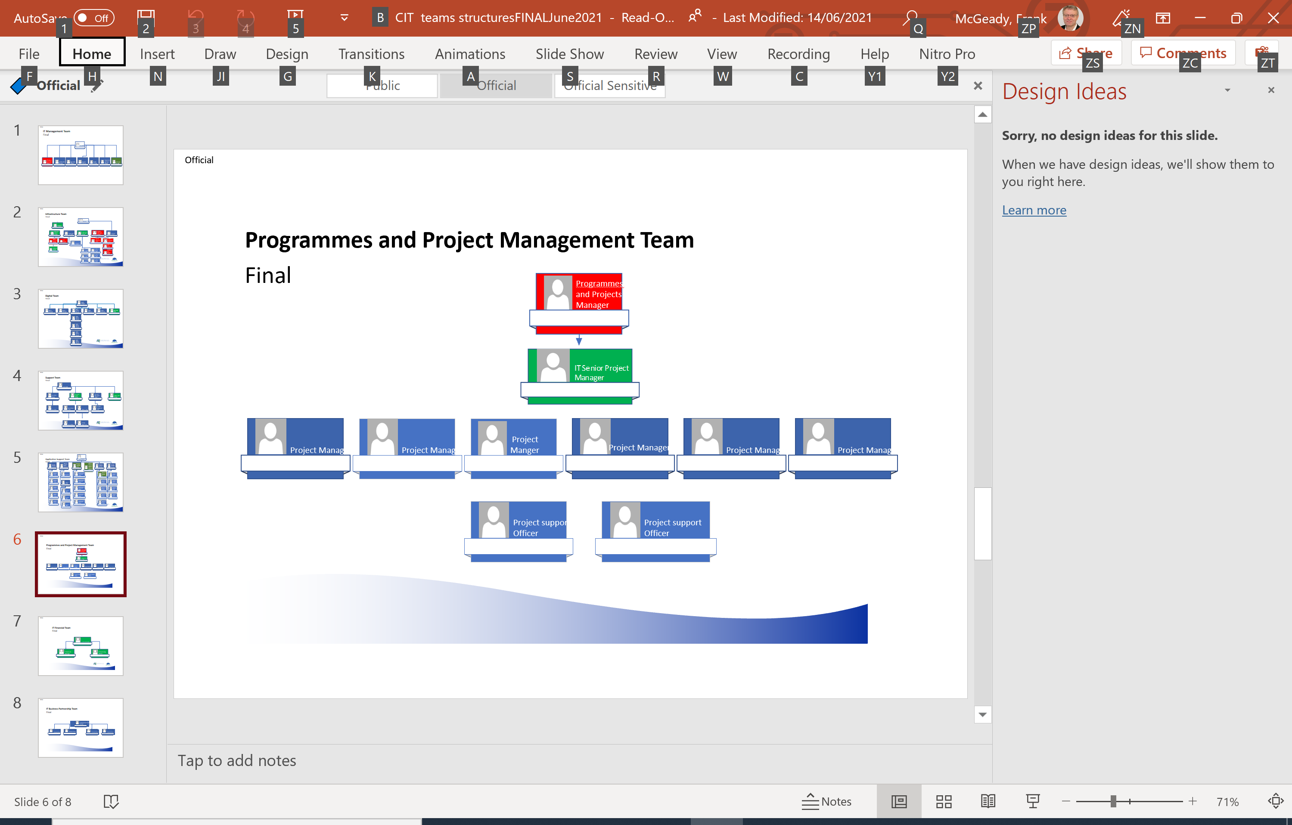
Person Specification
Provisional Job Title:  Project Manager | Grade:  PO3 – PO6
Section:  Corporate IT | Directorate:  Resources
Responsible to:  IT Senior Project Manager | Responsible for:  No staff line management applicable
Post Number/s: | Date: January 2022

Our Values and Behaviours

The values and behaviours we seek from our staff draw on the high standards of the two boroughs, and we prize these qualities in particular –

- taking responsibility and being accountable for achieving the best possible outcomes – a ‘can do’ attitude to work
- continuously seeking better value for money and improved outcomes at lower cost
- focusing on residents and service users, and ensuring they receive the highest standards of service provision.
- taking a team approach that values collaboration and partnership working

Requirements | Assessed by A & I/ T/ C
Knowledge
Comprehensive specialist knowledge of project and programme management ‘good-practice’ methodologies. | A/I/T
Knowledge of the complete project and programme life-cycles and typical challenges and issues associated with the delivery of business and IT projects. | A/I/T
Awareness of Corporate, Industry and Professional Standards associated with IT, business change and project practitioner roles. | A/I
Familiarilty with methods and techniques for structured evaluation and reviews, including technical architectures, business processes, test plans, business cases and any other key deliverables. | A/I
Broad knowledge of all key IT service and Council business functions. | A/I
Awareness of IT strategic objectives and their influence on projects. | A/I
Experience
Demonstrable proficiency and track-record in the use of formal project management methodologies. | A/I
Extensive experience in the use of appropriate project / programme management and supporting tools including, but not necessarily limited to, MS Project, Visio, Excel, Word and SharePoint. | A/I
Proficiency in Project Planning and Control Techniques associated with planning and monitoring the progress of projects / programmes and interdependencies between them. | A/I
Experience of incorporating external (supplier) resources and approaches / methodologies into projects and assessing the impact at both tactical and strategic levels. | A/I
Demonstrable people management experience in project contexts. | A/I
Demonstrable track-record of successful project delivery across different business functions. | A/I
Participation in appropriate project focus groups and forums. | A/I
Facilitating group discussion and reaching a consensus on the way forward. | A/I
Presenting IT issues to senior business audiences. | A/I
Skills
Ability to vary approach depending on the context of the project – e.g. dealing with standalone projects vs. projects managed within a programme. | A/I
Managing time, resources and budgets in a structured, effective manner. | A/I
Project planning and prioritisation skills. | A/I/C
Proficiency in principles, methods, techniques and tools for the effective management of projects through the complete lifecycle from initiation to post-implementation. | A/I
Strong customer service ethos. | A/I
Ability to produce and advise others in the production of compelling business cases and requirement specifications. | A/I
Gravitas to deal constructively and expediently with conflict and to reach mutually agreeable resolutions. | A/I
Being sensitive to organisational cultures, subcultures, hierarchies and politics - and shaping approach accordingly. | A/I
Ability to rapidly absorb and analyse written and verbal information, draw out key messages / conclusions and make appropriate recommendations | A/I
Presentation and influencing skills and ability to communicate effectively – both verbally and in writing. | A/I
People management skills to develop and mobilise immediate colleagues, the wider business and third-parties within projects. | A/I
Use of leading project management and other appropriate support tools and repositories such as: -  - Microsoft Project  - SharePoint  - Visio  - Microsoft Office | A/I/C
Qualifications
Educated to at least ‘A’ Level standard or equivalent. | C
Prince2 Practitioner qualification or other suitable project management accreditation (for grade PO4 and above). | C
ITIL Foundation qualification. | C
‘Managing Successful Programmes’ (MSP) Practitioner qualification (for grade PO6) | C

These values and behaviours will be developed further as the SSA becomes established.

