Job Profile comprising Job Description and Person Specification

Job Title:  Project Officer (Climate Change and Sustainability)  Two Year Fixed Term Contract | Grade:  PO1 – PO3
Section:  Climate Change and Sustainability - Climate Change, Policy and Communications | Directorate:  Chief Executive’s Group
Responsible to:  Head of Climate Change and Sustainability | Responsible for:  N/A
Post Number/s:  TBC | Last review date:  April 2024

Working for the Richmond/ Wandsworth Shared Staffing Arrangement

In July 2019 Richmond Council and Wandsworth Council declared Climate Emergencies, following this Wandsworth Council published its Environment and Sustainability Strategy in July 2019 and Richmond published its Climate Emergency Strategy in January 2020. Although both councils are committed to being net zero organisations by 2030 and to make both boroughs net zero by 2043 the individual strategies reflect the priorities for each borough and therefore contain actions and priorities which are unique to each. Both strategies are underpinned by ambitious action plans that involve services across all the whole organisation. These action plans cover the operations of both councils, the estates of both councils and the Shared Staffing Service workforce. Alongside these strategies and action plans each council has developed individual engagement and behaviour change programmes which look to involve residents, local groups, local businesses and partners in taking action to improve the environment and reduce carbon emissions.

The postholder will support the delivery of the two strategies and their supporting action plans. The postholder will support the delivery of individual actions, including projects and engagement activities, working closely with the wider Climate Change and Sustainability Team as well as other teams across the organisation.

This role is employed under the Shared Staffing Arrangement between Richmond and Wandsworth Councils. The overall purpose of the Shared Staffing Arrangement is to provide the highest quality of service at the lowest attainable cost. Staff are expected to deliver high quality and responsive services wherever they are based, as well as having the ability to adapt to sometimes differing processes and expectations.
Job Purpose:

Working alongside the Head of Climate Change and Sustainability, Policy and Programme Leads (Climate Change and Sustainability), the Partnership and Engagement Lead (Climate Change and Sustainability) and key contacts in service teams, the postholder will provide policy support, project development and management, partnership development, and support for the delivery of key actions within the climate action plans.

Specific Duties and Responsibilities:
- Undertake high-quality research on climate change and sustainability related issues and produce briefings for senior managers on those issues.
- Maintain an awareness of the latest national and regional climate emergency commitments and legislation and keep up to date with policy changes and approaches in other councils as they might apply to climate change and sustainability services in the SSA.
- Identify funding opportunities to deliver climate change and sustainability related projects and support on the development of funding bids.
- Support with implementing and delivering the Councils’ climate change strategies and action plans.
- Manage the delivery of climate mitigation and adaptation projects.
- Work in close collaboration with a wide range of Council departments, borough-wide partners, communities, and local organisations.
- Take responsibility for the detailed definition, documentation, delivery, and success of a range of climate change and sustainability projects.
- Liaise with the Head of Climate Change and Sustainability, the Policy and Programme Leads (Climate Change and Sustainability), the Partnership and Engagement Lead (Climate Change) and service leads on project start-up and initiation activities and the development / refinement of project brief and business case documents.
- Ensure projects are formally closed out and reported on so they can be handed over to ‘business-as-usual’ arrangements, monitoring and evaluation implemented, and that lessons learned are captured and actioned.
- Review if / how pilot projects should / can be scaled up across the boroughs and manage the delivery of these projects.
- Work with the Head of Climate Change and Sustainability, Policy and Programme Leads (Climate Change and Sustainability), and Partnerships and Engagement Lead in the delivery of partnership projects.
- Support in identifying links and opportunities for partnership working across projects.
- Build strategic, proactive relationships with colleagues, contractors, community organisations, institutions, and businesses to tackle climate change and sustainability issues.

Progression criteria

PO2
- Develop areas of climate change and sustainability policy and ensures that the Head of Climate Change and Sustainability and wider team are kept up to date on changes or developments and practice.
- Lead development of funding bids.
- Lead on interacting with and influencing project stakeholders, including SSA staff from across the organisation, local groups, local businesses, partners, and residents.
- Able to carrying out the full range of duties with minimal supervision and demonstrating initiative.
PO3
- Able to deputise for the Policy and Programme Leads (Climate Change and Sustainability) and Partnerships and Engagement Lead as needed.
- Represent both councils at meetings with stakeholders, local groups, partners, businesses, and residents, and build relationships across all these stakeholder groups.
- Lead development and delivery of projects.
- Respond to climate change and sustainability queries from Councillors, residents and other stakeholders in accordance with the Council’s procedures.
Generic Duties and Responsibilities

- To contribute to the continuous improvement of the Borough’s of Wandsworth and Richmond services.
- To comply with relevant Codes of Practice, including the Code of Conduct, and policies concerning data protection and health and safety.
- To adhere to security controls and requirements as mandated by the SSA’s policies, procedures and local risk assessments to maintain confidentiality, integrity, availability and legal compliance of information and system.
- To promote equality, diversity, and inclusion, maintaining an awareness of the equality and diversity protocol/policy and work to create and maintain a safe, supportive and welcoming environment where all people are treated with dignity and their identity and culture are valued and respected.
- To understand the both Council’s duties and responsibilities for safeguarding children, young people and adults as they apply to your role within the council.
- The Shared Staffing Arrangement will keep its structures under continual review and as a result the post holder should expect to carry out any other reasonable duties within the overall function, commensurate with the level of the post.
Additional Information
- This post will require occasional evening and weekend work, for which time off in lieu will be granted.
- The postholder will be required to work flexibly from Council offices onsite e.g. York Road, York House, and Wandsworth Town Hall.

Our Values
THINK BIGGER
EMBRACE DIFFERENCE
CONNECT BETTER
LEAD BY EXAMPLE
PUT PEOPLE FIRST

Current team structure
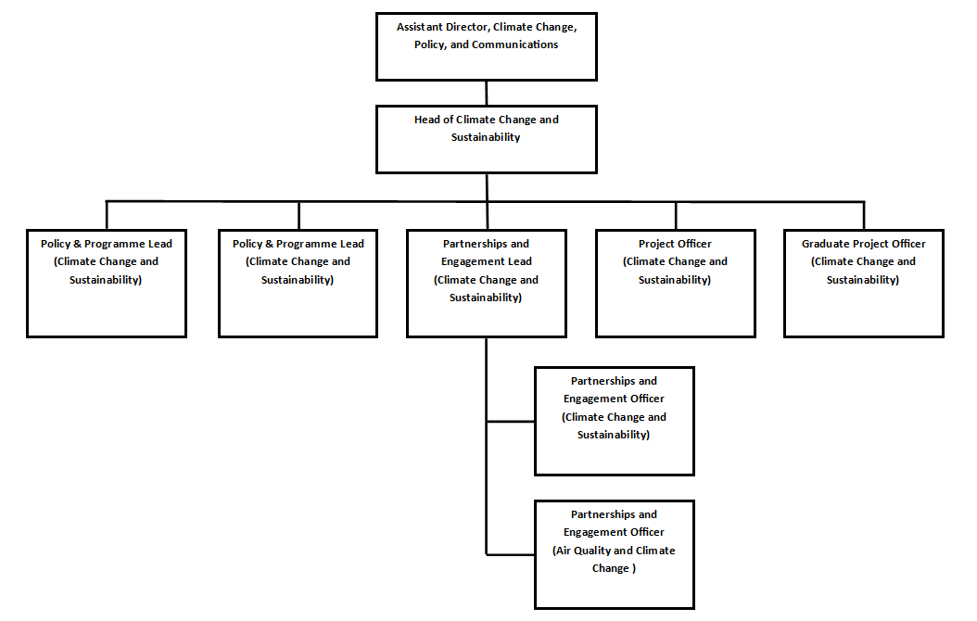
Person Specification

Job Title:  Project Officer (Climate Change and Sustainability)  Two Year Fixed Term Contract | Grade:  PO1 – PO3
Section:  Climate Change and Sustainability - Climate Change, Policy and Communications | Directorate:  Chief Executive’s Group
Responsible to:  Head of Climate Change and Sustainability | Responsible for:  N/A
Post Number/s:  TBC | Last review date:  April 2024

Person Specification Requirements |  |  | Assessed by  A & I/ T/ C  (see below for explanation)
Knowledge | Essential | Desirable | Assessed
An in-depth understanding of the climate change and sustainability agenda | X |  | A/I
Knowledge of the wider context within which local government operates and current climate change issues affecting local authorities | X |  | A/I
Knowledge of project management ‘good-practice’ methodologies |  | X | A/I
Experience and skills | Essential | Desirable | Assessed
Experience in the delivery of climate change or sustainability related projects | X |  | A/I
Experience of successfully managing own workload in an environment where deadlines and priorities frequently change | X |  | A/I
Experience of working and negotiating with and constructively challenging senior managers and colleagues | X |  | A/I
Experience of managing high profile, ambitious projects and their successful delivery | X |  | A/I
 | X |  | A/T
 | X |  | A/I
 | X |  | A/I
 | X |  | A/I
 |  | X | A/I
 | X |  | A/I
Skills | Essential | Desirable | Assessed
Ability to communicate effectively and authoritatively both orally and in writing, with councillors, officers, partner organisations and the public. | X |  | A/I
Ability to exercise tact and diplomacy, and first rate interpersonal, negotiation and influencing skills. | X |  | A/I
Ability to accurately analyse numeric, financial, textual, performance and carbon data and present your findings in a clear and coherent way to a variety of audiences. | X |  | A/I
Ability to lead and manage cross-departmental teams to deliver specific projects. | X |  | A/I
Managing time, resources and budgets in a structured, effective manner. | X |  | A/I
Project planning and prioritisation skills. | X |  | A/I
Ability to work at pace, assimilate new information quickly and make sound decisions and judgements. | X |  | A/I
Experience of managing a complex workload, achieving targets and responding flexibly to changing needs and priorities, often with limited supervision | X |  | A/I
Ability to work both independently and as an effective team member, using initiative and adapting to changing priorities and deadlines in a calm, well-organised and methodical manner. | X |  | A/I
Qualifications | Essential | Desirable | Assessed
Educated to degree level in a climate change or sustainability related subject area |  | X | A

Requirements | Assessed by A & I/ T/ C
Knowledge
Knowledge of the climate change and sustainability agenda | A/I
Knowledge of the wider context within which local government operates and current climate change issues affecting local authorities | A/I
Knowledge of project management ‘good-practice’ methodologies | A/I
Experience
Experience in the delivery of climate change or sustainability related projects | A/I
Experience of successfully managing own workload in an environment where deadlines and priorities frequently change | A/I
Experience of working and negotiating with and constructively challenging senior managers and colleagues | A/I
Experience of managing high profile, ambitious projects and their successful delivery | A/I
 | A/I
Skills
Ability to communicate effectively and authoritatively both orally and in writing, with councillors, officers, partner organisations and the public. | A/I
Ability to exercise tact and diplomacy, and first rate interpersonal, negotiation and influencing skills. | A/I
Ability to accurately analyse numeric, financial, textual, performance and carbon data and present your findings in a clear and coherent way to a variety of audiences. | A/I
Ability to lead and manage cross-departmental teams to deliver specific projects. | A/I
Managing time, resources and budgets in a structured, effective manner. | A/I
Project planning and prioritisation skills. | A/I
Ability to work at pace, assimilate new information quickly and make sound decisions and judgements. | A/I
Experience of managing a complex workload, achieving targets and responding flexibly to changing needs and priorities, often with limited supervision | A/I
Ability to work both independently and as an effective team member, using initiative and adapting to changing priorities and deadlines in a calm, well-organised and methodical manner. | A/I
Qualifications
Educated to degree level in a climate change or sustainability related subject area or equivalent through work experience | C

