Job Profile comprising Job Description and Person Specification
Job Description

Job Title:  Senior Communications and Campaigns Officer | Grade:  P04
Section:  Communications | Directorate:  Chief Executive
Responsible to following manager:  Head of Communications | Responsible for following staff:  Campaigns Officer
Post Number/s:  pending | Last review date: May 2024

Working for the Richmond & Wandsworth Better Service Partnership

We’re Richmond & Wandsworth Better Service Partnership, the shared public service team for Richmond and Wandsworth Councils. Like any local authority, our role is to deliver the agenda of our elected members on behalf of the people who live and work in our part of the world. We deliver key services to our communities including social care, public health, children’s services, housing and regeneration and environmental and community services.

Our joint workforce creates efficiency and resilience by bringing more creativity to the way we work, more objectivity and adaptability too, helping us deliver better services for all our residents.

We’re here to help our communities thrive in a changing world, and to be there for the people who need us most we believe we need to keep adapting. That’s why, at Richmond & Wandsworth Better Service Partnership, you’ll be at the forefront of innovation in local government, and we’ll invest in you and offer you opportunities to grow in a way only our unique organisation can.

Job Purpose

As the Senior Communications and Campaigns officer you will be responsible for developing and implementing communication plans to promote Wandsworth Council's projects, policies, and services. You will support behaviour change campaign efforts, communications planning, storytelling and content creation across the organisation, and identify and deliver proactive PR initiatives to enhance the council's reputation.

Specific Duties and Responsibilities
- To confidently lead account areas, manage and mentor more junior team members, and directly work with Cabinet members and senior leaders, external stakeholders and suppliers.
- To make empowered, informed and expert decisions around the right communications solution to a range of council initiatives.
- Communications Account Manager for Directorate Portfolios represented by the Councillor.
- Communications planning (GRIDS), and major campaign delivery and/or design
- Supporting HoC on Shaping policy development for behaviour change/population engagement
- Management and development of a P03 Campaign officer
- Develop and implement campaign and communication strategies to support the council's objectives and priorities
- Proactively create compelling communications materials to communicate key messages to various audiences.
- Support the planning and execution of integrated campaigns across multiple channels, including digital, social media, print, and events.
- Monitor and evaluate the effectiveness of PR and communication activities, providing regular reports and insights to the Senior Communications Manager
- Stay informed about developments in PR, and communications, and apply insights to enhance our approach.

Generic Duties and Responsibilities

- To contribute to the continuous improvement of the services of Richmond & Wandsworth Better Service Partnerships.

- To comply with relevant Codes of Practice, including the Code of Conduct and policies concerning data protection, handling complaints and health and safety.

- To adhere to security controls and requirements as mandated by Richmond and Wandsworth procedures and local risk assessments to maintain confidentiality, integrity, availability and legal compliance of information and systems

- To promote equality, diversity, and inclusion, maintaining an awareness of the equality and diversity protocol/policy and working to create and maintain a safe, supportive and welcoming environment where all people are treated with dignity and their identity and culture are valued and respected.

- To understand both Councils’ duties and responsibilities for safeguarding children, young people and adults as they apply to the roles within the Councils.

- The profile is not intended to be an exhaustive list of the duties the post holder will carry out. Other reasonable duties commensurate with the level of the post, including supporting emergency and priority situations, will form part of the role.
Additional Information

Team structure

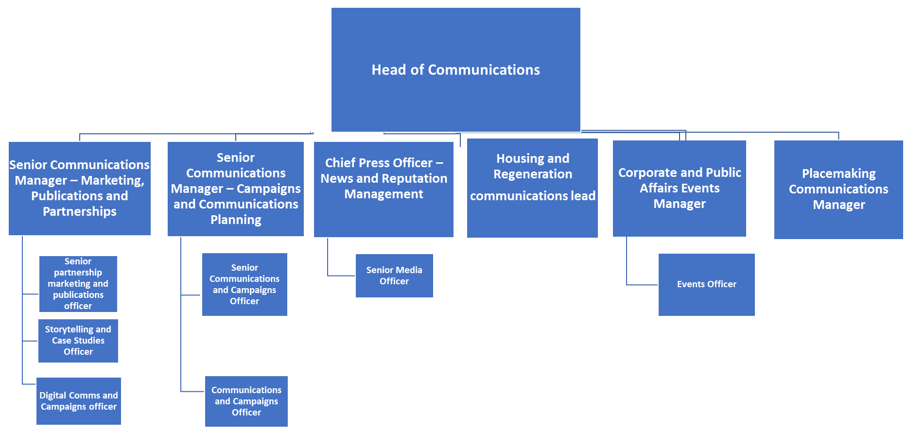

For the current structure please go to The Loop.

Person Specification

Our Values
THINK BIGGER
EMBRACE DIFFERENCE
CONNECT BETTER
LEAD BY EXAMPLE
PUT PEOPLE FIRST

Our Values are embedded across Richmond & Wandsworth Better Service Partnership and throughout all roles and responsibilities at all levels of the organisation. Please familiarise yourself with our values as they are an integral part of our recruitment and selection process.

Person Specification Requirements |  |  |  | Assessed by  A/I/T/C  (see below for explanation)
 | Knowledge | Essential | Desirable | Assessed
 | Outstanding writing, editing, and verbal communication skills | x |  | A&T
 | Knowledge of local government policies and issues |  | x | A&I
 | Excellent interpersonal skills, with the ability to build relationships and collaborate effectively with diverse stakeholders. | x |  | I
 | Experience | Essential | Desirable | Assessed
 | Experienced in PR, media relations, or communications, preferably within a public sector or government environment. Previous experience as a journalist would be an advantage. | x |  | A
 | Demonstrated ability to develop and execute successful PR campaigns, including crisis communications management. | x |  | A
 | Knowledgeable of Wandsworth borough. |  | x | A
 | Skills | Essential | Desirable | Assessed
 | Ability to tailor messages for different audiences. | x |  | T
 | Strategic thinking and problem-solving abilities, with a results-driven mindset | x |  | I&T
 | Clear understanding of how to use and assess the effectiveness of social media and other e-marketing tools. | x |  | A&I
 | Qualifications | Essential | Desirable | Assessed
 | Bachelor's degree in communications, public relations, journalism, or a related field |  | x | A

A – Application form / CV
I – Interview
T – Test
C - Certificate

