Job Profile
Job Description
Job Title: Systems Support Officer | Grade: PO1
Section: Technical Support | Directorate: Resources
Responsible to following manager:  Quality & Systems Team Leader | Responsible for following staff:
Post Number/s: | Last review date: April 2016

Working for the Richmond/Wandsworth Shared Staffing Arrangement
This role is employed under the Shared Staffing Arrangement between Richmond and Wandsworth Councils. The overall purpose of the Shared Staffing Arrangement is to provide the highest quality of service at the lowest attainable cost.
Staff are expected to deliver high quality and responsive services wherever they are based, as well as having the ability to adapt to sometimes differing processes and expectations.
The Shared Staffing Arrangement aims to be at the forefront of innovation in local government and the organisation will invest in the development of its staff and ensure the opportunities for progression that only a large organisation can provide.

Job Purpose
To ensure, through exception reporting, testing and the implementation of new systems releases and bug fixes, the high quality of information on the Benefits, Parking and Council Tax databases. This will allow for accurate business statistics to be produced.

Specific Duties and Responsibilities
Responsible for the day to day maintenance of Benefits, Council Tax and Parking IT systems and databases to ensure continued reliability to users, provide a resource for generating scheduled and ad-hoc management report with duties including not solely:

- Maintain and update IT systems ensuring that systems, policy and procedures are in line with regulations and are fit for purpose;
- Maintain databases to ensure the accuracy of assessment, statutory returns and externally reported performance
- Collate statistical performance overview and individual officer performance data for day to day management of Benefits, Council Tax and Parking services.
- Complete testing and implementation of systems to ensure they are fit for purpose and consistent with regulations for Benefits, Council Tax and Parking services.
- Complete all necessary housekeeping and testing for systems used by Benefits, Council Tax and Parking services
- Complete and monitor requests for Data Protection files and manage FOI requests within corporate timescales for Revenues Services.
- Provide business related reports from the databases as and when required, in the appropriate format including use of Excel, Access and Business Objects.
To ensure that the Benefits, Council Tax and Parking services for both Councils are dealt with on an equitable basis to deliver the standards required for each, as agreed annually by the Executives of both Councils.

To provide supervision as required to assigned staff and take responsibility for the allocation and checking of work by staff.

To advise and support managers on relevant matters affecting the Benefits, Council Tax and Parking services.

To contribute as required to performance review and improvement measures on an ongoing basis, helping to ensure that a customer focus is embedded within the function and innovative and creative solutions are evaluated to securing the highest quality and value for money function.

To contribute as required to change programmes within the Benefits, Council Tax and Parking services.

To support ways of working that ensure residents and stakeholders are actively engaged in the future of the function and are able to influence decision making.

To contribute as required to the commissioning, market testing and contract management of Benefits, Council Tax and Parking services.

To work as required in ways that develop good working relations and collaborative arrangements with internal and external stakeholders.

To act as deputy Quality and systems team leader as required.

Generic Duties and Responsibilities

- To contribute to the continuous improvement of the services of the Boroughs of Wandsworth and Richmond.

- To comply with relevant Codes of Practice, including the Code of Conduct and policies concerning data protection and health and safety.

- To adhere to security controls and requirements as mandated by the SSA’s policies, procedures and local risk assessments to maintain confidentiality, integrity, availability and legal compliance of information and systems

- To promote equality, diversity, and inclusion, maintaining an awareness of the equality and diversity protocol/policy and working to create and maintain a safe, supportive and welcoming environment where all people are treated with dignity and their identity and culture are valued and respected.

- To understand both Councils’ duties and responsibilities for safeguarding children, young people and adults as they apply to the role within the council.

- The Shared Staffing Arrangement will keep its structures under continual review and as a result the post holder should expect to carry out any other reasonable duties within the overall function, commensurate with the level of the post.

Additional Information

Current team structure
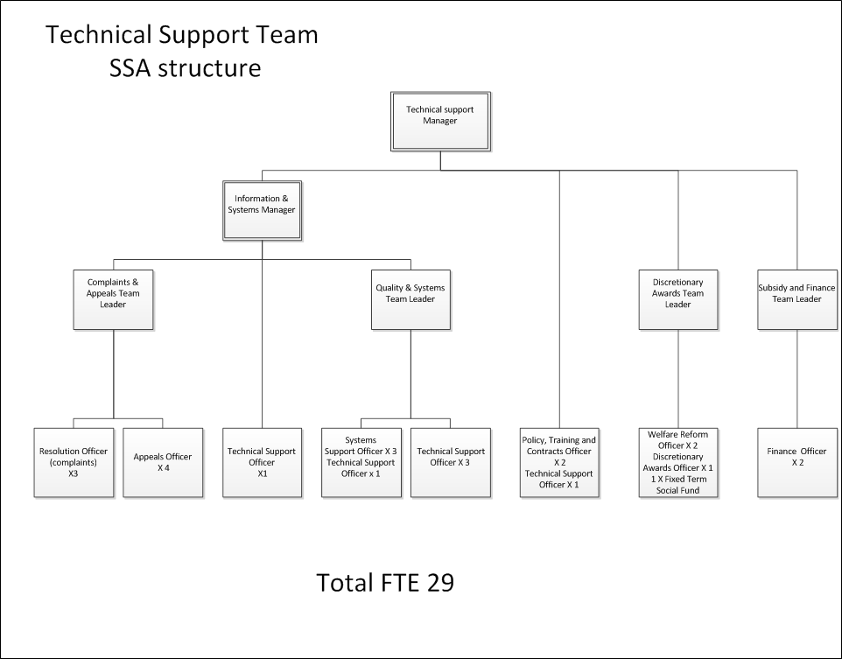

Person Specification
Job Title: Systems Support Officer | Grade: PO1
Section: Technical Support | Directorate: Resources
Responsible to following manager:  Quality & Systems Team Leader | Responsible for following staff:
Post Number/s: | Last review date: April 2016
Our Values and Behaviours

The values and behaviours we seek from our staff draw on the high standards of the two boroughs, and we prize these qualities in particular –

Being open. This means we share our views openly, honestly and in a thoughtful way. We encourage new ideas and ways of doing things. We appreciate and listen to feedback from each other.

Being supportive. This means we drive the success of the organisation by making sure that our colleagues are successful. We encourage others and take account of the challenges they face. We help each other to do our jobs.

Being positive. Being positive and helpful means we keep our goals in mind and look for ways to achieve them. We listen constructively and help others see opportunities and the way forward. We have a ‘can do’ attitude and are continuously looking for ways to help each other improve.

These values and behaviours will be developed further as the SSA becomes established.

Person Specification Requirements | Assessed by  A  & I/ T/ C (see below for explanation)
Knowledge
Experience of providing systems support including systems testing, report generation and database upkeep on either the IT systems related to:  - Benefits  - Council Tax  - Parking Permits / PCNs | A/I
In depth knowledge of the Services processes and procedures and the regulation and the statutory framework that underpins them for either:  - Benefits  - Council Tax  - Parking Permits / PCNs | A/I
Experience
Experience of system testing including regression and release testing of IT packages used by either:  - Benefits  - Council Tax  - Parking Permits / PCNs | A/I
Experience of successful generating system reports on both a scheduled and ad-hoc basis. | A/I
Significant experience of using standard IT packages to an advanced level as required for the role. This may include report writing (Word), presentations (PowerPoint) and manipulating statistical data (Excel/Access). | A/I
Evidence of working in changing circumstances | A/I
Skills
Ability to organise and prioritise own workload, to work under pressure and meet deadlines. | A/I
Ability to interrogate IT systems using reporting tools to obtain reports as specified by the Benefits, Council Tax and Parking services. | A/I
Good oral, written and presentation skills to provide clear and concise messages in a variety of internal and external contexts k | A/I
Qualifications

A – Application form
I – Interview
T – Test
C - Certificate

