Job Profile comprising Job Description and Person Specification
Job Description

Job Title:  Mechanical Engineer | Grade:  PO5 – PO6
Section:  Design Service | Directorate:  HRD
Responsible to following manager:  Principal Engineer | Responsible for following staff:  Graduate/Apprentice
Post Number/s: | Last review date:

Working for the Richmond/Wandsworth Shared Staffing Arrangement

This role is employed under the Shared Staffing Arrangement between Richmond and Wandsworth Councils. The overall purpose of the Shared Staffing Arrangement is to provide the highest quality of service at the lowest attainable cost.

Staff are expected to deliver high quality and responsive services wherever they are based, as well as having the ability to adapt to sometimes differing processes and expectations.

The Shared Staffing Arrangement aims to be at the forefront of innovation in local government and the organisation will invest in the development of its staff and ensure the opportunities for progression that only a large organisation can provide.

Job Purpose

- Fully Qualified or working toward Design qualification.
- Designing, implementing projects
- Using software and equipment for computer-aided design and other professional complex technical software.
- Establishing and enforcing construction, manufacturing and installation standards.
- Calculating and monitoring project costs and delivery timelines.
- Providing quality assurance for ongoing projects
- Collaborating with clients and other professionals.
- Writing regular reports, giving presentations and meeting with clients and management.

Specific Duties and Responsibilities

- Control project from start to finish to ensure high quality, innovative and functional design.
- Carry out the role of Principal Designer for all your projects.
- Take the “brief” to identify clients’ needs and put together feasibility reports and design proposals
- Develop ideas keeping in mind client’s needs, building’s usage and environmental impact.
- Undertake a desktop assessment of any key planning requirements or other potential constraints which will affect the Mechanical Design (e.g. listed building, conservation area etc) and advise the Client/Project Coordinator accordingly.
- Attend Planning Application meetings, Community Engagement sessions and the like.
- Carry out site inspection, investigate building defects and advise / implement appropriate action.
- Prepare reports in accordance with industry standards and best practice and give professional / technical Mechanical engineering advice.
- Compile project Presentations, drawings, blueprints, specifications, and construction documents as well as proficiency with AutoCAD.
- Keep within budgets and timelines reporting regularly to Client / Project coordinator.
- Ensure compliance with all applicable Building Regulations, British Standards, Legislation, Statutory Requirements etc.
- Undertake value engineering exercises and ensure the Electrical Designs are compatible with the Client’s budget.
- Make on site visits to check on project status and report on project
- Cooperate and liaise with construction professionals
- Follow industry trends and advancements
- Adjust designs and plans to meet the client's needs.
- Advise the Client/Project Coordinator if additional specialist consultancies are required to complete the Services such as fire risk assessors, acoustic engineers, structural engineers etc.
- Promote and ensure adherence to Sustainability and Health and Safety policies
- Motivate and mentor a graduate/apprentice as required.
- Undertake continual professional development
- Carry out other duties and responsibilities, as required, and as requested by members of the management team.

Linked Grade Progression criteria:
Note 1: Linked Grade progression is not automatic and is dependent on the level of responsibility, complexity of the role, skills, experience and the need of the Service.
Note 2: To be considered for any progression you must be doing the following:
- Demonstrate a high level of client satisfaction, proactive, diligent, meeting deadlines and have a quick response time to queries.
- Meeting the relevant performance and income KPI’s
- Demonstrate a high level of compliance with the service policies and procedures

Progression to PO6
- Post holder would be expected to perform the full duties of the post competently.
- Regularly deputising for line manager when required.
- Regularly leading complex team projects both from a technical and delivery perspective.
- The post holder should have developed the personal and professional qualities necessary to provide input to the overall management of the Service and to make recommendations to senior managers.

Client relationship management

- Ensure client satisfaction at each stage of the project.
- Submitting report of the project on a regular basis to the client and team.
- Keeping the client up to date at every step of the project, getting their approval for the next stage.
- Passionate, driven, motivated, proactive, kind and honest.

Generic Duties and Responsibilities

- To contribute to the continuous improvement of the services of the Boroughs of Wandsworth and Richmond.

- To comply with relevant Codes of Practice, including the Code of Conduct and policies concerning data protection and health and safety.

- To adhere to security controls and requirements as mandated by the SSA’s policies, procedures and local risk assessments to maintain confidentiality, integrity, availability and legal compliance of information and systems

- To promote equality, diversity, and inclusion, maintaining an awareness of the equality and diversity protocol/policy and working to create and maintain a safe, supportive and welcoming environment where all people are treated with dignity and their identity and culture are valued and respected.

- To understand both Councils’ duties and responsibilities for safeguarding children, young people and adults as they apply to the role within the council.

- The profile is not intended to be an exhaustive list of the duties the post holder will carry out. Other reasonable duties commensurate with the level of the post, including supporting emergency and priority situations, will form part of the role.
Additional Information
- Attendance at evening meetings required.
- The Service operates as a consultancy. Critical to its success is achieving high levels of customer care and customer satisfaction.
- The Service is in direct competition with the private sector and therefore needs to attract and retain creative, innovative, knowledgeable and experienced professional staff to be able to perform in a demanding environment.

Team structure

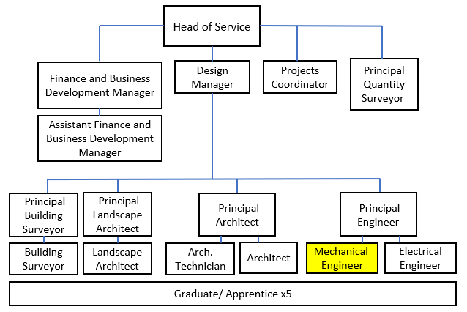
Person Specification

Job Title:  Mechanical Engineer | Grade:  PO5 – PO6
Section:  Design Service | Directorate:  HRD
Responsible to:  Principal Engineer | Responsible for:  Graduate/Apprentice
Post Number/s: | Last Review Date:

Our Values and Behaviours

The values and behaviours we seek from our staff draw on the high standards of the two boroughs, and we prize these qualities in particular:

Being open. This means we share our views openly, honestly and in a thoughtful way. We encourage new ideas and ways of doing things. We appreciate and listen to feedback from each other.

Being supportive. This means we drive the success of the organisation by making sure that our colleagues are successful. We encourage others and take account of the challenges they face. We help each other to do our jobs.

Being positive. Being positive and helpful means we keep our goals in mind and look for ways to achieve them. We listen constructively and help others see opportunities and the way forward. We have a ‘can do’ attitude and are continuously looking for ways to help each other improve.

Person Specification Requirements |  |  |  | Assessed by  A/I/T/C  (see below for explanation)
 | Knowledge | Essential | Desirable | Assessed
 | Experience in residential (single family houses and small developments) and Public Realm projects | Y |  | A/I
 | Detailed knowledge of Local planning |  | Y | A/I
 | Detailed knowledge of building codes and Standards | Y |  | A/I
 | Detailed knowledge of JCT contracts |  | Y | A/I
 | Experience | Essential | Desirable | Assessed
 | Experience of flexible working; reacting to changing and urgent priorities in a working environment |  | Y | A/I
 | Experience of having to set and deliver defined standards and targets and report accordingly | Y |  | A/I
 | Experience of negotiating effectively with individuals and organisations to achieve positive commercial outcome | Y |  | A/I
 | Experience of leading on several complex projects at any one time |  | Y | A/I
 | Knowledge of Project management software programs, Microsoft Office and AutoCAD, Revit, Adobe Creative Suite, etc. | Y |  | A/I
 | Skills | Essential | Desirable | Assessed
 | Excellent communication skills with the ability to communicate both verbally and in writing, with colleagues, staff within the organisation, clients, residents, agencies, Councillors, Committees, contractors, and consultants. | Y |  | A/I
 | Ability to manage a wide variety of schemes including large complex contracts |  | Y | A/I
 | Forward thinking and interested in developing smart ways of working with teams to realise client and operational objectives | Y |  | A/I
 | Excellent AutoCAD skills |  | Y | A/I
 | Strong organisational skills with the ability to multi-task and a positive and ‘can do’ approach. | Y |  | A/I
 | Ability to develop others through training and mentoring |  | Y | A/I
 | Qualifications | Essential | Desirable | Assessed
 | BS degree in Mechanical Engineering or working towards. Registered by the Engineering Council is desirable. |  | Y | A/C

A – Application form / CV
I – Interview
T – Test
C - Certificate

