Job Description

Job Title: | Grade:
Graduate Project Officer (Climate Change and Sustainability)  Two Year Fixed Term Contract | Scale 5 – Scale 6
Section: | Directorate:
Climate Change and Sustainability - Climate Change, Policy and Communications | Chief Executive’s Group
Responsible to following manager: | Responsible for following staff:  N/A
Head of Climate Change and Sustainability
Post Number/s: | Last review date:  April 2024
TBC

Working for the Richmond/Wandsworth Shared Staffing Arrangement

In July 2019 Richmond Council and Wandsworth Council declared Climate Emergencies, following this Wandsworth Council published its Environment and Sustainability Strategy in July 2019 and Richmond published its Climate Emergency Strategy in January 2020. Although both councils are committed to being net zero organisations by 2030 and to make both boroughs net zero by 2043 the individual strategies reflect the priorities for each borough and therefore contain actions and priorities which are unique to each. Both strategies are underpinned by ambitious action plans that involve services across all the whole organisation. These action plans cover the operations of both councils, the estates of both councils and the Shared Staffing Service workforce. Alongside these strategies and action plans each council has developed individual engagement and behaviour change programmes which look to involve residents, local groups, local businesses and partners in taking action to improve the environment and reduce carbon emissions.

The postholder will support the delivery of the two strategies and their supporting action plans. The postholder will support the delivery of individual actions, including projects and engagement activities, working closely with the wider Climate Change and Sustainability Team as well as other teams across the organisation.

This role is employed under the Shared Staffing Arrangement between Richmond and Wandsworth Councils. The overall purpose of the Shared Staffing Arrangement is to provide the highest quality of service at the lowest attainable cost. Staff are expected to deliver high quality and responsive services wherever they are based, as well as having the ability to adapt to sometimes differing processes and expectations.

Job Purpose

This post is designed to provide a range of career development experience and opportunities covering climate change and sustainability in local government.

The post-holder will develop their skills and knowledge during the course of the role, including advancing through IEMA membership to Practitioner level.

The post-holder will support and deliver projects that support Richmond and Wandsworth’s climate action plans.

Specific Duties and Responsibilities:

- Support the delivery of both Council’s climate strategies and action plans.
- Support the development, project management and delivery of climate change related projects.
- Undertake research and analyse information to assist with the development of climate change related policies and projects.
- Collate and interpret data and prepare technical reports including greenhouse gas emissions reports.
- Research, prepare and write up reports and briefing papers for managers.
- Arrange and support meetings, including the SSA Climate Change Steering Group
- Support the external reporting and validation of the Councils’ climate change work.
- Assist in the development and delivery of staff climate awareness training and behavioural change programmes, including supporting the SSA Sustainability Network.
- Support the delivery of climate change partnership and engagement events, activities, and campaigns.
- Work collaboratively with other Council departments and external partners and agencies, including the private and voluntary sector.
- Identify potential funding opportunities including grants and assist in the preparation of funding applications.
- Keep up to date and fully informed on national regulations, statutory requirements, policy documents and technical information relating to climate change and sustainability.
- Develop an understanding of the role of local government, the role of elected members and politicians and the requirements for both boroughs to reach net zero by 2043.
- Undertake training and knowledge/skills development to achieve IEMA Associate level.

Progression Criteria

Progression through the grade is based on the needs of the Council and is not automatic. The need for employees working at the higher grade/s will be assessed by the relevant manager. If it is established that there is a need, then the postholder will be subject to a full assessment about their ability to work at the higher level.

Additional Criteria for progression to Scale 6 of the linked grade in Year 2:

- Post holder will demonstrate the ability to work with increased responsibility and in a more independent manner.
- Ability to handle confidential or sensitive information and to distinguish between political and non-political activities.
      - Ability to work both independently and as an effective team member able to undertake a variety of work using own initiative, managing workload and adapting to changing priorities and deadlines.
- In the second year the post holder would be expected to lead on projects and oversee work of others where appropriate.
- Satisfactory progress made on IEMA membership.

Generic Duties and Responsibilities

• To contribute to the continuous improvement of the services of the Boroughs of
Wandsworth and Richmond services.
• To comply with relevant Codes of Practice, including the Code of Conduct, and policies concerning data protection and health and safety.
• To adhere to security controls and requirements as mandated by the SSA’s policies, procedures and local risk assessments to maintain confidentiality, integrity, availability and legal compliance of information and systems.
• To promote equality, diversity, and inclusion, maintaining an awareness of the equality and diversity protocol/policy and working to create and maintain a safe, supportive and welcoming environment where all people are treated with dignity and their identity and culture are valued and respected.
• To understand both Council’s duties and responsibilities for safeguarding children,
young people and adults as they apply to the role within the council.
• The Shared Staffing Arrangement (SSA) will keep its structures under continual review and as a result the post holder should expect to carry out any other reasonable duties within the overall function, commensurate with the level of the post.

Additional Information

• Post holder is required to work flexibly across Richmond and Wandsworth.
• Undertake other duties as deemed relevant and suitable to the role by relevant managers.

Our Values
THINK BIGGER
EMBRACE DIFFERENCE
CONNECT BETTER
LEAD BY EXAMPLE
PUT PEOPLE FIRST

Team structure

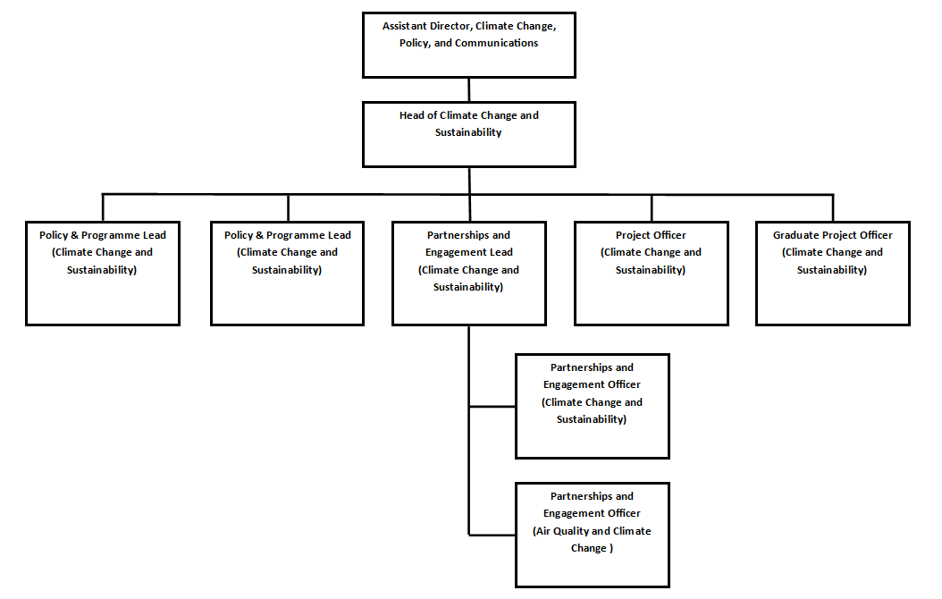
Person Specification

Job Title: | Grade:
Graduate Project Officer (Climate Change and Sustainability)  Two Year Fixed Term Contract | Scale 5 – Scale 6
Section: | Directorate:
Climate Change and Sustainability - Climate Change, Policy and Communications | Chief Executive’s Group
Responsible to following: manager: | Responsible for following staff:  N/A
Head of Climate Change and Sustainability
Post Number/s: | Last review date:  April 2024
TBC

Person Specification Requirements |  |  | Assessed by  A & I/ T/ C  (see below for explanation)
Experience | Essential | Desirable | Assessed
An in-depth understanding of the climate change and sustainability agenda | X |  | A/I
Understanding of greenhouse gas emissions accounting and carbon reduction |  | X | A/I
Demonstrate a clear and reasoned interest in working in local government | X |  | A/I
Knowledge and skills | Essential | Desirable | Assessed
Experience of conducting research and using evidence to draw conclusions | X |  | A/I
Experience of working collaboratively to achieve an agreed outcome | X |  | A/I
Ability to produce succinct and persuasive written reports | X |  | A/I
Excellent written and verbal communications skills | X |  | A/T
Ability to take decisions where appropriate to do so, rather than referring them to others | X |  | A/I
Able to develop positive working relationships at different levels | X |  | A/I
Ability to organise own workload, prioritise tasks to meet deadlines and respond flexibly to frequently changing needs and priorities | X |  | A/I
Ability to analyse and interpret data related to greenhouse gas emissions and climate policy |  | X | A/I
Ability to think flexibly, innovatively and resourcefully to solve complex problems | X |  | A/I
A good understanding of own strengths and development needs together with a commitment to self-improvement | X |  | A/I
Ability to use effective means of communication in order to resolve problems | X |  | A/I
Qualifications | Essential | Desirable | Assessed
Sustainability, climate change or environment related degree, minimum 2:2 attainment | X |  | A

A – Application form / CV
I – Interview
T – Test
C – Certificate

