Ernest Bevin College
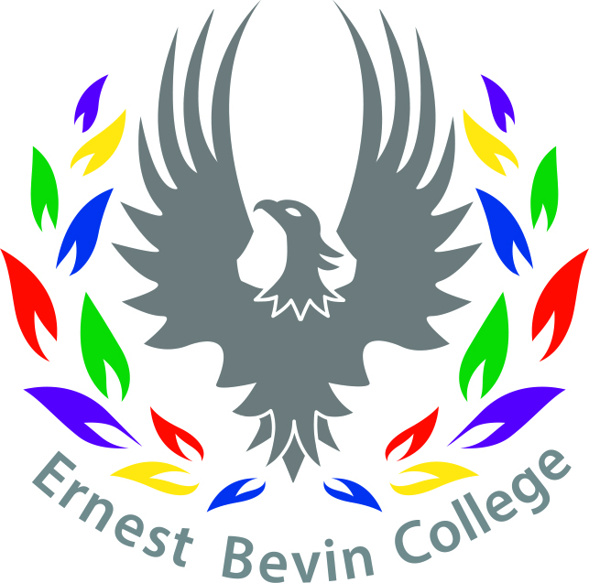
Job Description

Title: Personal Assistant to the Principal and Clerk to the Governors | Salary Scale: S01 Permanent  Hours: Term time + 2 weeks
Supported by and reporting to: The Principal | Assisted by: College staff

Job Purpose | To support the Principal on a day-to-day basis and to clerk the Governing Board and committees.
Personal and Professional Conduct | - Treat students with dignity, building relationships rooted in mutual respect, and at all times observing proper boundaries as appropriate  - Have regard to the need to safeguard students’ well-being, in accordance with statutory provisions  - Show tolerance of and respect for the rights of others  - Promote fundamental British values, including democracy, the rule of law, individual liberty and mutual respect, and tolerance of those with different faiths and beliefs  - Ensure that personal beliefs are not expressed in ways which exploit students’ vulnerability or might lead them to break the law  - Have a proper and professional regard for the ethos, policies and practice of the college and maintain high standards in their own attendance and punctuality
Key Responsibilities | - Organise and schedule meetings, prepare meeting agendas and take minutes during meetings  - Ensure documentation for regular meetings is collated and distributed as appropriate  - Co-ordinate college functions and events including logistical arrangements, invitations etc.  - Handle communications for the Principal including correspondence and telephone calls ensuring all relevant message are communicated promptly and efficiently.  - Prepare correspondence as required  - Manage the diary and schedule of the Principal  - Produce presentation materials using appropriate computer packages  - Maintain at all times a discrete and professional relationship with staff, parents and visitors  - Foster strong working relationships with other departments within the college  - Clerk the Governing Board and Committees, preparing agendas, chasing and collating papers, dispatching papers to Governors and minuting meetings - there are approximately three full Governing Board meetings and nine committee meetings per annum. Meetings commence at 5.00pm and are scheduled for 2 hours. TOIL is provided to enable these duties.  - Establish and maintain readily accessible, reliable filing systems (both paper and electronic)  - Undertake any other relevant duties as determined from time to time by the Principal  - Deal with all maters in a discreet and confidential manner  - To deal effectively and courteously with all of the Principal’s visitors  - Ensure archive records are maintained in accordance with current legislation  - To answer routine enquiries from staff, parents and other agencies made to the Principal and to deal with them effectively, in the first instance wherever possible.

To be fully aware of and understand the duties and responsibilities arising from the Children’s Act 2004 and Working Together in relation to child protection and safeguarding children and young people as this applies to the worker’s role within the organisation, and the principles of safeguarding as they apply to vulnerable adults in relation to the worker’s role. To ensure the worker’s line manager is made aware and kept fully informed of any concerns which the worker may have in relation to safeguarding and/or child protection.

Ernest Bevin College
Personal Specification

Title: Personal Assistant to the Principal and Clerk to the Governors | Salary Scale: S01 Permanent  Hours: Term time + 2 weeks
Supported by and reporting to: The Principal | Assisted by: College staff

CRITERIA | ESSENTIAL | DESIRABLE
QUALIFICATIONS | - Relevant L3 qualifications | - Clerking qualifications or equivalent
EXPERIENCE, KNOWLEDGE AND SKILLS | - Proficient in Microsoft Office including, Word, Excel, Power Point and Outlook/Email  - High levels of literacy and accuracy including a confident grasp of grammar and good drafting skills  - Exceptional organisational skills and an eye for detail  - Excellent inter-personal and an ambassador for the college  - Experience of managing projects individually or as part of a team  - Understand the imperative to meet deadlines  - Demonstrate flexibility and adaptability in a fast moving and busy environment  - Demonstrate an ability to motivate, enthuse and show unrelenting optimism  - Focus on getting things done | - A working understanding of school Management Information Systems  - Worked in a similar role in schools
PERSONAL QUALITIES AND CHARACTERISTICS | - Commitment to own learning and development  - Demonstrate professionalism, confidentiality, tact, diplomacy and discretion  - Passionate about the power of education to transform lives  - Commitment to the college’s vision and ethos  - Commitment to work in ways that promote equality of opportunity, participation, diversity and responsibility  - Demonstrate professional, proactive and an adaptable attitude  - Commitment to abide by and promote the college’s Safeguarding, Equal Opportunities, Health and Safety, Child Protection Policies  - The postholder will require an enhanced DBS  - Focus on getting things done instead of get things done  - Work as part of a team  - Ability to maintain strict confidentiality  - Seek advice and support when necessary  - Open – minded and receptive to new ideas, approaches and challenges
March 2021

