**Job Profile comprising Job Description and Person Specification**

**Job Description**

|  |  |
| --- | --- |
| **Job Title:**  Public Health Programmes Support Officer | **Grade**:  SO1 |
| **Section:**  Public Health | **Directorate:**  Adult Social Care and Public Health |
| **Responsible to following manager:**  Consultant in Public Health – Health Protection | **Responsible for following staff:**  N/A |
| **Post Number/s:**  1 | **Last review date:**  April 2016 |

**Working for the Richmond & Wandsworth Better Service Partnership**

This role is employed under the Richmond & Wandsworth Better Service Partnership. The overall purpose of Richmond & Wandsworth is to provide the highest quality of service at the lowest attainable cost.

Staff are expected to deliver high quality and responsive services wherever they are based, as well as having the ability to adapt to sometimes differing processes and expectations.

Richmond & Wandsworth Better Service Partnership aims to be at the forefront of innovation in local government and the organisation will invest in the development of its staff and ensure the opportunities for progression that only a large organisation can provide.

**Job Purpose**

Responsible for providing project management support and coordination to the Consultant in Public Health and their team. To assist with the management of projects, contracts and initiatives, and provide generic support.

**Specific Duties and Responsibilities**

* Be responsible for the **day-to-day administration** of designated project activities, working closely with all members of the project to provide administrative research and logistical support.
* Under the supervision of the Consultant in Public Health **facilitates, engages and finalises action plans and follows up** as appropriate.
* Develop and roll out a **standardised approach to project management** across their team.
* **Handle confidential information/processes** for example the Health Protection Team Mailbox and supporting Outbreak/Incident Management Meetings.
* **Draft, produce and quality assure documentation, including complex planning documents, reports, letters, memorandums, minutes** and **agendas**.
* **Maintain a plan of reports and actions** and ensure that all corporate documents are in line with business planning processes/schedules and committee report guidelines.
* Assist in providing **office support** to the Consultants in Public Health and the teams, to ensure the smooth running of the department, including dealing with enquiries and any other activities required within the service.
* **Work in partnership** with other officers within Public Health, other Wandsworth and Richmond services and outside organisations as required.
* **Arrange high level meetings** including cross-borough/agency meetings, including booking venues etc.
* **Deal with urgent diary issues** for the Consultant in Public Health and provide initial response in their specialist areas.
* **Provide cover for the Director of Public Health’s assistant** when absent, including telephone and other cover as required.
* Support the **delivery and development of key public health projects**.

**Generic Duties and Responsibilities**

* To contribute to the continuous improvement of the services of Richmond & Wandsworth Better Service Partnerships.
* To comply with relevant Codes of Practice, including the Code of Conduct and policies concerning data protection and health and safety.
* To adhere to security controls and requirements as mandated by Richmond and Wandsworth procedures and local risk assessments to maintain confidentiality, integrity, availability and legal compliance of information and systems
* To promote equality, diversity, and inclusion, maintaining an awareness of the equality and diversity protocol/policy and working to create and maintain a safe, supportive and welcoming environment where all people are treated with dignity and their identity and culture are valued and respected.
* To understand both Councils’ duties and responsibilities for safeguarding children, young people and adults as they apply to the roles within the Councils.
* The profile is not intended to be an exhaustive list of the duties the post holder will carry out. Other reasonable duties commensurate with the level of the post, including supporting emergency and priority situations, will form part of the role.

**Additional Information**

* The post holder will have the opportunity to combine home and on-site working under the Better Services Partnership (BSP) agile working model.
* When on-site the post holder will be expected to work flexibly across two locations (Wandsworth Town Hall and Richmond Civic Centre).

**Team structure**

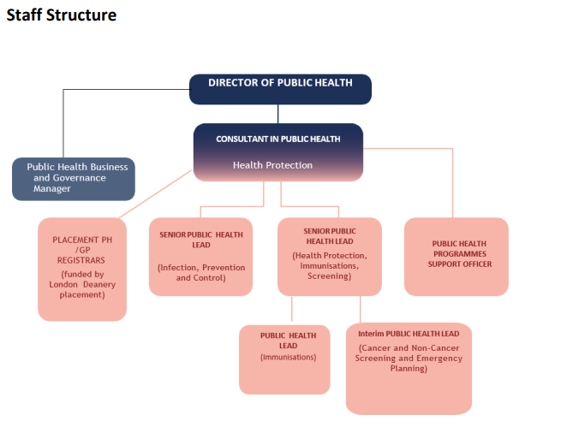

**PUBLIC HEALTH PROGRAMMES SUPPORT OFFICER**

**Person Specification**

|  |  |
| --- | --- |
| **Job Title:**  Public Health Programmes Support Officer | **Grade**:  SO1 |
| **Section:**  Public Health | **Directorate:**  Adult Social Care and Public Health |
| **Responsible to:**  Consultant in Public Health – Health Protection | **Responsible for:**  N/A |
| **Post Number/s:**  1 | **Last Review Date:**  April 2016 |

**Our Values**

**THINK BIGGER**

**EMBRACE DIFFERENCE**

**CONNECT BETTER**

**LEAD BY EXAMPLE**

**PUT PEOPLE FIRST**

Our Values are embedded across Richmond & Wandsworth Better Service Partnership and throughout all roles and responsibilities at all levels of the organisation. Please [familiarise yourself with our values](https://www.richmond.gov.uk/media/afdbdeao/five_values.pdf) as they are an integral part of our recruitment and selection process.

|  |  |  |  |
| --- | --- | --- | --- |
| **Person Specification Requirements** | | | **Assessed by**  **A/I/T/C**  **(see below for explanation)** |
| **Knowledge** | **Essential** | **Desirable** | **Assessed** |
| Proficient in use of Microsoft Office, including Outlook, Word, Excel and PowerPoint. | **Y** |  | **A/I/T** |
| **Experience** | **Essential** | **Desirable** | **Assessed** |
| Experience of working as an administrator and project officer at a senior level. |  | **Y** | **A/I** |
| **Skills** | **Essential** | **Desirable** | **Assessed** |
| Demonstrable project management skills. | **Y** |  | **A/I** |
| The ability to work effectively and accurately to tight deadlines in a sometimes, challenging environment and to manage multiple project deadlines. | **Y** |  | **A/I** |
| Ability to organise and prioritise own work in an efficient and effective way, and to work with minimum supervision. | **Y** |  | **A/I** |
| A high level of office and business management skills, diary management and the ability to organise meetings. | **Y** |  | **A/I/T** |
| Be able to demonstrate a meticulous approach and an eye for detail. | **Y** |  | **A/I** |
| The ability to communicate effectively and sensitively, orally and in writing on a wide range of detailed issues. | **Y** |  | **A/I/T** |
| The ability to take and transcribe action points/minutes of meetings and draft non-standard correspondence. | **Y** |  | **A/I/T** |
| Be able to collate information and maintain files and records accurately on computerised and manual recording systems. | **Y** |  | **A/I** |
| Be able to work as part of a team and be able to deal confidently, tactfully, calmly and sensitively with a wide range of Officers and professionals at all levels inside and outside of the organisation. | **Y** |  | **A/I** |
| **Qualifications** | **Essential** | **Desirable** | **Assessed** |
| Project management qualification or evidence of an equivalent qualification and/or experience. | **Y** |  | **A/C** |

**A – Application form / CV**

**I – Interview**

**T – Test**

**C - Certificate**