**Job Profile comprising Job Description and Person Specification**

**Job Description**

|  |  |
| --- | --- |
| **Job Title:**  Community Safety Intelligence Analyst | **Grade**:  PO3 |
| **Section:**  Stronger and Safer Communities | **Directorate:**  Chief Executive’s Group |
| **Responsible to following manager:**  Neighbourhoods and Criminal Justice Manager | **Responsible for following staff:**  **n/a**  **Sessional/graduate as and when** |
| **Post Number/s:** | **Last Review Date:**  Aug 2021 (Updated October 2023) |

**Working for the Richmond/Wandsworth Shared Staffing Arrangement**

This role is employed under the Shared Staffing Arrangement between Richmond and Wandsworth Councils. The overall purpose of the Shared Staffing Arrangement is to provide the highest quality of service at the lowest attainable cost.

Staff are expected to deliver high quality and responsive services wherever they are based, as well as having the ability to adapt to sometimes differing processes and expectations.

The Shared Staffing Arrangement aims to be at the forefront of innovation in local government and the organisation will invest in the development of its staff and ensure the opportunities for progression that only a large organisation can provide.

**Job Purpose**

The post holder will be responsible for leading on the provision of efficient and effective data analysis and insight, that informs the work of The Safer and Stronger Communities Team. The post holder will work closely with analysts within other teams across the council and the partnership.

**Specific Duties and Responsibilities**

1. To contribute to performance review and improvement measures on an ongoing basis, helping to ensure that the council values are embedded within the service with innovative and creative solutions which are evaluated to securing quality and value for money.
2. To lead on implementing an evidence based approach and a robust performance management framework for the Community Safety Partnership and the Safer and Stronger Communities Team.
3. Apply tools and techniques for data analysis and data visualisation (e.g. PowerBI, Infographics).
4. Manipulate and link different data sets, manage, clean, abstract and aggregate data alongside a range of analytical studies on that data. Perform data preparation and cleansing.
5. Make recommendations about the tasking and deployment of resources and interventions through the production of crime mapping and problem-solving reports, targeting resources and directing delivery of crime prevention programmes across the boroughs (geographically based).
6. Summarise and present data and conclusions in the most appropriate format for users. Use the most appropriate medium to visualise data to tell compelling and actionable stories relevant for business goals. Present, communicate, and disseminate data appropriately and with high impact.
7. Learn and apply various project management tools and techniques to data projects including collating and preparing monitoring reports to central agencies as needed (e.g. Home Office, MOPAC etc).
8. Identify problems in raw data, data processes, data products and services, with an understanding of the level of a problem and its impact on analytical products. Develop and implement of remedies and preventative measures.
9. Produce accurate and clear results. Develop and apply quality assurance, validation, and data linkage abilities. Demonstrate understanding of basic data issues and check that the data and analysis looks right. Able to ensure data for analysis fit for purpose and understand the context of the data.
10. Demonstrate an eagerness to learn and develop, including but not limited to learning concepts of statistics, coding, data management, quality assurance, project management, data science techniques, mapping etc.
11. To become a subject expert in a field of analysis, Community Safety, Crime reduction and prevention. To share knowledge and contribute towards wider partnership working both internally and externally. (health / social services, crime, housing, economic development, socio economic data or children’s services).
12. To log data and information sources from routine and ad-hoc sources.
13. To assess, interpret, evaluate data and evidence then develop a robust performance management framework for the Community Safety Partnerships and subgroups through the establishment of clear targets for delivery, regularly monitoring progress against these targets and provide clear information on performance and make recommendations for improvement.
14. To lead and produce succinct and structured written communication reports, conveying clear messages, documenting, explaining and justifying the analytical approach or evaluation framework undertaken.
15. To perform a variety of data and research duties, establish, update and maintain a library of official research papers, reference documents, service reports and statistical reviews.
16. To ensure close collaboration with the wider Policy, Performance, Analysis team, key corporate teams and partners, to provide the intelligence that informs service reviews and the challenge to managers to secure service improvement focused on crime reduction and Community Safety.
17. Develop and maintain good working relationships with internal and external stakeholders and work with them to understand their requirements. Provide advice and high-quality analytical products that inform service reviews, service improvement and changes, policy development and understanding of client and population need.
18. Maintains effective record and documentation of work to support business continuity, actively anticipating pressures, problems and taking appropriate independent action.
19. Adhering to the SSA data security, access, ethics policies which promotes diversity and community cohesion, challenges oppressive practices, and meets requirements.
20. Additional tasks to support the other duties that may be required to meet the requirements of the service and the Senior Management Team. These may be varied from time to time, such as providing analysis that will underpin and support bids for external funding.

**Generic Duties and Responsibilities**

* To contribute to the continuous improvement of the services of the Boroughs of Wandsworth and Richmond.
* To comply with relevant Codes of Practice, including the Code of Conduct and policies concerning data protection and health and safety.
* To adhere to security controls and requirements as mandated by the SSA’s policies, procedures and local risk assessments to maintain confidentiality, integrity, availability and legal compliance of information and systems
* To promote equality, diversity, and inclusion, maintaining an awareness of the equality and diversity protocol/policy and working to create and maintain a safe, supportive and welcoming environment where all people are treated with dignity and their identity and culture are valued and respected.
* To understand both Councils’ duties and responsibilities for safeguarding children, young people and adults as they apply to the role within the council.
* The profile is not intended to be an exhaustive list of the duties the post holder will carry out. Other reasonable duties commensurate with the level of the post, including supporting emergency and priority situations, will form part of the role.

**Additional Information**

* The post holder will act as the lead analyst for the Stronger and Safer Communities Team , carrying out the full range of duties with minimal supervision and demonstrating initiative.
* They will be required to support projects covering several areas including, serious violence, contextual safeguarding, ASB, serious crime incident response, offender management and other relevant themes.
* Due to the nature of the analytical work, there will be occasions when it is necessary to attend and present at meetings outside of the Department, in the evenings and to a public audience. In addition, being able to prepare and present and communicate findings, data issues and recommendations to elected members, Directors, and senior managers.
* The Post holder will have the ability to discover and understand the strengths and limitations of new data sources and incorporate them into analytical products.
* Post holder will be expected to work flexibly across two locations (Wandsworth Town Hall and Richmond Civic Centre).

**Team structure**

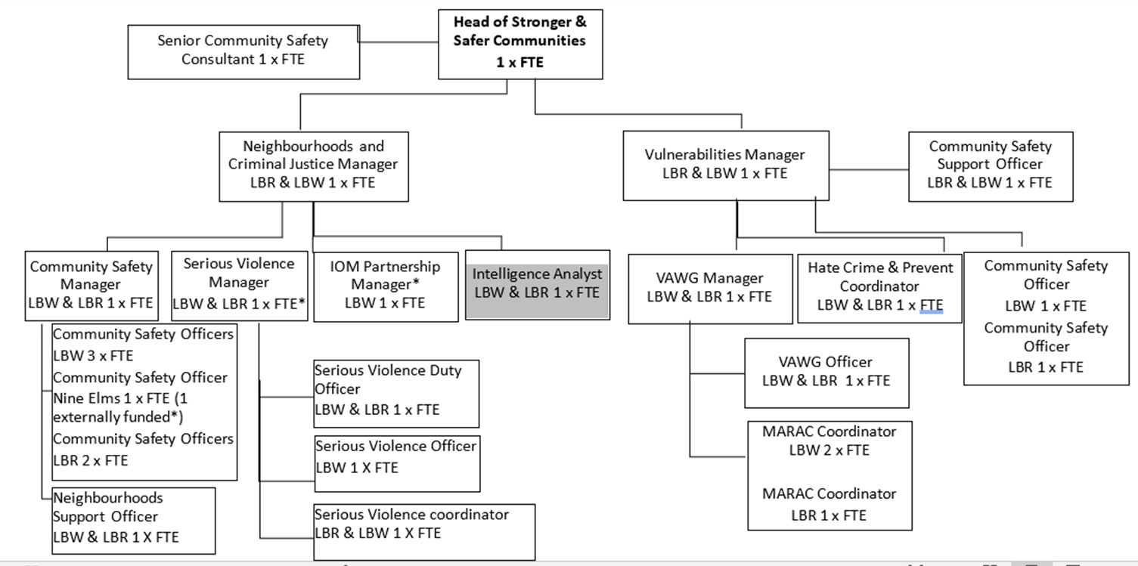

**Person Specification**

|  |  |
| --- | --- |
| **Job Title:**  Intelligence Analyst | **Grade**:  PO3 |
| **Section:**  stronger and Safer Communities Team | **Directorate:**  Chief Executive’s Group |
| **Responsible to following manager:**  Neighbourhoods and Criminal Justice Manager | **Responsible for following staff:**  n/a |
| **Post Number/s:** | **Last Review Date:**  May 2021 updated October 2023 |

**Our Values and Behaviours**

The values and behaviours we seek from our staff draw on the high standards of the two boroughs, and we prize these qualities in particular:

**Being open.** This means we share our views openly, honestly and in a thoughtful way. We encourage new ideas and ways of doing things. We appreciate and listen to feedback from each other.

**Being supportive.** This means we drive the success of the organisation by making sure that our colleagues are successful. We encourage others and take account of the challenges they face. We help each other to do our jobs.

**Being positive.** Being positive and helpful means we keep our goals in mind and look for ways to achieve them. We listen constructively and help others see opportunities and the way forward. We have a ‘can do’ attitude and are continuously looking for ways to help each other improve.

|  |  |  |  |
| --- | --- | --- | --- |
| **Person Specification Requirements** | | | **Assessed by**  **A/I/T/C**  **(see below for explanation)** |
| **Knowledge** | **Essential** | **Desirable** | **Assessed** |
| Wider determinants of Crime, serious violence and problem solving approaches such as the SARA and VOLT model. |  | **D** | A/I |
| Knowledge of the requirements of the Crime and Disorder Act 1998, Data Protection Act 2018, Human Rights Act 1998, Freedom of Information Act 2000. |  | **D** | A/I |
| An understanding of data security and confidentiality issues | **E** |  | A/I |
| An understand how to apply a range of analytical techniques such as data mining, forecasting and modelling techniques to identify and predict trends and patterns in data. | **E** |  | A/I/T |
| **Experience** | **Essential** | **Desirable** | **Assessed** |
| Significant proven experience of information analysis and presentation (tables, charts, info-graphics) | **E** |  | A/I/T |
| Work within the public sector (Police, NHS, council, other) structures and systems (desirable) |  | **D** | A/I |
| Experience of presenting written reports to working groups, committees or Partnerships to influence stakeholders | **E** |  | A/I/T |
| **Skills** | **Essential** | **Desirable** | **Assessed** |
| Highly numerate with skills and experience in the analysis and interpretation of data | **E** |  | **A/I** |
| Significant IT literacy   * Advance MS Excel skills * Proficient is use of Outlook, Work and PowerPoint * Geographic Information Systems e.g. ArcGIS * Statistical analysis software e.g. R, Python (desirable) * Able to query data using SQL * Able to dashboard using PowerBI | **E** |  | **A/I** |
| Good communications skills, both written and verbal, conveying highly complex or sensitive material | **E** |  | **A/I** |
| Able to engage with people partners and organisations at all levels | **E** |  | **A/I** |
| Ability to organise and prioritise own workload, within defined requirements for the role. | **E** |  | **A/I** |
| Ability to work independently and as a member of a team | **E** |  | **A/I** |
| **Qualifications** | **Essential** | **Desirable** | **Assessed** |
| Educated to degree level in a related subject area or equivalent through work experience | **E** |  | **A/I** |

**A – Application form / CV**

**I – Interview**

**T – Test**

**C - Certificate**