**Job Profile comprising Job Description and Person Specification**

**Job Description**

|  |  |
| --- | --- |
| **Job Title:**  Debt Recovery Officer | **Grade**:  Scale 6 – SO2 |
| **Section:**  ASCPH Finance - Business Resources | **Directorate:**  Adult Social Care and Public Health |
| **Responsible to following manager:**  Team Leader – Debt Recovery | **Responsible for following staff:** |
| **Post Number/s:** | **Last review date:** |

**Working for the Richmond & Wandsworth Better Service Partnership**

We’re Richmond & Wandsworth Better Service Partnership, the shared public service team for Richmond and Wandsworth Councils. Like any local authority, our role is to deliver the agenda of our elected members on behalf of the people who live and work in our part of the world. We deliver key services to our communities including social care, public health, children’s services, housing and regeneration and environmental and community services.

Our joint workforce creates efficiency and resilience by bringing more creativity to the way we work, more objectivity and adaptability too, helping us deliver better services for all our residents.

We’re here to help our communities thrive in a changing world, and to be there for the people who need us most we believe we need to keep adapting. That’s why, at Richmond & Wandsworth Better Service Partnership, you’ll be at the forefront of innovation in local government, and we’ll invest in you and offer you opportunities to grow in a way only our unique organisation can.

**Job Purpose**

To undertake debt recovery work for the Adult Social Care and Public Health directorate in an effective and timely manner to maximise income whilst dealing with vulnerable service users and possible complex cases.

**Specific Duties and Responsibilities**

**Scale 6:**

* To make or receive contact with service users or their representatives by phone or letter with a view to discussing outstanding invoices to obtain payment in a professional and courteous manner.
* To resolve any disputes or queries in relation to outstanding invoices. Liaising with other council departments to gather information to be able to respond effectively.
* To deal with general recovery matters and progress these to a suitable conclusion.
* To maintain records and systems such as the ASCPH system, Mosaic, and finance system, Integra.
* To produce standard reports and information as and when required including working with the Finance Team during end of year closing.
* To maintain an up-to-date knowledge of social care charging and debt policies, providing advice and support to stakeholders as and when required regarding these policies.
* To monitor the deferred payment property portfolio with a view to ensuring that the property valuation is current and up to date, there is suitable insurance cover, and we have adequate security as covered by the Care and Statutory Support Guidance issued by the Department of Health and Social Care (DHSC).
* To ensure service user and organisation payments are allocated against outstanding invoices as appropriate.
* To take service user payments over the phone as and when able and required.
* To prepare write off documentation and process once authorised.
* To identify and report cases where there may be fraud, misappropriation or misuse of service user’s funds in line with the council’s safeguarding and fraud procedures.
* To ensure that the services for both Councils are dealt with on an equitable basis to deliver the standards required for each, as agreed annually by the Executives of both councils.
* To advise and support managers on relevant debt matters affecting the service.
* To work as required in ways that develop good working relations and collaborative internal and external stakeholders particularly Shared Legal Services, Care Team, Financial Assessment Team, Transactional Services and Capita.
* **Specific Duties and Responsibilities (Scale SO1):**
* To deal with complex recovery matters and progress these to a suitable conclusion.
* Progress cases to court action via SLLP (South London Legal Partnership), if necessary, and produce a recovery strategy throughout detailing action to take during progress of the matter.
* To agree strategies and actions plans for resolving individual debt cases, involving liaison with the councils’ legal service (SLLP), Social Work Teams and other officers to progress debt recovery action and resolve complex cases, involving vulnerable service users, their families/or their legal representatives.
* To prepare and maintain detailed reports to inform Management about debt recovery cases, strategies and financial aspects.
* To prepare cabinet and executive reports for debts over £25k+ that need to be written off.
* To maintain details of SLLP cases updating when necessary.

**Specific Duties and Responsibilities (Scale SO2):**

* To lead on administering the Deferred Payments Scheme without supervision.
* To lead on collection and recovery for complex cases, agreeing action plans and coordinating input to debt recovery action from Social Work Teams, Financial Assessments Teams, the Transactional Services contractor (capita) and the Shared Legal Service (SLLP).
* To represent the council at court hearings in relation to debt recovery cases as and when required.
* To meet with service users and their representatives in negotiation of agreements, mediation and arbitration.
* To present reports at Management and staff meetings and prepare briefings on individual cases for senior managers when required.

**Generic Duties and Responsibilities**

* To contribute to the continuous improvement of the services of the Boroughs of Wandsworth and Richmond.
* To comply with relevant Codes of Practice, including the Code of Conduct and policies concerning data protection and health and safety.
* To adhere to security controls and requirements as mandated by the SSA’s policies, procedures and local risk assessments to maintain confidentiality, integrity, availability and legal compliance of information and systems
* To promote equality, diversity, and inclusion, maintaining an awareness of the equality and diversity protocol/policy and working to create and maintain a safe, supportive and welcoming environment where all people are treated with dignity and their identity and culture are valued and respected.
* To understand both Councils’ duties and responsibilities for safeguarding children, young people and adults as they apply to the role within the council.
* The Shared Staffing Arrangement will keep its structures under continual review and as a result the post holder should expect to carry out any other reasonable duties within the overall function, commensurate with the level of the post.

**Additional Information**

This post is regarded as customer facing and the post holder would be expected to work as part of a team to ensure that the council’s core hours are covered.

The role is a linked grade and has detailed progression criteria attached to it. Progression through the linked grade band is dependent upon the individual demonstrating each of the listed criteria over a regular period as set out in the job description.

**Current Team Structure**

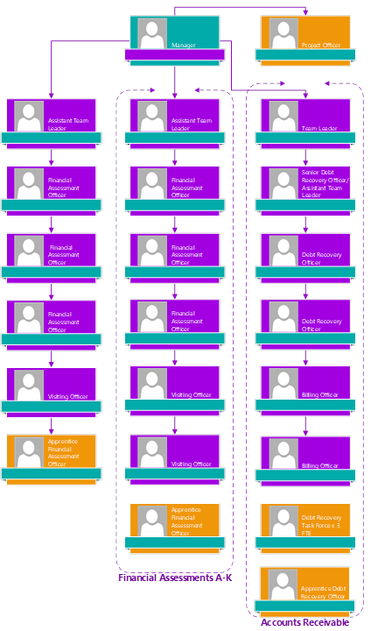

**Person Specification**

|  |  |
| --- | --- |
| **Job Title:**  **Debt Recovery officer** | **Grade**:  Scale 6 – SO2 |
| **Section:**  ASCPH Finance - Business Resources | **Directorate:**  Adult Social Care and Public Health |
| **Responsible to:**  Team Leader – Debt Recovery | **Responsible for:** |
| **Post Number/s:** | **Last Review Date:** |

**Our Values**

**THINK BIGGER**

**EMBRACE DIFFERENCE**

**CONNECT BETTER**

**LEAD BY EXAMPLE**

**PUT PEOPLE FIRST**

Our Values are embedded across Richmond & Wandsworth Better Service Partnership and throughout all roles and responsibilities at all levels of the organisation. Please [familiarise yourself with our values](https://www.richmond.gov.uk/media/afdbdeao/five_values.pdf) as they are an integral part of our recruitment and selection process.

|  |  |  |  |
| --- | --- | --- | --- |
| **Person Specification Requirements** | | | **Assessed by**  **A/I/T/C**  **(see below for explanation)** |
| **Knowledge** | **Essential** | **Desirable** | **Assessed** |
| Knowledge of the Care and Support Statutory Guidance in relation to charging for care |  | **A& I** |  |
| Knowledge of legislation regarding debt recovery in the context of local authority services. |  | **A& I** |  |
|  |  |  |  |
| **Experience** | **Essential** | **Desirable** | **Assessed** |
| Experience of debt recovery in the public sector |  | **A & I** |  |
| Significant experience of using standard IT packages and ability to support others in their day-to-day use |  | **A & I** |  |
| Experience of dealing with vulnerable people | **A & I** |  |  |
| **Skills** | **Essential** | **Desirable** | **Assessed** |
| Good oral and written skills to provide clear and concise messages | **A & I** |  |  |
| Ability to organise and prioritise own workload, to work under pressure and meet deadlines | **A & I** |  |  |
| Ability to deal with complex issues methodically and strategically | **A & I** |  |  |
| Ability to organise and prioritise own workload within defined requirements for the role | **A & I** |  |  |
| Ability to deal with confrontational situations in a calm and professional manner | **A & I** |  |  |
| **Qualifications** | **Essential** | **Desirable** | **Assessed** |
| Part qualification in AAT or equivalent e.g. experience of working in a financial environment |  | **A & C** |  |
|  |  |  |  |

**A – Application form / CV**

**I – Interview**

**T – Test**

**C - C**