**Job Profile comprising Job Description and Person Specification**

**Job Description**

|  |  |
| --- | --- |
| **Job Title:**  Senior Policy and Review Officer | **Grade**:  PO4 -PO6 |
| **Section:**  Policy, Performance, Analysis and Communications | **Directorate:**  Chief Executive’s Group |
| **Responsible to following manager:**  Policy and Review Manager | **Responsible for following staff:**  n/a |
| **Post Number/s:** | **Last Review Date:**  September 2025 |

**Working for the Richmond & Wandsworth Better Service Partnership**

This role is employed under the Richmond & Wandsworth Better Service Partnership. The overall purpose of Richmond & Wandsworth is to provide the highest quality of service at the lowest attainable cost.

Staff are expected to deliver high quality and responsive services wherever they are based, as well as having the ability to adapt to sometimes differing processes and expectations.

Richmond & Wandsworth Better Service Partnership aims to be at the forefront of innovation in local government and the organisation will invest in the development of its staff and ensure the opportunities for progression that only a large organisation can provide.

**Job Purpose**

The post holder will support the Head of Policy and Strategy in the delivery of key policy analysis, policy development and service review, and project oversight. The post will assist in the development of corporate policy initiatives.

The post holder will be expected to take a leading role in driving forward all aspects of corporate policy work.

**Specific Duties and Responsibilities**

1. Lead the adoption of innovative practice within the Better Service Partnership, helping us to become an organisation which thinks bigger, by maintaining an awareness of best and emerging practice from across local government and the wider public sector.
2. Proactively identify opportunities to work differently and challenge the status quo, and work with directorates to develop pilots for how new ways of working can be applied within Richmond and Wandsworth.
3. Enable the sharing of knowledge and best practice within and across the organisation, including leading the coordination of an internal innovation network.
4. Promote a positive and proactive approach to delivering the Councils' external facing equality work, reflecting the Councils’ commitment to embracing difference and putting our residents first. This includes working with services to develop strong Equality Impact Needs Assessments and equality comments on service proposals and signing these off in the Head of Policy and Strategy’s absence, and identifying opportunities to make Richmond and Wandsworth fairer boroughs for everyone who lives or works here.
5. Represent the Policy and Review team and councils through engagement with strategic partners and relevant London and national networks, contributing to an organisation which connects better and maximises opportunities to share learning and work collaboratively.
6. Lead project teams which deliver cross-cutting and high-profile projects, helping each council's administration to deliver their goals for the boroughs.
7. Lead on the production of each Council's corporate plan, including supporting services with their service planning, work with departments to monitor its delivery, and produce reports for senior officers and members on its progress.
8. Lead the completion and implementation of successful service reviews.
9. Keep abreast of relevant policy and legislation changes which affect the Councils and their services, and proactively produce at pace high-quality, detailed written and verbal briefings for senior officers and councillors. In addition, contribute to the production of routine briefings.
10. Lead on the production of well-written, concise reports on a range of topics, synthesising quantitative and qualitative data with other research, for review by management and/or Council committee.
11. Respond directly to enquiries from Members, including Lead Members.
12. Supervises the work of Policy and Review Officers in their delivery of key projects and policy work.

**Progression criteria**

**PO4**

* Undertakes all of the duties of the role but requires managerial oversight and support on leading major cross-cutting projects, briefing members and finalising major public reports.

**PO5**

* Prepares reports for Committee/Cabinet or other public audience with minimal need for managerial input / review.
* Leads consultation of staff on service reviews working closely with relevant managers and HR.
* Uses initiative to proactively identify emerging policy changes and developments in other councils, regionally and nationally which may be of relevance locally, and briefs senior officers and members accordingly.
* Credibility with senior officers and ability to challenge them with tact and self-assurance.

**PO6**

* Independently leads major service reviews and high-profile projects with minimal supervision or managerial input.
* Independently briefs Members on service review or policy issues without managerial input.
* Demonstrates political nous and awareness in all interactions.

**Generic Duties and Responsibilities**

* To contribute to the continuous improvement of the services of Richmond & Wandsworth Better Service Partnerships.
* To comply with relevant Codes of Practice, including the Code of Conduct and policies concerning data protection, handling complaints and health and safety.
* To adhere to security controls and requirements as mandated by Richmond and Wandsworth procedures and local risk assessments to maintain confidentiality, integrity, availability and legal compliance of information and systems
* To promote equality, diversity, and inclusion, maintaining an awareness of the equality and diversity protocol/policy and working to create and maintain a safe, supportive and welcoming environment where all people are treated with dignity and their identity and culture are valued and respected.
* To understand both Councils’ duties and responsibilities for safeguarding children, young people and adults as they apply to the roles within the Councils.
* The profile is not intended to be an exhaustive list of the duties the post holder will carry out. Other reasonable duties commensurate with the level of the post, including supporting emergency and priority situations, will form part of the role.

**Additional Information**

* Maybe required to attend meetings such as committees, working groups and Partnerships outside of the normal working day.
* Post holder will be expected to work flexibly across two locations (Wandsworth Town Hall and Richmond Civic Centre), and be in the office for at least two days each week.

**Current team structure**

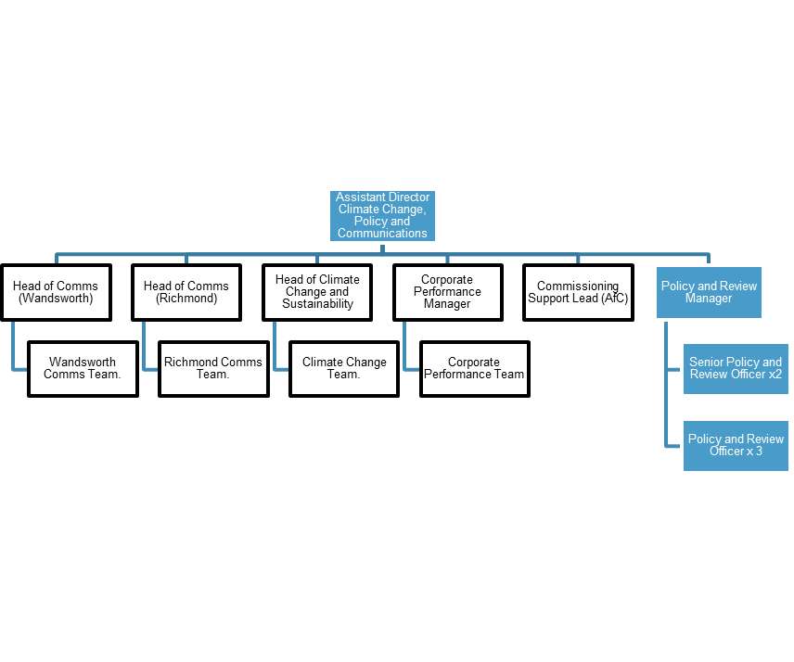

**Person Specification**

|  |  |
| --- | --- |
| **Job Title:**  Senior Policy and Review Officer | **Grade**:  PO4-6 |
| **Section:**  Policy, Performance and Analysis | **Directorate:**  Chief Executive’s Group |
| **Responsible to following manager:**  Head of Policy and Strategy | **Responsible for following staff:**  n/a |
| **Post Number/s:** | **Last Review Date:**  September 2025 |

**Our Values and Behaviours**

As an organisation, we have recently defined a new set of values which set out the standards we expect from our staff. Our new values have been built to capture the best of how we work together and to inspire the change we need to create in our culture.

As an organisation that’s come together to represent a broader part of London, our values reaffirm our commitment to embrace difference, to connect even more deeply and widely and to show compassion and empathy for the people we work with and the people we serve.

Our values are:

* Think Bigger
* Embrace Difference
* Connect Better
* Lead by Example
* Put people first

|  |  |
| --- | --- |
| **Person Specification Requirements** | **Assessed by**  **A**  **&**  **I/ T/ C (see below for explanation)** |
| **Knowledge** | |
| knowledge of policy development as it relates to local government and the delivery of services | A/I/T |
| knowledge of the wider context within which local government operates (including commissioning) and ability to develop appropriate local responses | A/I |
| Knowledge of equality, diversity, and inclusion delivery as it relates to the public sector. | A/I |
| **Experience** | |
| Experience of operating in a political environment, recognising and handling in an appropriate manner, confidential or sensitive information and distinguishing between political and non-political activities. | A/I |
| Experience of successfully managing own workload in an environment where deadlines and priorities frequently change and are often conflicting | A/I/T |
| **Skills** | |
| Ability to communicate effectively and authoritatively both orally and in writing, with councillors, officers, partner organisations and the public. | A/I |
| Ability to accurately analyse numeric, financial, textual and performance data and present your findings in a clear and coherent way to a variety of audiences. | A/I/T |
| Ability to oversee the delivery of projects / programmes and/or leading reviews of council services and making recommendations for change. | A/I |
| Ability to exercise tact and diplomacy, and first rate interpersonal, negotiation and influencing skills. | A/I |
| Ability to lead and manage cross-Departmental teams to deliver specific projects and/or reviews. | A/I |
| Ability to work at pace, juggle priorities, and assimilate new information quickly and ability to make sound decision and judgements under pressure. | A/I |
| Demonstrable ability to use IT applications to manage and manipulate information and of researching information (textual, financial and statistical) from a variety of sources to present it in a consistent, concise and understandable way, both orally and in writing. | A/I/T |
| Experience of managing a complex workload, achieving targets and responding flexibly to changing needs and priorities, often with limited supervision | A/I |
| Ability to work both independently and as an effective team member, using initiative and adapting to changing priorities and deadlines in a calm, well-organised and methodical manner. | A/I |
| **Qualifications** | |
| Educated to degree level in a related subject area or equivalent through work experience | A/C |

**A – Application form**

**I – Interview**

**T – Test**

**C - Certificate**