**JOB PROFILES**

**Job Profile comprising Job Description and Person Specification**

**Job Description**

|  |  |
| --- | --- |
| **Job Title:**  Customer Service Adviser | **Grade**:  Scale 4 – Scale 5 |
| **Section:**  Contracts and Leisure  (Registrars and Cemeteries) | **Directorate:**  Environment and Community Services |
| **Responsible to following manager:**  Business Development Manager | **Responsible for following staff:**  Not applicable |
| **Post Numbers** RWE1212 | **Last review date:** June 2021 |

**Working for the Richmond/ Wandsworth Shared Staffing Arrangement**

This role is employed under the Shared Staffing Arrangement between Richmond and Wandsworth Councils. The overall purpose of the Shared Staffing Arrangement is to provide the highest quality of service at the lowest attainable cost.

Staff are expected to deliver high quality and responsive services wherever they are based, as well as having the ability to adapt to sometimes differing processes and expectations.

The Shared Staffing Arrangement aims to be at the forefront of innovation in local government and the organisation will invest in the development of its staff and ensure the opportunities for progression that only a large organisation can provide.

**Job Purpose**

The Registration Service has responsibility for the registration of births deaths, marriage and civil partnership preliminaries, civil marriage and civil partnership registrations, civil partnership conversions, citizenship ceremonies and other celebratory services. It is an expanding service aiming to achieve the highest quality and most cost-effective service in accordance with the Council’s policies and statutory requirements.

**Specific Duties and Responsibilities**

1. Acts as ‘first point of contact’; provides a professional and customer focussed entry point that is friendly, welcoming, calm and discreet; manages appointments and waiting times; ensures that reception and waiting areas are tidy and safe for customers.
2. Liaises with Registration staff and partners (Coroners Officers, GP surgeries) to ensure customers are dealt with in a timely and professional manner.
3. Acts as Deputy Registrar for civil ceremonies at weekends, registering marriages and issuing certificates.
4. Collects fees, including cash handling.
5. Assists with office administration including preparing packs for citizenship ceremonies, organising marriage and civil partnership ceremonies, updating electronic bookings, indexing and filing.
6. Keeps records and assists in the analysis of information, compiles performance data. Maintains security and confidentiality of information, records and documents.
7. Support and maintains office systems and uses IT systems as required.
8. Performs any other duties commensurate with the grade deemed appropriate by the Head of Service (Superintendent Registrar) and management team.

**Additional duties for progression to Scale 5**

1. Independently handles complex enquiries from Registration staff and partners (Coroners Officers, GP surgeries).
2. Organises citizenship ceremonies and marriage and civil partnership ceremonies, including preparing and collating all necessary paperwork.
3. Takes a lead role in collating, analysing, and producing management information and data as requested by the Head of Service and management team.
4. Reviews office systems including IT systems and suggests improvements and enhancements to the Head of Service and management team.
5. Assists with the marketing and promotional activities of the service, including social media, open days and tours.
6. Assists with activities outlined in the Customer Engagement Strategy, including distribution and collation of customer surveys and feedback.
7. Takes minutes for all in-person and virtual team meetings and learning and development events.

**Generic Duties and Responsibilities**

* To contribute to the continuous improvement of the services of the Boroughs of Wandsworth and Richmond.
* To comply with relevant Codes of Practice, including the Code of Conduct and policies concerning data protection and health and safety.
* To adhere to security controls and requirements as mandated by the SSA’s policies, procedures and local risk assessments to maintain confidentiality, integrity, availability and legal compliance of information and systems.
* To promote equality, diversity, and inclusion, maintaining an awareness of the equality and diversity protocol/policy and working to create and maintain a safe, supportive and welcoming environment where all people are treated with dignity and their identity and culture are valued and respected.
* To understand both Councils’ duties and responsibilities for safeguarding children, young people and adults as they apply to the role within the council.
* The Shared Staffing Arrangement will keep its structures under continual review and as a result the post holder should expect to carry out any other reasonable duties within the overall function, commensurate with the level of the post.

**Additional Information**

* The post holder will be expected to work evenings and weekends on a rota basis.
* The post holder reports to the Business Development Manager
* The post holder has no line management responsibility
* The post holder has no budget responsibility

**Current team structure**

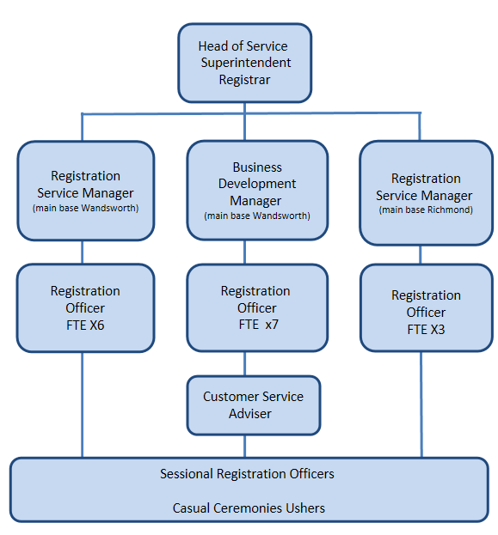

**Person Specification**

|  |  |
| --- | --- |
| **Job Title:**  Customer Service Adviser | **Grade**:  Scale 4 - Scale 5 |
| **Section:**  Contracts and Leisure  (Registrars and Cemeteries) | **Directorate:**  Environment and Community Services |
| **Responsible to following manager:**  Registration Service Manager | **Responsible for following staff:**  Not applicable |
| **Post Number/s:** RWE1212 | **Last review date:** June 2021 |

**Our Values and Behaviours**

The values and behaviours we seek from our staff draw on the high standards of the two boroughs, and we prize these qualities in particular:

**Being open.** This means we share our views openly, honestly and in a thoughtful way. We encourage new ideas and ways of doing things. We appreciate and listen to feedback from each other.

**Being supportive.** This means we drive the success of the organisation by making sure that our colleagues are successful. We encourage others and take account of the challenges they face. We help each other to do our jobs.

**Being positive.** Being positive and helpful means, we keep our goals in mind and look for ways to achieve them. We listen constructively and help others see opportunities and the way forward. We have a ‘can do’ attitude and are continuously looking for ways to help each other improve.

|  |  |
| --- | --- |
| **Person Specification Requirements** | **Assessed by A &**  **I/ T/ C (see below for explanation)** |
| **Knowledge** | |
| Knowledge of the requirements of the registration and nationality service | A&I |
| Knowledge of ICT packages and ability to use them effectively | A&I/T |
| **Experience** | |
| Experience of office administration activities including the preparation of information, organising ceremonies and maintaining corresponding records, files and bookings | A&I |
| Experience of dealing with a wide range of customers, including dealing with people in distress, in a sympathetic manner | A&I |
| Collection of monies and handling of cash | A&I |
| **Skills** | |
| Ability to liaise with registration staff and partners (Coroners Officers, GP surgeries) to ensure customers are dealt with in a timely and professional manner | A&I |
| Ability to maintain records and assists in the analysis of information and compilation of performance data | A&I |
| Ability to maintain the security and confidentiality of information, records and documents | A&I |
| Supports and maintains office systems and uses IT systems as required. | A&I |
| **Qualifications** | |
| Relevant ICT qualification | A&I |

**A – Application form**

**I – Interview**

**T – Test**

**C – Certificate**