Job Profile comprising Job Description and Person Specification
Job Description

Job Title:  FM Performance Administrator | Grade:  SO1
Section:  Property Services - FM Performance | Directorate:  Housing & Regeneration
Responsible to following manager:  FM Performance Team Leader | Responsible for following staff:
Post Number/s: | Last Review date: October 2017

Working for the Richmond/ Wandsworth Shared Staffing Arrangement

This role is employed under the Shared Staffing Arrangement between Richmond and Wandsworth Councils. The overall purpose of the Shared Staffing Arrangement is to provide the highest quality of service at the lowest attainable cost.

Staff are expected to deliver high quality and responsive services wherever they are based, as well as having the ability to adapt to sometimes differing processes and expectations.

The Shared Staffing Arrangement aims to be at the forefront of innovation in local government and the organisation will invest in the development of its staff and ensure the opportunities for progression that only a large organisation can provide.

Job Purpose:

Performance management support and management reporting of FM service delivery.
Provides administration, helpdesk and financial support to FM service delivery including FM Operations and FM Building Services
Monitoring and reporting of FM performance and customer satisfaction against operational and financial Key Performance Indictors.
Management of FM operating expenditure, forecasting and reporting against budget.

Specific Duties and Responsibilities

- To provide administration and budget management support to FM Operations and FM Building Services Teams.

- Working closely with FM Helpdesk and FM Team(s) to monitor FM service delivery performance and ensure high standards of quality, customer service and customer satisfaction.

- Convert Helpdesk Reactive tasks to Purchase Orders and issue of same to Integrated contractors and supply chain partners.

- Reconcile contractor and supply chain partner invoices for good and services against original HD and PO reference. Update Concerto CAFM system.

- Use of Capita Integra finance system and Concerto CAFM system.

- Assist in preparation of management information and forecasting of FM operational (opex) and capital programme (capex) expenditure against budget.

- Ensure that integrated contractor and supply chain partner invoices are processed for payment within agreed payment terms to avoid potential disruption to FM service delivery and maintain positive, collaborative working relationship(s).

- Monthly management information reporting of FM operations service delivery and financial performance against KPIs and budget.

- Monitoring and management information reporting of accolades and complaints.

- Escalating complaints and issue resolution to FM service delivery management.

- Ensure that the FM service delivery performance to both Councils is to the same high standards as agreed annually by the Executives of both Councils.

- To provide ad hoc management information reporting as required by the HOFM and HO FM Performance.

- To ensure that SSA Procurement Guidelines are followed at all times in the procurement of goods / services required in the delivery of FM services.

- To promote and develop collaborative working relations with integrated contractor and supply chain partners.

- Supporting the HO FM Performance in the identification of opportunities for innovation and continuous improvement.
- Maintaining the FM Contractor and Supply Chain Partner Register ensuring that all insurances, Safe Systems of Work, staff training records, trade qualifications and certification are current and compliant.

- Assist in coordinating FM Service Delivery Managers to ensure that directly employed staff Training Matrix is current and that staff are trained and competent to perform their duties safely and securely.

- Schedule regular 360 Performance Review meetings with key contractors and supply chain partners.

- Ensure that Team and FM department Business Continuity Plans are current and regularly tested and amended.

- Maintains the FM Emergency Response Team contact schedule.

Generic Duties and Responsibilities

- To contribute to the continuous improvement of the FM services in the Boroughs of Wandsworth and Richmond.

- To comply with relevant Codes of Practice, including the Code of Conduct, and policies concerning data protection and health and safety.

- To adhere to security controls and requirements as mandated by the SSA’s policies. procedures and local risk assessments to maintain confidentiality, integrity, availability and legal compliance of information and systems.

- To promote equality, diversity, and inclusion, maintaining an awareness of the equality and diversity protocol/policy and working to create and maintain a safe, supportive and welcoming environment where all people are treated with dignity and their identity and culture are valued and respected.

- To understand both Councils’ duties and responsibilities for safeguarding children, young people and adults as they apply to the role within the council.

- The Shared Staffing Arrangement will keep its structures under continual review and as a result the post holder should expect to carry out any other reasonable duties within the overall function, commensurate with the level of the post.
Additional Information
Manages
NA

Team structure

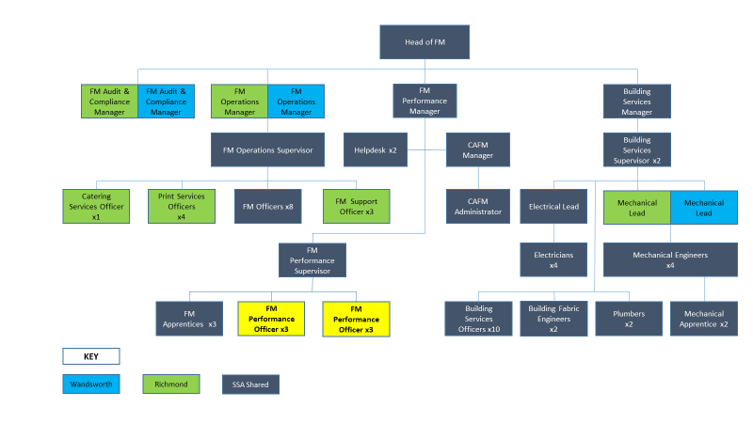

Person Specification

Job Title:  FM Performance Administrator | Grade:  SO1
Section:  Property Services - FM Performance | Directorate:  Housing & Regeneration
Responsible to following manager:  FM Performance Team Leader | Responsible for following staff:  NA
Post Number/s: | Last Review date: October 2017

Our Values and Behaviours

The values and behaviours we seek from our staff draw on the high standards of the two boroughs, and we prize these qualities in particular –

- taking responsibility and being accountable for achieving the best possible outcomes – a ‘can do’ attitude to work
- continuously seeking better value for money and improved outcomes at lower cost
- focussing on residents and service users, and ensuring they receive the highest standards of service provision.
- taking a team approach that values collaboration and partnership working

Person Specification Requirements | Assessed by A & I/ T/ C
Knowledge
Detailed knowledge of SSA finance systems and Procurement Guidelines. | A & I
Detailed working knowledge of Concerto CAFM system | A & I
Extensive knowledge of the Council’s property portfolio, | A & I
Knowledge of the property and facilities management industries. | A & I
Experience
Budget management and reporting | A & I
KPI monitoring and reporting | A & I
Contractor invoice processing | A & I
Working with finance and CAFM systems | A & I
Managing complex workloads to meet tight deadlines. | A & I
Skills
Numerate with an eye for detail | A & I
Excellent IT skills including as a minimum Intermediate Excel | A & I
Good oral, written and presentational skills | A & I
Qualifications
GCSE level education; or vocational qualifications | A & I

A = Application Form, I = Interview, T = Test, C = Certificate

