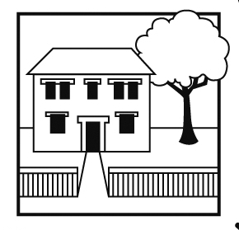
Balham Nursery School
Executive Headteacher: Ms Emma Williams B.Ed (ECE)
72 Endlesham Road, London SW12 8JL
Telephone: 020 8673 4055
Email: admin@balham-nursery.wandsworth.sch.uk
Website: www.balham-nursery.wandsworth.sch.uk

7th January 2022

Dear Applicant

Fixed Term Learning Support Assistant
Term time only plus 1 week (39weeks per year to include all INSET days))

Thank you for your interest in applying for the position of Learning Support Assistant at Balham Nursery School. You can find further information about the school and the post, including a job description and person specification, and download an application form at https://jobs.richmondandwandsworth.gov.uk Please also visit our website www.balham-nursery.wandsworth.sch.uk

The first step in the selection process is your application. To get the most out of your application, please ensure you read through the person specification carefully and provide specific examples to demonstrate how you meet all the shortlisting criteria. Your completed application should be returned to Emma Williams at admin@balham-nursery.wandsworth.sch.uk.

The deadline for us to receive your completed application is 12 noon on Friday, 21st January 2022.

Successful applicants will be invited to an interview on Friday, 28th January 2022.

If you have any special requirements to enable you to fully participate in the application and/or selection process, or have any questions about the application process, please contact me on 020 8673 4055 or by e-mail to admin@balham-nursery.wandsworth.sch.uk. Please ensure you provide a telephone number where you can be contacted or where we can leave a message.

If you do not hear from us by end of business on Monday, 24th January 2022 you should assume that you have not been shortlisted on this occasion.

We look forward to receiving your application.

Yours faithfully

Emma Williams
Executive Headteacher

