**Job Profile comprising Job Description and Person Specification**

**Job Description**

|  |  |
| --- | --- |
| **Job Title:**  Income Maximisation Officer | **Grade**:  S02 |
| **Section:**  Allocation & Provision | **Directorate:**  Housing and Regeneration |
| **Responsible to following manager:**  Income Maximisation Team Leader | **Responsible for following staff:**  n/a |
| **Post Number/s:** | **Last review date:**  May 2021 |

**Working for the Richmond/Wandsworth Shared Staffing Arrangement**

This role is employed under the Shared Staffing Arrangement between Richmond and Wandsworth Councils. The overall purpose of the Shared Staffing Arrangement is to provide the highest quality of service at the lowest attainable cost.

Staff are expected to deliver high quality and responsive services wherever they are based, as well as having the ability to adapt to sometimes differing processes and expectations.

The Shared Staffing Arrangement aims to be at the forefront of innovation in local government and the organisation will invest in the development of its staff and ensure the opportunities for progression that only a large organisation can provide.

**Job Purpose**

To maximise income collection for temporary accommodation tenants, ensuring that applicants pay their charges in a timely and regular way. To proactively and sensitively pursue and minimise arrears, advising on preventative action to be taken to stop them falling into arrears. To recommend court action/eviction processes as required and/or the write off of irrecoverable debt. To do the foregoing via regular and detailed interviews with often vulnerable homeless households.

**Specific Duties and Responsibilities**

1. Responsible for proactively pursuing debt on current and former tenant accounts and resolving credits on current and former tenants accounts. Responsible for ensuring that clients pay their temporary accommodation charges and to minimize any arrears on account by taking timely action. Where required creates and monitors repayment plans to ensure arrears do not increase.
2. To advise tenants on welfare benefits, by offering detailed advice and referring tenants to specialist advice and debt counselling. To assist tenants to maximise their income by ensuring that they are claiming their benefit entitlements and managing existing debt. To support and advise tenants with Housing Benefit claims and requesting backdating where required.
3. To participate in duty rotas, generally and within the Customer Service Centre across both boroughs. Frequently assists clients by telephone or via personal interview to complete a Housing Benefit form and maintains a close liaison with the Housing Benefit Section, ensuring temporary accommodation payments are maximised. Explains to clients their own responsibilities for payments, as appropriate, advising and assisting on the accessing of appropriate welfare benefits available to the client and offers support in maximizing income.
4. To arrange and/or attend liaison meetings with both Internal and external agencies to ensure effective case management and or to represent the department when a multi-agency approach is required.
5. Pursues current and former rent arrears for temporary accommodation and liaises with various agencies, as appropriate, helping to resolve problems in relation to benefits. Responsible for negotiating repayment programmes, advising of any appropriate assistance. Refers client for debt counselling, as necessary, and advises on implications of possession action. Recording and confirming all agreed actions to ensure that decisions are reasonable and defendable in Court. Where debt recovery on former tenants’ arrears has proved unsuccessful, implementation of Former Tenants Arrears in line with council procedures.
6. Regularly monitors and resolves all account discrepancies, including housing benefit, promptly. Establishes any client overpayments on account and produces a financial breakdown, recommending client reimbursements to housing benefit or other services. Prepares and submits accounting journals as directed and arranges any refund due to the client.
7. Prepares cases for Notice to Quit in line with current procedures for those who have failed to pay. Ensures that work around vulnerable clients has been fully completed. Attends possession hearings in County Court to give verbal evidence and provide the case history. Agrees within guidelines, on behalf of the Council, terms and method of payment of arrears following to Court judgements.
8. To arrange for the production and distribution of regular rent statements to tenants and advise tenants on these accordingly.
9. To arrange and participate in any welfare benefits take up campaigns or surgeries as required
10. To manage clients’ accounts for removal and storage services as applicable and ensure that payments to accounts are maintained.
11. Drafts replies to Members’ enquiries and complaints for the approval of line management.

**Generic Duties and Responsibilities**

* To contribute to the continuous improvement of the services of the Boroughs of Wandsworth and Richmond.
* To comply with relevant Codes of Practice, including the Code of Conduct and policies concerning data protection and health and safety.
* To adhere to security controls and requirements as mandated by the SSA’s policies, procedures and local risk assessments to maintain confidentiality, integrity, availability and legal compliance of information and systems
* To promote equality, diversity, and inclusion, maintaining an awareness of the equality and diversity protocol/policy and working to create and maintain a safe, supportive and welcoming environment where all people are treated with dignity and their identity and culture are valued and respected.
* To understand both Councils’ duties and responsibilities for safeguarding children, young people and adults as they apply to the role within the council.
* The Shared Staffing Arrangement will keep its structures under continual review and as a result the post holder should expect to carry out any other reasonable duties within the overall function, commensurate with the level of the post.

**Additional Information**

1. Identify service improvements and enhancements to ensure that the team continuously improve.
2. To attend statutorily convened or otherwise multi-disciplinary meetings/forums
3. To do visits at accommodation and travel to other sites, and able to use public transport

**Team structure**

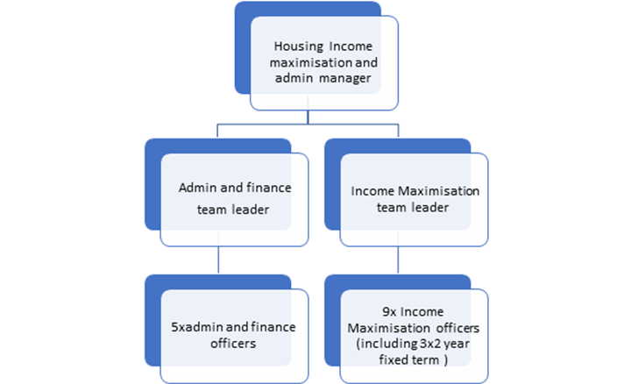

**Person Specification**

|  |  |
| --- | --- |
| **Job Title: Job Title:**  Income Maximisation Officer | **Grade**:  SO2 |
| **Section: Housing Services** | **Directorate:** Housing and Regeneration |
| **Responsible to: Operations Team Leader- Income and Support** | **Responsible for**  **n/a:** |
| **Post Number/s:** | **Last Review Date:**  **May 2021** |

**Our Values and Behaviours**

The values and behaviours we seek from our staff draw on the high standards of the two boroughs, and we prize these qualities in particular:

**Being open.** This means we share our views openly, honestly and in a thoughtful way. We encourage new ideas and ways of doing things. We appreciate and listen to feedback from each other.

**Being supportive.** This means we drive the success of the organisation by making sure that our colleagues are successful. We encourage others and take account of the challenges they face. We help each other to do our jobs.

**Being positive.** Being positive and helpful means we keep our goals in mind and look for ways to achieve them. We listen constructively and help others see opportunities and the way forward. We have a ‘can do’ attitude and are continuously looking for ways to help each other improve.

|  |  |  |  |
| --- | --- | --- | --- |
| **Person specification Requirements** | **Assessed by A**  **&**  **I/ T/ C (see below for explanation)** | | |
| **Knowledge** |  | | |
| Knowledge of good practice around arrears management and debt collection |  | | |
| Demonstrate an understanding of welfare based benefits in context of this role and able to give advice to clients |  | | |
| **Experience** |  | | |
| Experience of working within a team in a busy environment with multiple priorities |  | | |
| Experience of working with the public and ability to give advice regarding debt management and income maximisation |  | | |
| Ability to apply experience of giving advice and resolving complex cases. |  | | |
| **Skills** |  | | |
| The ability to use information technology to a high standard. |  | | |
| The ability to undertake a wide range of financial tasks. |  | | |
| Ability to deal with vulnerable clients |  | | |
| The ability to manage a varying case load and find creative solutions |  | | |
| The ability to respond effectively to staff, outside agencies, suppliers and case manage with multiple agencies |  | | |
| Proven literacy, numeracy and communication skills. |  | | |
| A calm and empathetic approach when working with the public and dealing with complaints and problems |  | | |
| A good attention to detail |  | | |
| Able to work under pressure |  | | |
| The ability to use public transport to visit clients at their placement |  | | |
| **Qualifications** | | |
| Maths and English GCSE grade C and above or equivalent. | |

**A – Application form / CV**

**I – Interview**

**T – Test**

**C - Certificate**