Job Profile comprising Job Description and Person Specification
Job Description

Job Title:  Public Health Lead | Grade:  PO6
Section:  Public Health | Directorate:  Adult Social Care and Public Health
Responsible to following manager:  Senior Public Health Lead (Health Improvement) | Responsible for following staff:  N/A
Post Number/s: RWC0024A | Last review date: August 2021

Working for the Richmond/Wandsworth Shared Staffing Arrangement

This role is employed under the Shared Staffing Arrangement between Richmond and Wandsworth Councils. The overall purpose of the Shared Staffing Arrangement is to provide the highest quality of service at the lowest attainable cost.

Staff are expected to deliver high quality and responsive services wherever they are based, as well as having the ability to adapt to sometimes differing processes and expectations.

The Shared Staffing Arrangement aims to be at the forefront of innovation in local government and the organisation will invest in the development of its staff and ensure the opportunities for progression that only a large organisation can provide.

Job Purpose

Develop and coordinate public health programmes and Council’s prevention framework covering healthy eating and nutrition, obesity, prevention of long-term conditions and related programmes as allocated by the Senior Public Health Lead and or the Consultant in Public Health, assess health needs and interpret evidence, manage projects, and undertake partnership working to deliver outcomes and provide relevant advice to members and officers.

Specific Duties and Responsibilities

Some duties have been mapped against the Public Health Skills and Knowledge Framework (PHSKF) for guidance. Relevant descriptors are shown in brackets.

- Plan, organise, implement and evaluate Public Health projects relating to specific topic areas, including support for commissioning of services and associated pathways, in order to improve outcomes for residents. (A1.5, A2.4, A2.5, B3.3)

- Apply specialist Public Health skills, knowledge and experience in a multiagency and multidisciplinary environment to support the planning, delivering and developing specialist services, such as healthy eating interventions, adult weight management and topic related services.

- Working with individuals, groups, communities and organisations to influence and improve population health. (B2.1, B2.2, B2.4)
- Contributing to the development of local health improvement programmes and services and marketing the health improvement service to relevant groups and communities, this includes working closely with other agencies to achieve health improvement aims.
- Monitoring and evaluating the impact and outcomes of health improvement programmes and initiatives.

- Use Public Health skills to support Health (ICS, SWL Clinical Commissioning Group (SWLCCG) and wider health and social care partners including influencing partners to ensure that Public Health priorities and principles are reflected in commissioning plans.

- Support the development of long-term strategic plans and projects on behalf of the boroughs in relation to Health Eating, Obesity, Prevention in long term conditions and related Public Health issues which impact on a range of community agencies and strategic partnerships, and work with partners to enable appropriate implementation. (A4.3, B2.4, C1.5)

- Support multi-agency and multi-disciplinary partnerships with Council and CCG officers, GPs, local stakeholders, neighbouring local authorities and regional and national bodies, such as NHS England and Public Health England that address their topic areas.

- Identify and assess the health and healthcare needs within the boroughs, contributing to specific Joint Strategic Needs Assessments, and undertaking needs assessments relevant to their work area using a range of public health data sources, data analysis and quantitative and qualitative methodologies.

- Identify, implement and evaluate Public Health interventions and models of service provision using the most appropriate evidence base and economic evaluation (cost effectiveness), and taking into account their ethical and political consequences. (A4.4, A5.2, B2.3, B4.1, B4.2, C3.4)

- Develop effective communication, including media (radio, press, etc) and social media, in line with Borough requirements, liaising closely with the communications team and the relevant consultant in public health. (C2.1, C2.4)

- Create written reports and deliver presentations on behalf of the Public Health division department to a wide range of audiences and communicating important public health messages around obesity, health eating and nutrition and healthy weight in consultation with the Senior Public Health Lead. (B4.2, B4.3, C2.2

- Commission, oversee or participate in Public Health research projects and audits as well as contribute to, respond to and advise on the development of patient and public surveys. (A4.3, A4.6, A5.5, C2.5)

Generic Duties and Responsibilities

- To contribute to the continuous improvement of the services of the Boroughs of Wandsworth and Richmond.

- To comply with relevant Codes of Practice, including the Code of Conduct and policies concerning data and health and safety (A1.4, PEii, PEiii)

- To adhere to security controls and requirements as mandated by the SSA’s policies, procedures and local risk assessments to maintain confidentiality, integrity, availability and legal compliance of information and systems. (PEii)

- To promote equality, diversity, and inclusion, maintaining an awareness of the equality and diversity protocol/policy and working to create and maintain a safe, supportive and welcoming environment where all people are treated with dignity and their identity and culture are valued and respected. (PEii, PEiii)

- To understand both Councils’ duties and responsibilities for safeguarding children, young people and adults as they apply to the role within the council. (PEiii)

- To maintain Continuous professional development and undertake PDP

Additional Information

- Effectively manage a delegated budget for specific commissioned services and/or projects, with supervision from Senior Public Health Lead. Write bids to secure funding for Public Health and partnership projects.

- Act as a deputy for the Senior Public Health Lead as required.

- Initiate, develop and commission training and education programmes for the benefit of health and other professional staff and evaluate effectiveness, including presentations to small groups, conferences, students, meetings, and networks.

- Post holder may be expected to work flexibly across two locations (Wandsworth Town Hall and Richmond Civic Centre).

- The Shared Staffing Arrangement will keep its structures under continual review and as a result the post holder should expect to carry out any other reasonable duties within the overall function, commensurate with the level of the post.

- The post holder will be expected to participate in the organisation’s staff appraisal scheme and departmental audit and ensure appraisal and development of any staff for which s/he is responsible.

Current team structure

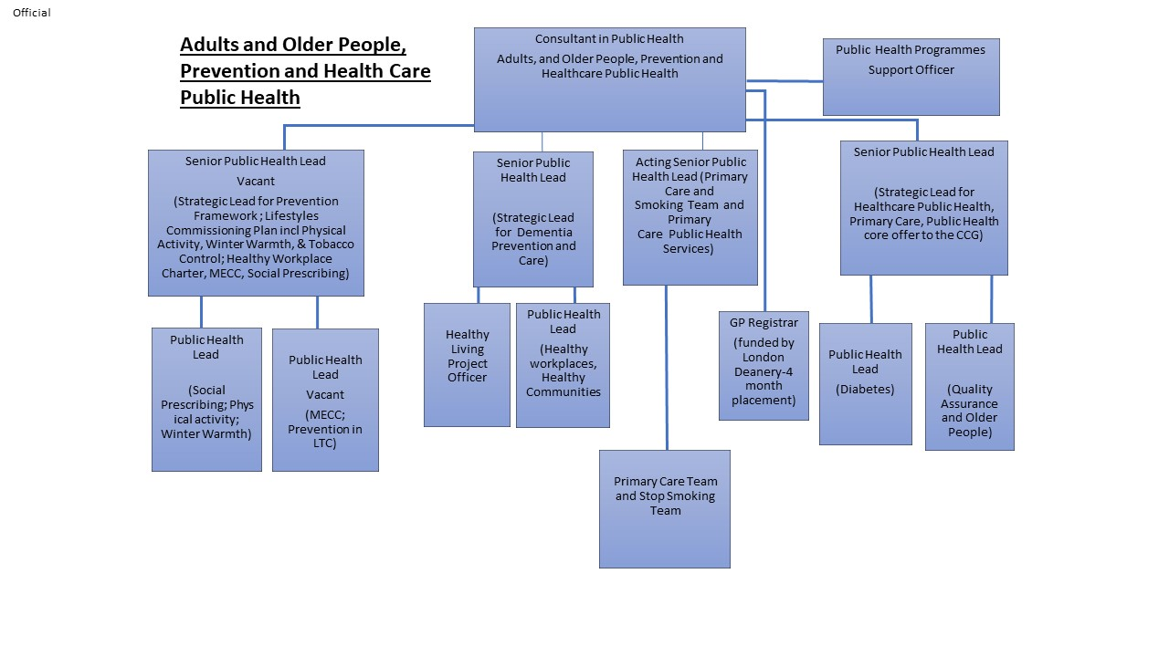

Person Specification

Job Title:  Public Health Lead | Grade:  PO6
Section:  Public Health | Directorate:  Adult Social Care and Public Health
Responsible to following manager:  Senior Public Health Lead (Health Improvement) | Responsible for following staff:  N/A
Post Number/s: RWC0024A | Last review date: April 2016

Our Values and Behaviours

The values and behaviours we seek from our staff draw on the high standards of the two boroughs, and we prize these qualities in particular:
Being open. This means we share our views openly, honestly and in a thoughtful way. We encourage new ideas and ways of doing things. We appreciate and listen to feedback from each other.

Being supportive. This means we drive the success of the organisation by making sure that our colleagues are successful. We encourage others and take account of the challenges they face. We help each other to do our jobs.

Being positive. Being positive and helpful means, we keep our goals in mind and look for ways to achieve them. We listen constructively and help others see opportunities and the way forward. We have a ‘can do’ attitude and are continuously looking for ways to help each other improve.

Essential (E) or Desirable (D) | Person Specification Requirements | Assessed by A & I/ T/ C (see below for explanation)
 | Knowledge
E | Understanding of social and political environment, including national and local policy, strategies, and guidance. | A / I
E | Knowledge of health improvement, health eating, nutrition, obesity, impact of lifestyle and behaviours | A/I/T
E | Understanding of epidemiology and statistics, public health practice, health promotion, health economics, health care evaluation. | A / I /T
 | Experience
E | Substantial experience in public health or health-related posts | A / I
D | Experience of using project management models and delivery e.g. Keto . | A / I
 | Skills
E | Excellent communicator in oral, written and presentation skills. | A/I/T
E | Excellent report writing skills with ability to translate complex information and create high quality written material , including statistical tables, for a wide range of audiences | A / I / T
E | Ability to analyse and interpret information for effective decision making- undertake literature review and critically assess evidence | A/I/T
E | Ability to think strategically, creatively, analyse manage problems, and develop solutions. | A / I / T
E | Effective team member with strong interpersonal, influencing and facilitation skills. | A / I
E | Flexible, pro-active, uses initiative, prioritises, manages own workload, and works well under pressure and to tight timeframes | A / I
E | Ability to work autonomously and with minimal supervision. | A /i
E | Ability to carry out research and evaluate research carried out by others. | A / I
E | Commitment to undertaking continuous professional development (CPD) | A / I
E | Computer literate with ability to produce reports, presentations, spread sheets, databases, | A / I / T
E | Ability to manage budgets and prepare bids for external funding. | A / I
 | Qualifications
E | Higher degree or postgraduate qualification in public health /course relevant to public health or equivalent knowledge gained through /post-graduate training. | A / I / C
D | Registered with a relevant public health body or working towards this- e.g.UKPHR | A/I

A – Application form
I – Interview
T – Test
C - Certificate

