**Job Profile**

|  |  |
| --- | --- |
| **Provisional Job Title:**  Public Health Business and Governance Manager | **Grade**: PO6 |
| **Section:**  Public Health | **Directorate:**  Directorate of Adult Social Services and Public Health |
| **Responsible to:**  Director of Public Health | **Responsible for:** Staff on public health placements |
| **Post Number/s:** RWCPP02 (TBC) | **Date**  August 2023 |

**Working for the Richmond / Wandsworth Shared Staffing Arrangement**

This role is employed under the Shared Staffing Arrangement between Richmond and

Wandsworth Borough Councils. The overall purpose of the Shared Staffing

Arrangement is to provide the highest quality of service at the lowest attainable cost.

Staff are expected to deliver high quality and responsive services wherever they are based, as well as having the ability to adapt to sometimes differing processes and expectations.

The Shared Staffing Arrangement aims to be at the forefront of innovation in local government and the organisation will invest in your development and ensure the opportunities for progression that only a large organisation can provide.

**Job Purpose:**

Lead on supporting the Director of Public Health in the smooth running of the Public Health Division, including strategic planning for the Divisional Management Team, Public Health Board and Health Protection Board.

Lead on the coordination, maintenance and review of the Public Health Service Plan and performance reporting. The post holder will also lead the Public Health Divisional induction programme and lead to ensure compliance with corporate governance and reporting requirements for the division.

In addition, the post holder is expected to carry out service review, performance analysis and project oversight, providing a lead on service planning, governance, and performance reporting, with minimal supervision.

**Specific Duties and Responsibilities:**

**Programme and Project Management**

1. Design, manage, implement and evaluate programmes and projects, (including related to population health), to increase efficiency and effectiveness in the division including business processes and service plan delivery.
2. Lead on the development of service specifications and implementation of procurement processes, including leading on these tasks in relation to specific projects and programmes as agreed with the Director of Public Health (e.g. service specifications and procurement of divisional public health workforce development work)
3. Lead the strategic coordination of evidence-based public health communications and campaigns, producing reports and developing relationships with the corporate communications teams, consultants in public health and the wider council on behalf of the Director of Public Health.
4. Ensuring the implementation and monitoring of an annual strategic communications plan for each borough in liaison with the corporate communications teams and relevant stakeholders.
5. Lead on procurement and payment processes in relation to specific programmes and projects agreed with the Director of Public Health, for example Association of Directors of Public Health (ADPH) London core programmes and training placements and fellowships.

**Workforce development and training**

1. Lead on forward planning for the workforce development group.
2. Manage the public workforce development group and lead on the co-ordination and timely implementation of a plan to address public health skills and competency development. This includes using their initiative and creativity to plan and commission team development and training days on behalf of the Director of Public Health
3. Work with the Director of Public Health to plan and commission team away days

Manage the budget lines for Training, Travelling Expenses, and Stationary in the staff management cost centre. Provide accurate and timely information as part of the Councils’ financial procedures, undertaking monthly budget monitoring and reporting to Divisional Management Team on the budget position

**Report management and forward planning**

1. Prepare reports, briefings and communications for the Director of Public Health, for Adult Social Care and Public Health Senior Management Team, or Health and Wellbeing Board, adapting the style for internal and external audiences (e.g. the Annual Public Health Board report, performance reports, etc.)
2. Advise staff on service and forward planning for Committee cycles in the Councils, supporting the Division to ensure that all deadlines are met
3. Manage the forward planning for the Divisional Management Team, Public Health Board, and Core Public Health Team Meetings, including agenda planning, template development, compliance submission requirements and deadlines, and provide quality control
4. Lead on agenda setting and report coordination for the Richmond and Wandsworth Public Health Board. Produce and deliver an Annual Report of the Public Health Board to Directors’ Board and respective Health and Wellbeing Boards.

**Corporate processes and report coordination**

1. Lead the annual review and quarterly reporting on the divisional performance targets and corporate plan projects and co-ordinate the Division’s response to corporate requirements, like the Public Health contracts register, information asset register, and annual risk certificate working in liaison with the relevant departments
2. Coordinate the responses to complex Member enquiries, Council questions, queries from external bodies, etc., liaising with other officers within Public Health and other council departments. This will involve having contacts and relationships with all support services across the Council, for example Business Support, Policy and Performance, Democratic Services, Legal, Procurement and Finance
3. Use initiative to proactively identify emerging business, governance or performance needs in the Division and act accordingly to solve them, and advise on changes in standards, procedures or practices required by the Division.

**Staff management**

1. May provide day to day line management of some public health placements
2. Supervise new staff in completing the Public Health Division induction programme and responsible for updating the programme and conducting an annual audit on compliance.
3. Develop and deliver communications for public health staff on behalf of the Director of Public Health and the Divisional Management Team.

**Report writing**

1. Write and present reports to a variety of stakeholders, including high level boards. Reports will be presented to the Divisional Management Team, Senior Management Team, Public Health Board, and Health and Wellbeing Board. Examples of reports include the Public Health Board Annual Report, and Public Health Outcomes Framework annual report.

# Generic Duties and Responsibilities

* To contribute to the continuous improvement of the Boroughs of Wandsworth and Richmond services.

* To comply with relevant Codes of Practice, including the Code of Conduct, and policies concerning data protection and health and safety.

* To promote equality, diversity, and inclusion, maintaining an awareness of the equality and diversity protocol/policy and work to create and maintain a safe, supportive and welcoming environment where all people are treated with dignity and their identity and culture are valued and respected.

* To understand both Council’s duties and responsibilities for safeguarding children, young people and adults as they apply to your role within the council.
* The profile is not intended to be an exhaustive list of duties the post holder will carry out. Other reasonable duties commensurate with the level of the post, including supporting emergency and priority situations, will form part of the role.

**Additional Information**

1. Effectively manage delegated budgets for training and or projects
2. Initiate, develop and commission training and education programmes for the benefit of public health staff and evaluate effectiveness, including presentations to the public health core team and Divisional Management Team
3. The post holder is accountable to the Director of Public Health, or Consultant in Public Health deputising for the Director of Public Health
4. Post holder may be expected to work flexibly across two locations (Wandsworth Town Hall and Richmond Civic Centre)
5. The Shared Staffing Arrangement will keep its structures under continual review and as a result the post holder should expect to carry out any other reasonable duties within the overall function, commensurate with the level of the post
6. The post holder will be expected to participate in the organisation’s staff appraisal scheme and departmental audit and ensure appraisal and development of any staff for which s/he is responsible.

# Current team structure

  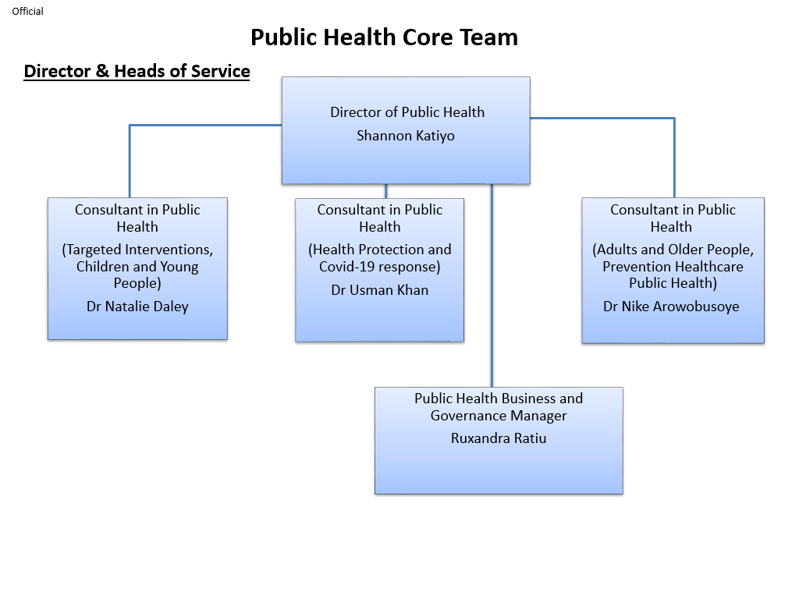

**Person Specification**

|  |  |
| --- | --- |
| **Provisional Job Title:**  Public Health Governance and Business Manager | **Grade**: TBC |
| **Section:**  Public Health | **Directorate:**  Directorate of Adult Social Services and Public Health |
| **Responsible to:**  Director of Public Health | **Responsible for:** (none)N/A |
| **Post Number/s:** RWCPP02 (TBC) | **Date**  August 2023 |

# Our Values and Behaviours

The values and behaviours we seek from our staff draw on the high standards of the two boroughs, and we prize these qualities in particular:

**Being open.** This means we share our views openly, honestly and in a thoughtful way. We encourage new ideas and ways of doing things. We appreciate and listen to feedback from each other.

**Being supportive.** This means we drive the success of the organisation by making sure that our colleagues are successful. We encourage others and take account of the challenges they face. We help each other to do our jobs.

**Being positive.** Being positive and helpful means we keep our goals in mind and look for ways to achieve them. We listen constructively and help others see opportunities and the way forward. We have a ‘can do’ attitude and are continuously looking for ways to help each other improve.

|  |  |  |  |
| --- | --- | --- | --- |
| **Person Specification Requirements** | | | **Assessed by A &** I**/ T/ C** |
| **Knowledge** | **Essential** | **Desirable** | **Assessed** |
| Knowledge and understanding of local government legislative and policy frameworks | E |  | A/I |
| Good understanding of project/programme management techniques and tools | E |  | A/I |
| An understanding of governance and administrative procedures within local authority or similar organisations | E |  | A/I |
| **Experience** | **Essential** | **Desirable** | **Assessed** |
| Proven and substantial experience of operating at a senior level in a local authority or other public sector organisation | E |  | A/I |
| Experience of report writing to a high standard, including developing and producing public health related procedures and plans | E |  |  |
| Experience of analysis of data and information | E |  | A/I |
| Experience of successfully managing own workload in an environment where deadlines and priorities frequently change and are often conflicting | E |  | A/I |
| Experience of procurement processes | E |  | A/I |
| **Skills** | **Essential** | **Desirable** | **Assessed** |
| To act as a super-user for standard IT packages in the relevant service areas, providing advanced support on complex queries |  | D | A/I |
| Able to communicate effectively and authoritatively orally and in writing, on a wide range of complex issues, providing constructive feedback and speaking confidently and knowledgeably at a range of meetings and committees | E |  | A/I/T |
| Able to analyse, evaluate and assimilate large volumes of data and present the findings in a clear and coherent way to a variety of audiences | E |  | A/I |
| Ability to negotiate effectively with internal and external directorates and agencies that have led to positive outcomes | E |  | A/I |
| Experience of managing complex workload, achieving targets and responding flexibly to changing needs and priorities, often with limited supervision | E |  | A/I |
| Ability to work both independently and as an effective team member, using initiative and adapting to changing priorities and deadlines in a calm in a calm, well-organised and methodical manner | E |  | A/I |
| Able to deal confidently, sensitively and calmly with colleagues, members of the public, colleagues in other organizations and contractors | E |  | A/I |
| Ability to oversee the delivery of projects/programmes and or/leading reviews of public health services and making recommendations for change | E |  | A/I |
| **Qualifications** | **Essential** | **Desirable** | **Assessed** |
| Degree in a relevant domain, for example business or public health  Experience working in a public health or related role  Evidence of on-going professional development | E  E | D | A/C |
|  |  |  | A/C |