**Job Profile comprising Job Description and Person Specification**

**Job Description**

|  |  |
| --- | --- |
| **Job Title:**  Refugee Services Senior Housing Officer | **Grade**:  P03 |
| **Section:**  Adult Social Care | **Directorate:**  Adult Social Care and Public Health |
| **Responsible to following manager:**  Refugee Services Senior Housing Officer | **Responsible for following staff:**  None |
| **Post Number/s:** | **Last review date:** |

**Working for the Richmond/Wandsworth Shared Staffing Arrangement**

This role is employed under the Shared Staffing Arrangement between Richmond and Wandsworth Councils. The overall purpose of the Shared Staffing Arrangement is to provide the highest quality of service at the lowest attainable cost.

Staff are expected to deliver high quality and responsive services wherever they are based, as well as having the ability to adapt to sometimes differing processes and expectations.

The Shared Staffing Arrangement aims to be at the forefront of innovation in local government and the organisation will invest in the development of its staff and ensure the opportunities for progression that only a large organisation can provide.

**Job Purpose**

To oversee the team responsible for the procurement of properties for recently arrived residents affected by forced migration.

**Specific Duties and Responsibilities**

1. Provide oversight and day-to-day management of up to six Refugee Services Housing Officers, ensuring that they feel supported in their work.
2. To work with the team to support and resolve complex cases.
3. To ensure the team are efficiently procuring private sector accommodation within statutory guidelines for sanctuary-seeking residents.
4. To develop relationships with landlords and agents to empower the team to negotiate the terms of which the Council will procure continuous supply of properties within approved procedures ensuring that they deliver value for money. To have extensive contact with landlords and clients, to promote the various Council schemes to ensure supply.
5. To identify improvement and new initiatives and mobility schemes; focusing on developing links and partnerships with private sector landlords and letting agents as well as other providers of housing to increase the supply of suitable accommodation to meet various housing duties and powers for households who are homeless or at risk of homelessness.
6. To quality assure the inspections of properties in and outside of the boroughs, assessing physical conditions in line with the Housing Health & Safety Rating System.
7. Ensure the team are allocating properties in line with the Homelessness Reduction Act 2017 and adhering to Schedule 3 of the Suitability Act 2012 and wider sanctuary legislation.
8. Ensure that appropriate performance and accurate budgetary information is maintained, acts as a verification officer, in line with applicable guidance from the Director of Finance and/or Head of Audit, for the purposes of confirming the authenticity of documents provided in support of claims for Local Housing Allowance
9. To ensure any visits or contact with residents and/or landlords is undertaken in line with workplace safety guidance and is risk-assessed.
10. To monitor casework for quality, and sharing best practice to support the team in developing their skills, including achieving value for money.
11. Be committed to continuous improvement, and able to have difficult and challenging conversations that will improve the quality of work of staff within the team.
12. Track programme spending and accurately record financial data.
13. To ensure the accurate recording and management of data and monitor data and identify trends which may improve the service and/or reduce homelessness.
14. To develop, implement and keep under review the communications plan to ensure our schemes are regularly promoted and have an active presence on social media and other platforms.
15. To maintain an up-to-date knowledge of housing policy as it applies to residents impacted by forced migration.
16. To work closely with colleagues in the Refugee Services team to deliver a well-coordinated service to residents.
17. To be pro-active in working with the Refugee Services Residents Manager in having an approach to make the best value use of resources across and with both internal and external partners.

**Generic Duties and Responsibilities**

* To contribute to the continuous improvement of the services of the Boroughs of Wandsworth and Richmond.
* To comply with relevant Codes of Practice, including the Code of Conduct and policies concerning data protection and health and safety.
* To adhere to security controls and requirements as mandated by the SSA’s policies, procedures and local risk assessments to maintain confidentiality, integrity, availability and legal compliance of information and systems
* To promote equality, diversity, and inclusion, maintaining an awareness of the equality and diversity protocol/policy and working to create and maintain a safe, supportive and welcoming environment where all people are treated with dignity and their identity and culture are valued and respected.
* To understand both Councils’ duties and responsibilities for safeguarding children, young people and adults as they apply to the role within the council.
* The Shared Staffing Arrangement will keep its structures under continual review and as a result the post holder should expect to carry out any other reasonable duties within the overall function, commensurate with the level of the post.
* To maintain a working knowledge of the Welfare Reform Act 2012, with a key focus on the benefit cap and implications on assessing affordability when mobilising applicants.
* To proactively publicise and explore for new business by way of agent visits, cold calling, attending landlord-focused events as well as other methods in line with our comms plan. Maintaining key links with current landlords and agents to ensure a regular supply of properties.
* Maintaining an up-to-date knowledge of the private housing market with particular focus on London but also beyond.
* Develop good practice for landlord management, including arranging landlord events and developing a knowledge hub

**Additional Information**

* Must be able to carry out visits and/or be able to carry out visits using public transport.
* This role is best suited to an individual who has a geuine passion and interest in supporting vulnerable people, particularly people affected by forced migration.

**Team structure**

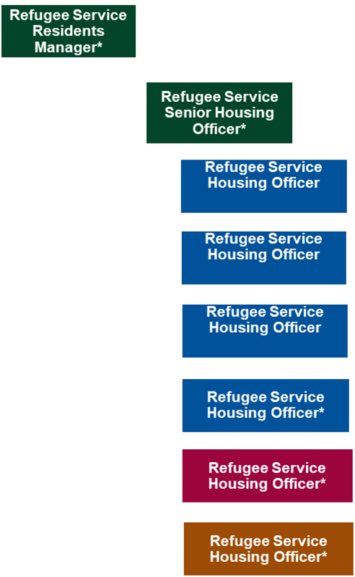

**Person Specification**

|  |  |
| --- | --- |
| **Job Title:**  Refugee Services Senior Housing Officer | **Grade**:  P03 |
| **Section:**  Adult Social Care | **Directorate:**  Adult Social Care and Public Health |
| **Responsible to following manager:**  Refugee Services Senior Housing Officer | **Responsible for following staff:**  None |
| **Post Number/s:** | **Last review date:** |

**Our Values and Behaviours**

The values and behaviours we seek from our staff draw on the high standards of the two boroughs, and we prize these qualities in particular:

**Being open.** This means we share our views openly, honestly and in a thoughtful way. We encourage new ideas and ways of doing things. We appreciate and listen to feedback from each other.

**Being supportive.** This means we drive the success of the organisation by making sure that our colleagues are successful. We encourage others and take account of the challenges they face. We help each other to do our jobs.

**Being positive.** Being positive and helpful means we keep our goals in mind and look for ways to achieve them. We listen constructively and help others see opportunities and the way forward. We have a ‘can do’ attitude and are continuously looking for ways to help each other improve.

|  |  |  |
| --- | --- | --- |
| **Person Specification Requirements** | **Assessed by**  **A**  **&**  **I/ T/ C (see below for explanation)** | **Essential/Desirable** |
| **Knowledge** | |  |
| Detailed knowledge of complex legislation applicable with particular experience with homelessness legislation, case law, welfare benefits, and Landlord and Tenant Law and how it applies to sanctuary-seekers | A/I | E |
| Detailed knowledge of welfare Reform in context of role – benefit advice to ensure rehousing solutions and how it applies to sanctuary-seekers | A/I | E |
| HHSRS/ Health and Safety property inspections | A/I | E |
| **Experience** | |  |
| Experience of building relationships with Landlords and Agents to deliver private sector properties for the use of Temporary or settled accommodation. | A/I | E |
| Experience managing a team through change, evolving workloads and innovation. | A/I | E |
| The ability to communicate and mediate with a broad range of people and adapt to different styles in order to develop the team as individuals. | A/I | E |
| Experience in efficiently managing data and presenting reports. | A/I | E |
| Ability to lead and use judgement to make challenging decisions. | A/I | E |
| Able to adapt quickly managing competing priorities. | A/I | E |
| **Qualifications** | |  |
| Housing studies and HHSRS desirable or equivalent experience. | A/C | E |

**A – Application form / CV**

**I – Interview**

**T – Test**

**C - Certificate**