**Job Profile comprising Job Description and Person Specification**

**Job Description**

|  |  |
| --- | --- |
| **Job Title:**  Community Engagement Officer (two- year fixed term) | **Grade**:  SO2 |
| **Section:**  Community and Partnerships,  Stronger and Safer Communities | **Directorate:**  Chief Executive’s Group |
| **Responsible to following manager:**  Community Engagement Manager | **Responsible for following staff:** |
| **Post Number/s:**  3 | **Last review date:**  January 2022 |

**Working for the Richmond/Wandsworth Shared Staffing Arrangement**

This role is employed under the Shared Staffing Arrangement between Richmond and Wandsworth Councils. The overall purpose of the Shared Staffing Arrangement is to provide the highest quality of service at the lowest attainable cost.

Staff are expected to deliver high quality and responsive services wherever they are based, as well as having the ability to adapt to sometimes differing processes and expectations.

The Shared Staffing Arrangement aims to be at the forefront of innovation in local government and the organisation will invest in the development of its staff and ensure the opportunities for progression that only a large organisation can provide.

**Job Purpose**

This post is in the Council’s Community Engagement Team, which sits within the Community and Partnerships section of the Stronger and Safer Communities Department, within the Chief Executive’s Group. The team provides a coherent approach to developing the Council’s relationship with its residents, partners and service users. This involves a focus on engaging with and involving communities, promoting transparency, and the need to promote public accountability. This post specifically supports activities within Richmond.

The Community Engagement Team provides leadership, support and advice to residents and all services across the Council on all aspects of:

• consultation and engagement activity

• community involvement

• the provision of information to the public to promote accountability

Richmond Council is continually reviewing its structures and ways of working in order to provide the best services possible for residents, in the most efficient way. As a result the key tasks in any job may be varied and the post holder will be expected to take on such variations consistent with the level of responsibility of the post.

**Specific Duties and Responsibilities**

The Community Engagement Officer will support the Community Engagement Manager in implementing the community engagement programme, including outreach work. This will help deliver the Council’s vision and approach to community engagement in order to:

a) fulfil the Council’s commitment to put residents at the heart of all it does

b) to facilitate stronger, more vibrant communities with active residents taking responsibility for their own lives and local areas

The purpose of the Community Engagement Team is to act as a channel of information between the Council, its partners and local people, whilst facilitating individuals and groups to get more involved and in taking action for themselves.

1. Assist in the coordination and delivery of opportunities for individuals and community groups to get involved in community activity
2. Work with less heard communities to raise awareness of Council services and sources of support from the voluntary sector and other key public sector services through extensive outreach work.
3. To plan and organise Community Conversations
4. Working with colleagues across the Council and the Community Engagement Network, to understand what Council activity is being undertaken and how it feeds into the community engagement plan
5. To act as a catalyst in establishing communications between the Council, community stakeholders, partners and residents
6. Keep the community engaged and well informed through all platforms, including social media
7. Manage outcomes from community engagement activities, for example the Community Conversations
8. To administer, promote and monitor the Council’s Community Fund programme
9. To build upon the knowledge and good working relationships with partners, residents and community and voluntary groups in specific ward areas
10. To understand and promote sources of support for local people who want to get involved in their communities
11. To utilise community intelligence and evidence-based data for targeted engagement work
12. To actively seek out local groups, give presentations and signpost to Council services.
13. To work with ward members to ensure they have the information they need to fulfil their roles in respect of Community Conversations and supporting residents’ needs.

**Generic Duties and Responsibilities**

* To contribute to the continuous improvement of the services of the Boroughs of Wandsworth and Richmond.
* To comply with relevant Codes of Practice, including the Code of Conduct and policies concerning data protection and health and safety.
* To adhere to security controls and requirements as mandated by the SSA’s policies, procedures and local risk assessments to maintain confidentiality, integrity, availability and legal compliance of information and systems
* To promote equality, diversity, and inclusion, maintaining an awareness of the equality and diversity protocol/policy and working to create and maintain a safe, supportive and welcoming environment where all people are treated with dignity and their identity and culture are valued and respected.
* To understand both Councils’ duties and responsibilities for safeguarding children, young people and adults as they apply to the role within the council.
* The Shared Staffing Arrangement will keep its structures under continual review and as a result the post holder should expect to carry out any other reasonable duties within the overall function, commensurate with the level of the post.

**Team structure**

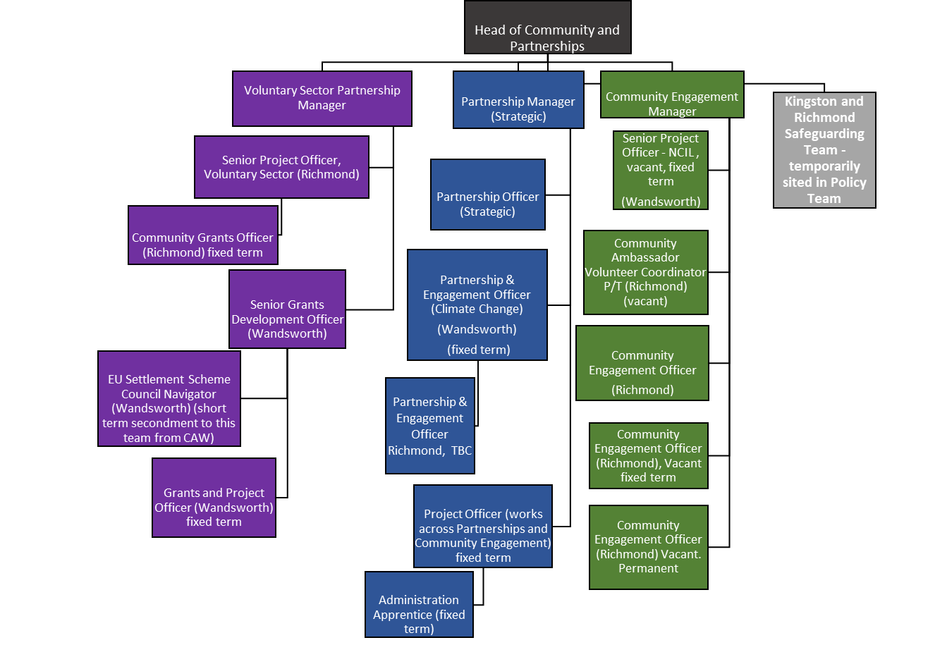

**Person Specification**

|  |  |
| --- | --- |
| **Job Title:**  Community Engagement Officer | **Grade**: SO2 |
| **Section:**  Community and Partnerships, Stronger and Safer Communities | **Directorate:**  Chief Executive’s Group |
| **Responsible to:**  Community Engagement Manager | **Responsible for:** |
| **Post Number/s:** 3 | **Last Review Date: January 2022** |

**Our Values and Behaviours**

The values and behaviours we seek from our staff draw on the high standards of the two boroughs, and we prize these qualities in particular:

**Being open.** This means we share our views openly, honestly and in a thoughtful way. We encourage new ideas and ways of doing things. We appreciate and listen to feedback from each other.

**Being supportive.** This means we drive the success of the organisation by making sure that our colleagues are successful. We encourage others and take account of the challenges they face. We help each other to do our jobs.

**Being positive.** Being positive and helpful means, we keep our goals in mind and look for ways to achieve them. We listen constructively and help others see opportunities and the way forward. We have a ‘can do’ attitude and are continuously looking for ways to help each other improve.

|  |  |
| --- | --- |
| **Person Specification Requirements** | **Assessed by**  **A**  **& I/ T/ C (see below for explanation)** |
| **Knowledge** | |
| Knowledge of local government structures and role of local ward councilors. | A/I |
| Understanding of consumer-focused service delivery and customer care standards. | A/I |
| **Experience** | |
| Managing and building strong relationships with volunteers, service users, partners and external agencies. | A/I |
| Experience in communicating effectively and sensitively in oral and written form to a wide range of individuals and organisations. | A/I/T |
| Some experience in producing information/publicity material including web editing and providing text for social media. | A/I |
| Substantial experience of delivering community involvement and capacity building projects in a local authority or similar organisation | A/I |
| Understanding of the strategic aims of the Council and the ability to exercise good judgement in promoting them | A/I/T |
| **Skills** | |
| Proven organisational and time management skills. | A/I |
| Ability to organise and prioritise own workload, to work under pressure and meet deadlines. | A/I |
| Ability to handle confidential or sensitive information, together with an understanding of data protection requirements. | A/I |
| Ability to critically investigate issues and prepare briefings/assessments as required. | A/I |
| Ability to develop and maintain policy and procedure for the Community Fund (NCIL) | A/I |
| Good working knowledge of using standard IT packages including Microsoft packages. | A/I |
| Able to maintain a range of different record keeping systems. | A/I |
| Ability to facilitate and maintain positive communications both internally and externally. | A/I |
| Ability to deliver high impact verbal and written presentations to a range of stakeholders including Councillors, senior members of staff, residents and volunteers. | A/I/T |
| Strong understanding and experience of using the internet, websites and social media as engagement channels | A/I |
| **Qualifications** | |
|  |  |

**A – Application form / CV**

**I – Interview**

**T – Test or Practical Exercise**

**C - Certificate**