**Job Profile comprising Job Description and Person Specification**

**Job Description**

|  |  |
| --- | --- |
| **Job Title:**  Financial Assessments Manager | **Grade**:  SSA MG1 |
| **Section:**  ASCHPH Finance | **Directorate:**  Adult Social Care and Public Health Finance (ASCPH) |
| **Responsible to the following manager:**  Head of ASCPH Finance | **Responsible for the following staff:**  Team Leaders for financial assessments and debt recovery |
| **Post Number/s:**  **RWA1026** | **Last Review Date:** |

**Working for the Richmond & Wandsworth Better Service Partnership**

This role is employed under the Richmond & Wandsworth Better Service Partnership. The overall purpose of Richmond & Wandsworth is to provide the highest quality of service at the lowest attainable cost.

Staff are expected to deliver high quality and responsive services wherever they are based, as well as having the ability to adapt to sometimes differing processes and expectations.

Richmond & Wandsworth Better Service Partnership aims to be at the forefront of innovation in local government and the organisation will invest in the development of its staff and ensure the opportunities for progression that only a large organisation can provide.

**Job Purpose**

To manage the Shared Financial Assessment Service and have overall management responsibility for adult social care and public health financial assessments and debt recovery functions.

To be responsible for leading the Financial Assessments Teams to ensure timely and accurate financial assessments are carried out for people receiving adult social care and public health services. The role requires understanding of the business needs for adult social care services and coming up with practical and customer-focused solutions to meet these needs, including leading on complaints investigation and resolution for charging.

**Specific Duties and Responsibilities**

1. To ensure that the services for both councils are dealt with on an equitable basis to deliver the standards required for each, as agreed annually by the Executives of both councils.
2. To provide operational and motivational leadership of staff with the primary aim of delivering high quality services.
3. To manage resources in an ever-changing environment adapting work methods and practices to accommodate technology, external factors (e.g. Covid) and changes in national policy (e.g. ASC reform).
4. To provide effective management of staff, including recruitment, training, development and appropriate application of policies and codes of practice on staffing matters.
5. To ensure all Member queries about ASCPH financial assessments and debt are dealt with promptly and effectively.
6. To advise and support senior managers on service and operational matters relating to finance, financial assessment and debt recovery.
7. To assist as required with the management of budgets, including ensuring that all necessary processes and procedures are carried out in a timely and effective way.
8. To provide guidance to senior care manager’s and care workers on complex cases in relation to ASCPH Finance.
9. To assist with and, as required, lead change programmes within the service.
10. To ensure that effective commissioning, market testing and contract management of services processes are in place and operating to all required standards.
11. To contribute towards the development of good working relations and collaborative arrangements with relevant third-party organisations including private, voluntary and other public organisations, to forge effective partnership working.
12. To support the Head of Service in representing the SSA, and where appropriate customers, in dealing with external organisations
13. To support the Head of Service with matters relating to area of responsibility.
14. To respond to difficult customer enquiries and complaints, including Members and MPs’ enquiries
15. To respond to complex freedom of information (FOI) requests and ensure that general FOI requests are dealt with according to deadlines.
16. Responsible for ensuring the accurate and equitable implementation of charging regulations and providing advice on changes in charging legislation.
17. Oversee the Department’s income generation ensuring that income is being maximised, and debts are being appropriately monitored and managed.
18. To ensure that policies and procedures are in place and updated for ASCPH financial assessment and debt recovery.
19. To ensure that debt is recovered according to legislation that is in place, particularly Annex D of the Care Act’s Care and Support Statutory guidance.
20. To ensure that internal policies and procedures are in place and updated for ASCPH financial assessment and debt recovery.
21. To review complex financial assessment cases where a management view is required providing advice and decisions where needed.
22. To review complex debt cases where a management view is required providing advice and decisions as needed.
23. To ensure the council’s deferred payment scheme is working according to legislation and updated as and when required.
24. To ensure the deferred payment return for the DHSC is completed on an annual basis according to the deadline set.
25. To provide statistics to senior management as required for financial assessments and debt recovery.
26. Attend senior management meetings when required.
27. To provide a monthly operational report and dashboard detailing strategic information to senior management for ASCPH financial assessment and debt recovery.
28. To authorise escalation of debt recovery cases to the council’s legal department.
29. To review and sign off ASCPH debts for write off independently up to a value of £500.
30. To review and countersign off ASCPH debt with the Assistant Director of Resources and ASCPH Head of Finance for amounts between £500 and £25,000.
31. To ensure debts over £25,000 have an appropriate report and are submitted to the respective committee for write off on an annual basis.
32. To work with the Head of Finance and Finance Manager to ensure that the FAIR department is correctly reflected in closing for the end of the financial year.
33. To ensure that all financial assessments are reviewed on an annual basis for the end of the financial year.
34. To lead on any staff disciplinary matters within the department.
35. Make final decision in relation to complex financial assessment cases such as disregard of capital assets or income.
36. Manage the team leaders in the department in relation to all staff matters.
37. Liaise with senior managers in other areas as and when required e.g. Corporate Finance, Care Team, Legal, Complaints etc.
38. Provide statistics to other areas of the council as and when required e.g. Corporate Finance, Performance Team etc.

**Generic Duties and Responsibilities**

* To contribute to the continuous improvement of the services of Richmond & Wandsworth Better Service Partnerships.
* To comply with relevant Codes of Practice, including the Code of Conduct and policies concerning data protection handling complaints and health and safety.
* To adhere to security controls and requirements as mandated by Richmond and Wandsworth procedures and local risk assessments to maintain confidentiality, integrity, availability and legal compliance of information and systems
* To promote equality, diversity, and inclusion, maintaining an awareness of the equality and diversity protocol/policy and working to create and maintain a safe, supportive and welcoming environment where all people are treated with dignity and their identity and culture are valued and respected.
* To understand both Councils’ duties and responsibilities for safeguarding children, young people and adults as they apply to the roles within the Councils.
* The profile is not intended to be an exhaustive list of the duties the post holder will carry out. Other reasonable duties commensurate with the level of the post, including supporting emergency and priority situations, will form part of the role.

**Additional Information**

**N/A**

**Team structure**

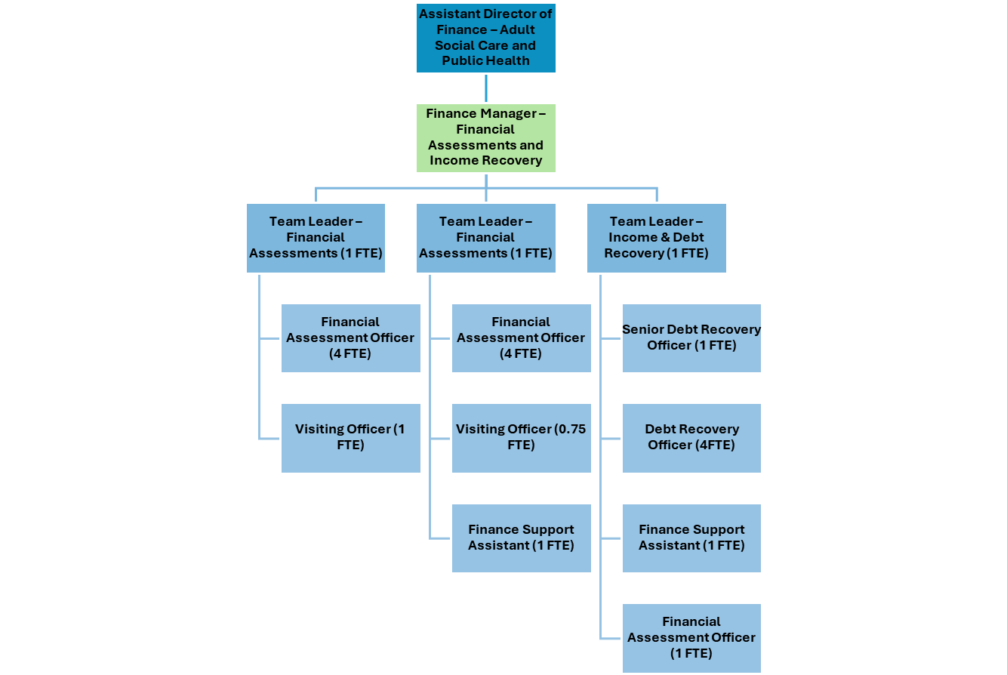

**Person Specification**

|  |  |
| --- | --- |
| **Job Title:**  Financial Assessments Manager | **Grade**:  MG1 |
| **Section:**  ASCPH Finance | **Directorate:**  Adult Social Care and Public Health (ASCPH) |
| **Responsible to the following manager:**  Assistant Director of ASCPH Finance | **Responsible for the following staff:**  Team Leaders for Financial Assessments and Debt Recovery |
| **Post Number/s:**  **RWA1026** | **Last Review Date:** December 2024 |

**Our Values**

**THINK BIGGER**

**EMBRACE DIFFERENCE**

**CONNECT BETTER**

**LEAD BY EXAMPLE**

**PUT PEOPLE FIRST**

Our Values are embedded across Richmond & Wandsworth Better Service Partnership and throughout all roles and responsibilities at all levels of the organisation. Please [familiarise yourself with our values](https://www.richmond.gov.uk/media/afdbdeao/five_values.pdf) as they are an integral part of our recruitment and selection process.

|  |  |  |  |  |
| --- | --- | --- | --- | --- |
| **Person Specification Requirements** | | | | **Assessed by**  **A/I/T/C**  **(see below for explanation)** |
| **Knowledge** | **Essential** | **Desirable** | **Assessed** |
| Clear understanding of the charging framework for adult social services | **Y** |  | **A/I** |
| An up-to-date knowledge of legislation relating to Adult Social Services | **Y** |  | **A/I** |
| **Experience** | **Essential** | **Desirable** | **Assessed** |
| Proven experience of successfully managing a Financial Assessment Team |  | **Y** | **A/I** |
| Evidence of successfully leading change in a positive way | **Y** |  | **A/I** |
| Experience of managing staff with positive outcomes | **Y** |  | **A/I** |
| Some experience of appropriately managing budgets and/ or staff resources | **Y** |  | **A/I** |
| **Skills** | **Essential** | **Desirable** | **Assessed** |
| Good level of customer service skills e.g. good oral, written and presentation skills to provide clear and concise messages in a variety of internal and external contexts | **Y** |  | **A/I/T** |
| Significant experience of using standard IT packages and ability to support others in their day-to-day use | **Y** |  | **A/T** |
| Ability to use, for example, Mosaic to record casework, monitor caseloads and management data and to train and support other members of staff on a day-to-day basis | **Y** |  | **A/I** |
| Ability to organise and prioritise own workload, to work under pressure and meet deadlines | **Y** |  | **A/I** |
| **Qualifications** | **Essential** | **Desirable** | **Assessed** |
| Educated to A-level or equivalent by experience | **Y** |  | **A/I/C** |
| Management Qualification |  | **Y** | **A/C** |
| Accountancy Qualification |  | **Y** | **A/C** |

**A – Application form / CV**

**I – Interview**

**T – Test**

**C - Certificate**