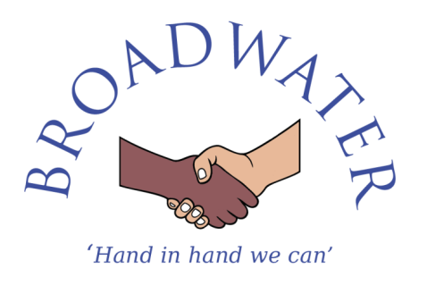

Person Specification – Behaviour and Learning Mentor

Behaviour and Learning Mentor Selection Criteria | Essential or  Desirable
Qualifications
- GCSE English and Maths (Grade C or above) or equivalent  - NVQ Level 3 Learning, Development & Support Services (LDSS) or equivalent qualification  - Willingness to participate in development and training opportunities  - First Aid Certificate | - Essential  - Desirable  - Essential  - Desirable
Experience
- Experience of working with or caring for children ( 3-11 years of age)  - Experience of working in a school  - Experience of supporting children and young people to find out about and use services and facilities.  - Knowledge or experience of working with other agencies. | - Essential  - Desirable  - Desirable  - Desirable
Professional knowledge and understanding
- Ability to establish, develop and maintain effective and positive one-to-one mentoring relationships with children.  - Ability to provide a positive role model to children with a commitment to supporting children with achieving their full potential.  - Good listening skills and the ability to communicate effectively with children, young people, families, school staff and a range of other professionals.  - Knowledge and awareness of issues and factors related to underachievement and barriers to learning.  - Ability to exercise initiative, work independently and take responsibility for the delivery of a learning mentoring programme.  - Basic understanding of principles of child development and learning processes across the primary age range  - General understanding of the National Curriculum and the Early Years Foundation Stage principles and practice  - Knowledge of a range of strategies for dealing with and managing pupils with a variety of needs  - Understanding of the importance of values development within the broader curriculum and ethos of the school to support the school community and individual pupils as citizens of the local and world community  - Knowledge of safeguarding children and young people  - Awareness of health and safety | - Essential  - Essential  - Essential  - Essential  - Essential  - Essential  - Essential  - Essential  - Essential  - Essential  - Essential

Skills
- Good level of written and spoken English  - Able to encourage and motivate children.  - Abie to advise, instruct, negotiate and explain to children.  - Able to assist with the organisation of the learning environment  - Able to use assertive discipline strategies in the school.  - Able to model an assertive and respectful way in talking and dealing with children.  - Able to model the idea of respect between all staff and pupils.  - Able to plan and prioritise tasks within specific deadlines  - Able to engage with and communicate effectively to a range of audiences  - Able to judge when to make decisions and when to consult with others  - Able to deal sensitively with people and resolve conflicts  - Able to use ICT effectively to support learning | - Essential  - Essential  - Essential  - Essential  - Essential  - Essential  - Essential  - Essential  - Essential  - Essential  - Essential  - Essential

Professional Qualities
- Committed to excellence with high aspirations for all pupils  - Committed to the maintenance of good relationships with staff, parents, pupils, governors, the community and other stakeholders  - Well organised and able to work under pressure and to deadlines  - Able to self-evaluate learning needs and actively seek professional development opportunities  - Committed to equality, with respect and empathy to all  - Enthusiastic and inspiring to staff, pupils and parents  - Consistent and fair to all  - Capacity to be flexible and adaptable – willing to take on and develop the best of ideas from within and outside the school  - Able to comply with policies and procedures  - Able to respond to every day and emergency situations calmly and quickly  - Resilient and has a good sense of humour | - Essential  - Essential  - Essential  - Essential  - Essential  - Essential  - Essential  - Essential  l  - Essential  - Essential  - Essential

Broadwater Primary School is committed to safeguarding and promoting the welfare of children and young people and expects all staff and volunteers to share this commitment. This post is subject to a Disclosure & Barring Service (DBS) check.

