**Job Profile comprising Job Description and Person**

# Specification Job Description

|  |  |
| --- | --- |
| **Job Title:**  FM Projects Officer | **Grade**: PO6 |
| **Section:**  Property Services – Facilities  Management | **Directorate:**  Housing & Regeneration |
| **Responsible to following manager:**  FM Maintenance Manager | **Responsible for following staff:** 0 |
| **Post Number/s 1** | **Last review date:** |

**Working for the Richmond/Wandsworth Shared Staffing Arrangement**

This role is employed under the Shared Staffing Arrangement between Richmond and Wandsworth Councils. The overall purpose of the Shared Staffing Arrangement is to provide the highest quality of service at the lowest attainable cost.

Staff are expected to deliver high quality and responsive services wherever they are based, as well as having the ability to adapt to sometimes differing processes and expectations.

The Shared Staffing Arrangement aims to be at the forefront of innovation in local government and the organisation will invest in the development of its staff and ensure the opportunities for progression that only a large organisation can provide.

## Job Purpose

To effectively manage and deliver FM projects by developing positive collaborative working relationships with key stakeholders and internal and external customers. Understanding, and interpreting their requirements and managing projects to their expectations within programme and budget.

Responsible for coordinating all project inputs, resources and overseeing the delivery of FM related projects to achieve customer satisfaction.

Ensure that FM projects are well managed, deliver value and are compliant with the Council’s FM & PMO processes and procurement rules. This management will include both management of consultants (internal and external) and contractors.

Managing project delivery to satisfy both statutory requirements and in line with health & safety requirements of the SSA.

Responsible for the accommodation duties which includes managing the desk/ equipment moves (CHURN) and will include large scale decanting and relocating staff and equipment.

Be responsible for managing budgets for specific FM and other Directorates projects.

Assisting the Technical Services Manager and Maintenance Manager with the preparation of business cases for capital approval.

Ensure all projects meet the aims of the climate change strategies for both Richmond and Wandsworth, liaising with the Energy and Sustainability Manager and Policy teams as necessary to ensure the Councils achieve net zero carbon by 2030

## Specific Duties and Responsibilities

1. Establish project requirement(s) through regular update meetings with FM Technical Services Manager, FM Performance and Quality Services Manager, Design Services and Project Management Office (PMO).

1. Responsible for the delivery of the workspace strategy within FM ensuring the councils office environment is of a first-class standard.

1. Responsible for consulting with the customer(s) to fully understand their requirements and expectations. Coordinating all project stakeholders to ensure that requirements and expectations are clearly understood.

1. Responsible to writing and issuing the technical scope of works (specification) document(s) with input from the FM Technical Services Manager, Design Services and PMO as required.

1. Responsible for agreeing the project budget with HO Facilities Management and Technical Services Manager, Design Services and PMO Teams ensuring that costs (pre-tender estimate) are within the agreed revenue or capital programme budgets.

1. Responsible for agreeing project programme with all stakeholders including the customer(s) and contractors.

1. Responsible for coordinating project pre-start meetings with all stakeholders to ensure that where required a Construction Phase Plan is in place and CDM Regulations have been addressed.

1. Responsible for regular site inspections whilst the project is in progress to ensure that the works are being delivered safely to the required quality of materials. Workmanship and are on programme and budget.

1. Regularly meet with the customer(s) to ensure customer satisfaction. Ensure that the project works are causing minimal disruption to their core business operation, the local community, and the environment.

1. Responsible for ensuring that any variance to project cost and/or programme are risk / impact assessed, justifiable and communicated to all stakeholders.

1. Ensure that effective project management, planning, budget, and risk management controls systems are in place to ensure a high standard of project delivery.

1. Work with the Head of Facilities Management, Head of Design Services, Head of Construction, FM Technical Services Manager, FM Maintenance Manager and FM Performance and Service Quality Manager to develop the annual Capital programme(s) for Richmond and Wandsworth.

1. Understand the Capital Bids process and timetable so that feasibility and budget is established in advance of Capital Bids timetable.

1. Ensure the highest levels of Health and Safety are achieved on all projects. Ensure that all project related work i is undertaken safely and is compliant with statutory and industry regulations including CDM Regulations 2015.

1. Responsible for project financial management and planning to include the management of project budgets in line with the Council’s procurement guidelines.

1. Ensure compliance with all budget management and financial requirements through the effective monitoring of purchase orders issued and works undertaken to ensure clear audit trails and financial accountability.

1. Produce, develop, and manage a project database in Share Point which captures all relevant project data including but not limited to site location, project description, cost, duration, risk, and critical success factors.

1. Develop strong collaborative working relationships with all project stakeholders including customers, contractors, and stakeholders.

1. Identify opportunities for innovation, continuous improvement which deliver cost efficiencies without compromising service levels. Ensure that good practice and continuous improvement from lessons learned is embedded into the delivery of FM projects.

1. Use a range of communication methods, including presentations and progress reports to update internal and external stakeholders as required.

1. Leading the planning and implementation of projects. Defining the project scope and goals. Planning and scheduling project timescales Resource planning and allocation. Quality Assurance, including regular site visits during the construction period.

1. Carrying out risk assessments and determining project risks

1. Managing project administration including all relevant documentation.

1. Ensuring that projects are accepted into service, following the FM Projects Policy and that all defects are cleared before end of defects liability period (DLP)

1. Working with our stakeholders take the briefs for proposed staff relocations and manage these accommodation projects.

1. Chairing project meetings with consultants, contractors, stakeholders (Councillors may be present for specific projects). During these meetings the post holder may deliver presentations.

## Generic Duties and Responsibilities

* To contribute to the continuous improvement of the services of the Boroughs of Wandsworth and Richmond.

* To comply with relevant Codes of Practice, including the Code of Conduct and policies concerning data protection and health and safety.

* To adhere to security controls and requirements as mandated by the SSA’s policies, procedures, and local risk assessments to maintain confidentiality, integrity, availability and legal compliance of information and systems.

* To promote equality, diversity, and inclusion, maintaining an awareness of the equality and diversity protocol/policy and working to create and maintain a safe, supportive, and welcoming environment where all people are treated with dignity and their identity and culture are valued and respected.

* To understand both Councils’ duties and responsibilities for safeguarding children, young people, and adults as they apply to the role within the council.

* The Shared Staffing Arrangement will keep its structures under continual review and as a result the post holder should expect to carry out any other reasonable duties within the overall function, commensurate with the level of the post.

## Additional Information

The Post Holder will be expected to adopt a ‘one team delivery’ approach using both in-house and external resources to ensure a proactive and professional service delivery.

**Manages:** No direct reports

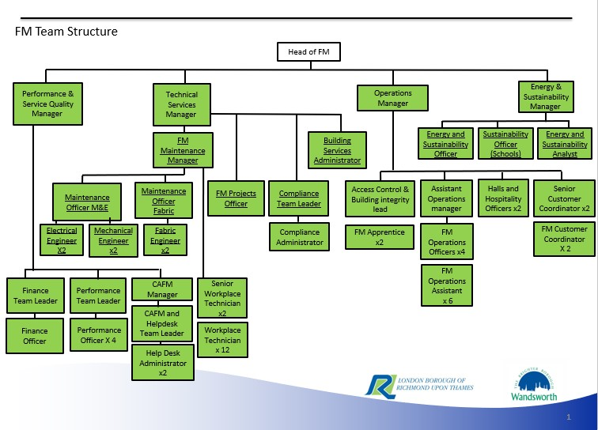

6

# Person Specification

|  |  |
| --- | --- |
| **Job Title:**  FM Projects Officer | **Grade**: PO6 |
| **Section:**  Property Services – Facilities Management | **Directorate:**  Housing & Regeneration |
| **Responsible to following manager:**  FM Maintenance Manager | **Responsible for following staff:** 0 |
| **Post Number/s 1** | **Last review date:** NA |

## Our Values and Behaviours

The values and behaviours we seek from our staff draw on the high standards of the two boroughs, and we prize these qualities in particular:

* taking responsibility and being accountable for achieving the best possible outcomes – a ‘can do’ attitude to work
* continuously seeking better value for money and improved outcomes at lower cost
* focussing on residents and service users, and ensuring they receive the highest standards of service provision
* taking a team approach that values collaboration and partnership working.

**Being open.** This means we share our views openly, honestly and in a thoughtful way. We encourage new ideas and ways of doing things. We appreciate and listen to feedback from each other.

**Being supportive.** This means we drive the success of the organisation by making sure that our colleagues are successful. We encourage others and take account of the challenges they face. We help each other to do our jobs.

**Being positive.** Being positive and helpful means we keep our goals in mind and look for ways to achieve them. We listen constructively and help others see opportunities and the way forward. We have a ‘can do’ attitude and are continuously looking for ways to help each other improve.

|  |  |
| --- | --- |
| **Requirements** | **Assessed by A &** I**/ T/ C** |
| **Knowledge** |  |
| Thorough knowledge of project management methodologies | A & I |
| Thorough knowledge of delivering FM Building Services projects | A & I |
| Good understanding of construction including fabric, mechanical & electrical and public health systems | A & I |
| Previous knowledge of working for a Council’s properties, assets, and operations. | A & I |
| Knowledge of working with CAFM systems | A & I |
| Knowledge of contractual matters and their impact upon the delivery of an operational service | A & I |
| Good understanding of the building regulations. | A & I |
| **Experience** |  |
| Extensive experience of managing Fabric and Building Services projects in a dynamic multi-site organisation | A & I |
| Experience in process review and re-engineering. | A & I |
| Managing multi-faceted technical projects | A & I |
| Change management in a dynamic, pressurised environment | A & I |
| Dealing with building regulations approvals and planning consents including listed building approvals | A & I |
| **Skills** |  |
| Technically competent in project management methodologies | A & I |
| Excellent organisational skills, ability to quickly identify pragmatic solutions to complex operational problems | A & I |
| Excellent verbal and written skills | A & I |
| Ability to organise and prioritise own workload to meet tight deadlines whilst managing a large variable workload and changing priorities.  Ability to plan and co-ordinate activities despite conflicting priorities | A & I |
| Ability to think creatively and develop new solutions to resolve problems.  Demonstrate an innovative approach with the ability to identify and deliver improvements. |  |
| **Qualifications** |  |
| PRINCE2 Project Management | A & I |
| NEBOSH Health and Safety | A & I |

## A = Application form / CV I = Interview T = Test C = Certificate