**Job Profile comprising Job Description and Person Specification**

**Job Description**

|  |  |
| --- | --- |
| **Job Title:**  Policy and Programme Lead (Climate Change and Sustainability) | **Grade**:  PO5- PO6 |
| **Section:**  Policy, Performance, Analysis and Communications | **Directorate:**  Chief Executive’s Group |
| **Responsible to following manager:**  Policy and Review Manager | **Responsible for following staff:**  n/a |
| **Post Number/s:** | **Last Review Date:**  December 2021 |

**Working for the Richmond/Wandsworth Shared Staffing Arrangement**

This role is employed under the Shared Staffing Arrangement between Richmond and Wandsworth Councils. The overall purpose of the Shared Staffing Arrangement is to provide the highest quality of service at the lowest attainable cost.

Staff are expected to deliver high quality and responsive services wherever they are based, as well as having the ability to adapt to sometimes differing processes and expectations.

The Shared Staffing Arrangement aims to be at the forefront of innovation in local government and the organisation will invest in the development of its staff and ensure the opportunities for progression that only a large organisation can provide.

**Job Purpose**

In July 2019 Richmond Council and Wandsworth Council declared Climate Emergencies, following this Wandsworth Council published its Environment and Sustainability Strategy in July 2019 and Richmond published its Climate Emergency Strategy in January 2020. Although both councils are committed to being net zero organisations by 2030 and to make both boroughs net zero by 2050 the individual strategies reflect the priorities for each borough and therefore contain actions and priorities which are unique to each. Both strategies are underpinned by ambitious action plans that involve services across all Directorates. These action plans cover the operations of both councils, the estates of both councils and the Shared Staffing Service workforce. Alongside these strategies and action plans each council has developed individual engagement and behaviour change programmes which look to involve residents, local groups, local businesses and partners in taking action to improve the environment and reduce carbon emissions. This post is required to ensure the delivery of the two strategies, their supporting action plans and the two engagement programmes.

The postholder will programme manage, alongside the other Policy and Programme Lead (Climate Change and Sustainability), the further development and delivery of the strategies, action plans and engagement strategies. They will identify where actions are at risk of slipping and will work with services to get progress back on track. They will also look to identify where policy can be developed to support both council’s ambitious strategies and achieve the 2030 and 2050 targets and to identify projects and funding to deliver the climate action plans.

The post holder will be expected to take a leading role in driving forward all aspects of climate change and sustainability work.

In fulfilling this role the postholder will ensure the successful delivery of these high-profile and ambitious strategies.

**Specific Duties and Responsibilities**

1. To programme manage the action plans which underpin the Wandsworth and Richmond strategies. This will involve liaising with senior officers to identify actions taken, critically appraising if actions are on track and working with senior officers to bring actions back on deadline, where required.
2. To work closely with officers across the SSA to deliver the agreed engagement and behaviour change strategies. This will require liaison with local groups, local businesses, stakeholders, partners, residents and staff.
3. To lead on supporting the Assistant Chief Executive on delivering the governance structures which have been agreed to deliver both the strategies. This includes the SSA Climate Change Steering Group.
4. To lead on providing formal reports to Members on the progress of both the action plans and on providing detailed briefings to Members, both written and face to face, as required. This will include the Leaders of both councils and Executive Members/Committee Chairs
5. To lead on the updating of the annual action climate plans.
6. To undertake research and detailed policy analysis that helps to determine the implications and opportunities arising from policy and legislation changes in relation to climate change, sustainability and the environment.
7. To keep up-to-date with policy changes and initiatives in other councils, public sector bodies and developments in other countries and critically assesses the opportunities for learning as they might apply to services in the SSA – presenting options to senior managers and members as required.
8. To lead the development of cross cutting policy as it relates to climate change, sustainability and the environment
9. As required to, lead and co-ordinate project teams that deliver high profile cross cutting projects.
10. To represent both councils at meetings and events with stakeholders, local groups, partners, businesses and residents and build relationships across all these stakeholder groups.
11. To represent the council at pan-London or national meetings and to establish a peer network across councils in order that ideas can be shared.
12. To manage graduates, if placements in relation to this area, are supported
13. To ensure that the services for both councils are dealt with on an equitable basis to deliver the standards required for each, as agreed annually by the Executives of both Councils.
14. To ensure all actions are delivered in accordance with the Equality Act 2010 and look to narrow gaps and ensure services are accessible to all residents.

**Generic Duties and Responsibilities**

* To contribute to the continuous improvement of the services of the Boroughs of Wandsworth and Richmond.
* To comply with relevant Codes of Practice, including the Code of Conduct and policies concerning data protection and health and safety.
* To adhere to security controls and requirements as mandated by the SSA’s policies, procedures and local risk assessments to maintain confidentiality, integrity, availability and legal compliance of information and systems
* To promote equality, diversity, and inclusion, maintaining an awareness of the equality and diversity protocol/policy and working to create and maintain a safe, supportive and welcoming environment where all people are treated with dignity and their identity and culture are valued and respected.
* To understand both Councils’ duties and responsibilities for safeguarding children, young people and adults as they apply to the role within the council.
* The Shared Staffing Arrangement will keep its structures under continual review and as a result the post holder should expect to carry out any other reasonable duties within the overall function, commensurate with the level of the post.

**Additional Information**

* Maybe required to attend meetings such as committees, working groups and Partnerships outside of the normal working day.
* Post holder will be expected to work flexibly across two locations (Wandsworth Town Hall and Richmond Civic Centre)

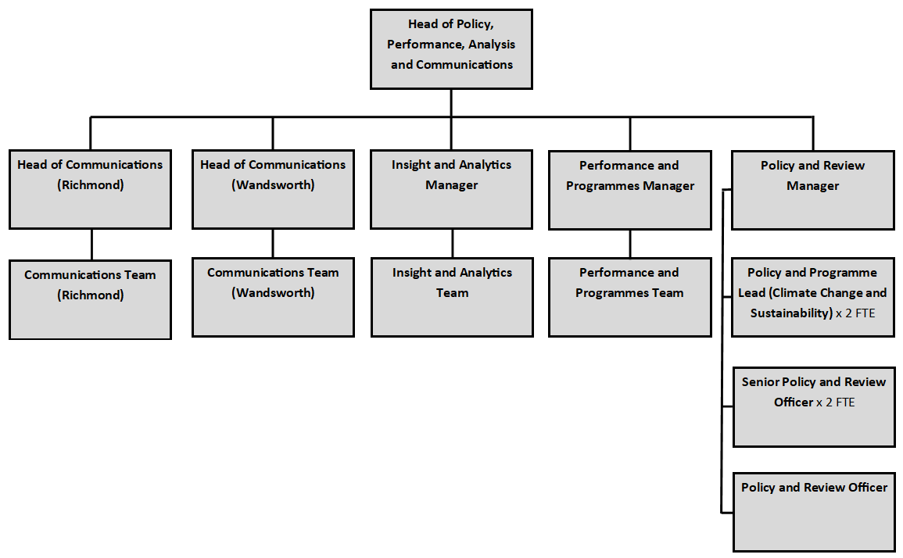**Current team structure**

**Person Specification**

|  |  |
| --- | --- |
| **Job Title:**  Policy and Programme Lead (Climate Change and Sustainability) | **Grade**:  PO5 - PO6 |
| **Section:**  Policy, Performance, Analysis and Communications | **Directorate:**  Chief Executive’s Group |
| **Responsible to following manager:**  Policy and Review Manager | **Responsible for following staff:**  n/a |
| **Post Number/s:** | **Last Review Date:**  December 2021 |

**Our Values and Behaviours[1]**

The values and behaviours we seek from our staff draw on the high standards of the two boroughs, and we prize these qualities in particular –

* taking responsibility and being accountable for achieving the best possible outcomes – a ‘can do’ attitude to work
* continuously seeking better value for money and improved outcomes at lower cost
* focussing on residents and service users, and ensuring they receive the highest standards of service provision
* taking a team approach that values collaboration and partnership working

|  |  |
| --- | --- |
| **Person Specification Requirements** | **Assessed by**  **A**  **&**  **I/ T/ C (see below for explanation)** |
| **Knowledge** | |
| Knowledge of the climate change and sustainability agenda | A/I |
| Knowledge of policy development as it relates to local government and the delivery of services | A/I |
| Knowledge of the wider context within which local government operates (including commissioning) and ability to develop appropriate local responses | A/I |
| Climate and sustainability related knowledge of the following areas would be an advantage:  Finance and resources, housing, regeneration, waste and recycling, schools and children’s services. | A/I |
| **Experience** | |
| Experience in the delivery of climate change or sustainability related programmes and/or projects | A/I |
| Experience of operating in a political environment, recognising and handling in an appropriate manner, confidential or sensitive information and distinguishing between political and non-political activities. | A/I |
| Experience of successfully managing own workload in an environment where deadlines and priorities frequently change and are often conflicting | A/I |
| Experience of working and negotiating and constructively challenging senior managers and colleagues | A/I |
| Experience of managing high profile, ambitious projects or programmes | A/I |
| **Skills** | |
| Ability to communicate effectively and authoritatively both orally and in writing, with councillors, officers, partner organisations and the public. | A/I |
| Ability to exercise tact and diplomacy, and first rate interpersonal, negotiation and influencing skills. | A/I |
| Ability to accurately analyse numeric, financial, textual, performance and carbon data and present your findings in a clear and coherent way to a variety of audiences. | A/I |
| Demonstrable ability to use IT applications to manage and manipulate information and of researching information (textual, financial and statistical) from a variety of sources to present it in a consistent, concise and understandable way, both orally and in writing. | A/I |
| Ability to develop policy and strategy, either in a local government or climate change / sustainability context | A/I |
| Ability to oversee the delivery of projects / programmes. | A/I |
| Ability to lead and manage cross-departmental teams to deliver specific projects and/or reviews. | A/I |
| Ability to work at pace, juggle priorities, and assimilate new information quickly and ability to make sound decision and judgements under pressure. | A/I |
| Experience of managing a complex workload, achieving targets and responding flexibly to changing needs and priorities, often with limited supervision | A/I |
| Ability to work both independently and as an effective team member, using initiative and adapting to changing priorities and deadlines in a calm, well-organised and methodical manner. | A/I |
| **Qualifications** | |
| Educated to degree level in a climate change or sustainability related subject area or equivalent through work experience | A/I |

**A – Application form**

**I – Interview**

**T – Test**

**C - Certificate**

1. These values and behaviours will be developed further as the SSA becomes established.