

July 2024

# Re: Higher Level Teaching Assistant – Part Time 21 hours - 1 Year Fixed Term

Thank you for showing an interest in the above position we have here at Penwortham Primary School.

Penwortham is located in a sought-after area of Tooting and set within a diverse and vibrant community.

In response to the lack of pupil places in our area and due to the on-going popularity of our school, Penwortham has been permanently expanded to a 3 Form of Entry School and at this time, we continue to maintain our projected pupil roll.

We have very attractive school grounds and learning environments and are fortunate enough not to have controlled parking restrictions immediately surrounding our school therefore residential street parking is available to our staff and visitors.

We are proud to be known as a nurturing and truly inclusive school which provides children with the knowledge and skills to prepare for their future in an ever-changing world and staff and pupil wellbeing initiatives are embedded in our ethos and practice.

Visits are most welcome. Please contact Clair Varrow our Admin Officer to arrange this. We suggest you allow approximately 30-45 minutes for the tour.

We would be grateful if application forms and supporting statements could be sent to us preferably by email to jobs@penwortham.wandsworth.sch.uk or by post to the above address.

The closing date of the advert is Midday on September 12th 2024.

Interviews will be held on September 17th 2024.

We look forward to hearing from you.

## Yours sincerely,

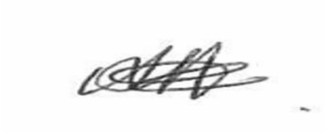

Sandie Andrews, Headteacher.

