**Job Profile comprising Job Description and Person Specification**

**Job Description**

|  |  |
| --- | --- |
| **Job Title:**  Admin and finance officer | **Grade**:  SO1 |
| **Section:**  Allocations & Provision | **Directorate:**  Housing and Regeneration |
| **Responsible to following manager:**  Admin and Finance Team Leader | **Responsible for following staff:**  None |
| **Post Number/s:** | **Last review date:**  May 2021 |

**Working for the Richmond/Wandsworth Shared Staffing Arrangement**

This role is employed under the Shared Staffing Arrangement between Richmond and Wandsworth Councils. The overall purpose of the Shared Staffing Arrangement is to provide the highest quality of service at the lowest attainable cost.

Staff are expected to deliver high quality and responsive services wherever they are based, as well as having the ability to adapt to sometimes differing processes and expectations.

The Shared Staffing Arrangement aims to be at the forefront of innovation in local government and the organisation will invest in the development of its staff and ensure the opportunities for progression that only a large organisation can provide.

**Job Purpose**

To provide a comprehensive finance and administrative for Housing Services across Wandsworth and Richmond Councils. Manage supplier accounts for temporary accommodation. Responsible for the administration of online housing applications, orders and invoices for the section.

**Specific Duties and Responsibilities**

1. Verify invoices received by Housing Services from accommodation providers and other suppliers of services. To resolve any discrepancies directly with external suppliers over incorrect charges or incomplete, inaccurate invoices, ensuring credit notes are received, where appropriate, before payment by line management.
2. Liaise directly with both temporary accommodation and property management teams regarding any discrepancies in invoices that cannot be resolved by accommodation provider.
3. Liaise with temporary accommodation providers to ensure that clients are signing in within procedures and matching the information to invoices prior to payments
4. Inputs all invoices into Council systems to ensure authorisation and payment within agreed timescales.
5. Responsible for all aspects of administration for payments to housing mobility scheme. Submitting requests to various council financial departments to check for outstanding debts and ensuring they respond within the agreed time scales. Communicating with clients to ensure all documents and bank details required from them are relevant and up to date, providing a breakdown of payments to the client and dealing with any queries arising from this.

1. Responsible for the prompt payment of Council Tax and Utilities bills for void periods in leased properties in the Capita Integra system. To interrogate NPS to establish correct billing period. To a request new bill from local authority or utilities provider if bill is for a period we are not liable for.
2. Responsible for all aspects of administration regarding the receipt and initial verification of Part VI Housing Application forms, submitted through on­line applications and paper applications for the Council’s referral queues.
3. Responsible for accurately indexing all documents received into the correct housing applications using the electronic W2 system and ensuring the correct team or officer are alerted.
4. Responsible for the logging and distribution of all electronic and physical post to the correct records in the W2 system.
5. Responsible for the ordering, amending and receiving of goods & services, including stationary, office equipment, training courses, furnishings for temporary accommodation and removals for the under-occupation scheme, via the councils Integra System. Including raising orders for goods and services to correct

allocation codes, amending quantities, prices and goods where necessary and liaising with suppliers.

1. Ensuring invoices are correct and receipted in Integra to ensure timely payment and dealing with any price or quantity mismatches as and when they arise.
2. Copy and process files and relevant documents within timescales as requested by the Directorate for Data Protection Act (DPA), statutory review or appeal and generally. Check for any third parties on file and remove documents not relevant to the case. Check data bases ensure details of requested file are correct. Liaise with the clients to ensure appropriate permissions have been sought prior to releasing information to third parties.
3. Make arrangement for payment by the Primary Care Trust for medical invoices requested.
4. To participate when necessary in duty rotas
5. Any other admin and finance duties as directed by the Housing Income Maximisation and admin manager.

**Generic Duties and Responsibilities**

* To contribute to the continuous improvement of the services of the Boroughs of Wandsworth and Richmond.
* To comply with relevant Codes of Practice, including the Code of Conduct and policies concerning data protection and health and safety.
* To adhere to security controls and requirements as mandated by the SSA’s policies, procedures and local risk assessments to maintain confidentiality, integrity, availability and legal compliance of information and systems
* To promote equality, diversity, and inclusion, maintaining an awareness of the equality and diversity protocol/policy and working to create and maintain a safe, supportive and welcoming environment where all people are treated with dignity and their identity and culture are valued and respected.
* To understand both Councils’ duties and responsibilities for safeguarding children, young people and adults as they apply to the role within the council.
* The Shared Staffing Arrangement will keep its structures under continual review and as a result the post holder should expect to carry out any other reasonable duties within the overall function, commensurate with the level of the post.

**Team structure**

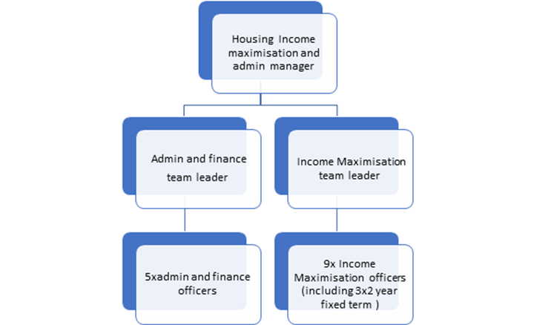

**Person Specification**

|  |  |
| --- | --- |
| **Job Title: Admin & Finance Officer** | **Grade**: SO1 |
| **Section: Allocations & Provision** | **Directorate:** Housing and Regeneration |
| **Responsible to: Admin and Finance Team Leader** | **Responsible for: None** |
| **Post Number/s:** | **Last Review Date:**  **May 2021** |

**Our Values and Behaviours**

The values and behaviours we seek from our staff draw on the high standards of the two boroughs, and we prize these qualities in particular:

**Being open.** This means we share our views openly, honestly and in a thoughtful way. We encourage new ideas and ways of doing things. We appreciate and listen to feedback from each other.

**Being supportive.** This means we drive the success of the organisation by making sure that our colleagues are successful. We encourage others and take account of the challenges they face. We help each other to do our jobs.

**Being positive.** Being positive and helpful means we keep our goals in mind and look for ways to achieve them. We listen constructively and help others see opportunities and the way forward. We have a ‘can do’ attitude and are continuously looking for ways to help each other improve.

|  |  |
| --- | --- |
| **Person specification Requirements** | **Assessed by A**  **&**  **I/ T/ C (see below for explanation)** |
| **Knowledge** |  |
| Demonstrate an understanding of good practice and principles of admin and invoicing |  |
| How to use financial IT systems to good practice |  |
| **Experience** |  |
| Experience of working within a team |  |
| Experience of working with different team and agencies in the context of this role |  |
| Able to apply experience of working in a busy, changing environment |  |
| Able to work under pressure |  |
| **Skills** |  |
| The ability to use information technology to a high standard. |  |
| The ability to undertake a wide range of financial and administrative tasks. |  |
| The ability to adapt to both varying tasks and those of a routine nature. |  |
| The ability to respond effectively to staff, outside agencies, suppliers and |  |
| the public, both in person, in writing and over the telephone. |  |
| Proven literacy, numeracy and communication skills. |  |
| excellent attention to detail |  |
| **Qualifications** | |
| Maths and English GCSE grade C and above or equivalent. |  |