**Job Profile comprising Job Description and Person Specification**

**Job Description**

|  |  |
| --- | --- |
| **Job Title:**  Community Engagement Project Officer (Wandsworth) | **Grade**:  S02 |
| **Section:**  Community and Partnerships | **Directorate:**  Chief Executive |
| **Responsible to following manager:**  Community Funding Manager (Wandsworth NCIL) | **Responsible for following staff:**  0 |
| **Post Number/s:**  1 | **Last review date:**  August 2025 |

**Working for the Richmond & Wandsworth Better Service Partnership**

We’re Richmond & Wandsworth Better Service Partnership, the shared public service team for Richmond and Wandsworth Councils. Like any local authority, our role is to deliver the agenda of our elected members on behalf of the people who live and work in our part of the world. We deliver key services to our communities including social care, public health, children’s services, housing and regeneration and environmental and community services.

Our joint workforce creates efficiency and resilience by bringing more creativity to the way we work, more objectivity and adaptability too, helping us deliver better services for all our residents.

We’re here to help our communities thrive in a changing world, and to be there for the people who need us most we believe we need to keep adapting. That’s why, at Richmond & Wandsworth Better Service Partnership, you’ll be at the forefront of innovation in local government, and we’ll invest in you and offer you opportunities to grow in a way only our unique organisation can.

**Job Purpose**

A crucial part of this role is about building meaningful relationships and trust with our communities – so this role is highly social, requires someone who is empathetic, can think strategically about community solutions, whilst also being outcomes focused, and results driven. We don’t want to simply identify things we can do to make things better; we want to bring all the right people together to make it a reality.

No one day is the same in Wandsworth’s Community and Partnerships team, and we view the diversity of our communities, and our work, to be a strength that delivers a high degree of job satisfaction; making this team one of the most exciting and rewarding teams in local government.

Managing, planning and delivering large-scale partnership events and facilitating events for senior managers and Lead Members to engage with strategic partners and the community.

**Main Purpose**

The prime responsibilities of the Community Engagement Officer as a key member of Stronger and Safer Communities, is to ensure that an adequate level of communication between the Council and residents is developed, maintained and the engagement of residents in participating in decision making for their area, is stimulated, and developed. This work will inevitably involve close links with senior officers in other Council departments, statutory agencies and the voluntary and community sector.

The Community Engagement Officer will take the leading role for the key areas of information, consultation, participation, and community development with all residents within the borough. Community Engagement Officers will receive guidance, co-ordination, and line management from the Community Funding Manager (Wandsworth NCIL).

**Specific Duties and Responsibilities**

* You will build relationships with residents, voluntary sector and community groups, and our wider partners across and within neighbourhoods to develop a thorough understanding of local aspirations, resources, and requirements
* Supporting and promoting the Leader’s Roadshow programme in communities, specifically underrepresented groups and to enable community representatives to engage with the council and elected members.
* You will use a strength-based community development model and deliver a new community solution and public engagement process. There will be a requirement to support this process locally and for ongoing engagement with neighbourhood and community groups to promote the programme and to engage locally to support co-production of local solutions and potential bids for NCIL and other funding sources. This will require fluid dialogue with local communities and organisations who may not have the capacity to deliver but may still have a viable project to develop.
* Place-based working: you will be responsible for a ‘patch’ of wards where you will be out and about on the ground (at least 60% of the time) as a present and active Member of the community.
* Community insight reporting: you will work will a wide range of community groups, councillors, council services, and key partners to produce quarterly reports - painting a picture of what is happening across each ward you cover.
* Area Forums, area action plans, and community events: you will seek to maximise community development and attendance, ensuring the events are meaningful, relevant, and inclusive. You will also be expected to support communities to run events of their own. You will ensure these events lead to outcomes by developing associated outcomes focused action plans.
* Community organising and funding: you will work with community groups to identify and then deliver on the local priorities, aspirations and needs. You will support groups to identify and access funding and/or Council and community assets to help turn their ideas into reality. You will work closely with Councillors, supporting them in their role as Community Leaders so they can champion local projects and programmes.

1. Community Engagement activities

a) Outreach work with communities to better understand how they work and what they need, part of this will be to connect them with the right partners to collaborate on potential projects including pulling together a funding proposal e.g. for NCIL.

b) Creating channels of engagement for communities, ensuring that resident views are reported back to the appropriate department or project group.

2. Provision of Information and Publicity

a) Assist in the provision of information and publicity co-ordination on all services provided by the Council and other agencies at the local level.

3. Other Duties

a) To map and support a programme of community led programmes & schemes in allocated patch.

b) To provide a wide range of opportunities for development and volunteering by the local community and organisations in Wandsworth.

c) Establishes and develops face to face relationships with members of the community within targeted areas in line with the programmes stated aims and objectives.

d) Support members of the community in articulating their views on issues which affect them, particularly to support people’s participation in local decision making.

e) To work closely with partners in statutory/non statutory services including the voluntary and community groups and other partners, developing relationships which further the achievement of the Wandsworth Council’s objectives.

Partnership Working:

* Collaborate with all partners for the mutual benefit of participants and programme performance.
* Liaise with external, strategic partners and stakeholders to ensure Wandsworth Council programme delivery adds value to existing provision across the borough. Integrate with wider team and share knowledge to benefit the holistic development of programmes.

**Generic Duties and Responsibilities**

* To contribute to the continuous improvement of the services of Richmond & Wandsworth Better Service Partnerships.
* To comply with relevant Codes of Practice, including the Code of Conduct and policies concerning data protection, handling complaints and health and safety.
* To adhere to security controls and requirements as mandated by Richmond and Wandsworth procedures and local risk assessments to maintain confidentiality, integrity, availability and legal compliance of information and systems
* To promote equality, diversity, and inclusion, maintaining an awareness of the equality and diversity protocol/policy and working to create and maintain a safe, supportive and welcoming environment where all people are treated with dignity and their identity and culture are valued and respected.
* You must cooperate in all matters relating to Health and Safety and implement all procedures for your job role. The identification of Health and Safety related risks within the working environment must be highlighted to your management.
* To operate in a pro-active and innovative manner, to generate solutions which support a diverse customer base into sustainable employment, maintaining a belief in the customers’ ability to be employed throughout.
* To understand, be aware of and assume the appropriate level of responsibility for safeguarding and promoting the welfare of children, young people and vulnerable adults and to report any concerns in accordance with the organisation’s safeguarding policies.
* These other duties must be equivalent to or below the salary and status of the role and, where appropriate, under the Equality Act 2010, due consideration must be given to any employees with a “protected characteristic” group.
* Ability to work outside normal office hours
* The profile is not intended to be an exhaustive list of the duties the post holder will carry out. Other reasonable duties commensurate with the level of the post, including supporting emergency and priority situations, will form part of the role.

**Team structure**

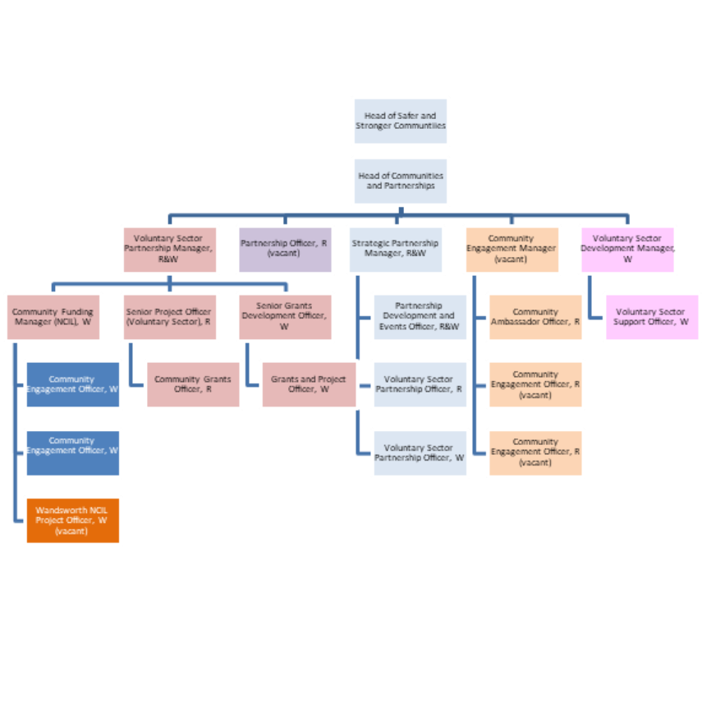

**Person Specification**

|  |  |
| --- | --- |
| **Job Title:**  Community Engagement Project Officer (Wandsworth) | **Grade**:  S02 |
| **Section:**  Community & Partnerships | **Directorate:**  Chief Executive |
| **Responsible to:**  Community Funding Manager (Wandsworth NCIL) | **Responsible for:**  0 |
| **Post Number/s:**  1 | **Last Review Date:**  August 2025 |

**Our Values**

**THINK BIGGER**

**EMBRACE DIFFERENCE**

**CONNECT BETTER**

**LEAD BY EXAMPLE**

**PUT PEOPLE FIRST**

Our Values are embedded across Richmond & Wandsworth Better Service Partnership and throughout all roles and responsibilities at all levels of the organisation. Please [familiarise yourself with our values](https://www.richmond.gov.uk/media/afdbdeao/five_values.pdf) as they are an integral part of our recruitment and selection process.

|  |  |  |  |  |
| --- | --- | --- | --- | --- |
| **Person Specification Requirements** | | | | **Assessed by**  **A/I/T/C**  **(see below for explanation)** |
| **Knowledge** | **Essential** | **Desirable** | **Assessed** |
| Knowledge of community organising and mobilising communities |  | X | **A/I/T** |
| Knowledge of Asset Based Community Development (ABCD) | X |  | **A/I/T** |
| **Experience** | **Essential** | **Desirable** | **Assessed** |
| Experience of working with underrepresented groups | X |  |  |
| Experience of producing community engagement plans | X |  |  |
| At least two years working in community engagement or similar | X |  | **A/I/T** |
| **Skills** | **Essential** | **Desirable** | **Assessed** |
| Ability to work on own initiative and in a team. | X |  | A/I/T |
| **Working with People**  a) Demonstrates an interest in and understanding of others  b) Adapts to team and builds team spirit  c) Recognises and rewards the contribution of others  d) Listens, consults others, and communicates proactively  e) Supports and cares for others  f) Develops and openly communicates self-insight, such as an awareness of own strengths and weaknesses | X |  | A/I/T |
| **Relating and Networking**  a) Establishes good relationships with customers and staff  b) Builds wide and effective networks of contacts inside and outside of the organisation  c) Relates well to people at all levels  d) Manages conflict  e) Uses humour appropriately to enhance relationships with others | X |  | A/I/T |
| **Presenting and Communicating Information**  a) Speaks clearly and fluently  b) Expresses opinions, information, and key points of an argument clearly  c) Makes presentations and undertakes public speaking with skill and confidence  d) Responds quickly to the needs of an audience and to their reactions and feedback | X |  | A/I/T |
| **Planning and Organising**  a) Set clearly defined objectives  b) Plans activities and projects well in advance and takes account of possible changing circumstances  c) Manages time effectively  d) Identifies and organises resources needed to accomplish tasks  e) Monitors performance against deadlines and milestones | X |  | A/I/T |
| **Adapting and responding to change**  a) Adapts to changing circumstances  b) Accepts new ideas and change initiatives c) Adapts interpersonal style to suit different people or situations  d) Shows respect and sensitivity towards cultural and religious differences  (e) Deals with ambiguity, making positive use of the opportunities it presents | X |  | A/I/T |
| Ability to build and maintain effective working relationships with the community and at all levels within the Council and external organisations. | X |  | A/I/T |
| Ability to occasionally work on evenings and weekends | X |  | A/I/T |
| Ability to travel around the Borough | X |  | A/I/T |
| **Qualifications** | **Essential** | **Desirable** | **Assessed** |
| Degree level or equivalent qualification through experience. |  | X | A/I/T/C |
| Asset Based Community Development |  | X | A/I/T |

**A – Application form / CV**

**I – Interview**

**T – Test**

**C - Certificate**