**Candidate**

**Information Pack- 2019/20**

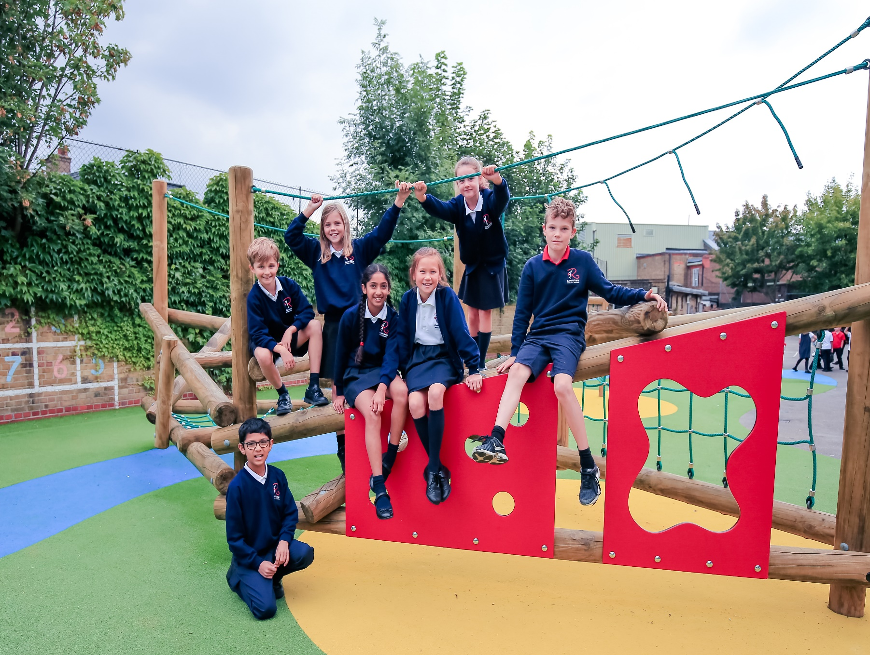**Teaching assistant – emotional and social Support**

RAVENSTONE PRIMARY SCHOOL

**Teaching assistant – Emotional and social support**

**Fixed term (2 years)**

**(Monday to Friday )- Start January 2020**



Welcome and thank you for considering Ravenstone. I hope that this application pack gives you everything you need to consider working with us.

Ravenstone is a fantastic school. Every child that steps through the gates is welcomed into an aspirational, creative community that focuses on allowing children to flourish as individuals and reach their potential academically.

As Headteacher, I passionately believe that we should allow our children to experience a wide range of creative enrichment opportunities and develop as confident, caring individuals who excel academically, and reach their full potential. It is this mixture that makes Ravenstone so special. We will not sacrifice any of these elements.

I believe that the success of a school is down to its teachers and I am proud to say that everything we focus on and do is to develop as professionals and deliver the best possible education for every child in our school. We constantly strive to improve and introduce initiatives that will inspire every pupil to achieve and become motivated individuals who can succeed in their futures.

The school building is one of the school’s biggest strengths. We have wonderful grounds with a purpose build site that allows our children to be active and engage with learning outside.

I am incredibly proud of our exceptionally talented staff that strive to get the very best out of every child. I want to continue to provide my team with the best possible career opportunities to thrive as teachers and future leaders.

Please do get in touch if I can help in any way possible.

Joe Croft

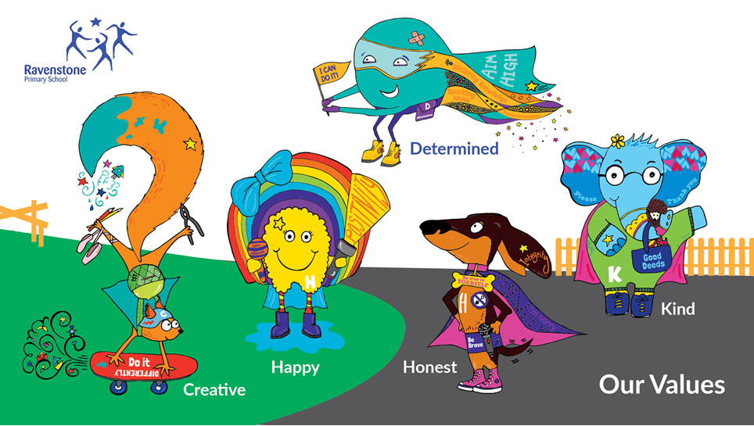





**About Ravenstone**

Ravenstone is a community primary school in Balham, funded by the London Borough of Wandsworth. The school has served the local community for the last 100 years. We are conveniently placed for public transport links – Balham main line train and tube station is 3 minutes away with easy access to all of London, Kent, Surrey and Sussex. We also have parking available onsite. The open space of Tooting Bec Common and the vibrant Balham centre are a few minutes from the school.

**School organisation**

380 children are currently on roll including full-time and part-time nursery children. These are arranged in 15 classes and the nursery. We are a two form entry school.

**Autistic hub**

The Hive is a brand new unit for children on the autism spectrum at Ravenstone School.  We opened in November 2017. We will eventually cater for 16 pupils, from reception to year 6, but in this beginning phase we have 7 pupils, across reception to year 2. Pupils in The Hive have opportunities throughout the day to access mainstream education, with support from the specialised ASD trained staff.

**Facilities:**

* 2 classrooms set up according to TEACCH principles
* a sensory room
* a soft play room
* an outdoor learning garden
* therapy/quiet room for more individualised learning
* high staff-pupil ratio

**What we provide:**

* A highly differentiated curriculum to ensure the needs of all pupils are met and that all pupils progress to their fullest potential.
* An individualised approach to encourage independence and life skills.
* Fun and exciting learning opportunities, which help to remove the emotional barriers and to ensure a positive, safe and respectful environment for every pupil.
* Specialised teaching approaches using ASD specific strategies such as TEACCH, SCERTS, Intensive Interaction, Makaton and PECS.
* Inclusion opportunities in the mainstream school in relevant year groups.
* A commitment to working with parents through regular communication and workshops.
* A multidisciplinary approach to learning to ensure speech, language and communication needs are met, as well as motor skill development.

**School focus**

We are committed to the continuous improvement of every aspect of school life for children at Ravenstone. We seek to deliver an outstanding educational experience of the highest quality for children of diverse backgrounds and abilities. Enthusiasm, enjoyment, creativity, imagination and high expectations of both pupils and staff are at the centre of a wide variety of learning activities.

Our school vision is ‘Children reaching their potential in the heart of the community’ and our core values are Happy, Kind, Creative, Honest, Determined. We promote this in everything we do and we strive to allow our children to be confident individuals are understand themselves and will grow into well rounded adults who add to the world we live in.

As a school we focus on developing the adult as much as the child. We believe if every member of staff is the best they can possible be while constantly looking at ways to improve then this will provide our children with an outstanding environment to learn within.

Our ultimate aim is to become outstanding and continue to become a centre of excellence within the local community and beyond.

**Community**

We are proud to serve and be supported by our community. We offer a vibrant and rewarding environment with a committed team of hardworking staff, supportive governors and enthusiastic parents. The children are happy and keen to learn. We pride ourselves on the friendliness, confidence and character of our children.

The partnership between school and home is very important to us. We value parental involvement and have a thriving parents’ and carers’ association, Friends of Ravenstone, which organises social events and raises funds for the school which are used to enhance the children’s educational experience. Recently funds have been used to develop our music provision, the redevelopment of parts of the playground, the purchase of IT equipment and contributions to school trips and school journey.

We welcome volunteers from both the parent body and the local community to help in the school with reading, gardening, chess and newspaper clubs.

Everyone is encouraged to make a positive contribution to the wider community; on a local level, the school council recently organised a collection for a nearby foodbank. Looking further afield, for the last 14 years, we have had a partnership with a school in Yameriga, Ghana and Ravenstone children have been very active in supporting projects there.

**Listening to pupils**

The children elect representatives from each class to participate in the school council and discuss topics that are meaningful to the children. We value hearing pupils’ views and opinions and present them with regular opportunities in lessons and assemblies to voice these. Such information can offer ideas on how to improve their learning experience.

We have an established peer mentoring and mediation scheme so that the trained mentors can support their peers in the playground.

**Curriculum enrichment/Ravenstone Entitlement**

The Ravenstone entitlement is an offer to every child in the school. This offer includes at least one external trip, one inspirational internal visit and a curriculum themed day every term. We believe that every child deserved to learn in an engaging and purposeful learning environment that inspires them to become curious and ambitious.

Ravenstone celebrates each child’s participation and achievement in a wide range of activities including languages, food, art, sport, music and dance. We want all pupils to experience London’s rich diversity and we organise school trips as well as visits to the school by outside speakers.

Sport is one of the cornerstones of the school’s identity. We are fortunate to have a full time dedicated sports teacher and part time dance teacher and Ravenstone regularly excels in inter-school competitions. We have represented Wandsworth in athletics and swimming at the London Youth Games. Though competition is encouraged, children understand that sport is primarily undertaken for enjoyment and can be accessed by all, regardless of ability or experience.

**Extra-curricular**

We run a number of clubs before and after school and during lunchtimes: for example, choir, gardening, chess and newspaper club. We also have several externally-run clubs.

**Working at Ravenstone**

* A focus on work life balance and managing workload
* A culture of learning together
* Additional planning/leadership release at the end of every half term and term.
* A good school on the journey to outstanding
* A school that allows for teachers to flourish and allocates a large percentage of their budget to staff development
* An exceptionally well-resourced learning environment
* An Outstanding leadership team who think differently
* Excellent professional development and career progression opportunities
* A collaborative and caring school community

which is culturally diverse and inclusive

* Wonderful pupils

**Wandle Teacher School Alliance**



Ravenstone works as part of the Wandle Teacher School Alliance. The Alliance consists of a wide range of schools from different phases and specialisms and institutions who work together in a variety of ways to identify and tackle key issues within schools. We have a dedicated and enthusiastic staff in all phases and sectors. This depth and breadth of experience offers trainee teachers a unique opportunity to explore the many complex and exciting areas of teaching and learning. Whatever stage you are in your career the Teaching School and its partners offer a comprehensive package to support both career and professional development right through to Headship and Masters qualifications.

**Maths Hub **

The London South West Maths Hub aims to support schools in seven boroughs (Wandsworth, Merton, Sutton, Kingston, Richmond, Hillingdon and Hammersmith & Fulham) through a range of national and local projects each year. The core purpose of the Hub is to engineer a school based support network to develop Mastery style teaching at all levels of education.

As a school Ravenstone has embraced the support offered by the maths hub and our lead teacher is a mastery specialist and works with a range of other local schools.

**JOB DESCRIPTION**

Position: Teaching assistant – Emotional and social support

Grade: Scale 2c, Point 2

Responsible to: Assistant Head (Inclusion Manager) and Headteacher

#### PURPOSE OF THE JOB

SUPPORT FOR THE PUPIL:

* Under the direction or instruction of the teacher or Line Manager, to work with and support children with additional needs to ensure they access the curriculum in a safe, caring and learning environment.
* To attend to the pupil’s personal needs, and implement related personal programs, including social, health, physical, hygiene, first aid and welfare matters including medical procedures (where necessary) following appropriate training.
* To supervise and support pupils to ensure their safety and access to learning.
* To establish good relationships with pupils, acting as a role model and being aware of and responding appropriately to individual needs of children.
* To promote the inclusion and acceptance of pupils.
* To encourage pupils to interact with others and engage in activities led by the teacher.
* To encourage pupils to act independently as appropriate.
* To collaborate with class teacher or Line Manager to plan and design materials to support the learning of children in lessons.
* To support and monitor the children’s behaviour during morning playtimes and lunchtimes.
* To engage in Social Skills group work with children, during playtimes and lunchtimes.
* Use specialist skills to meet the needs of children ie social stories etc.

#### SUPPORT FOR THE TEACHER:

* Support the delivery of learning activities for the children you are working with, individually, in small group or as a whole class, including the use of ICT.
* Be aware of children’s problems, progress and achievements and report to the teacher as agreed.
* Discuss with and report back to the teacher on the planning and assessment of children’s learning.

Undertake pupil record keeping as requested.

* Support the teacher in managing pupil behaviour, reporting difficulties as appropriate.
* Gather and report information from and to parents or carers as directed.
* Contribute to the management of appropriate learning environments and resources including displays.
* Work with colleagues to plan and modify materials/resources to support children.
* Be aware of and comply with policies and procedures relating to child protection, equal opportunities, health and safety, security, confidentiality and data protection, reporting concerns to the appropriate person.
* Work as a team ensuring the effective organisation of playtime and lunchtime.
* Contribute to the overall ethos /aims of the school.
* Participate in training, other learning activities and performance development as required.
* Attend and participate in relevant meetings as required.
* Familiarise and adhere to the school’s policies

#### SUPPORT FOR THE CURRICULUM:

* Support children to understand instructions.
* Support children in undertaking literacy and numeracy tasks as directed by the teacher.
* Support children in using basic ICT as directed.
* Prepare and maintain equipment and resources as directed by the teacher and assist children in their use.
* Organise and run interventions to allow children to reach their targets.

#### SUPPORT FOR THE SCHOOL:

* Be aware of and comply with policies and procedures relating to child protection, health and safety and security, confidentiality and data protection, reporting all concerns to an appropriate person.
* Be aware of and support difference and ensure all pupils have equal access to opportunities to learn and develop.
* Contribute to the overall ethos, work and aims of the school.
* Appreciate and support the role of other professionals.
* Attend relevant meetings as required.
* Participate in training and other learning activities and performance development as required.
* Assist with the supervision of pupils out of lesson times, including before and after school as applicable.
* Accompany teaching staff and pupils on visits, trips and out of school activities as required.

#### ADDITIONAL RESPONSIBILITIES:

* Consolidate and develop further the role of the Teaching Assistant , working in partnership with the Class Teacher.
* Implement the revised proforma for recording and evaluation of pupils.
* Ensure that there is regular feedback to the Class teacher relating to the support of children.
* Carry out a half-termly profile update on children you work with in line with the school record profile.
* Carry out duties consistent with assisting teachers in the classroom and this could include mounting, putting up displays and hearing readers etc.
* Under the supervision of the Head of Phase, take responsibility for the smooth running and organisation of the communal corridor/stairs and hall areas and ensure that the areas are kept tidy and well maintained.
* Be responsible for the putting up of creative displays in the communal corridor/stairs and hall areas as directed by the Class teacher.

*This job description describes in general terms the normal duties, which the post holder will be expected to undertake. However, the job description or the duties therein may vary or be amended from time to time without changing the level of responsibility associated with this post or the grade.*

|  |  |  |
| --- | --- | --- |
| **Job Specification** | **Essential** | **Desirable** |
| **Qualifications** | * GCSE English and Maths grade or international equivalent * Excellent numeracy and literacy skills * NVQ Level 1 or equivalent qualification or experience. * Have undertaken training relevant to working with children with complex needs and behaviours.   Candidates will need to have an enhanced DBS clearance. | Qualification related to working with children or young people and in particular children with SEN  E.L.S.A Trained  Higher Education Current First Aid certificate |
| **Skills** | * Work as a member of a team * Lead sessions for small groups of children (e.g. social skills activities) * Liaise and communicate effectively with others (both children and adults) * Supervise children and adhere to defined standards * Contribute to writing accurate reports of pupil progress as appropriate. * Contribute to assessment, observation, recording, planning and the IEP (SEN Profile). * Accept and respond to authority and supervision * Demonstrate good organisational skills * Has responsibility for promoting and safeguarding the welfare of children within the school * Ability to motivate children with challenging behaviour and/or emotional needs. * Use ICT to support learning. * Have an understanding of the schools equal opportunities policy and how it is implemented. | To be able to plan and deliver a modified and differentiated curriculum for individuals. |
| **Experience** | * Working with young children with challenging behaviour and/or emotional needs. * Delivering a modified and differentiated curriculum for individuals. * Good understanding of key SEN issues e.g. Code of Practice * To be responsible for promoting and safeguarding the welfare of children within the school |  |
| **Knowledge and Understanding** | * Good understanding of the social and communication needs of children with SEN * Knowledge and basic understanding of the National Curriculum * Ability to observe, monitor and provide construction feedback on pupil progress work constructively as part of a team, understanding classroom roles and responsibilities and your own position within these |  |
| **Personal Qualities** | * Good communication skills and interpersonal skills * Ability to work well within a team * Good organisation skills * Supports school policies and ethos * Willing to continue own professional development. * Good understanding of issues relating to disability and Inclusion.. |  |



t

**24. Ability to comply with Health & Safety regulations to ensure that al**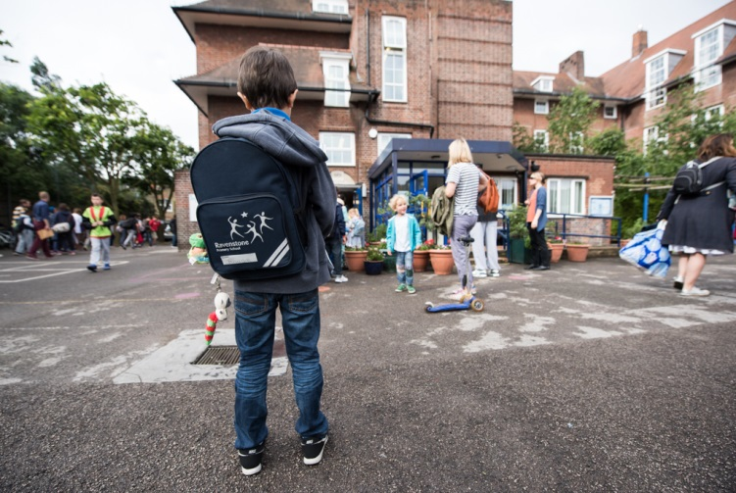

**Contact us;**

Telephone: 0208 673 0594020 7622 1619

Email:

[info@ravenstone.wandsworth.sch.uk](mailto:info@ravenstone.wandsworth.sch.uk)

RAVENSTONE PRIMARY SCHOOL

**Teaching assistant – emotional and social Support**

**(Fixed term – 2 years)**

**Experience of working with children who have emotional and social needs? An eye for development? Looking to work in a dynamic and very committed team who strive towards improvement and excellence?**

Job Purpose

To support a child with emotional and social needs to ensure they access the curriculum in a safe, caring and learning environment while reaching their potential academically, personally and socially.

We are looking for one Teaching assistant who has experience in working with children with emotional and social needs.

**Visits are welcome as you will be able to gain an overview of the school and the school community. Please phone 020 8673 0594 to arrange a mutually convenient time.**

To apply please download an application and details from this web page or from the Wandsworth Council website https://jobs.wandsworth.gov.uk/

Completed applications should be returned to the school by email on: [recruitment@ravenstone.wandsworth.sch.uk](mailto:recruitment@ravenstone.wandsworth.sch.uk)

**Closing Date: 16th December 2019 with interviews in early January**

We are committed to safeguarding and promoting the welfare of children, young people and vulnerable adults and expect all staff and volunteers to share this commitment. This post is subject to an enhanced DBS check. CVs are not accepted.