**Job Profile comprising Job Description and Person Specification**

**Job Description**

|  |  |
| --- | --- |
| **Job Title:**  Senior Public Health Lead (Health Improvement) | **Grade**:  MG1 |
| **Section:**  Public Health Division | **Directorate:**  Adult Social Care and Public Health |
| **Responsible to following manager:**  Consultant in Public Health – Adults and Older People | **Responsible for following staff:**  Public Health Leads |
| **Post Number/s:RWC0019** | **Last review date:**  April 2021 |

**Working for the Richmond/Wandsworth Shared Staffing Arrangement**

This role is employed under the Shared Staffing Arrangement between Richmond and Wandsworth Councils. The overall purpose of the Shared Staffing Arrangement is to provide the highest quality of service at the lowest attainable cost.

Staff are expected to deliver high quality and responsive services wherever they are based, as well as having the ability to adapt to sometimes differing processes and expectations.

The Shared Staffing Arrangement aims to be at the forefront of innovation in local government and the organisation will invest in the development of its staff and ensure the opportunities for progression that only a large organisation can provide.

**Job Purpose**

Senior Lead responsibility for Health Improvement, Prevention including lifestyle services and healthy behaviours. Strategic responsibility for the relevant Health Improvement and some Wider Determinants domain of the Public Health Outcomes Framework. This would be achieved by taking the lead in prevention and health improvement and using your specialist knowledge, experience and skills to lead and plan health improvement and prevention services and initiatives ensuring there are clear and robust plans that impact on the wider determinants, in order to improve the health of the local population in the London boroughs of Richmond and Wandsworth This role will contribute to the delivery of Richmond and Wandsworth’s corporate priorities and the delivery of the Public Health Division service plan.

**Specific Duties and Responsibilities**

*All duties have been mapped against the Public Health Skills and Knowledge Framework (PHSKF). Relevant descriptors are shown in brackets.*

**Leadership**

* Proactively lead the specialist public health improvement and prevention work to ensure effective working relationships, and to plan, organise, implement and evaluate Public Health programmes relating to promoting healthy lifestyles and behaviours, improving health outcomes and reducing ill health and health inequalities, including support for commissioning of services and pathways, in order to improve outcomes for residents. *(A1.5, A2.4, A2.5, B3.3)*
* Manage a team of public health leads according to relevant corporate policies, support talent management across the team and implement the council’s appraisal and performance related pay system. (PEi, PEii, PEiii)
* Lead on managing complex, multi-agency and multi-disciplinary partnerships including, neighbouring local authorities and regional and national bodies, (e.g. NHS England Public Health England and the Voluntary Sector),; to influence or lead on policy development and strategic planning creating opportunities to address local health needs, promote health and build approaches to prevention and address barriers to collaboration while managing risk. *(B1.4, B2.2, B2.4, C1.2, C1.5)*
* Take leadership responsibility for planning, organising, implementing and evaluating health improvement and prevention projects, programmes, strategies or policy. Specifying and delivering outcomes, within budget and through managing change accordingly to protect and improve the health and wellbeing of the local population. *(A2.4, A2.5, A5.4, B1.3, B1.5, C3.3)*
* Lead the development of evidence based long-term strategic plans and projects on behalf of the boroughs in relation to highly complex Public Health issues which impact on a range of community agencies and strategic partnerships, and work with partners to enable appropriate implementation by use of leadership skills. (A2.5, A4.3, B2.4, C1.5)
* Develop updates and communications for wider stakeholders and council members to ensure key stakeholders remain briefed and informed on key developments; applying the principles of social marketing, and/or behavioural science to reach specific groups. (C2.2, *C2.4)*
* Actively support the Director of Public Health and/or consultant to ensure effective contribution at senior council meetings; providing verbal and written reports to Divisional Management Teams, Core Public Health Team, Public Health Boards, to ensure that effective plans are in place to improve the public’s health. *(B1.5, B4.2, B4.5, C2.2)*
* Facilitate dialogue with and influence groups or communities using a range of evidence-based tools and technologies to improve behaviour change, health literacy and consult / listen to those likely to be affected by planned intervention or change. *(A2.1, A2.3, A2.6, A5.3, C2.3, C2.5)*
* Create complex written reports, including briefings to and deliver presentations to senior Council, CCG and partnership groups, conferences and seminars in order to influence major stakeholders. This includes communicating highly sensitive, complex or contentious Public Health issues to residents, Councillors, CCG and local stakeholders, in consultation with the Consultant in Public Health and operating within decision making political processes. *(B1.4, B4.2, B4.3, C2.2)*

**Management and Operational**

* Lead, design and facilitate the implementation and evaluation of any health improvement and prevention actions required to take forward new policies and plans within the legislative framework e.g. via designated projects within the organisation, including behaviour change*(A2.2, A2.5, A5.4, B1.4, B1.5, B4.5)*
* Quality assure and audit services, interventions, policies and plans to control risk and improve quality and effectiveness, making recommendations for change/improvement, manage uncertainty and problem solve; reporting these to Public Health DMT and other identified Council and partnership meetings/committees. *(A5.5, C1.5, C3.5)*
* Develop, establish and implement staff and public engagement and participation with regard to improving knowledge and raising awareness of health improvement issues, connecting communities to local resources and services. *(A5.3, B1.3, B2.5, B4.4, C1.4, C2.5)*
* Develop updates and communications for wider stakeholders including communities and council members to ensure key stakeholders remain briefed and informed on key developments; applying the principles of social marketing, and/or behavioural science to reach specific groups. (A2.6, C2.1, C2.2, *C2.4)*
* Set commissioning priorities according to need, evidence base and economic case for investment; developing specifications, performance indicators and outcomes; following end to end commissioning and contract monitoring where appropriate. *(B3.1, B3.2, B3.3, B3.4, B3.5, B3.6, C3.1)*
* Use specialist expert skills, knowledge and experience to collate, analyse, interpret and communicate highly complex epidemiological and statistical information from a variety of sources, including Government statistics and public consultations, and to make judgements about a range of possible solutions to highly complex Public Health problems. (A1.2, A1.5, C2.2)
* Identify, implement and evaluate Public Health interventions and models of service provision which the post holder decides are the most appropriate in terms of their evidence base and cost effectiveness, taking into account their ethical and political consequences, supporting others to understand these (A4.4, A5.2, B2.3, B4.1, B4.2, C3.4)
* Ensure that effective communication, including media (radio, press, etc) and social media, is developed by the staff/teams, in line with Borough requirements, liaising closely with the PH team communications representative and communications team. (B2.4, C2.1, C2.4)
* Commission, oversee or participate in Public Health research projects and audits as well as contribute to, respond to and advise on the development of patient and public surveys. (A4.3, A4.6, A5.5, C2.5)
* Lead on budget/finance management for specific topic areas. This will include conducting economic analysis of services and interventions against health impact and return on investment, identifying and securing funding sources and deploying resources towards clear strategic goals. (*A5.1, C4.1, C4.2, C4.3)*

**Generic Duties and Responsibilities**

* Assess the impact and benefits of health and other policies and strategies that contribute to improving the public’s health and addressing health inequalities; continuously improving the services of the Boroughs of Wandsworth and Richmond. *(B1.2)*
* To comply with relevant Codes of Practice, including the Code of Conduct and policies concerning data and health and safety *(A1.4, PEii, PEiii)*
* To adhere to security controls and requirements as mandated by the SSA’s policies, procedures and local risk assessments to maintain confidentiality, integrity, availability and legal compliance of information and systems. *(PEii)*
* To promote equality, diversity, and inclusion, maintaining an awareness of the equality and diversity protocol/policy and working to create and maintain a safe, supportive and welcoming environment where all people are treated with dignity and their identity and culture are valued and respected. *(PEii, PEiii)*
* To understand both Councils’ duties and responsibilities for safeguarding children, young people and vulnerable adults as they apply to the role within the council. *(PEiii)*

**Additional Information**

* The post holder is accountable to the Director of Public Health and will deputise for / represent the Director of Public Health and/or public health consultant as appropriate in matters related to Health Improvement, Prevention and Wider Determinants as requested.
* Post holder may be expected to work flexibly across two locations (Wandsworth Town Hall and Richmond Civic Centre). The post is currently based at home in accordance with national guidance.
* The Shared Staffing Arrangement will keep its structures under continual review and as a result the post holder should expect to carry out any other reasonable duties within the overall function, commensurate with the level of the post as *agreed with the Consultant in Public Health and/ Director of Public Health.*
* Act with integrity, consistency and purpose, and actively continue own personal development (C1.1)

**Team Structure**

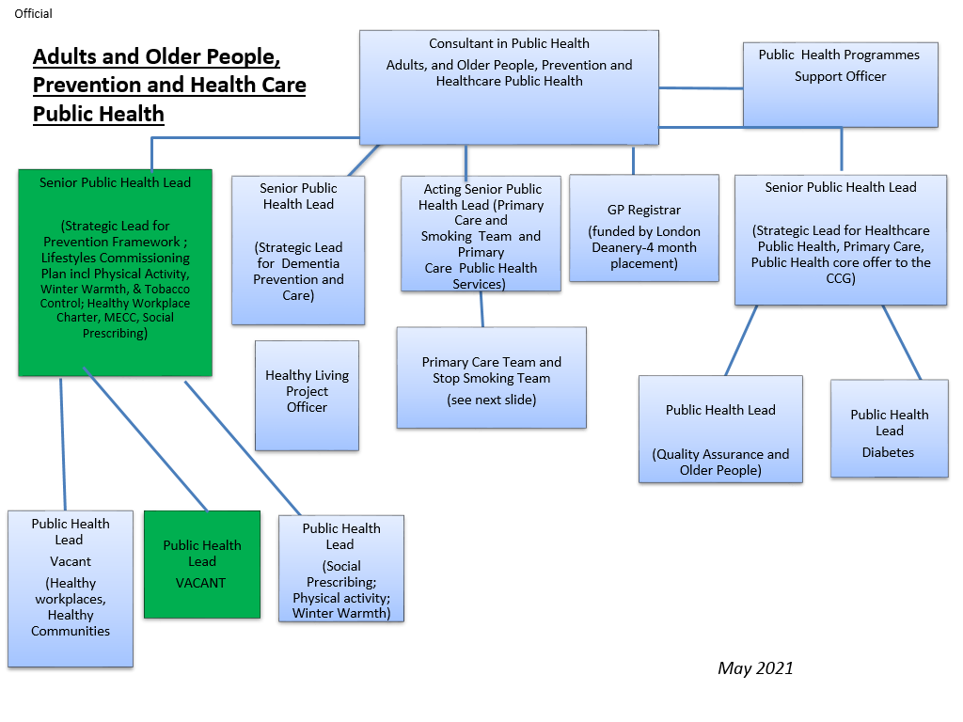

**Professional obligations**

The post holder will be expected to:

* Participate in the organisation’s staff appraisal scheme and departmental audit and ensure appraisal and development of any staff for which s/he is responsible.
* Contribute actively to the training programme for Foundation Year Doctors/ Specialty Registrars in Public Health as appropriate, and to the training of practitioners and primary care professionals within the locality.
* Pursue a programme of CPD, either voluntarily or as part of the requirement for registered UKPHR Practitioners.

**Person Specification**

|  |  |
| --- | --- |
| **Job Title:**  Senior Public Health Lead (Health Improvement) | **Grade**:  MG1 Salary |
| **Section:**  Public Health | **Directorate:**  Adult Social Care and Public Health |
| **Responsible to following manager:**  Consultant in Public Health – Adults and Older People | **Responsible for following staff:**  Public Health Leads |
| **Post Number/s: RWC0019** | **Last review date:**  April 2021 |

**Our Values and Behaviours**

* Being open means we share views openly, honestly and in a thoughtful way. We encourage new ideas and ways of doing things. We appreciate and listen to feedback from each other.
* Being supportive means, we drive the success of the organisation by making sure that our colleagues are successful. We encourage others and take account of the challenges they face. We help each other to do our jobs.
* Being positive and helpful means, we keep our goals in mind and look for ways to achieve them. We listen constructively and help others see opportunities and the way forward. We have a ‘can do’ attitude and are continuously looking for ways to help each other improve.

|  |  |
| --- | --- |
| **Person Specification Requirements** | **Assessed by A &**  **I/ T/ C (see below for explanation)** |
| **Knowledge** | |
| Highly developed specialist knowledge of Public Health principles and practices, PH evidence base, epidemiology, statistics, health economics and community development approaches. | A / I/T |
| Understanding of social and political environment, including national and local policy, strategies and guidance. | A/I |
| **Experience** | |
| Extensive experience as a senior Public Health / Health Promotion specialist, including experience at a management level. At least 3 years | A / I |
| Substantial experience in leading, developing, implementing and monitoring Public Health and related strategies. At least 5 years | A / I |
| Varied and broad experience of staff, budget, project and change management, and leading multi-agency partnerships. | A / I/T |
| **Skills** | |
| Be highly politically astute. | A/I |
| Excellent communication and interpersonal skills (oral, written, presentation, influencing and negotiation). | A / I / T |
| Ability to think strategically, creatively, analyse and communicate complex data, manage problems and develop solutions. | A / I / T |
| Able to develop, influence and implement local policies with a thorough understanding of local political challenges. | A / I/T |
| Ability to work autonomously, flexibly, within a changing environment, maintaining an overview, within tight and demanding deadlines. | A / I |
| Ability to lead and motivate, including team members. | A/I |
| Ability to lead without authority. | A/I |
| **Qualifications** | |
| A first degree or equivalent academic ability AND a Master’s degree in Public Health / Health Promotion or a relevant subject. | A/C |

**A – Application form**

**I – Interview**

**T – Test**

**C – Certificate**