**Job Profile comprising Job Description and Person Specification**

**Job Description**

|  |  |
| --- | --- |
| **Job Title:**  Regeneration Project Officer | **Grade**: PO 1-3 |
| **Section:**  Regeneration | **Directorate:**  Housing and Regeneration |
| **Responsible to following manager:** Regeneration Team Manager | **Responsible for following staff:** |
| **Post Number/s:** | **Last review date:** |

**Working for the Richmond/Wandsworth Shared Staffing Arrangement**

This role is employed under the Shared Staffing Arrangement between Richmond and Wandsworth Councils. The overall purpose of the Shared Staffing Arrangement is to provide the highest quality of service at the lowest attainable cost.

Staff are expected to deliver high quality and responsive services wherever they are based, as well as having the ability to adapt to sometimes differing processes and expectations.

The Shared Staffing Arrangement aims to be at the forefront of innovation in local government and the organisation will invest in the development of its staff and ensure the opportunities for progression that only a large organisation can provide.

**Job Purpose**

The regeneration project officer role is to assist in the delivery of the Council’s objectives for the regeneration programme. Specifically the post relates to the delivery of two large scale, complex, high value and high profile regeneration of two estates – Winstanley and York Road and Alton.

The post is part of a regeneration team working to the regeneration team manager for direction and to meet the priorities identified by the regeneration project managers for Winstanley/York Road and Alton.

Key roles are to undertake consultation and engagement with estate residents, neighbourhood residents and wider stakeholders, to assist with the successful and effective decant of estate residents in line with the phasing plan and to be responsible for the delivery of an individual regeneration theme objective and bespoke projects.

This is a career grade post and it is intended that the range of work should enable the post holder to develop a wider knowledge of the regeneration field and appropriate training will be provided, subject to budget restrictions, where appropriate.

**Specific Duties and Responsibilities**

1. As directed by the Regeneration Team Manager (RTM) to be responsible for the decant of residents from the regeneration areas. This includes the conducting of interviews to assess residents’ housing needs and requirements, the identification of appropriate early move alternative properties and the making of offers to residents, arranging and conducting appointments to view properties and agreeing and administrating compensation arrangements. Ensure proper records are kept of the transactions, payments and agreements. Ensure that Council policies on Health and Safety and Safeguarding are adhered to. It is anticipated that the majority of interviews with residents will take place in their homes. Also responsible as directed by the RTM for gathering and analysing other data in order to assist in understanding housing and other social needs across the regeneration areas.
2. As directed by the RTM to be responsible for preparing a decant strategy for the regeneration areas in agreement with the development partner.
3. Responsible for the design, development and implementation of an engagement strategy and engagement activity to maximise resident involvement in the physical and social regeneration of the area. This may take various forms such as organising community events liaising closely with other council departments or agencies such as Wandsworth CCG and Wandsworth Police or assisting residents, residents’ associations and other community groups in organising, running and publicising community events. Where appropriate undertake skills assessments of active local residents to identify appropriate training provision to meet any skills or knowledge gaps identified.
4. As directed by the RTM be responsible for delivery of a specific theme objective within the regeneration project. Themes may include socio-economic priorities such as promoting local employment, or promoting the development of arts and culture or may for example involve concentrating on developing the design code, addressing the needs of older people or evolving support mechanisms for troubled families. This will involve effective engagement with the development partner, engagement with local people and developing networks with relevant other agencies and stakeholders both within and outside the Council. The postholder will be expected to represent the regeneration and the Council at meetings and engagement events related to this theme.
5. To deputize as required for the RTM.
6. Responsible for organising and publicising public, Officer, Joint Venture Board, Regeneration Board, Housing Zone and contractor meetings as required for the regeneration projects. This includes organising venues and IT requirements, delivery of materials and assessment of health and safety requirements for public events. Attend and minute these meetings as required.
7. As directed by the RTM, be responsible for the support and development of key consultative bodies within the regeneration area. Key roles include but are not exclusively; organising regular meetings for tenure, area and interest specific groups, co-ordinating dates, preparing information and agendas for meetings, booking venues and publicising meetings. Key groups to be supported include, but not exclusively, Residents’ Association Groups, Project Steering Groups, Leaseholder and Tenant Groups.
8. Working with Central Communications staff lead on the production of publicity material for the project and maintain and update the project websites and social media platforms.
9. As directed by the RTM be responsible for the further development and publicizing of the Residents Offer.
10. As directed by the RTM, monitor the regeneration team budget and provide regular reports to the RTM. Provide details and projections of spend for the annual office management budget and assist in the preparation of the regeneration team’s annual budget plan.
11. Co-ordinate all requisitions for supplies on behalf of the Regeneration Project Manager, ensuring value for money and adherence to correct financial control procedures.
12. Responsible for a petty cash float of £500. Recommend and process petty cash requests for the Regeneration Team. Processes petty cash vouchers for decorations to vacant properties and ex-gratia payments, ensuring correct allocation codes are used. Maintain appropriate records.

**Generic Duties and Responsibilities**

* To contribute to the continuous improvement of the services of the Boroughs of Wandsworth and Richmond.
* To comply with relevant Codes of Practice, including the Code of Conduct and policies concerning data protection and health and safety.
* To adhere to security controls and requirements as mandated by the SSA’s policies, procedures and local risk assessments to maintain confidentiality, integrity, availability and legal compliance of information and systems
* To promote equality, diversity, and inclusion, maintaining an awareness of the equality and diversity protocol/policy and working to create and maintain a safe, supportive and welcoming environment where all people are treated with dignity and their identity and culture are valued and respected.
* To understand both Councils’ duties and responsibilities for safeguarding children, young people and adults as they apply to the role within the council.
* The Shared Staffing Arrangement will keep its structures under continual review and as a result the post holder should expect to carry out any other reasonable duties within the overall function, commensurate with the level of the post.

**Additional Information**

* The postholder will be expected as directed to work in both regeneration areas
* Regular attendance at evening and weekend meetings and events.

**Progression to P02**

* Works independently on managing and coordinating community event and engagement programmes, whether directing other Regeneration team members or wider department officers to achieve planned outcomes.
* Attends Public and other important meetings as the representative of the Team.
* Carries out research and prepares reports on own initiative, to advance the regeneration objectives whether decant or aspirational.
* Consults with the Regeneration Team Manager on non-routine staff and financial management responsibilities.

**Progression to PO3**

* Covers for the Regeneration Team Manager in his/her absence within own area of responsibility.
* On behalf of the Regeneration Team or Project Manager takes a role in supervision of Consultants and contract staff on projects and supervises less experienced Project Officers within the Team, including project assistants and apprentices/graduates as necessary.
* Liaises with client and Senior representatives from outside organisations and agencies.
* Contributes and drafts reports/documents with important/high profile target audience, such as committee reports, business updates, Councillor response/speeches as required.
* Consults with the Regeneration Team Manager on the more high-level staff and financial management responsibilities.
* Deals with legal administration and attends Court or Public Inquiries to give evidence, referring to the Project and Regeneration Manager/s as appropriate.
* Leads and coordinates legal action, (tenancy and leasehold) in response to refurbishment project works as required as part of supervision of the Special estates officer role.
* Monitors and co-ordinates income and costs on commissions in the Section to provide management information to the Head of Service

**Current team structure**

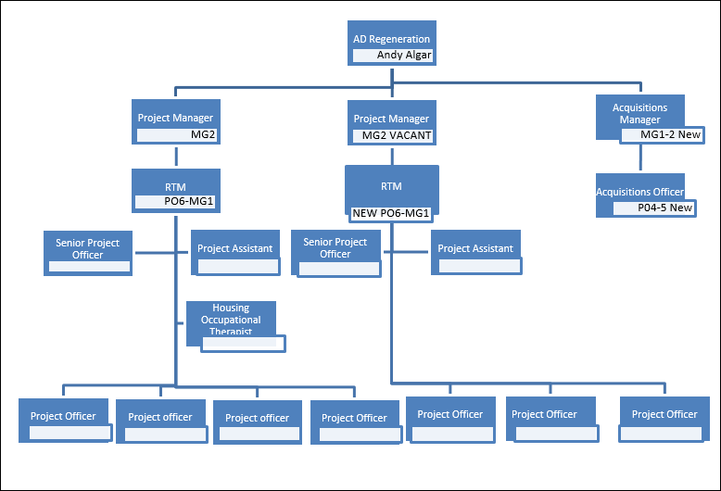

**Person Specification**

|  |  |
| --- | --- |
| **Job Title:** Regeneration Project Officer | **Grade**: PO 1-3 |
| **Section:** | **Directorate:** |
| **Responsible to:** Regeneration Team Manager | **Responsible for:** |
| **Post Number/s:** | **Last Review Date:** |

**Our Values and Behaviours[1]**

The values and behaviours we seek from our staff draw on the high standards of the two boroughs, and we prize these qualities in particular –

* taking responsibility and being accountable for achieving the best possible outcomes – a ‘can do’ attitude to work
* continuously seeking better value for money and improved outcomes at lower cost
* focussing on residents and service users, and ensuring they receive the highest standards of service provision
* taking a team approach that values collaboration and partnership working.

|  |  |
| --- | --- |
| **Person Specification Requirements** | **Assessed by**  **A**  **&**  **I/ T/ C (see below for explanation)** |
| **Knowledge** | |
| Knowledge and understanding of the issues that arise when undertaking estate regeneration projects and in particular of the impact of those issues on local residents | A, I |
| Knowledge of the different methods of engaging with local residents and of the related equalities issues | A, I |
| Knowledge of public sector processes and protocols, preferably in the housing field | A, I |
| Understanding and working knowledge of the direct issues which apply in the management and operation of affordable housing | A, I |
| Understanding of and sensitivity to providing services in an economically deprived and ethnically diverse community. | A, I |
| Knowledge and interest in the principles of urban renewal | A, I |
| Knowledge of computer packages including Word, Outlook and Excel with the potential to develop an understanding of and skills to use bespoke IT packages relevant to the regeneration projects. | A, I, t |
| **Experience** | |
| Experience of working with the public in a front facing service where customer skills are required. |  |
| Experience of organising events and public meetings to engage local people in local social and housing issues and of the requirements for a safe and successful event and issues which may arise. | A, I, T |
| Experience of working with personal confidential information | A, I |
| Experience of budget monitoring and management | A, I |
| Experience of working in a changing environment, to a number of different priorities. | A, I |
| **Skills** | |
| Excellent communication skills and able to communicate clearly and effectively with the public, other stakeholders and senior council staff. | A, I |
| Ability to cope with robust and challenging situations and conversations | A, I |
| Able to organise and prioritise own workload, to work under pressure and meet deadlines | A, I |
| Numeracy and administrative skills and ability to compile and record accurate and relevant information | A, I, T |
| **Qualifications** | |
|  | C |

**A – Application form**

**I – Interview**

**T – Test**

**C - Certificate**

1. These values and behaviours will be developed further as the SSA becomes established.