Job Profile

Provisional Job Title:  Supported Travel Team Leader - Parking | Grade: PO2
Section:  Parking Service | Department:  Resources
Responsible to:  Permits and Supported Travel Manager - Parking | Responsible for:  7 x FTE

Working for the Richmond/ Wandsworth Shared Service

This role is employed under the Shared Service Arrangement between Richmond and Wandsworth Borough Councils. The overall purpose of the Shared Service Arrangement is to provide the highest quality of service at the lowest attainable cost.

Staff are expected to deliver high quality and responsive services wherever they are based, as well as having the ability to adapt to sometimes differing processes and expectations.

The Shared Service Arrangement aims to be at the forefront of forging change in local government and the organisation will invest in your development and ensure the opportunities for progression that only a large organisation can provide.

Job Purpose:

To provide assistance to the Permits and Supported Travel Manager in the day to day management of the Supported Travel Team ensuring that applications in the form of Blue Badges, Disabled Freedom Passes & Taxi cards are processed effectively and in accordance with London Councils and DfT Guidance.
Specific Duties and Responsibilities:

Responsible for the administration of;

- the supported travel service for both Councils ensuring the schemes for Blue Badges, Freedom Passes, Taxi Cards and Shopping Bus operate effectively

- managing applications for supported travel within locally set timescales

- Ensuring supported travel services are accessible for all qualifying residents

- Assist with the management of the Occupational Therapists workloads at both locations

- Facilitate the introduction of changes to the supported travel schemes either through local decisions or enforced decisions by governing bodies

- Assist the Permits and Supported Travel Manager with the allocation of resources, incorporating planning and productivity

To ensure that the services for both Councils are dealt with on an equitable basis to deliver the standards required for each, as agreed annually by the Executives of both Councils.

To provide operational and motivational leadership of staff, providing a visible presence to the workforce and promoting a good working environment with the primary aim of delivering high quality services

To provide operational line management to staff including a visible presence to employees, promoting a good working environment with the primary aim of delivering a high quality service
To ensure all Member queries about service delivery are dealt with promptly and effectively

To advise and support managers on relevant matters affecting the service

To assist as required with performance review and improvement measures on an ongoing basis, helping to ensure that a customer focus is embedded within the function and innovative and creative solutions are evaluated to securing the highest quality and value for money function

To contribute as required to change programmes within the service

Generic Duties and Responsibilities

To contribute to the continuous improvement of the Borough’s of Wandsworth and Richmond services.

To comply with relevant Codes of Practice, including the Code of Conduct, and policies concerning data protection and health and safety.

To promote equality, diversity, and inclusion, maintaining an awareness of the equality and diversity protocol/policy and work to create and maintain a safe, supportive and welcoming environment where all people are treated with dignity and their identity and culture are valued and respected.

To understand the both Council’s duties and responsibilities for safeguarding children, young people and adults as they apply to your role within the council.

The Shared Staffing Arrangement will keep its structures under continual review and as a result the post holder should expect to carry out any other reasonable duties within the overall function, commensurate with the level of the post.
Additional Information
Assists the Permits and Supported Travel Manager in managing the staffing resources and administration for;

- all supported travel functions totalling approx. 40,000 (live applications)

Manages 7 X Supported Travel staff within the Council’s Codes of Practice incorporating:
1 x OT PO*
6 X SC* -***

May be required to deputise for Permits and Supported Travel Manager and attend high level meetings internally and externally.

Current team structure

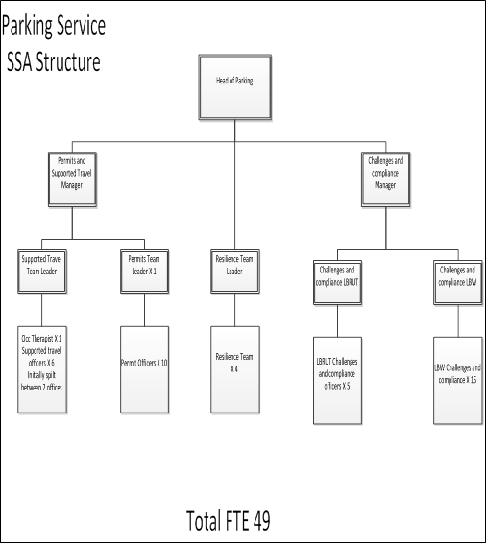

Provisional Job Title: | Grade: PO2
Section: Revenues | Directorate: Resources
Responsible to: | Responsible for:
Post Number/s: | Date:

Our Values and Behaviours
The values and behaviours we seek from our staff draw on the high standards of the two boroughs, and we prize these qualities in particular:
Being open. This means we share our views openly, honestly and in a thoughtful way. We encourage new ideas and ways of doing things. We appreciate and listen to feedback from each other.
Being supportive. This means we drive the success of the organisation by making sure that our colleagues are successful. We encourage others and take account of the challenges they face. We help each other to do our jobs.
Being positive. Being positive and helpful means we keep our goals in mind and look for ways to achieve them. We listen constructively and help others see opportunities and the way forward. We have a ‘can do’ attitude and are continuously looking for ways to help each other improve.

Requirements | Assessed by  A & I/ T/ C
Knowledge
An understanding of all Supported Travel Schemes | AI
Knowledge of available process enhancements and digital/alternative delivery methods | AI
Knowledge of Department for Transport Regulations and London Councils role | AI
Experience
Experience of managing staff with positive outcomes | AI
Evidence of successfully managing change | AI
Experience of working to deadlines | AI
Experience of appropriately allocating staff resources | AI
Skills
Significant experience of using standard IT packages and ability to support others in their day-to-day use | AIT
Good oral and written skills to provide clear and concise information via correspondence or presentation | AI
The ability to introduce new working practices accordingly | AI
The ability to both motivate and support a team | AI
The ability to show a high level of attention to detail to maintain expected Quality controls | AI
Qualifications
Accredited learning qualification or equivalent experience. | C

These values and behaviours will be developed further as the SSA becomes established.

