**Job Profile comprising Job Description and Person Specification**

**Job Description**

|  |  |
| --- | --- |
| **Job Title:**  Allocations and Mobility Officer | **Grade**: PO1  Full time (36hrs) |
| **Section:**  Allocations and Provision – Housing Services | **Directorate:**  Housing and Regeneration |
| **Responsible to following manager:**  Allocation Manager/Deputy | **Responsible for following staff:** |
| **Post Number/s:** | **Last review date:**  April 2016 |

**Working for the Richmond/Wandsworth Shared Staffing Arrangement**

This role is employed under the Shared Staffing Arrangement between Richmond and Wandsworth Councils. The overall purpose of the Shared Staffing Arrangement is to provide the highest quality of service at the lowest attainable cost.

Staff are expected to deliver high quality and responsive services wherever they are based, as well as having the ability to adapt to sometimes differing processes and expectations.

The Shared Staffing Arrangement aims to be at the forefront of innovation in local government and the organisation will invest in the development of its staff and ensure the opportunities for progression that only a large organisation can provide.

**Job Purpose**

Responsible for allocating offers of all accommodation under Part VI of the Housing Act 1996. To manage and promote mobility schemes, as well creating resources for housing opportunities.

**Specific Duties and Responsibilities**

1. Responsible for the allocation and letting of various type of accommodation available to the Councils under their sovereign housing duties, powers and functions within the frameworks of the Housing Allocations Scheme, Homeless Code of Guidance and the approved allocations plan.
2. Responsible for identifying any voids and pre-voids and ensuring the matching process is applied promptly and within prescribed timescales, minimising void periods and complying with service standards and performance target.
3. Responsible for the maintenance of administrative functions in relation to settled offers. Liaising with relevant bodies re status of offers, tenancy commencement dates and for determining the suitability of offer made both at the time of offer and where the household receiving the offers wishes to refuse.
4. To ensure that all applicants are interviewed prior to refusing any offer of accommodation in order to determine refusal reason and to advise of implications of the decision being taken. Responsible for maintaining and analysing information of refusal reasons, identifying and implementing service improvements where possible.
5. To determine the suitability of accommodation being offered and whether or not refusal of an offer end a duty or leads to exclusion for such period set out in the Housing Allocations scheme.
6. Liaises with RSLs and Private Sector Landlords regarding the vacancies and nominations of priority applicants and ensuring that applicants are selected within the framework of allocations scheme and statutory guideline the targets within the approved allocations plan. To ensure that appropriate support and risk assessments relating to the applicant are passed to RSLs.
7. To create and increase mobility opportunities for social housing tenants with the aim of increasing significant resources and making the best use of each Councils’ stock. Identify creative and innovative opportunities to increase housing mobility and to improve processes and system to implement such moves
8. To identify, create and facilitate under-occupation moves within targets in order to release family sized social housing and to ensure the best use of Council stock
9. Responsible for the promotion and administration for national sub regional and local housing options mobility schemes to create rehousing opportunities. To
10. ensure maximum take up of schemes and to administer exchange requests and also create exchanges through the matching of applicants.
11. To manage and assist in decant moves resulting from any major works and regeneration schemes

**Generic Duties and Responsibilities**

* To contribute to the continuous improvement of the services of the Boroughs of Wandsworth and Richmond.
* To comply with relevant Codes of Practice, including the Code of Conduct and policies concerning data protection and health and safety.
* To adhere to security controls and requirements as mandated by the SSA’s policies, procedures and local risk assessments to maintain confidentiality, integrity, availability and legal compliance of information and systems
* To promote equality, diversity, and inclusion, maintaining an awareness of the equality and diversity protocol/policy and working to create and maintain a safe, supportive and welcoming environment where all people are treated with dignity and their identity and culture are valued and respected.
* To understand both Councils’ duties and responsibilities for safeguarding children, young people and adults as they apply to the role within the council.
* The Shared Staffing Arrangement will keep its structures under continual review and as a result the post holder should expect to carry out any other reasonable duties within the overall function, commensurate with the level of the post.

**Additional Information**

* Be prepared to work outside of usual working hours to cover emergencies
* Attend evening meetings
* To be part of duty team where necessary
* To arrange and set up mobility events
* Must have use of motorised transport and be able to carry out visits and/or be able to carry out visits using public transport
* As and when required in response to staff shortages and service needs to undertake the duties of an officer in the property management team and or temporary accommodation team.

**Team structure**

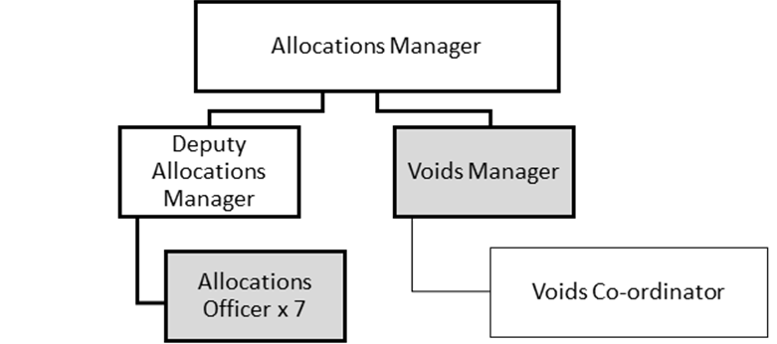

**Person Specification**

|  |  |
| --- | --- |
| **Job Title:**  Allocations and Mobility Officer | **Grade**: PO1  Full time (36hrs) |
| **Section:**  Allocations and Provision – Housing Services | **Directorate:**  Housing and Regeneration |
| **Responsible to:**  Allocations Manager/Deputy | **Responsible for:** |
| **Post Number/s:** | **Last Review Date:**  April 2016 |

**Our Values and Behaviours**

The values and behaviours we seek from our staff draw on the high standards of the two boroughs, and we prize these qualities in particular:

**Being open.** This means we share our views openly, honestly and in a thoughtful way. We encourage new ideas and ways of doing things. We appreciate and listen to feedback from each other.

**Being supportive.** This means we drive the success of the organisation by making sure that our colleagues are successful. We encourage others and take account of the challenges they face. We help each other to do our jobs.

**Being positive.** Being positive and helpful means, we keep our goals in mind and look for ways to achieve them. We listen constructively and help others see opportunities and the way forward. We have a ‘can do’ attitude and are continuously looking for ways to help each other improve.

|  |  |
| --- | --- |
| **Person Specification Requirements** | **Assessed by**  **A**  **&**  **I/ T/ C (see below for explanation)** |
| **Knowledge** | |
| Housing and homeless legislation relating to part 7 and part 6 offers | A/I |
| Welfare reform | A/I |
| Homeless and Allocation Codes of Guidance | A/I |
| **Experience** | |
| Working a team in delivering a high performing front line service | A/I |
| Ability to apply working knowledge of Allocation Scheme | A/I/T |
| Working with RSLs | A/I |
| Applying Good practice around decanting and moving under-occupiers | A/I |
| Managing incentive schemes | A/I |
| **Skills** | |
| Excellent communication skills both orally and in writing. | A/I/T |
| Ability to deal with a range of applicants within Equality Act | A/I/T |
| Ability to create innovative solutions in relation to mobility and reducing the relet time | A/I/T |
| Ability to create and analyse performance and budgetary, as well as other management information to ensure best value in the delivery of the service | A/I |
| Ability to adapt quickly when priorities and targets change | A/I |
| **Qualifications** | |
| Maths and English GCSE grade C and above or equivalent | A/I |

**A – Application form / CV**

**I – Interview**

**T – Test**

**C - Certificate**