



**Our Lady Queen of Heaven RC School**

***Journeying together with Christ***



**HEADTEACHER**

**Candidate Information**

**Letter from Chair of Governors**

Dear Applicant

Thank you very much for your interest in the role of Headteacher at Our Lady Queen of Heaven RC School. You can learn much about OLQH on our [website](http://www.ourladyqueenofheaven.wandsworth.sch.uk/) , where you can see the range and breadth of our curriculum, and read the most recent [OFSTED](https://files.api.ofsted.gov.uk/v1/file/2074783) report (2012) and the Section 48 Inspection Report (2018).

Whilst we are very proud of these formal assessments, most important for us is the progress of each child from their own starting point. This is above all a happy school with a strong commitment to inclusion, living out our mission as given to us by the Church. We are extremely fortunate in our talented and dedicated staff, and we enjoy close and friendly relationships in the local community, not least with other primary schools.

Our children, staff, parents and governors are looking for an inspirational leader to maintain the high standards built up over several decades and take the school forward.

Please do come and visit the school to help prepare your application, you will be assured of a warm welcome. To arrange a visit please contact the school office on 020 8788 7420 or email [aduncan@ourladyqueenofheaven.wandsworth.sch.uk](mailto:aduncan@ourladyqueenofheaven.wandsworth.sch.uk)

Yours faithfully

Geraldine Isherwood

Chair of Governors

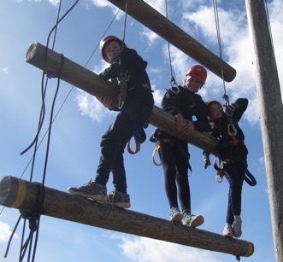

**About Our School**

**School Mission Statement**

**Our school provides a warm welcome to everyone.**

**We treat others with respect and recognise each other’s talents.**

**Everyone in our school matters and is encouraged to do their best.**

**In our school we never stop learning and we know there is always room for improvement.**

**We try to live our lives like Jesus.**

(School Council, October 2017)

Prayer, worship, Liturgy and the Gospel message are central to our daily lives. The value and importance of our Catholic faith is reflected in our attitudes, relationships and charitable responses.

Every person within our school community matters and has the opportunity to achieve their full potential and exceed their expectations. We aim to deliver a broad and rich curriculum, appropriate and accessible to all pupils.



We encourage respect for self and others by promoting positive attitudes and relationships within our school community. As individuals we recognize each other’s gifts, needs and contributions. As a school we aim to develop a trusting and supportive environment in which everyone feels valued and appreciated.

By working closely with the home and parish we seek to prepare our pupils for their lives in the wider community. We help them develop as responsible and caring citizens, who are able to take ownership of their choices and actions in society as lifelong learners.

In a caring and sharing environment we offer friendship and welcome to all.

We seek to journey together with Christ as his disciples, learning from him how to live well.

**THEMES**

What have you done today to make you feel proud?

Be the best we can be. To be more, not to have more.

At Our Lady Queen of Heaven we are committed to equality for all our pupils and employees. We welcome our duty under the Equality Act 2010 to eliminate discrimination, to advance equality of opportunity and foster good relations. We believe that everybody has a right to be treated equally and well. Children have the right to work, play and learn in a positive, supportive environment. As a UNICEF Rights Respecting School (SILVER AWARD), we are proud to promote the United Nations Convention on the Rights of the Child, which the UK Government has signed, and ensure that the whole school community learns about their rights and shows respect for each other.

It is our mission to affirm each other's worth and dignity within an atmosphere where Gospel values are lived out. We aim to support our children as they learn about their rights and responsibilities within the school and wider community, encouraging them to develop as reflective, caring and considerate members of society.

*“The community feel of the school which is fantastic considering how many nationalities are represented at the school.” (Parent)*

**Headteacher Job Description**



JOB PURPOSE**:** To lead and manage the school in consultation with the Governing Body, in order to provide a Catholic Christian educational community in which all are enabled to achieve their highest potential.

RESPONSIBLE TO: The headteacher is an employee of the Governing Body and is required to carry out professional duties as detailed in this job description, and in Canon Law, the Trust Deed and Instrument of Government for the school (Articles of Association and Memorandum of Understanding for academies) and, where applicable those set out in the current School Teachers Pay and Conditions Document.

STRATEGIC DIRECTION AND DEVELOPMENT OF SCHOOL

The strategic direction and development of the school stems from the educational mission of the Church which is reflected in the school’s mission statement, the school’s development/improvement plan and all policies and procedures.

Main Tasks:

* To ensure the vision for the school is clearly articulated, shared, understood and acted upon effectively by all
* To work with the Diocese, parishes and others to create a shared culture and positive climate that reflects the Mission of the Church in education
* To work with the Governing Body in forming educational aims and objectives, targets, outcomes and policies for their implementation
* To develop the schools development/improvement plan to promote and sustain ongoing improvement
* To work with and motivate others to ensure creativity, innovation and quality, including in the use of appropriate new technology, to achieve excellence and nurture human wholeness
* To ensure that strategic planning is based on the Governing Body’s policies and takes account of the diversity, values and experiences of the school and wider community and the mission of the Church in education

LEADING LEARNING AND TEACHING

In a Catholic school the search for excellence is expressed in learning and teaching which responds to the needs and aspirations of all its pupils and acknowledges their individual worth as children of God.

Main tasks:

* In consultation with the Governing Body to develop curriculum policies and practices that meet statutory requirements, are relevant to the aptitude and stages of development of all pupils, including those with special needs, and provide for the spiritual, moral, cultural, social and emotional development of all pupils
* To determine and implement a diverse and flexible curriculum and implement an effective assessment framework
* To develop systems of evaluating individual pupil progress to improve learning and teaching, motivate pupils, inform parents and challenge staff, including the use of new technology to enhance and extend the learning experience of pupils and staff
* To ensure the Diocesan policies on religious education, sex and relationship education and worship are implemented
* To monitor, evaluate and review teaching practices and promote improvement strategies
* To identify excellent practice in teaching and disseminate to develop practice across the school
* To challenge underperformance at all levels and ensure effective remedial action.
* To implement strategies to secure high standards of behaviour and attendance
* To develop an extended school programme providing high quality opportunities for pupils and staff to pursue learning outside of the classroom setting

LEADING AND MANAGING STAFF

In a Catholic school the role of the headteacher is one of leadership of a learning community rooted in faith. Christ is the inspiration for the headteacher’s leadership. The headteacher’s management of staff should demonstrate an awareness of their unique contribution as individuals, valued and loved by God.

Main tasks:

* To assist the Governing Body in determining the staffing structure for the school
* To develop and maintain effective strategies for recruitment, induction, professional development and appraisal of staff having regard to Diocesan guidance and advice
* To treat all staff fairly, equitably and with dignity and acknowledge their contributions by acknowledging and praising success
* To ensure effective planning, allocation, support and evaluation of work undertaken by teams and individuals, ensuring clear delegation of tasks and responsibilities
* To develop and maintain a realistic culture of high expectation for self and others and take appropriate action where necessary
* To review own practice regularly, set targets and take responsibility for own development
* To have regard to the work/ life balance of individual members of staff

MANAGING THE ORGANISATION

In the Catholic school the deployment of staff, finance, material resources, and time should be done to promote the common good in achieving the outcomes identified in the development/improvement plan.

Main tasks:

* To implement policies and procedures of the Governing Body to create an organisational structure, which reflects the school’s Catholic Christian values and enables the management systems, structures and processes to work effectively in compliance with statutory requirements.
* To take responsibility and account for the financial and material resources which are delegated to the headteacher
* To manage the school’s financial, and human resources effectively and efficiently to achieve
* the school’s educational goals and priorities
* To manage and organise the school environment efficiently and effectively to ensure that it meets the needs of the curriculum, health and safety regulations and reflects the distinctive nature of the Catholic school
* To ensure stewardship of the buildings and grounds in relation to Diocesan requirements
* To provide a safe and secure environment for all who work in and visit the school
* To ensure the use of all resources is monitored, evaluated and reviewed to improve the quality of education for all pupils and to secure value for money
* To use new technology to improve the effective use of resources

SECURING ACCOUNTABILITY

In the Catholic school the headteacher fulfils her/his responsibilities in accordance with its Instrument of Government (Articles of Association and Memorandum of understanding for academies). The headteacher supports the Governing Body in fulfilling its responsibilities under Canon Law to the Diocese and in accordance with English law.

Main tasks:

* To fulfil contractual commitments in relation to the governing body including attendance at Governing Body meetings, reporting to the Governing Body as required and assisting it in its work as needed
* To develop and maintain positive relationships with parishes, the wider Catholic Community, other Catholic schools and other schools in the area
* To recognise the authority of the Archbishop in relation to the provision of Catholic education in the Diocese and to work with Diocesan authorities to provide them with such information as they require
* To develop a Catholic ethos enabling all to work collaboratively, share knowledge and understanding, celebrate success and share responsibility for outcomes
* To ensure individual staff responsibilities are defined clearly, understood and agreed and are subject to review and evaluation
* To develop and present a coherent, understandable and accurate account of the school’s performance to a range of audiences including parents, governors, the Diocese and the local authority
* To provide opportunities for parents to have dialogue and meetings with staff in the school
* to support their children’s learning
* To liaise with other agencies as appropriate.
* To ensure accurate and up to date records are maintained to satisfy safeguarding regulations
* To reflect on own personal contributions to school achievement and to take account of feedback from others

STRENGTHENING COMMUNITY

In a Catholic school the headteacher shares responsibility for the mission of the school and the wider Diocesan educational system and is therefore called to work in collaboration with others including, parents, clergy, religious, diocesan officers, colleague headteachers and agencies set up by the Catholic Bishops’ Conference of England and Wales, as and when appropriate.

Main tasks:

* To build a school culture and curriculum which takes account of the richness and diversity of the school’s communities rooted in the Catholic Christian faith
* To create and promote positive strategies for challenging all types of prejudices and discrimination
* To liaise, where appropriate, with offsite learning providers to ensure an appropriate curriculum relevant to individual needs and aspirations
* To seek opportunities to invite parents, past pupils, community figures, businesses and other organisations into the school to enhance and enrich the school and its value to the wider community
* To contribute to the development of the education system by, for example, sharing good practice, working in partnership with other schools and promoting innovative initiatives, especially with other Diocesan schools
* To promote and develop the good reputation of the school within the local and wider communities

*“I have watched staff stop what they are doing, look at a child and really listen when*

*a child excitedly shares some news with them. (Parent)*

**Headteacher Person Specification**

INTRODUCTION

The core purpose of the Headteacher in a Catholic school is to provide leadership in the context of a community rooted in the Catholic faith. Thus it is an essential requirement that the person appointed to the post has a strong, personal faith and recognises the opportunities and challenges facing the Catholic school as a vibrant part of the mission of the Church in education.

EXPERIENCE

* Proven successful track record of teaching in at least two key stage areas (E)
* Successful experience of senior leadership at assistant or deputy level or equivalent (E)
* Successful experience of leading one or more subject areas, key stages or whole school curriculum initiatives (E)
* Thorough knowledge and understanding of current educational issues (E)
* Recent experience in a Catholic school (D)

STRATEGIC LEADERSHIP

* Ability to articulate and share a vision for the Catholic school (E)
* Ability to inspire and motivate all in the school community (E)
* Evidence of successful strategies for planning, monitoring, reviewing and evaluating school improvement (E)
* Ability to analyse data, develop strategic plans, set targets and achieve desired outcomes (E)
* Ability to develop policies and procedures that demonstrate the Catholic ethos of the school and a commitment to equal opportunities for all (E)
* Understanding of the role of the governing body in the Catholic school (E)
* Ability to develop and maintain a positive culture of high expectation and performance (E)
* Understanding of and commitment to promoting the safeguarding and welfare of pupils (E)

LEARNING AND TEACHING

* A secure understanding of the statutory requirements for the curriculum and assessment (E)
* Knowledge and experience of a range of successful learning and teaching strategies to meet

pupils’ needs (E)

* A secure understanding of assessment procedures and practices which enhance pupils’’

learning (E)

* Experience of effective monitoring and evaluation of learning and teaching (E)
* Experience of individual pupil tracking and monitoring to improve achievement including the use of new technology (E)
* Successful experience in creating an effective learning environment and developing and implementing policy and practice to ensure excellent pupil behaviour (E)
* The ability to role model excellent teaching (D)
* An understanding of the Curriculum Directory for Religious Education (D)

LEADING AND MANAGING STAFF

* Ability to build and support effective teams (E)
* Ability to delegate and support colleagues (E)
* Experience of performance management for staff and supporting continuing professional development relevant to the school and the individual (E)
* Understanding of budget planning, staff deployment and effective use of resources (E)
* A commitment to the pastoral care of staff (E)
* Experience of working with governors in strategic areas (D)
* Involvement in staff recruitment, appointment and induction (D)

ACCOUNTABILITY

* An understanding of the relationship between the headteacher and the governing body (E)
* Ability to communicate effectively in writing and orally to a range of audiences including pupils, parents, staff, governors, clergy, fellow professionals and the media (E)
* Ability to produce clear reports, information and advice to staff and governors (E)
* Ability to provide clear information to the Diocese and the CES when required (E)
* Ability to set clear targets and the means in which to achieve them (E)
* Ability to present the school at its best in the Catholic and wider communities and in the media. (E)
* Understanding the criteria for evaluating a Catholic school (D)
* Experience of presenting reports to governors (D)

SKILLS, QUALITIES & ABILITIES

* High quality teaching skills (E)
* Unreserved commitment to the mission of the Catholic school (E)
* High expectation of pupils’ learning and attainment (E)
* Strong commitment to school improvement through the pursuit of excellence (E)
* Ability to build and maintain good relationships (E)
* Ability to remain positive an enthusiastic when working under pressure (E)
* Ability to prioritise, meet deadlines and manage own time effectively (E)
* Empathy with children (E)
* Good interpersonal skills (E)

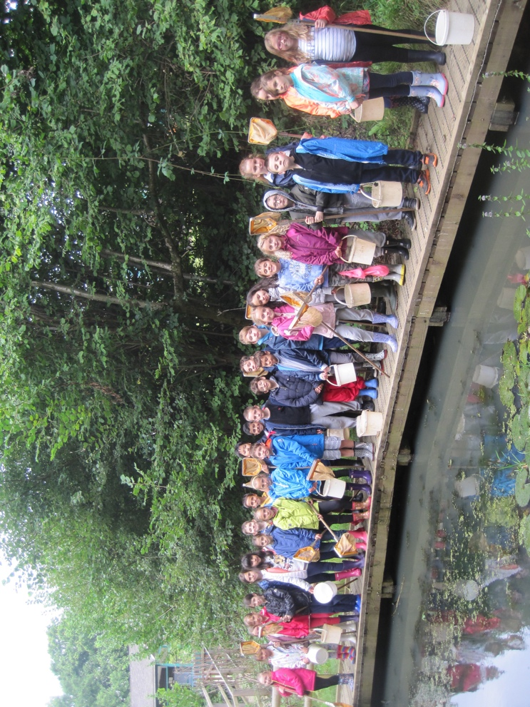

PERSONAL ATTRIBUTES

* Stamina, energy and resilience (E)
* Optimistic outlook (E)
* Confidence (E)
* Commitment to own work/life balance (E)

*“The school continues to keep its ‘gentle’ teaching of the Catholic faith at the forefront while at the same time teaching our children about (and tolerance of) all other faiths.” (Parent)*

|  |  |
| --- | --- |
|  | Wandsworth Council Children’s Services Department  Town Hall Wandsworth High Street  London SW18 2PU  Please ask for/reply to: Lesley Lynch  Telephone: 020 8871 8273  Fax: 020 8871 5806  Email: csschools@wandsworth.gov.uk  Web: www.richmondandwandsworth.gov.uk  Date: 7 February 2019 |
|  |
|
|
|
|
|

## Dear Candidate

Thank you for your interest in applying for the position of Headteacher at Our Lady Queen of Heaven Primary School. You can find further information about the school and the post, including a job description, person specification, and application pack at <https://jobs.richmondandwandsworth.gov.uk>

The first step in the selection process is your application. To get the most out of your application, please ensure you read through the person specification carefully and **provide specific examples to demonstrate how you meet all the criteria.**

We encourage you to visit the School to help you prepare for your application. Please contact the school office, on 020 8788 7420 to make an appointment. The deadline for us to receive your completed application is midnight on **Sunday 3 March 2019.**

Shortlisting will take place on Tuesday 5 March 2019.

Successful applicants will be invited to an interview and assessment day on **Tuesday 19 March 2019.**

If you have any special requirements to enable you to fully participate in the application and/or selection process, please contact me on 020 8871 8273 or by e-mail to [csschools@wandsworth.gov.uk](mailto:csschools@wandsworth.gov.uk) if you have any enquiries regarding the application process. Please ensure you provide a telephone number where you can be contacted or where we can leave a message.

We look forward to receiving your application.

Yours sincerely



**Lesley Lynch**

**Senior Human Resources Officer**