Job Profile comprising Job Description and Person Specification
Job Description

Job Title:  Senior Consultation Officer | Grade:  PO4
Section:  Resident Engagement | Directorate:  Chief Executive’s Group
Responsible to following manager:  Consultation Manager | Responsible for following staff:  Pool of casual Consultation, Research and Insight Analysts
Post Number/s: | Last review date:

Working for the Richmond/Wandsworth Shared Staffing Arrangement

This role is employed under the Shared Staffing Arrangement between Richmond and Wandsworth Councils. The overall purpose of the Shared Staffing Arrangement is to provide the highest quality of service at the lowest attainable cost.

Staff are expected to deliver high quality and responsive services wherever they are based, as well as having the ability to adapt to sometimes differing processes and expectations.

The Shared Staffing Arrangement aims to be at the forefront of innovation in local government and the organisation will invest in the development of its staff and ensure the opportunities for progression that only a large organisation can provide.

Job Purpose
The Senior Consultation Officer will support the Consultation Manager to develop and implement a coherent, innovative and intelligence-led approach to consultation and engagement across the organisation. Leading on specific aspects and assisting with others in terms of the development and delivery guidance, training and advice as required. The overall aim of the team is to deliver and advise on high quality best practice consultation and engagement, to enable residents, businesses and staff to have their say on issues that affect them, and to ensure consultation feedback is incorporated into council decision-making processes.

Specific Duties and Responsibilities

The post-holder will be responsible for the pool of Consultation, Research and Insight Analysts. This includes ensuring that objectives are met, and consultation-related activity is delivered to agreed timescales.

The key responsibilities for the post are listed below:

- On a frequent basis to provide effective, innovative and high-quality best practice advice and support to councillors, council officers (including senior officers and senior members), partners and local residents

- To deputise for the Consultation Manager in their absence in all day to day and operational aspects of the role.

- To support the Consultation Manager in the development and implementation of processes for ensuring the quality of consultation and engagement activity across both Councils, in order to meet members’ aspirations and comply with best practice.

- Act as the Consultation Team lead for advising and supporting service areas in reviewing resident enquires or information requests related to live or closed consultation activities, developing robust responses while taking into consideration community and political sensitivities, any potential technical or process adaptions and next steps.

- To provide effective full line management responsibilities of the pool of casual Consultation, Research and Insight Analysts, including training, development and appropriate application of policies and codes of practice

- To identify projects that are appropriate to be assigned to the casual Consultation, Research and Insight Analysts, retaining oversight of the projects and liaison with the service and responsibility for ensuring effective delivery in terms of quality and timescales

- To support the Consultation manager in the development and delivery of the corporate consultation programme for both Councils, leading on certain aspects as required

- Support the Consultation Manager to develop and deliver innovative and intelligence-led approaches to consultation and engagement. Including the review of team and business processes

- To co-ordinate and advise on complex and sensitive consultation exercises on behalf of both Councils, ensuring the latest best practice is followed, implications of recent case law is considered, risks are highlighted and options for continuous development and improvement in terms of consultation and engagement approaches, methodologies, practice and process. Working closely with colleagues in services, communications and customer services to ensure a joined-up approach is taken

- To lead and develop specific data analytic projects involving complex data analysis drawing on a range of data sets interpreting evidence and to provide intelligence, insight and trends about residents and service users, to support effective community engagement (particularly with hard to reach groups) decision-making, and policy development

- To build the organisation’s knowledge of ‘what works’ in getting local residents involved

- Organise own workload and prioritise tasks to meet deadlines and respond flexibly to frequently changing needs and priorities across several work streams / projects simultaneously with limited supervision

- To ensure that the services for both Councils are dealt with on an equitable basis to deliver the standards required for each, as agreed annually by the Executives of both Councils

Generic Duties and Responsibilities

- To contribute to the continuous improvement of the services of the Boroughs of Wandsworth and Richmond

- To comply with relevant Codes of Practice, including the Code of Conduct and policies concerning data protection and health and safety

- To adhere to security controls and requirements as mandated by the SSA’s policies, procedures and local risk assessments to maintain confidentiality, integrity, availability and legal compliance of information and systems

- To promote equality, diversity, and inclusion, maintaining an awareness of the equality and diversity protocol/policy and working to create and maintain a safe, supportive and welcoming environment where all people are treated with dignity and their identity and culture are valued and respected

- To understand both Councils’ duties and responsibilities for safeguarding children, young people and adults as they apply to the role within the council

- The Shared Staffing Arrangement will keep its structures under continual review and as a result the post holder should expect to carry out any other reasonable duties within the overall function, commensurate with the level of the post

Additional Information

- Line management responsibility for a pool of casual Consultation, Research and Insight Analysts (between 2 to 4 analysts)

- Post holder will be expected to work flexibly across two locations (Wandsworth and Richmond)

Team structure

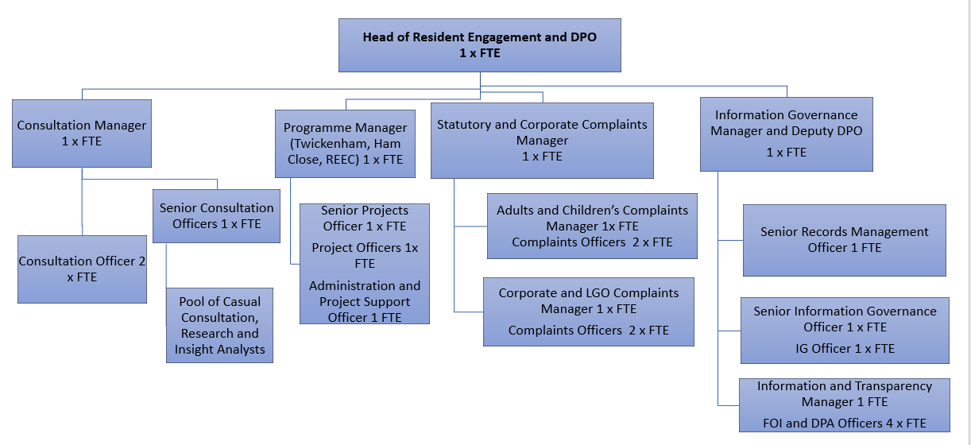
Person Specification

Job Title:  Senior Consultation Officer | Grade:  PO4
Section:  Resident Engagement | Directorate:  Chief Executive’s Group
Responsible to following manager:  Consultation Manager | Responsible for following staff:  Pool of casual Consultation, Research and Insight Analysts
Post Number/s: | Last review date:

Our Values and Behaviours

The values and behaviours we seek from our staff draw on the high standards of the two boroughs, and we prize these qualities in particular:

Being open. This means we share our views openly, honestly and in a thoughtful way. We encourage new ideas and ways of doing things. We appreciate and listen to feedback from each other

Being supportive. This means we drive the success of the organisation by making sure that our colleagues are successful. We encourage others and take account of the challenges they face. We help each other to do our jobs

Being positive. Being positive and helpful means we keep our goals in mind and look for ways to achieve them. We listen constructively and help others see opportunities and the way forward. We have a ‘can do’ attitude and are continuously looking for ways to help each other improve

Person Specification Requirements | Assessed by  A  & I/ T/ C (see below for explanation)
Knowledge
A high level of knowledge of community engagement and consultation methodologies and their application to local government | A/I
Experience
Proven experience of working in a consultation and/or research role in a local authority or similar organisation | A/I
Some experience of managing staff | A/I
Experience of supporting the development and implementation of corporate processes across a complex organisation | A/I
Experience of liaising with external providers commissioned to undertaken consultation and research | A/I
Experience of successfully managing own workload in an environment where deadlines and priorities frequently change and are often conflicting | I
Skills
Strong interpersonal skills including the ability to successfully negotiate with service specialists and with providers in order to deliver cost-effective consultation and engagement exercises | I
Excellent analytical and critical thinking skills with ability to analyse data, draw robust and insightful conclusions and make recommendations | I/T
The ability to work collaboratively with Members and Officers at all levels in order to understand business needs and ensure projects deliver on those needs whilst meeting consultation best practice standards | I
Ability to communicate effectively orally, in writing and using visual and other techniques in order to present findings in an engaging and effective way | I/T
Qualifications
Educated to degree level or equivalent, or with clear evidence of training or equivalent experience in research and consultation (e.g. certified membership of the Market Research Society) | A/C

A – Application form
I – Interview
T – Test
C - Certificate

