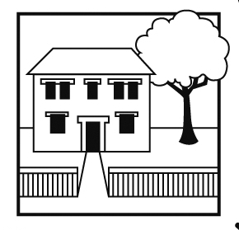

Balham Nursery School

Executive Headteacher: Ms Emma Williams B.Ed (ECE)

72 Endlesham Road, London SW12 8JL

Telephone: 020 8673 4055

Email: [admin@balham-nursery.wandsworth.sch.uk](mailto:admin@balham-nursery.wandsworth.sch.uk)

Website: www.balham-nursery.wandsworth.sch.uk

|  |
| --- |
|  |

26th April 2022

## Dear Applicant

**Early Years Class Teacher**

Thank you for your interest in applying for the position of Class Teacher at Balham Nursery School. You can find further information about the school and the post, including a job description and person specification, and download an application form at <https://jobs.richmondandwandsworth.gov.uk> Please also visit our website [www.balham-nursery.wandsworth.sch.uk](http://www.balham-nursery.wandsworth.sch.uk)

The first step in the selection process is your application. To get the most out of your application, please ensure you read through the person specification carefully and provide specific examples to demonstrate how you meet all the shortlisting criteria. Your completed application should be returned to Emma Williams at [admin@balham-nursery.wandsworth.sch.uk](mailto:admin@balham-nursery.wandsworth.sch.uk)

The deadline for us to receive your completed application is 5.00pm on Wednesday, 11th May 2022.

Successful applicants will be invited to an interview on Monday, 16th May 2022.

Please note that visits to the school are essential. To arrange a time to come and see us, please contact the School Office on 020 8673 4055.

If you have any special requirements to enable you to fully participate in the application and/or selection process, or have any questions about the application process, please contact me on 020 8673 4055 or by e-mail to [admin@balham-nursery.wandsworth.sch.uk](mailto:admin@balham-nursery.wandsworth.sch.uk). Please ensure you provide a telephone number where you can be contacted or where we can leave a message.

We look forward to receiving your application.

Yours faithfully

**Emma Williams**

**Executive Headteacher**