Job Profile comprising Job Description and Person Specification
Job Description

Job Title:  Data Quality Officer | Grade:  SO1
Section:  Assurance and Innovation | Directorate:  Adult Social Care & Public Health
Responsible to following manager:  Deputy Adults Performance Manager | Responsible for following staff:  Nil
Post Number/s:  RWA0603 | Last review date:  21/02/2023

Working for the Richmond/Wandsworth Shared Staffing Arrangement

This role is employed under the Shared Staffing Arrangement between Richmond and Wandsworth Councils. The overall purpose of the Shared Staffing Arrangement is to provide the highest quality of service at the lowest attainable cost.

Staff are expected to deliver high quality and responsive services wherever they are based, as well as having the ability to adapt to sometimes differing processes and expectations.

The Shared Staffing Arrangement aims to be at the forefront of innovation in local government and the organisation will invest in the development of its staff and ensure the opportunities for progression that only a large organisation can provide.

Job Purpose
To provide accurate data cleansing of information recorded on Adult Social Care IT systems and to reflect on data cleansing tasks to identify common patterns of mistakes or “hot spot” errors of data cleansing.
To apply this knowledge to provide support to users of adult social care case management systems, to prevent the creation of further data cleansing and to support the Performance Team to create and maintain a performance culture where data is recorded in a timely and accurate fashion; where the meaning and importance of good data quality is understood and used to support service decision making and data required for National Statutory Returns.

Specific Duties and Responsibilities

- To take the lead on data quality projects, building positive relationships across the social care teams, and supporting operational colleagues to input accurate information in the adults’ social care IT system.

- To take responsibility for initiatives to achieve regular data cleansing, in the social care IT systems, working closely with managers and social workers allocating tasks where required.

- To support with data cleansing and maintenance of good data quality for national data submissions to NHS England, Department of Health & Social Care and other government departments to agreed timescales.

- To create and maintain an appropriate audit trail and data quality metrics to demonstrate that data quality issues and performance management issues are being undertaken and resolved locally.

- To take the lead in promoting a ‘Right First Time’ data recording culture.

- To support and promote timely recording of data on adults’ social care IT systems.

- To work closely with the Adults Performance Team and the Business Systems Team to understand and support resolving data quality issues through system and business process training.

- To be responsible for running data quality sessions for operational service areas to increase their understanding of systems, and pathways; educating them about statutory requirements and need to record and maintain data.

- To develop an understanding of information reporting tools and be able to run and analyse management information reports to support identifying data quality issues.

- To keep up to date with changes in business processes, system changes, and national reporting requirement changes.

Generic Duties and Responsibilities

- To contribute to the continuous improvement of the services of the Boroughs of Wandsworth and Richmond.

- To comply with relevant Codes of Practice, including the Code of Conduct and policies concerning data protection and health and safety.

- To adhere to security controls and requirements as mandated by the SSA’s policies, procedures and local risk assessments to maintain confidentiality, integrity, availability and legal compliance of information and systems

- To promote equality, diversity, and inclusion, maintaining an awareness of the equality and diversity protocol/policy and working to create and maintain a safe, supportive and welcoming environment where all people are treated with dignity and their identity and culture are valued and respected.

- To understand both Councils’ duties and responsibilities for safeguarding children, young people and adults as they apply to the role within the council.

- The Shared Staffing Arrangement will keep its structures under continual review and as a result the post holder should expect to carry out any other reasonable duties within the overall function, commensurate with the level of the post.

Team structure

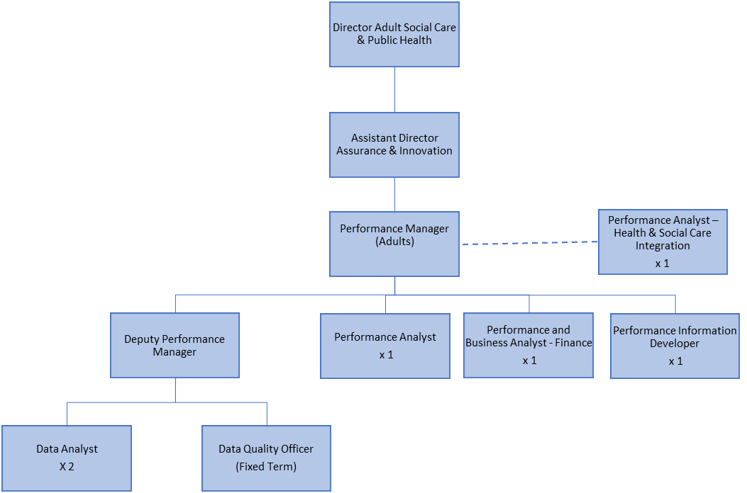
Person Specification

Job Title:  Data Quality Officer | Grade:  SO1
Section:  Assurance and Innovation | Directorate:  Adult Social Care & Public Health
Responsible to following manager:  Deputy Adults Performance Manager | Responsible for following staff:  Nil
Post Number/s:  RWA0603 | Last review date:  21/02/2023

Our Values and Behaviours

The values and behaviours we seek from our staff draw on the high standards of the two boroughs, and we prize these qualities in particular:

Being open. This means we share our views openly, honestly and in a thoughtful way. We encourage new ideas and ways of doing things. We appreciate and listen to feedback from each other.

Being supportive. This means we drive the success of the organisation by making sure that our colleagues are successful. We encourage others and take account of the challenges they face. We help each other to do our jobs.

Being positive. Being positive and helpful means we keep our goals in mind and look for ways to achieve them. We listen constructively and help others see opportunities and the way forward. We have a ‘can do’ attitude and are continuously looking for ways to help each other improve.

Person Specification Requirements | Assessed by  A  & I/ T/ C (see below for explanation)
Knowledge
Knowledge of best practice models and mechanisms to ensure robust and high quality data in local government/large organisation. | A/I
Knowledge of social care or health processes and systems. | A/I
Experience
Of working with medium to large datasets and able to undertake basic data analysis | A/T
Of using web based business intelligence tools and applications for example, Power BI and Business Objects | A/I
Of using social care IT or other systems, e.g. Mosaic. | A/I
Of using other Microsoft products including Word, Outlook, PowerPoint | A/I
Skills
Intermediate to Advanced MS Excel skills | A/I/T
Ability to clearly communicate issues, processes and concepts relating to data capture, data quality and information management to operational teams and operational managers | A/I
Excellent attention to detail and the ability to identify patterns of common data cleansing mistakes. | A/I
Ability to build and maintain productive and effective working relationships with all levels of management and operational staff. | A/I
Proactive self-starter with the ability to work as part of a team and independently using own initiative | A/I
Ability to manage time and prioritise work to maximise productivity and effectiveness. | A/I
Qualifications
Math and English qualifications or equivalent experience | A/C

A – Application form / CV
I – Interview
T – Test
C - Certificate

