Job Profile comprising Job Description and Person Specification

Job Description

Job Title:  FM Assistant | Grade:  Scale 3
Section:  Property Services - FM Operations | Directorate:  Housing & Regeneration
Responsible to following managers:  FM Operations Manager | Responsible for following staff:  Not applicable
Post Number/s: | Last review date: 08 Nov 2017

Working for the Richmond/ Wandsworth Shared Staffing Arrangement

This role is employed under the Shared Staffing Arrangement between Richmond and Wandsworth Councils. The overall purpose of the Shared Staffing Arrangement is to provide the highest quality of service at the lowest attainable cost.

Staff are expected to deliver high quality and responsive services wherever they are based, as well as having the ability to adapt to sometimes differing processes and expectations.

The Shared Staffing Arrangement aims to be at the forefront of innovation in local government and the organisation will invest in the development of it staff and ensure the opportunities for progression that only a large organisation can provide.

Job Purpose:
To be responsible for an SSA wide full document and production support service, working to ensure all courier, confidential waste, document delivery, Printing and postal duties are completed in accordance with established procedures to audit and security regulations within prescribed deadlines and priorities.

Specific Duties and Responsibilities:

- Responsible for collection and delivery of postal items including bulk mailings and specifically quoted tasks.
- Complete all postal related duties in accordance with financial, security and audit regulations.
- Responsible for the monitoring and secure collection and processing of all confidential waste.
- Work flexibly and with minimum supervision understanding deadlines and observing key team priorities, ensuring all tasks are completed in an organised, efficient way paying attention to detail and accuracy
- To deal promptly and effectively with internal and external customers, to meet their prescribed deadlines, prioritising individual workloads, maintaining confidentiality and secure document handling.
- To fulfil meeting room services including room layout alterations, refreshments and provision of A.V. equipment.
- To provide site security out of hours for late and weekend working of staff and contractors. Locking principal buildings and some satellite offices.
- To triage and provide minor repairs to building fabric. Update FM Helpdesk.
- Provide support to evening meetings, Committees and Council meetings.
- Facilitate small office clearances and moves in conjunction with IT, Communications and contractors.
- Assist in managing access to Town Hall complex for staff/visitors/contractors, providing access cards, keys and controlling car park barriers.
- Support FM Building Services Officers as required.

Generic Duties and Responsibilities

- To contribute to the continuous improvement of the Boroughs of Wandsworth and Richmond services.

- To comply with relevant Codes of Practice, including the Code of Conduct, and policies concerning data protection and health and safety.

- To promote equality, diversity, and inclusion, maintaining an awareness of the equality and diversity protocol/policy and work to create and maintain a safe, supportive and welcoming environment where all people are treated with dignity and their identity and culture are valued and respected.

- To understand the both Council’s duties and responsibilities for safeguarding children, young people and adults as they apply to your role within the council.

- The Shared Staffing Arrangement will keep its structures under continual review and as a result the post holder should expect to carry out any other reasonable duties within the overall function, commensurate with the level of the post.

Team Structure

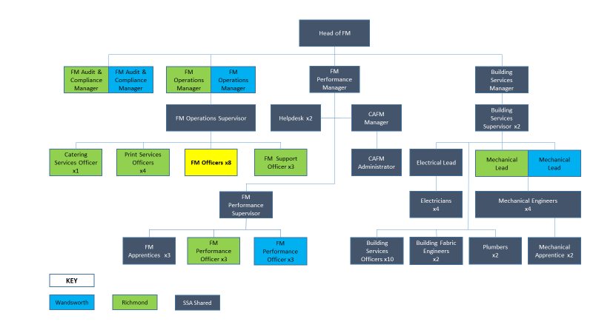

Person Specification

Job Title:  FM Assistant | Grade:  Scale 3
Section:  Property Services - FM Operations | Directorate:  Housing & Regeneration
Responsible to following managers:  FM Operations Manager | Responsible for following staff:  Not applicable
Post Number/s: | Last review date: October 2017
Our Values and Behaviours

The values and behaviours we seek from our staff draw on the high standards of the two boroughs, and we prize these qualities in particular –

- taking responsibility and being accountable for achieving the best possible outcomes – a ‘can do’ attitude to work
- continuously seeking better value for money and improved outcomes at lower cost
- focussing on residents and service users, and ensuring they receive the highest standards of service provision
- taking a team approach that values collaboration and partnership working.

Person Specification Requirements | Assessed by  A & I/ T/ C
Knowledge
knowledge of the operational requirements of a complete postal and courier service | A & I
Experience
Working in a fast moving, multi-tasking team environment | A & I
Postal processes and automated equipment including digital scanners, folders and franking machines | A & I
Skills
Good communication skills both written and verbal | A & I
Good IT user skills | A & I
Ability to work independently and as an effective team member using own initiative and adapting to changing priorities | A & I
Qualifications
Relevant vocational qualifications or equivalent experience | A & I

A = Application form, I = Interview, T = Test, C = Certificate

