Job Profile comprising Job Description and Person Specification
Job Description

Job Title:  Development Finance Analyst (3 year fixed-term contract) | Grade: PO5 to PO6
Section:  Regeneration & Development | Directorate:  Housing and Regeneration
Responsible to following manager:, Head of Housing Development | Responsible for following staff:  -[None]
Post Number/s: RWH404FT | Last review date: October 2021

Working for the Richmond/Wandsworth Shared Staffing Arrangement

This role is employed under the Shared Staffing Arrangement between Richmond and Wandsworth Councils. The overall purpose of the Shared Staffing Arrangement is to provide the highest quality of service at the lowest attainable cost.

Staff are expected to deliver high quality and responsive services wherever they are based, as well as having the ability to adapt to sometimes differing processes and expectations.

The Shared Staffing Arrangement aims to be at the forefront of innovation in local government and the organisation will invest in the development of its staff and ensure the opportunities for progression that only a large organisation can provide.

Job Purpose

It is envisaged that Analyst will provide more general and specialised advice depending upon their past experience and exigencies of the service. This might include, but is not limited to, advice on evaluating and measuring the financial performance of new property across a range of tenures, promoting best practice on programme risk management in the light of variable inputs in costs, social housing grant and sale income.

Since 2017, the Council has a target of delivering a minimum of 1,000 low cost homes by 2025 years through its own development programme. The council also has an active Regeneration programme currently on two estates: Winstanley & York Road, and The Alton. Regeneration sites are progressed under a combination of direct-delivery of peripheral sites, and large-scale JV’s with Developer partners lasting in excess of 10 years.

Housing and Regeneration activities are funded by a mix of grant and long-term loans made against assets in Wandsworth’s Housing Revenue Account. Working under the Head of Housing Development but with regular contact with colleagues in Finance & Business Support, this post provides oversight into Wandsworth’s housing and regeneration programme finances, including support to the Housing and Regeneration teams in maintaining up to date financial appraisals and cashflows.

The post involves close, collaborative and coordinated working with council and departmental colleagues, requiring significant understanding of housing and development investment strategies, budgeting and modelling. The post will be responsible for coordination of activity required to regularly track progress against projected development spending, liaison with Housing Enablement & Projects teams to maximise grant and accurately forecast dates of receipt.

Whilst the post is part of the SSA the focus of this post is to assist and lead in the delivery of Wandsworth Council’s council build programme.

Specific Duties and Responsibilities

GRADE PO5

- Reports to the HHD and deputises for that post in the postholder’s absence on housing development and regeneration matters as directed by Assistant Director of Regeneration.

- Responsible as directed for:-

- Oversight of financial performance of WBC’s housing development and Regeneration works using various software tools to ensure delivery of the programme to agreed KPI’s;
- Working closely with Development and Regeneration teams to ensure annual and monthly spend and income forecasts are within agreed tolerances.
- Working with colleagues in Property Services team to model rental streams from street purchases as directed by the Head Housing Development.

- Responsible for oversight of financial performance in the delivery of Council led development schemes from initiation to completion. This includes working closely with Housing and Regeneration project managers to accurately forecast spend and income budgets on direct-delivery sites and those procured under joint-venture arrangements with Developer partners.

- Responsible for downloading actual monthly income and expenditure from the purchase ledger before importing into the Council’s dedicated development appraisal and cashflow-forecasting software ready for Development Project Managers to re-forecast variations in conjunction with the Development Programme Coordinator.

- Responsible producing monthly cashflow reports and monitoring programme-wide KPI’s for review by HHD and Financial Control prior to issuing to the Regeneration and Development Project Board, along with twice-yearly reports of the programme-wide KPI position for WBC’s Housing Regeneration Overview and Scrutiny Committee (HROSC).

- As required and directed by the HHD on occasion to cover and assist with the work of the Finance & Business Support and Financial Control teams to ensure WBC meets its work and programme objectives.

PROGRESSION TO PO6

- Prepares reports when required for distribution to the Director of Housing and Regeneration, Assistant Director (Regeneration), other Housing Officers, the Assistant Director of Property Services and other Council Departments and the Cabinet Member for Housing.

- Provides guidance, informal training and support to members of the Housing Development & Regeneration team on matters of project viability, working collaboratively to identify the most viable mix and financial profile of given development projects.

- Keeps abreast of Homes England, MHCLG and GLA policy and other publications in relation to financing the delivery of Council led development.

- As required represents the Council at local, regional and national level in respect to the Financial performance of the Council’s development programme.

Generic Duties and Responsibilities

- Make a positive contribution to the delivery of the service, this will include working flexibly and positively to achieve the objectives of the Council.
- Manage a customer focused service and the effective use of resources.
- Ensure that the Council’s overall vision, values and ethos are central to the requirements of the service.
- Support effective working relationships and act as an ambassador and advocate with external organisations.
- Keep up to date with developments in service delivery and best practice to ensure the service performs effectively and to the highest standards.
- To act as a professional role model to junior staff in the department and to senior managers across the council, keeping expert professional knowledge up to date at all times.
- To mentor and support apprentices and lead professional training for the department within own area of responsibility.
- To lead in financial reporting within own area of responsibility, ensuring that government returns and similar statistical submissions are completed promptly and accurately, and that the financial implications of the information contained therein are understood and acted upon.
- To draft financial implications for formal committee reports, up to and including for Cabinet and to brief senior managers and Directors accordingly.
- To attend committee meetings as may be required from time to time.
- To advise on and maintain effective systems of financial control and intervene as necessary, with a high degree of professional integrity and credibility, to prevent breaches of financial control.
- To advise managers on the implications of audit reports and of the actions to be taken in response.
- To contribute to the continuous improvement of the services of the Boroughs of Wandsworth and Richmond.

- To comply with relevant Codes of Practice, including the Code of Conduct and policies concerning data protection and health and safety.

- To adhere to security controls and requirements as mandated by the SSA’s policies, procedures and local risk assessments to maintain confidentiality, integrity, availability and legal compliance of information and systems

- To promote equality, diversity, and inclusion, maintaining an awareness of the equality and diversity protocol/policy and working to create and maintain a safe, supportive and welcoming environment where all people are treated with dignity and their identity and culture are valued and respected.

- To understand both Councils’ duties and responsibilities for safeguarding children, young people and adults as they apply to the role within the council.

- The Shared Staffing Arrangement will keep its structures under continual review and as a result the post holder should expect to carry out any other reasonable duties within the overall function, commensurate with the level of the post.

Proposed team structure

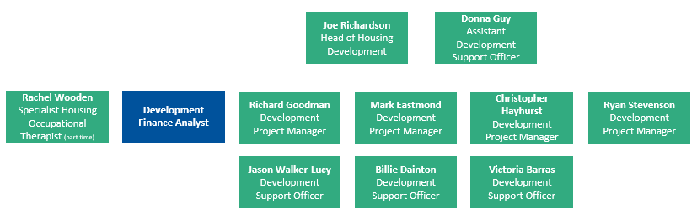

Primary contacts & collaborative working

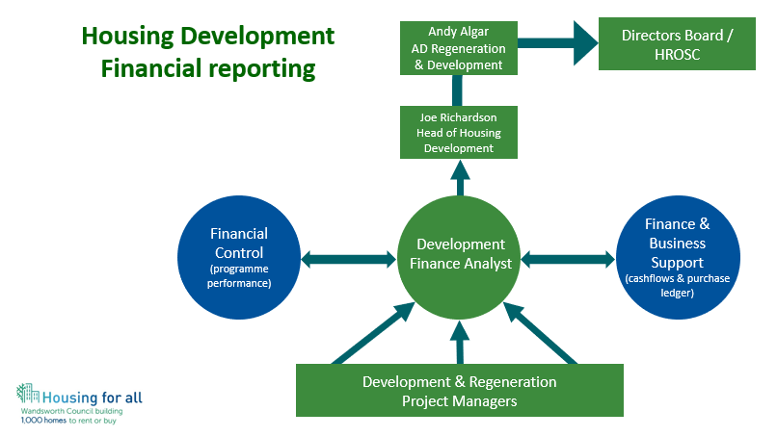
Person Specification

Job Title:  Development Finance Analyst (3 year fixed-term contract) | Grade: TO BE EVALUATED
Section:  Housing Strategy and Development | Directorate:  Housing and Regeneration
Responsible to following manager:, Head of Housing Development | Responsible for following staff:  -[None]
Post Number/s: TBA | Last review date: May 2021

Our Values and Behaviours

The values and behaviours we seek from our staff draw on the high standards of the two boroughs, and we prize these qualities in particular:

Being open. This means we share our views openly, honestly and in a thoughtful way. We encourage new ideas and ways of doing things. We appreciate and listen to feedback from each other.

Being supportive. This means we drive the success of the organisation by making sure that our colleagues are successful. We encourage others and take account of the challenges they face. We help each other to do our jobs.

Being positive. Being positive and helpful means we keep our goals in mind and look for ways to achieve them. We listen constructively and help others see opportunities and the way forward. We have a ‘can do’ attitude and are continuously looking for ways to help each other improve.

Person Specification Requirements | Assessed by  A  & I/ T/ C (see below for explanation)
Knowledge
Be able to demonstrate sound knowledge of the financing and viability of housing development | A&I/T
Be able to demonstrate competence and experience in the use of development financial software including Excel at an Advanced user level. | A&I/T
Experience
Experience of providing financial advice and leadership in a large and complex organisation, working with a high degree of professional independence and integrity. | A&I
Able to demonstrate an understanding of economic appraisal processes in the development of housing and to be able to interpret and analyse data | A&I/T
Experience of advising on managing all aspects of large and complex budgets, delivering significant improvements as a result. | A&I
Experience of contracting for services, providing financial and commercial advice to inform procurement strategy and negotiations. | A&I
Skills
Be able to work as part of a team | A&I
Manage people, performance and budgets. | A&I
Contribute to the longer term development of the service area | A&I
Ability to analyse, interpret and report upon large amounts of complex financial, accounting and output information and to analyse complex business processes | A&I
Excellent communication skills including the ability to explain complex financial issues to non financial managers, Directors and Members, adapting style to suit the audience and the issue. | A&I
Excellent interpersonal, negotiating and influencing skills. | A&I
Strong leadership skills, capable of motivating and inspiring junior staff and building effective working relationships at senior levels across the organisation and with partners. | A&I
Able to organise resources and plan work to meet individual, team and departmental objectives. | A&I
Be able to communicate effectively, orally and in writing, on a wide range of complex issues | A&I
Be reliable and able to manage own workload and deal with competing priorities and deadlines with minimal supervision. | A&I
Be able to collate information, maintain files and records accurately on computerised and manual recording systems | A&I
Demonstrate sound administrative and office skills | A&I
Be able to use IT packages including word processing, spreadsheets and database systems. | A&I/T
Qualifications
CCAB Qualified CCAB Qualified Accountant with significant post qualification experience | A&I/T
Evidence of significant relevant Continuing Professional Development (CPD) | A&I

A – Application form
I – Interview
T – Test
C - Certificate

These values and behaviours will be developed further as the SSA becomes established.

