**Job Profile comprising Job Description and Person Specification**

**Job Description**

|  |  |
| --- | --- |
| **Job Title:**  Principal CIL and S106 Officer | **Grade**:  PO5 |
| **Section:**  Spatial and Transport Planning | **Directorate:**  Environment and Community Services |
| **Responsible to following manager:**  Information and Planning Obligations Team Manager | **Responsible for following staff:**  Senior CIL and S106 Officers  CIL and S106 Officers |
| **Post Number/s:** | **Last review date: January 2023** |

**Working for the Richmond/Wandsworth Shared Staffing Arrangement**

This role is employed under the Shared Staffing Arrangement between Richmond and Wandsworth Councils. The overall purpose of the Shared Staffing Arrangement is to provide the highest quality of service at the lowest attainable cost.

Staff are expected to deliver high quality and responsive services wherever they are based, as well as having the ability to adapt to sometimes differing processes and expectations.

The Shared Staffing Arrangement aims to be at the forefront of innovation in local government and the organisation will invest in the development of its staff and ensure the opportunities for progression that only a large organisation can provide.

**Job Purpose:**

To deliver high quality, robust and transparent decision making within tight time frames on the provision and administration of Community Infrastructure levy and Section 106 agreements, to ensure that the Planning and Transport Strategy Division is recognised as delivering an excellent planning service for all of our customers. The Principal CIL and S106 Officer will act as a professional expert and lead a team administering the Community Infrastructure Levy and S106 agreements, providing a definitive professional service for the Council, creating and applying best practice to the collation, analysis and provision of all types of CIL and S106 related data for a range of internal and external customers and to assist in the delivery of successful outcomes.

**Specific Duties and Responsibilities:**

1. Responsible to the Information and Planning Obligations Team Manager for taking the lead on, and personal responsibility for, the full range of CIL and S106 work as directly related to the Spatial and Transport Strategy Division. Workload to include the collection and analysis of CIL and S106 information, to lead in the preparation of CIL charging schedules, annual reporting and internal reporting as required, to include monitoring of performance against agreed measures.
2. To oversee the management and monitoring of S106 Agreements and the Community Infrastructure Levy. To assist in the production of policy and guidance notes and advice on a range of matters within their remit. Ensuring it is effectively and efficiently carried out to identifiable deadlines in a manner which is successful in meeting corporate targets and objectives.
3. Is proactive in identifying issues and proposing improvements within the context of current and future service requirements in order to continually deliver high quality, customer focused planning services to customers and managers.
4. To manage and maintain a system for the management and monitoring of both S106 and CIL monies.
5. Co-ordinate with development management and other sections of the Councils to enable the smooth running of the S106 and CIL to include its collection and subsequent allocation for spending.
6. To take the lead on implementing identified agreed projects to deliver organisational objectives, continual improvements and efficiencies in ensuring a high quality customer focused service.
7. To ensure that all policy and best practice and committee reports, and correspondence, are well written and accurate and set out coherent and robust recommendations based on the Council's policies and other material considerations.
8. Coach and facilitate the acquisition and development of skills and knowledge in others so that they are better equipped to be self-reliant in dealing with technical and people issues.
9. Present to the appropriate Committee and other internal and public meetings on complex and/or controversial CIL/S106 related planning matters in a clear and concise manner including providing professional advice to Members.
10. To provide advice and guidance on complex or high risk issues particularly where precedent is less readily available including that of new legislation and initiatives relating to technical, operational and contractual aspects pertaining to the areas of responsibility set out in 1 above.
11. To ensure key performance indicators, targets and customer service standards are fully up-to-date using service wide electronic recording and monitoring systems and that proactive action is taken to ensure that those performance indicators, targets and standards are met.
12. To assist as required with the management of budgets, including ensuring that all necessary processes and procedures are carried out in a timely and effective way.
13. Responsible for day to day line management, supervision and allocation of work for the Senior CIL and S106 Officer and the CIL and S106 Officer posts.
14. To initiate, participate in and take the management lead on matters relating to compliance and enforcement matters taking responsibility for effective negotiation and conflict resolution to ensure high quality innovative outcomes that reflect Council-wide objectives and policies.
15. Demonstrate an ability to build and develop strong working relationships both inside and outside the service in order to deliver departmental and corporate objectives and to mitigate risk and to be an ambassador for the planning function in these interactions.
16. Maintains an up-to-date knowledge of relevant legislation and national policy and guidance and takes a proactive approach to relevant changes in these, recommending revised procedures and practices and managing the implementation of those revisions.
17. To deputise for the Information and Planning Obligations Team Manager including attendance at any appropriate Overview and Scrutiny Committee and evening meetings as required.

**Generic Duties and Responsibilities**

* To contribute to the continuous improvement of the services of the Boroughs of Wandsworth and Richmond.
* To comply with relevant Codes of Practice, including the Code of Conduct and policies concerning data protection and health and safety.
* To adhere to security controls and requirements as mandated by the SSA’s policies, procedures and local risk assessments to maintain confidentiality, integrity, availability and legal compliance of information and systems.
* To promote equality, diversity, and inclusion, maintaining an awareness of the equality and diversity protocol/policy and working to create and maintain a safe, supportive and welcoming environment where all people are treated with dignity and their identity and culture are valued and respected.
* To understand both Councils’ duties and responsibilities for safeguarding children, young people and adults as they apply to the role within the council.
* The Shared Staffing Arrangement will keep its structures under continual review and as a result the post holder should expect to carry out any other reasonable duties within the overall function, commensurate with the level of the post.

**Additional Information**

Over time Council services change and develop. This can impact upon the main duties and responsibilities of the role, and subsequently the post holder, who will be required to adapt. Any changes will be appropriate to the grading of the post and will be made in discussion with the post holder.

**Current Team structure**

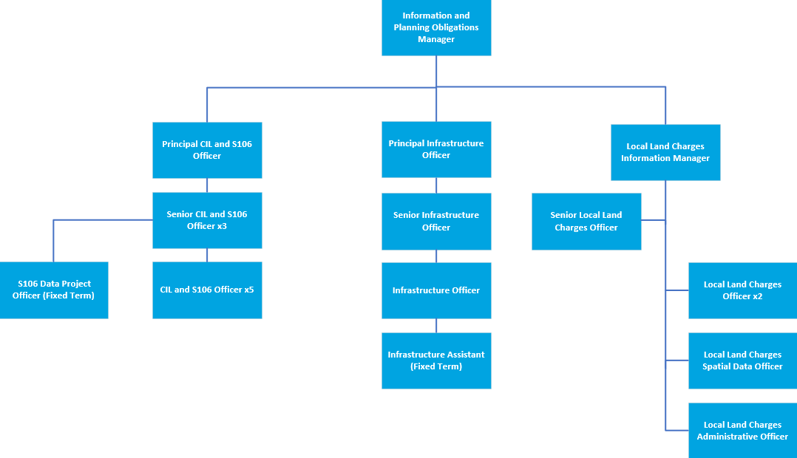

**Person Specification**

|  |  |
| --- | --- |
| **Job Title:**  Principal CIL and S106 Officer | **Grade**:  PO5 |
| **Section:**  Spatial and Transport Planning | **Directorate:**  Environment and Community Services |
| **Responsible to following manager:**  Information and Planning Obligations Team Manager | **Responsible for following staff:**  Senior CIL and S106 Officers  CIL and S106 Officers |
| **Post Number/s:** | **Last review date: January 2023** |

**Our Values and Behaviours**

The values and behaviours we seek from our staff draw on the high standards of the two boroughs, and we prize these qualities in particular:

**Being open.** This means we share our views openly, honestly and in a thoughtful way. We encourage new ideas and ways of doing things. We appreciate and listen to feedback from each other.

**Being supportive.** This means we drive the success of the organisation by making sure that our colleagues are successful. We encourage others and take account of the challenges they face. We help each other to do our jobs.

**Being positive and helpful.** This means we keep our goals in mind and look for ways to achieve them. We listen constructively and help others see opportunities and the way forward. We have a ‘can do’ attitude and are continuously looking for ways to help each other improve.

|  |  |
| --- | --- |
| **Person Specification Requirements** | **Assessed by**  **A & I (see below for explanation)** |
| **Knowledge** | |
| Comprehensive knowledge and understanding of Planning legislation, policy guidance and circulars, practice and case law and the ability to apply that knowledge to the application of S106 and Community Infrastructure Levy, delivering a responsive, high quality service. | A/I/T |
| Knowledge and understanding of how to implement effective customer relations and customer care practices | A/I |
| Knowledge and understanding of performance management and staff development and the ability to apply that knowledge to setting challenging targets for yourself and team members to ensure optimum service delivery | A/I/T |
| **Experience** | |
| Experience of managing S106 and/or CIL data administration systems to meet the everyday needs of a busy planning service. | A/I/T |
| Proven experience of providing creative solutions to problem solving and demonstrating a “can-do” attitude to improvements in service delivery including solutions involving the provision of complex data. | A/I/T |
| An advanced knowledge of the Microsoft Office package, particularly Excel, and ability to use a wide range of computer software to collate, query, analyse, interpret, and present data, such as Microsoft Power BI. | A/I |
| Experience of working at pace in a high-pressure environment | A/I/T |
| **Skills** | |
| Ability to manage the deployment of resources on a day-to-day basis to ensure that they are allocated to optimise efficiency and effectiveness to deliver a quality service at speed. | A/I |
| Ability to organise own workload and work within agreed timeframes to maintain high quality decision making at speed and to achieve set deadlines and targets. | A/I |
| Effective supervisory skills and the ability to coach junior staff so that they can become self-reliant in dealing with technical and people issues. | A/I |
| Ability to apply appropriate techniques to motivate teams and individuals at work to ensure the delivery of a high quality, high performing service with quick turnaround times. | A/I |
| Articulate in written and oral communication skills with particular reference to report and letter writing, public speaking, presentation skills and communicating with Members, the public, staff and other professionals. | A/I/T |
| Ability to analyse and interpret complex data and present key facts including policy implications in the preparation of reports, policy formulation and other material. | A/I/T |
| Well developed inter-personal skills. | I |
| A clear understanding and commitment to take effective action to promote equality and the value of diversity in service delivery and employment. | A/I |
| Flexible approach to working hours, location and getting the job done and the ability to attend meetings and other events outside normal working hours, occasionally at short notice. | A/I |
| **Qualifications** | |
| Fully qualified planner (member or eligible for full membership of the RTPI or equivalent) or a relevant degree or other appropriate technical qualification. | A/C |

**A – Application**

**I – Interview**

**T – Test**

**C - Certificate**