Job Profile

Provisional Job Title:  Challenges and Compliance Team Leader - Parking | Grade: PO2
Section:  Parking Service | Department:  Resources
Responsible to:  Challenges and Compliance Manager - Parking | Responsible for:  WBC (X 15 FTE)  LBRuT (X 5 FTE)

Working for the Richmond/ Wandsworth Shared Service

This role is employed under the Shared Service Arrangement between Richmond and Wandsworth Borough Councils. The overall purpose of the Shared Service Arrangement is to provide the highest quality of service at the lowest attainable cost.

Staff are expected to deliver high quality and responsive services wherever they are based, as well as having the ability to adapt to sometimes differing processes and expectations.

The Shared Service Arrangement aims to be at the forefront of forging change in local government and the organisation will invest in your development and ensure the opportunities for progression that only a large organisation can provide.

Job Purpose:

To provide assistance to the Challenges and Compliance Manager in the day to day management of the Challenges and Compliance Team ensuring that all statutory actions are compliant to assist with the progression and collection of PCN income, for reconciliation in accordance with audit guidelines.

Specific Duties and Responsibilities:

Responsible for the administration of;

- To locally manage all statutory challenges against the issue of PCNs, in accordance with relevant legislations and within set timescales

- To assist in the management of statutory progression in accordance with relevant legislations

- To administer and report the effectiveness of debt recovery solutions for unpaid PCNs

- To administer and report income for all of Parking Services

- To assist the Challenges and Compliance Manager with the allocation of resources, incorporating planning and productivity

To ensure that the services for both Councils are dealt with on an equitable basis to deliver the standards required for each, as agreed annually by the Executives of both Councils.

To provide operational and motivational leadership of staff, providing a visible presence to the workforce and promoting a good working environment with the primary aim of delivering high quality services

To provide operational line management to staff including a visible presence to employees, promoting a good working environment with the primary aim of delivering a high quality service
To ensure all Member queries about service delivery are dealt with promptly and effectively

To advise and support managers on relevant matters affecting the service

To assist as required with performance review and improvement measures on an ongoing basis, helping to ensure that a customer focus is embedded within the function and innovative and creative solutions are evaluated to securing the highest quality and value for money function

To contribute as required to change programmes within the service

Generic Duties and Responsibilities

To contribute to the continuous improvement of the Boroughs of Wandsworth and Richmond services.

To comply with relevant Codes of Practice, including the Code of Conduct, and policies concerning data protection and health and safety.

To promote equality, diversity, and inclusion, maintaining an awareness of the equality and diversity protocol/policy and work to create and maintain a safe, supportive and welcoming environment where all people are treated with dignity and their identity and culture are valued and respected.

To understand the both Council’s duties and responsibilities for safeguarding children, young people and adults as they apply to your role within the council.

The Shared Staffing Arrangement will keep its structures under continual review and as a result the post holder should expect to carry out any other reasonable duties within the overall function, commensurate with the level of the post.
Additional Information
Assists the Challenges and Compliance Manager in reconciling and reporting on parking income for each borough, totalling approximately £50 million.

A total of 20 X Challenges and Compliance administration staff to be managed within the Council’s Codes of Practice across two boroughs incorporating two Challenges and Compliance Team Leaders;
WBC 15 X SC4-S01
LBRUT 5 X SC4 -S01

May be required to deputise for Challenges and Compliance Manager and attend high level meetings internally and externally.

Current team structure
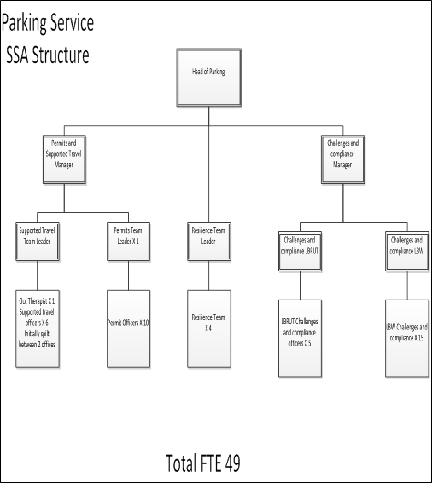

Our Values and Behaviours

The values and behaviours we seek from our staff draw on the high standards of the two boroughs, and we prize these qualities in particular:

Being open. This means we share our views openly, honestly and in a thoughtful way. We encourage new ideas and ways of doing things. We appreciate and listen to feedback from each other.

Being supportive. This means we drive the success of the organisation by making sure that our colleagues are successful. We encourage others and take account of the challenges they face. We help each other to do our jobs.

Being positive. Being positive and helpful means, we keep our goals in mind and look for ways to achieve them. We listen constructively and help others see opportunities and the way forward. We have a ‘can do’ attitude and are continuously looking for ways to help each other improve.

Requirements | Assessed by  A & I/ T/ C
Knowledge
Knowledge and understanding of Parking legislation and the administration of said legislation | AI
Knowledge of available process enhancements and digital/alternative delivery methods | AI
Knowledge and understanding of legislation for Enforcement Agencies to collect debt | AI
Experience
Experience of managing staff with positive outcomes | AI
Evidence of successfully managing change | AI
Experience of working to deadlines | AI
Experience of appropriately allocating staff resources | AI
Skills
Significant experience of using standard IT packages and ability to support others in their day-to-day use | AIT
Good oral and written skills to provide clear and concise information via correspondence or presentation | AI
The ability to introduce new working practices accordingly | AI
The ability to both motivate and support a team | AI
The ability to show a high level of attention to detail to maintain expected Quality controls | AI
Qualifications
Accredited learning qualification or equivalent experience. | C

