24th March 2025

Dear Candidate,

I am delighted that you have taking an interest in our wrap around care vacancies at Allfarthing Primary School, we are a two form entry primary school situated near Wandsworth Common. We have two outside spaces, a forest school, science room and many other interesting areas as well as close rail links and a carpark onsite.

Our school vision is:

**Excellence for All**

* Children are engaged and leave with strong connections, a sense of achievement and have

reached their potential

* A whole team culture of kindness and excellence. People who feel valued and are keen to

grow.

* An enriched curriculum that enables everyone to reach their full potential.
* An inclusive community in which everyone feels welcome.

Our behaviour policy is built on Paul Dix’s book ‘When The Adults Change Everything Changes’ and our three school values are ‘Be kind, Be safe and Go above and beyond.’ We believe strongly in giving staff opportunities to develop here with most of our Leadership team doing NPQ qualifications, lesson studies, using Iris Connect and gallery lessons are some examples of professional development our staff have had in the last year. We are also active members in the Wandsworth maths and literacy hubs.

We also believe in staff kindness and wellbeing. We start each week with ‘Shines’ in briefing, have a staff shine board, offer paid and unpaid wellbeing days to all staff as well as having achieved our wellbeing for schools award two years ago.

Please take the time to read through all the candidate information and visit our website-the school newsletters will give you a valuable snapshot of the school and find out more about Allfarthing.

The wrap around care team have created a good quality provision and you will be joining an enthusiastic team.

The closing date for applications is **Monday 21st April 25 by 4pm.**

Yours sincerely

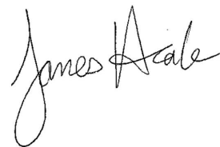

James Heale

Headteacher