Job Profile comprising Job Description and Person Specification
Job Description

Job Title:  FOI and DPA Officer | Grade:  PO2
Section:  Customers and Partnerships | Directorate:  Chief Executive’s Group
Responsible to following manager:  Information and Transparency Manager | Responsible for following staff:  Non Applicable
Post Number/s: | Last review date:  April 2016

Working for the Richmond/Wandsworth Shared Staffing Arrangement

This role is employed under the Shared Staffing Arrangement between Richmond and Wandsworth Councils. The overall purpose of the Shared Staffing Arrangement is to provide the highest quality of service at the lowest attainable cost.

Staff are expected to deliver high quality and responsive services wherever they are based, as well as having the ability to adapt to sometimes differing processes and expectations.

The Shared Staffing Arrangement aims to be at the forefront of innovation in local government and the organisation will invest in the development of its staff and ensure the opportunities for progression that only a large organisation can provide.

Job Purpose:

- To provide information to the public in response to requests under the Freedom of Information Act, Environmental Information Regulations and Data Protection Act

- To support the Information and Transparency Manager in providing advice and training and designing and implementing processes to ensure that the Councils comply with Data Protection and Freedom of Information/EIR legislation

Specific Duties and Responsibilities

- To work with colleagues across the organisation to ensure that responses are provided to requests for information in compliance with FOIA/EIR, including meeting quality requirements and statutory response time limits

- To assist the Information and Transparency Manager in ensuring that the Council complies with the DPA and to draft and implement DPA policies / procedures

- To co-ordinate and monitor subject access requests under the DPA and assist Departments to implement agreed subject access request procedure effectively

- To provide practical guidance, training and support on FOI, EIR and DPA across the Councils

- To be the first point of contact for public queries in respect of DPA and FOIA matters and to resolve any such queries, in conjunction with colleagues across the Councils where necessary

- To be responsible for the ongoing maintenance of the Councils’ Publication Schemes under the FOIA

- To support the Information and Transparency Manager and Complaints and FOI Manager in promoting transparency and accountability across the organisation

- To undertake all duties and interactions with employees, partner providers and customer fairly, without unlawful discrimination and with due regard to Equality and Diversity in Employment and Service Delivery Policies

- To ensure that the services for both Councils are dealt with on an equitable basis to deliver the standards required for each, as agreed annually by the Executives of both Councils

Generic Duties and Responsibilities

- To contribute to the continuous improvement of the services of the Boroughs of Wandsworth and Richmond

- To comply with relevant Codes of Practice, including the Code of Conduct and policies concerning data protection and health and safety

- To adhere to security controls and requirements as mandated by the SSA’s policies, procedures and local risk assessments to maintain confidentiality, integrity, availability and legal compliance of information and systems

- To promote equality, diversity, and inclusion, maintaining an awareness of the equality and diversity protocol/policy and working to create and maintain a safe, supportive and welcoming environment where all people are treated with dignity and their identity and culture are valued and respected

- To understand both Councils’ duties and responsibilities for safeguarding children, young people and adults as they apply to the role within the council

- The Shared Staffing Arrangement will keep its structures under continual review and as a result the post holder should expect to carry out any other reasonable duties within the overall function, commensurate with the level of the post

Additional Information
- Post holder will be expected to work flexibly across two locations (Wandsworth and Richmond), although most days are currently spent working from home.

Current team structure

Divisional Structure
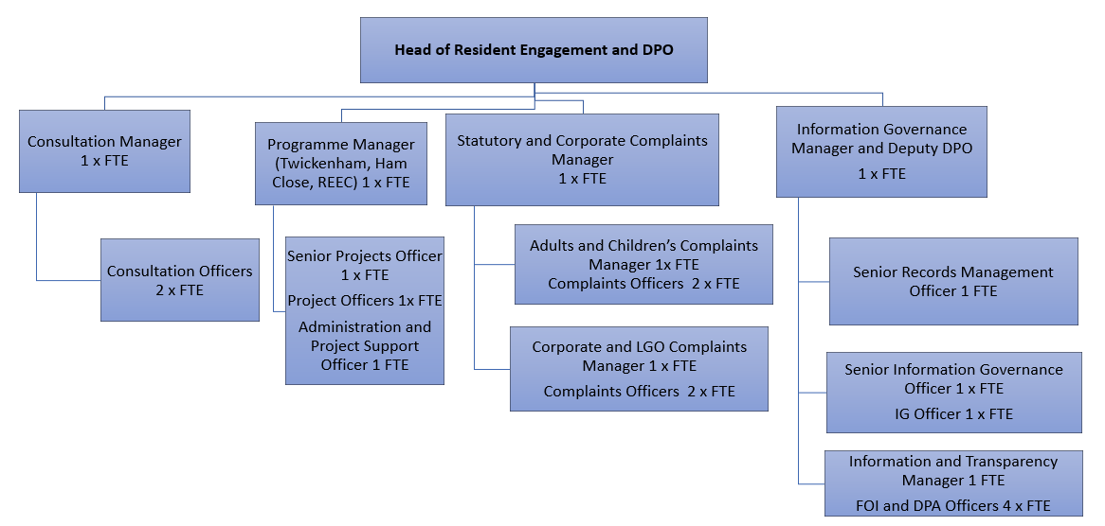

Person Specification

Job Title:  FOI and DPA Officer | Grade: PO2
Section:  Customers and Partnerships | Directorate:  Chief Executive’s Group
Responsible to following manager:  Information and Transparency Manager | Responsible for following staff:  Not Applicable
Post Number/s: | Last review date:  April 2016

Our Values and Behaviours

The values and behaviours we seek from our staff draw on the high standards of the two boroughs, and we prize these qualities in particular:

Being open. This means we share our views openly, honestly and in a thoughtful way. We encourage new ideas and ways of doing things. We appreciate and listen to feedback from each other.

Being supportive. This means we drive the success of the organisation by making sure that our colleagues are successful. We encourage others and take account of the challenges they face. We help each other to do our jobs.

Being positive. Being positive and helpful means we keep our goals in mind and look for ways to achieve them. We listen constructively and help others see opportunities and the way forward. We have a ‘can do’ attitude and are continuously looking for ways to help each other improve.

Person Specification Requirements | Assessed by  A & I/ T/ C (see below for explanation)
Knowledge
A broad understanding of the Data Protection Act 2018 and its application to local authorities | A & I
Knowledge of the Freedom of Information Act 2000 and Environmental Information Regulations and their application to local authorities | A & I
Understanding of the transparency and accountability agenda | A & I
Experience
Communicating with people at all levels across a complex organisation | A & I
Negotiating, influencing and building constructive relationships with key stakeholders | A & I
Dealing with members of the public to resolve their enquiries in a constructive way | A & I
Skills
Good oral and written communication skills in order to convey both information and complex legal reasoning effectively to members of the public | A & I
Ability to work co-operatively with colleagues, outside agencies, Members and senior managers | A & I
Ability to organise and prioritise own workload, to work under pressure and meet deadlines | A & I
Qualifications
Qualification in Information Law desirable but not essential | A

A – Application form
I – Interview
T – Test
C - Certificate

