Job Profile comprising Job Description and Person Specification
Job Description
Job Title:  Public Health Lead, Children and Young People | Grade:  PO6
Section:  Public Health | Directorate:  Adult Social Care and Public Health
Responsible to following manager:  Senior Public Health Lead | Responsible for following staff:  N/A
Post Number/s: | Last review date: September 2021

Working for the Richmond/Wandsworth Shared Staffing Arrangement

This role is employed under the Shared Staffing Arrangement between Richmond and Wandsworth Councils. The overall purpose of the Shared Staffing Arrangement is to provide the highest quality of service at the lowest attainable cost.

Staff are expected to deliver high quality and responsive services wherever they are based, as well as having the ability to adapt to sometimes differing processes and expectations.

The Shared Staffing Arrangement aims to be at the forefront of innovation in local government and the organisation will invest in the development of its staff and ensure the opportunities for progression that only a large organisation can provide.

Job Purpose
Leading on the delivery of key aspects of the Children’s Start Well domain, as outlined in the Public Health Outcomes Framework, including but not limited to Early Years and Childhood obesity. Working with the Consultant in Public Health and Senior Public Health Lead to develop and coordinate public health programmes under minimal supervision. Assessing health needs, interpreting evidence, managing projects and undertaking partnership working to deliver outcomes and provide relevant advice to members and officers. Deputising for the Senior Public Health Lead as required.
Specific Duties and Responsibilities

- To lead on key areas of the children’s portfolio including breastfeeding, childhood obesity, healthy early years and quality assurance. (A2.1, A2.3, A2.4, A2.5, A2.6)

- Plan, organise, implement and evaluate public health projects and interventions to improve outcomes for children and families. (A2.4, A2.5, B3.3, C3.1, C3.2, C3.3, C3.4,)

- Provide support for the commissioning of services and associated care pathways in partnership with commissioners and other partners and lead on the commissioning of small public health projects or interventions.

- Apply specialist public health skills, knowledge and experience to influence multiagency partners (Clinical Commissioning Groups/Integrated Care Systems, NHS England and Improvement, UK Health Security Agency, Office for Health Inequalities and Disparities, the Voluntary and Community Sector, the wider health system, education and social care) to ensure that Public Health priorities and principles are reflected in key local strategies and commissioning plans. (A2, B3.2, B2.1, B2.2, B2.3, B3.5 B2.4, B2.5).

- Leading and managing multi-agency partnerships to develop local strategies and policies in line with key regional and national initiatives. (B2.1, B2.2,).

- Support the development of long-term strategic plans and projects in relation to public health issues which impact on a range of community agencies and strategic partnerships, and work with partners to enable appropriate implementation. (B1.2, B1.3, B1.4, B1.5, B2.4, C1.4, C1.5).

- Collate, analyse, interpret and communicate epidemiological and statistical information from a variety of sources, including Government statistics and public consultations, and to recommend possible solutions to public health problems such as tackling health inequalities (A1.1, A1.2, A1.3, A1.5).

- Identify and assess the health and healthcare needs within the boroughs, leading on specific health needs assessments and contribute to the Joint Strategic Needs Assessment using a range of quantitative and qualitative methodologies (A1.2, A1.5).

- Implement and provide advice in relation to national guidance, policy, legislation and other measures that reduce inequalities in health. (B4.2, B4.4, B4.5) A3.5)

- Identify, implement and evaluate evidence based and cost-effective public health interventions and models of service provision, taking into account their ethical and political consequences. Obtain assurance from key stakeholders to provide assurance reports to the relevant boards (A5.5, A5.2, A5.3, A5.4, A5.5, A3.3, A4.4, A5.2, B2.3, B4.1, B4.2, C3.4)

- Create written reports and deliver presentations on behalf of the Public Health
department to Council, CCG and partnership groups, conferences and seminars in
order to influence major stakeholders. This includes communicating public health issues to residents, GPs and local stakeholders, in consultation with the Senior
Public Health Lead and Consultant (C2.2, C2.5).

- Lead on and develop communications, including media (radio, press, websites and resources and social media), in partnership with, community, council and wider stakeholders, actively working with the communications team in relation to health and wellness messaging. Lead on the Richmond and Wandsworth contribution to and development of the South West London Gettingiton website and associated resources and campaigns (C2.1, C2.2, C2.3, C2.4, C2.5).

- Lead on, commission or participate in public health research projects and audits including leading, responding to and advising on the development of patient and public surveys. (A4.1, A4.2, A4.3, A4.4, A4.6, A5.5, C2.5)

- Initiate, develop, commission and evaluate training and education programmes (including presentations to small groups, conferences, students, meetings, and networks) for the benefit of communities and frontline staff (C4.4, C4.5).

Generic Duties and Responsibilities

- To contribute to the continuous improvement of the services of the Boroughs of Wandsworth and Richmond.

- To comply with relevant Codes of Practice, including the Code of Conduct and policies concerning data and health and safety (A1.4, PEii, PEiii).

- To adhere to security controls and requirements as mandated by the SSA’s policies, procedures and local risk assessments to maintain confidentiality, integrity, availability and legal compliance of information and systems. (PEii)

- To promote equality, diversity, and inclusion, maintaining an awareness of the equality and diversity protocol/policy and working to create and maintain a safe, supportive and welcoming environment where all people are treated with dignity and their identity and culture are valued and respected. (PEii, PEiii)

- To understand and contribute to both Councils’ duties and responsibilities for safeguarding children, young people and adults as they apply to the role within the council. (PEiii)

Additional Information

- Effectively manage a delegated budget for specific commissioned services and/or projects, with supervision from Senior Public Health Lead. Write bids to secure funding for Public Health and partnership projects (C4.1, C4.2, C4.3).

- Responsible for the management of member(s) of the Public Health team, as allocated to the post holder – including direct line management and/or project/matrix management of staff.

- The post holder is accountable to the Senior Public Health Lead and Consultant in Public Health. They will deputise for / represent the leadership team as appropriate.

- Post holder may be expected to work flexibly across two locations (Wandsworth Town Hall and Richmond Civic Centre). There will be opportunities for agile working.

- The Shared Staffing Arrangement will keep its structures under continual review and as a result the post holder should expect to carry out any other reasonable duties within the overall function, commensurate with the level of the post.

- The post holder will be expected to participate in the organisation’s staff appraisal scheme and departmental audit and ensure appraisal and development of any staff for which s/he is responsible.

Current Team Structure

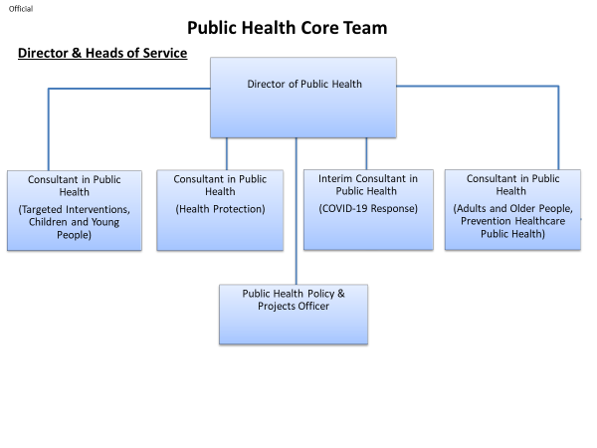
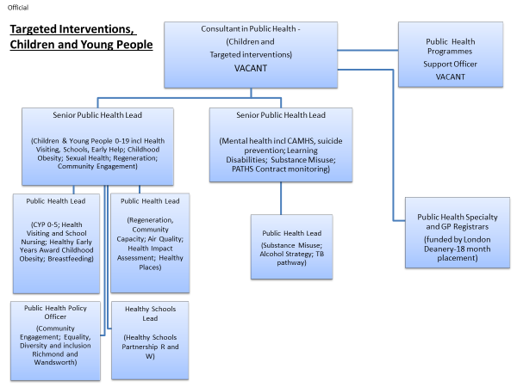

Person Specification

Job Title:  Public Health Lead, Children and Young People | Grade:  PO6
Section:  Public Health | Directorate:  Adult Social Care and Public Health
Responsible to following manager:  Senior Public Health Lead (Health  Protection) | Responsible for following staff:  N/A
Post Number/s: | Last review date: September 2021

Our Values and Behaviours

The values and behaviours we seek from our staff draw on the high standards of the two boroughs, and we prize these qualities in particular:

Being open. This means we share our views openly, honestly and in a thoughtful way. We encourage new ideas and ways of doing things. We appreciate and listen to feedback from each other.

Being supportive. This means we drive the success of the organisation by making sure that our colleagues are successful. We encourage others and take account of the challenges they face. We help each other to do our jobs.

Being positive and helpful. Being positive and helpful means, we keep our goals in mind and look for ways to achieve them. We listen constructively and help others see opportunities and the way forward. We have a ‘can do’ attitude and are continuously looking for ways to help each other improve.

Person Specification Requirements | Essential / Desirable | Assessed by A & I/ T/ C
Knowledge
Understanding of social and political environment, including national and local policy, strategies, and guidance. | E | A / I
Understanding of epidemiology and statistics, public health practice, health promotion, health inequalities and the wider determinants of health, and health care evaluation. | E | A / I / T
Experience
Substantial experience in public health or health-related posts. | E | A / I
Experience of project management and delivery. | E | A / I
Experience of multiagency working and managing stakeholders. | E | A / I
Contributing to the delivery of public health initiatives. | E | A / I
Experience in the children’s and start well public health agenda. | D | A / I
Managing teams, direct and/or indirect reports | D | A/I
Skills
Excellent communicator in oral, written and presentation skills. | E | A/I/
Excellent report writing skills with ability to translate complex information and create high quality written material, including statistical tables, for a wide range of audiences. | E | A / I /
Ability to analyse and interpret information for effective decision making, undertake literature review and critically assess evidence. | E | A/I/
Ability to think strategically, creatively, analyse, manage problems, and develop solutions. | E | A / I /T
Effective team member with strong interpersonal, influencing and facilitation skills. | E | A / I
Flexible, pro-active, uses initiative, prioritises, manages own workload, and works well under pressure and to tight timeframes with minimal supervision. | E | A / I
Ability to work autonomously and with minimal supervision. | E | A /I
Ability to carry out research and evaluate research carried out by others. | E | A / I
Commitment to undertaking continuous professional development (CPD) | E | A / I
Computer literate with ability to produce reports, presentations, spread sheets, databases. | E | A / I /
Ability to manage budgets and prepare bids for external funding. | D | A / I
Qualifications
Post-graduate degree in public health/related discipline or equivalent experience | E | A/I/C
Registered with a relevant public health body or working towards this is desirable - e.g. UKPHR. | D | A/I/C
A – Application form, I – Interview, T – Test C - Certificate

Gov (2019). Public Health Skills and Knowledge Framework: Mapping Tool. Available at: https://www.gov.uk/government/publications/public-health-skills-and-knowledge-framework-tools-and-guidance
As part of the recruitment process, you will be required to undertake a test that will assess capabilities in areas outlined in the person specification above.

