Job Profile comprising Job Description and Person Specification
Job Description

Job Title:  CAFM Administrator | Grade:  SO2
Section:  FM Performance - Property Services | Directorate:  Housing & Regeneration
Responsible to following manager:  CAFM Manager | Responsible for following staff:  Not applicable
Post Number/s: | Last review date: September 2018

Working for the Richmond/Wandsworth Shared Staffing Arrangement

This role is employed under the Shared Staffing Arrangement between Richmond and Wandsworth Councils. The overall purpose of the Shared Staffing Arrangement is to provide the highest quality of service at the lowest attainable cost.

Staff are expected to deliver high quality and responsive services wherever they are based, as well as having the ability to adapt to sometimes differing processes and expectations.

The Shared Staffing Arrangement aims to be at the forefront of innovation in local government and the organisation will invest in the development of its staff and ensure the opportunities for progression that only a large organisation can provide.

Job Purpose
To deputise in the absence of the CAFM Manager.
Work closely with the CAFM Manager and the CAFM provider Concerto to continually develop the system to maximise use of the system capabilities. To assist with training to all end users.

Specific Duties and Responsibilities

- Support and deputise in the absence of the CAFM Manager in the continuous development and ongoing management of the CAFM system ensuring that CAFM data is always accurate and up to date. Ensure that the FM Building Services annual PPM Plan tasks are scheduled on the due date(s) to maintain compliance with Statutory and Regulatory requirements.
- Responsible for providing technical support in the development of an SSA security access control system which will be functional across both boroughs.
- Work closely with key stakeholders including Directors and Senior Officers to ensure access control is installed, maintained and updated to meet the needs of the SSA.
- Working closely with FM Helpdesk and FM Team(s) to monitor FM service delivery performance and ensure high standards of quality, customer service and customer satisfaction.
- Manage the version control of the technical and working guides to the CAFM system. Ensuring that the documents are reviewed and reissued at pre-defined frequencies.
- Act as the SPOC for 3rd party supply partner queries and faults relating to the CAFM system. This may include visits to 3rd party supplier sites to deliver training in CAFM use.
- Provide first line support, and where appropriate escalation of issues to central IT or Concerto to ensure quick resolution of issues. This includes mobile application support.
- Assist in the preparation of management information and forecasting of FM operational (opex) and capital programme (capex) expenditure against budget. Support system administration tasks including user management
- Add/remove/amend site information and/or asset data, ensuring that the system is updated to ensure that the planned task schedules reflect current data.
- Responsible for the wider development opportunities for the CAFM system, e.g. Integration with Capita finance system.
- Ensure the integrity of data is maintained by carrying out regular audit checks.
- Deputise in the absence of the CAFM Manager. Develop and produce management information reports and data analysis, relating to FM service Key Performance Indicators. Develop bespoke reports as required. Identify opportunities to improve the effectiveness of the CAFM system.

Generic Duties and Responsibilities

- To contribute to the continuous improvement of the services of the Boroughs of Wandsworth and Richmond.

- To comply with relevant Codes of Practice, including the Code of Conduct and policies concerning data protection and health and safety.

- To adhere to security controls and requirements as mandated by the SSA’s policies, procedures and local risk assessments to maintain confidentiality, integrity, availability and legal compliance of information and systems.

- To promote equality, diversity, and inclusion, maintaining an awareness of the equality and diversity protocol/policy and working to create and maintain a safe, supportive and welcoming environment where all people are treated with dignity and their identity and culture are valued and respected.

- To understand both Councils’ duties and responsibilities for safeguarding children, young people and adults as they apply to the role within the council.

- The Shared Staffing Arrangement will keep its structures under continual review and as a result the post holder should expect to carry out any other reasonable duties within the overall function, commensurate with the level of the post.
Additional Information
Super-user responsibility for Concerto CAFM system and SSA Access Control system(s).

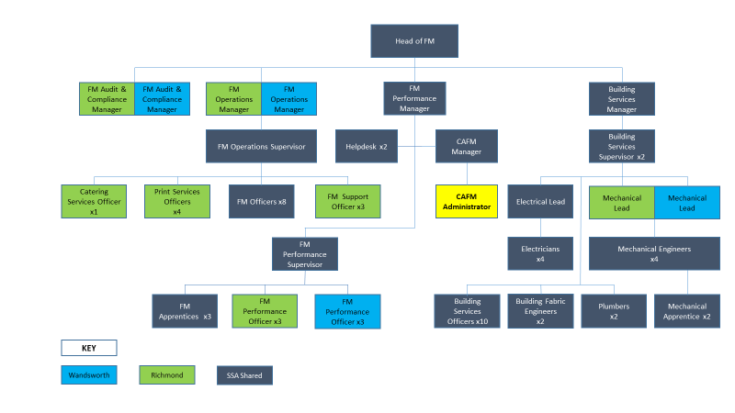
Team Structure

Person Specification

Job Title:  CAFM Administrator | Grade:  SO2
Section:  FM Performance -Property Services | Directorate:  Housing & Regeneration
Responsible to following manager:  CAFM Manager | Responsible for following staff:  Not applicable
Post Number/s: | Last review date: October 2017

Our Values and Behaviours
The values and behaviours we seek from our staff draw on the high standards of the two boroughs, and we prize these qualities in particular –

- taking responsibility and being accountable for achieving the best possible outcomes – a ‘can do’ attitude to work
- continuously seeking better value for money and improved outcomes at lower cost
- focussing on residents and service users, and ensuring they receive the highest standards of service provision
- taking a team approach that values collaboration and partnership working.

Person Specification Requirements | Assessed by  A & I/ T/ C
Knowledge
Excellent knowledge of IT system methodology and how systems can be developed to meet the specific needs of the FM user group | A & I
A sound knowledge of Information Security, Data Protection and Business Continuity issues so that these can be considered during the development of an IT system | A & I
An understanding of the Council’s organisation and methods to appreciate the potential for CAFM system development | A & I
Experience
Experience of developing IT systems to meet the specific needs of an FM user group | A & I
Experience of dealing with IT system suppliers and specifying system developments with them | A & I
Experience of successfully managing change and contributing to / advising a project team | A & I
Skills
Exceptional IT skills in order to develop systems and innovate practical solutions to meet users’ demands | A & I
The ability to assimilate information and apply it to CAFM system development through workflow solutions | A & I
Organise and prioritise own workload, to work under pressure and meet deadlines. | A & I
Qualifications
GCSE level education; or vocational qualifications in relevant management or administration subjects or equivalent | A & I

A = Application form, I = Interview, T = Test, C = Certificate

