**Job Profile comprising Job Description and Person Specification**

**Job Description**

|  |  |
| --- | --- |
| **Job Title:** Strategic Hub Lead – Careers Hubs | **Grade**: PO5 £41,292 – £50,034 |
| **Section:** South London Partnership | **Directorate:** Chief Executive |
| **Responsible to following manager:**  Polly Persechino | **Responsible for following staff:** Operational Hub Lead – Careers Hub |
| **Post Number/s:** | **Last review date:** 10th December 2021 |

**Working for the Richmond/Wandsworth Shared Staffing Arrangement**

This role is employed under the Shared Staffing Arrangement between Richmond and Wandsworth Councils. The overall purpose of the Shared Staffing Arrangement is to provide the highest quality of service at the lowest attainable cost.

Staff are expected to deliver high quality and responsive services wherever they are based, as well as having the ability to adapt to sometimes differing processes and expectations.

The Shared Staffing Arrangement aims to be at the forefront of innovation in local government and the organisation will invest in the development of its staff and ensure the opportunities for progression that only a large organisation can provide.

**Job Purpose**

Careers Hubs and the wider Enterprise Adviser Network are the external infrastructure for delivery of The Careers & Enterprise Company’s objectives to improve careers education for 11-18-year olds. Our Network acts as a catalyst, connecting employers with schools and colleges throughout England to deliver world-class careers education.

Careers Hubs build on the tried and tested model of partnership and collaboration where the virtual Hub is the centre point of a localised careers offer, accessible to all mainstream schools and colleges across that geography. Careers Hubs lead partnerships of schools, colleges, South London Partnership, local authorities, local businesses and careers providers, helping young people connect closely to local skills and economic need through a tailored careers education programme.

Through joining a Careers Hub, we enable schools and colleges to receive professional guidance in how to develop their careers programme, peer to peer support and learning in what works, access to funding and coordinated activity. The Hubs are incubators for innovation, taking our national mantra of test, learn and adapt and applying that locally. Nationally, we’ve created a network of Careers Hubs, bringing together the Hub leaders regularly to review progress, share good practice, collaborate and innovate. All of which is accelerating progress rapidly.

The South London Partnership are establishing a Careers Hub in south London and are looking for a strong and enthusiastic Strategic Lead who will drive systemic change in careers education in south London and ensure the Careers Hub is fully integrated into the education, skills and employment ecosystem.

**Specific Duties and Responsibilities**

Lead and drive sustainable system change in careers provision within the hub and as part of the -national network of Careers Hubs across England by ensuring the hub is at the centre of local careers provision and policy making decisions

Lead and drive cross sector engagement and collaboration to ensure all young people can access high quality careers and enterprise education that aligns with the South London Economic Recovery Action Plan, growth, economic and skills priorities, ensures improved career outcomes and achieves sustainable change in careers provision at a local and national level.

Lead, manage and develop a team of delivery professionals and volunteers to provide high quality careers provision in accordance with the best practice outlined in Gatsby Benchmarks, the Government’s Careers Strategy and the Grant Funding Agreement with the Careers and Enterprise Company.

**The main responsibilities include:**

Create the vision, set and direct the long-term strategy for the Careers Hub with clearly defined and measurable outcomes that evidence sustained change in careers provision for all young people.

Build and implement a Careers Hub strategic plan that harmonises local economic and skills priorities, achieves sustained change in careers provision and meets the Grant Funding Agreement.

Lead, develop and retain a team of staff and volunteers from business, to deliver the work streams and achieve the outcomes outlined in the Careers Hub strategic plan and achieve the Grant Funding Agreement.

Work closely with Operational Hub Leads to ensure the team are supported to achieve results as identified in the strategic plan and Grant Funding Agreement.

Build an accountability culture and climate where staff and stakeholders are empowered to achieve results. Embed a structured process for setting objectives, tracking progress and providing support and direction to address performance gaps.

Establish a governance group of relevant local senior stakeholders to support and steer the direction of the Careers Hub and act as a guiding coalition to enable change.

Engage and influence senior cross sector leaders and stakeholders to support the delivery of the strategic plan by providing inspiration, thought leadership and driving cross sector engagement and collaboration to deliver the strategic plan.

Implement a culture and process for continuous improvement, fostering innovation, embedding quality assurance and driving sustainable change across the team and the wider hub community.

Evidence impact and elevate the achievements of the Careers Hub ensuring it is established as the beacon of best practice, able to influence policy and wider practice on careers across the region and nationally.

Establish a model to cascade the learning and scale best practice from within the Hub to schools, colleges, and delivery partners beyond the hub to drive sustainable change in career provision for all young people.

Establish and embed robust systems and processes for contract management, financial and risk management and tracking and reporting on key deliverables. Ensure clear accountabilities, transparency and decision-making structures are in place to ensure the hub budget and Grant Funding Agreement reporting requirements are achieved.

Collaborate with other Hub Leads to support peer to peer learning, engage with action learning sets, scale best practice and be part of the movement that is driving sustained change in careers provision at a national, regional as well as local level.

Establish and embed a research and evaluation methodology to demonstrate the impact of the Careers Hub.

**Generic Duties and Responsibilities**

* To contribute to the continuous improvement of the services of the Boroughs of Wandsworth and Richmond.
* To comply with relevant Codes of Practice, including the Code of Conduct and policies concerning data protection and health and safety.
* To adhere to security controls and requirements as mandated by the SSA’s policies, procedures and local risk assessments to maintain confidentiality, integrity, availability and legal compliance of information and systems
* To promote equality, diversity, and inclusion, maintaining an awareness of the equality and diversity protocol/policy and working to create and maintain a safe, supportive and welcoming environment where all people are treated with dignity and their identity and culture are valued and respected.
* To understand both Councils’ duties and responsibilities for safeguarding children, young people and adults as they apply to the role within the council.
* The Shared Staffing Arrangement will keep its structures under continual review and as a result the post holder should expect to carry out any other reasonable duties within the overall function, commensurate with the level of the post.

**Additional Information**

**Team structure**

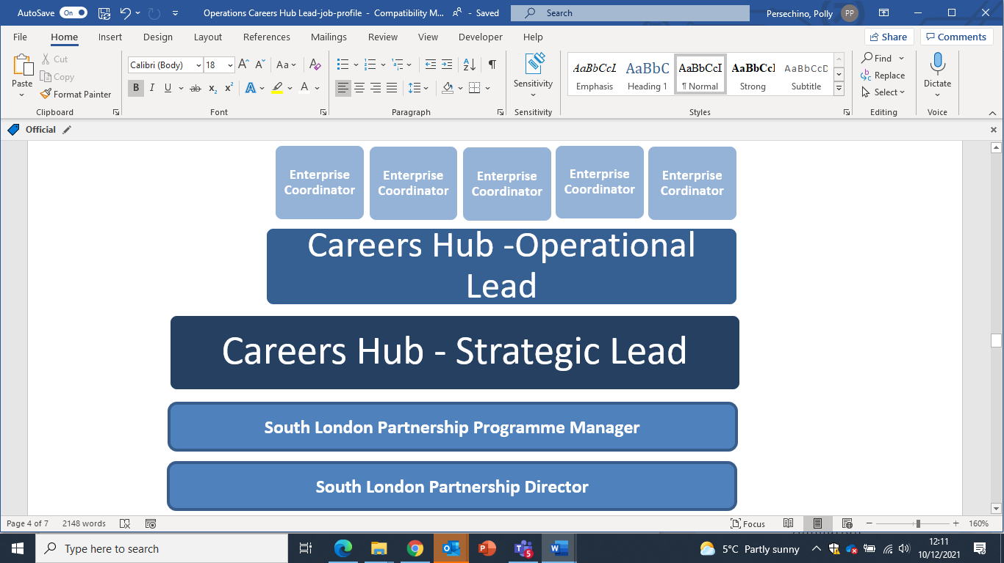

**Person Specification**

**Our Values and Behaviours**

The values and behaviours we seek from our staff draw on the high standards of the two boroughs, and we prize these qualities in particular:

**Being open.** This means we share our views openly, honestly and in a thoughtful way. We encourage new ideas and ways of doing things. We appreciate and listen to feedback from each other.

**Being supportive.** This means we drive the success of the organisation by making sure that our colleagues are successful. We encourage others and take account of the challenges they face. We help each other to do our jobs.

**Being positive.** Being positive and helpful means we keep our goals in mind and look for ways to achieve them. We listen constructively and help others see opportunities and the way forward. We have a ‘can do’ attitude and are continuously looking for ways to help each other improve.

|  |  |
| --- | --- |
| **Person Specification Requirements** | **Assessed by**  **A**  **&**  **I/ T/ C (see below for explanation)** |
| **Knowledge** | |
| An understanding of school culture and the challenges faced by schools in delivering careers and enterprise education. | A,I |
| An understanding of relevant local and national policy relating to skills and economic development and the issues and barriers to employment faced by young people. | A,I |
| **Experience** | |
| Demonstrable experience and success of leading and managing a multi discipline field-based team that works with multiple stakeholders. | A,I |
| Demonstrable experience of managing performance, objective setting aligned to organisation goals and proactively addressing underperformance and coaching for improvement | A,I |
| Experience of strategic/ business planning, vision and mission creation. | A,I |
| A proven track record of engaging with and influencing senior, cross sector stakeholders to drive collaboration and affect change. | A,I |
| A proven track record of working with and navigating ambiguity. | A,I |
| A strong track record of communicating with a variety of audiences, preferably in the education and careers sector. | A,I |
| Strong evidence of initiating and managing the successful delivery of projects with impact and evaluation at their core to drive sustainable change. | A,I |
| An understanding of relevant local and national policy relating to skills and economic development and the issues and barriers to employment faced by young people. | A,I |
| A proven track record and understanding of contract management and grant funding and the fiscal and risk management associated with this. | A,I |
| A track record of achieving results in a matrix management structure and achieving balance between central and local management structures. | A,I |
| Experience of leading and managing programmes with volunteers from business | A,I |
| Experience of marketing and promotions communications and strategies to engage stakeholders. | A,I |
| Up to date knowledge of the careers education sector and the wider economic, political and social drivers of business for engaging with and supporting schools, colleges and young people. | A,I |
| **Skills** | |
| Strong leadership skills, able to set, communicate and inspire stakeholders to achieve a clear vision. | A,I |
| Highly effective at strategic planning/ business planning and managing performance against the outcomes within a plan. | A,I |
| Focussed and applies continuous improvement in all aspects of their work. | A |
| Strong relationship management skills, able to engage and influence stakeholder at all levels across a range of sectors both commercial and third sector. | A,I |
| Able to inspire and drive collaboration with a diverse range of stakeholders at all levels to drive results and affect change. | A,I |
| Articulate and confident public speaker and excellent communicator. | I |
| Excellent people management skills – able to set clear objectives, build accountability and empower a team to deliver on strategic outcomes. | A,I |
| Motivational, able to encourage and influence others to drive results. | A,I |
| Proficient contract manager, fiscally competent and able to manage and mitigate risk. | A,I |
| Highly organised - Proactive and can work autonomously, well developed time management skills and applies effective priority setting strategies. | A,I |
| Resilient, tenacious able to remain calm under pressure to achieve goals and remain focussed. | A,I |
| Able to manage ambiguity and achieve a balance between the demands of the local vs central management structures and priorities. | A,I |
| Competent user of mainstream IT software, web-based technology and social media. | A,I |
| **Qualifications** | |
| Educated to degree level or equivalent relevant professional qualification or experience | A,C |

**A – Application form / CV**

**I – Interview**

**T – Test**

**C - Certificate**

**South London Partnership**

The South London Partnership (SLP) is a cross-party five borough sub-regional partnership of Croydon, Kingston upon Thames, Merton, Richmond upon Thames and Sutton. Since relaunching in January 2016 under a new director it has built a small dynamic core team working closely with politicians, chief executives, senior managers and subject specialists in each of the five boroughs, as well as London and local stakeholders and partners. Together they have forged an ambitious programme of work that is securing greater sub-regional collaboration and traction on areas including health, skills and employment, economy and innovation.

The SLP boroughs collaborate sub-regionally on things where they can secure more together than individually. The SLP team focuses on areas where collaboration leads to increased influence, increased powers and funding and better delivery of the services our residents need.

SLP is hosted by Richmond Council. The post holder will therefore be employed by the Richmond and Wandsworth Shared Staffing Arrangement [SSA]. The team is usually based at the Richmond Civic Centre in Twickenham, but all team members can and are expected to work in other SLP borough offices when that makes sense to build working relationships and make most effective use of their time.

**Working from Home**

In the current climate, we will support all team members to work from home however, if you need to work from the office in order to do your job, or need to work away from home, all Richmond offices and Council buildings are open and safe for you. All offices will remain open, with safety precautions in place, so if you need to come to the office for your own personal wellbeing reasons, you are welcome to do so.