Job Profile comprising Job Description and Person Specification
Job Description

Job Title:  Benefit Visiting Officer | Grade:  Sc6-SO1
Section:  Benefit Service, Revenues | Directorate:  Resources
Responsible to following manager:  Team Leader : Resilience | Responsible for following staff:  n/a
Post Number/s: | Last review date:  April 2016

Working for the Richmond/Wandsworth Shared Staffing Arrangement

This role is employed under the Shared Staffing Arrangement between Richmond and Wandsworth Councils. The overall purpose of the Shared Staffing Arrangement is to provide the highest quality of service at the lowest attainable cost.

Staff are expected to deliver high quality and responsive services wherever they are based, as well as having the ability to adapt to sometimes differing processes and expectations.

The Shared Staffing Arrangement aims to be at the forefront of innovation in local government and the organisation will invest in the development of its staff and ensure the opportunities for progression that only a large organisation can provide.

Job Purpose
- To assist in the assessment and payment of Housing Benefit and/or Council Tax reduction according to government legislation, by visiting customers in their home to collect information and evidence to support their claim, and to check the accuracy of details provided.

Specific Duties and Responsibilities
- To provide an effective and efficiency visiting service by:
  - Maintaining a knowledge and understanding of Housing Benefit and Council Tax Reduction, and other associated welfare benefits
  - Assisting completion of application forms, verifying evidence, providing welfare benefit guidance, undertaking residency checks and other project visiting work
  - Organising own workload and visiting schedule to ensure that customers are seen within set performance targets and provide statistical information as required.
  - Using mobile technology to give up to date information and undertake assessments in the home or in the office
  - Attending surgeries / advice days to provide advice and promote take up of welfare benefits within the community

SO1 duties
  - Providing mentoring and completing quality assurance checks when requested by the Line Manager including undertaking shadowing of visits.
  - Investigating and responding to complaints, liaising where necessary with other sections.
  - Providing support to others and customers in explaining the more complex areas of regulations in writing, face to face interviews, surgeries and over the telephone

- To ensure that the services for both Councils are dealt with on an equitable basis to deliver the standards required for each, as agreed annually by the Executives of both Councils.

- To advise and support managers on relevant matters affecting the service

- To contribute as required to performance review and improvement measures on an ongoing basis, helping to ensure that a customer focus is embedded within the function and innovative and creative solutions are evaluated to securing the highest quality and value for money function

- To work as required in ways that develop good working relations and collaborative arrangements with internal and external stakeholders.

Generic Duties and Responsibilities
- To contribute to the continuous improvement of the services of the Boroughs of Wandsworth and Richmond.

- To comply with relevant Codes of Practice, including the Code of Conduct and policies concerning data protection and health and safety.

- To adhere to security controls and requirements as mandated by the SSA’s policies, procedures and local risk assessments to maintain confidentiality, integrity, availability and legal compliance of information and systems.

- To promote equality, diversity, and inclusion, maintaining an awareness of the equality and diversity protocol/policy and working to create and maintain a safe, supportive and welcoming environment where all people are treated with dignity and their identity and culture are valued and respected.

- To understand both Councils’ duties and responsibilities for safeguarding children, young people and adults as they apply to the role within the council.

- The Shared Staffing Arrangement will keep its structures under continual review and as a result the post holder should expect to carry out any other reasonable duties within the overall function, commensurate with the level of the post.

Additional Information
- Lone Worker
- DBS required

Current team structure

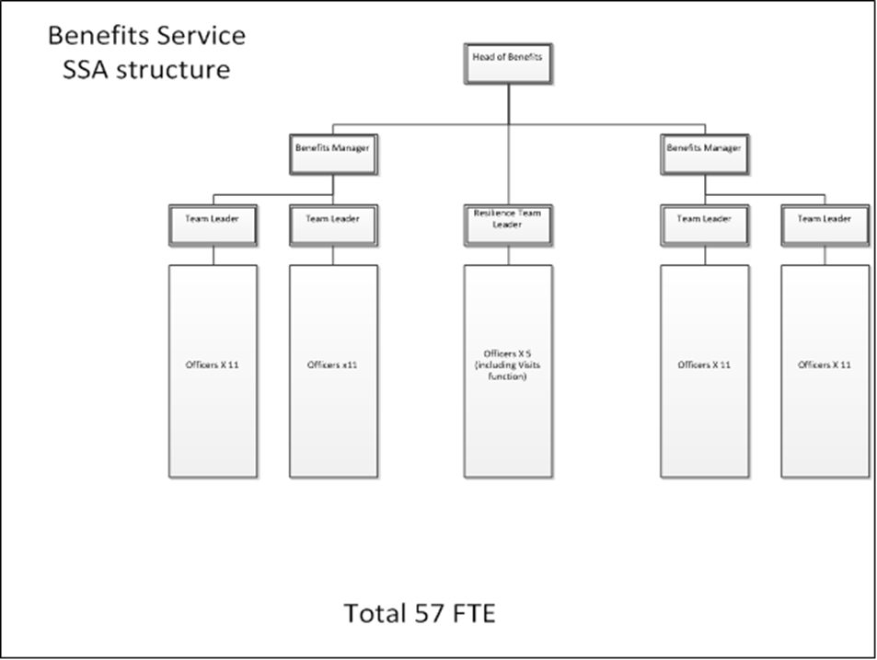

Person Specification

Job Title:  Benefit Visiting Officer | Grade:  Sc6-SO1
Section:  Benefit Service | Directorate:  Resources
Responsible to following manager:  Team Leader: Resilience | Responsible for following staff:  n/a
Post Number/s: | Last review date:  April 2016
Our Values and Behaviours
The values and behaviours we seek from our staff draw on the high standards of the two boroughs, and we prize these qualities in particular:
Being open. This means we share our views openly, honestly and in a thoughtful way. We encourage new ideas and ways of doing things. We appreciate and listen to feedback from each other.
Being supportive. This means we drive the success of the organisation by making sure that our colleagues are successful. We encourage others and take account of the challenges they face. We help each other to do our jobs.
Being positive. Being positive and helpful means we keep our goals in mind and look for ways to achieve them. We listen constructively and help others see opportunities and the way forward. We have a ‘can do’ attitude and are continuously looking for ways to help each other improve.

Person Specification Requirements | Assessed by  A  & I/ T/ C (see below for explanation)
Knowledge
Basic knowledge of and ability to use standard IT packages (Microsoft Office and Outlook) | A/I
Knowledge of Housing Benefit and Council Tax Reduction and other related Welfare Benefits | A/I/T
SO1
Detailed knowledge of Housing Benefit and Council Tax Reduction and other related Welfare Benefits | A/I/T
Experience
Experience of dealing with the public within a diverse working environment | A/I
Evidence of working in changing circumstances | A/I
SO1
Experience of working within a Housing Benefit & Council Tax Reduction environment | A/I
Experience of providing an excellent customer service as a lone worker | A/I
Skills
Good level of oral and written skills to provide clear and concise messages | A/I
Ability to use IT systems and mobile technology to record visits, assess cases and provide management data. | A/I
Ability to organise and prioritise own workload, within defined requirements for the role. | A/I
Ability to undertake financial calculations | A/I/T
SO1
Ability to understand and deal with more complex areas of the legislation | A/I/T
Ability to deputise for the Team Leader | A/I
Qualifications
n/a

A – Application form
I – Interview
T – Test
C - Certificate

