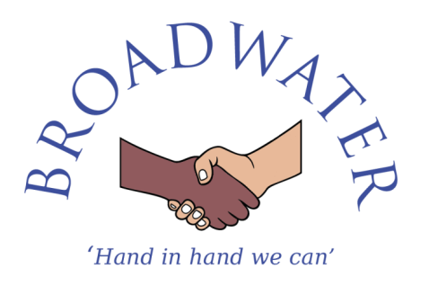

Person Specification – Site Manager

Site Manager Selection Criteria | Essential or  Desirable
Qualifications
- Hold recognised training/qualifications associated with premises management.  - Risk Assessment experience and/or qualification.  - Hold a pool technician qualification (desirable).  - Willingness to participate in development and training opportunities  - Full, clean driving licence | - Essential  - Essential  - Desirable  - Essential  - Essential
Experience
- Significant experience or skills in a trade.  - Experience of working in a school environment  - Staff management experience. | - Desirable  - Desirable  - Desirable
Professional knowledge and understanding
- The ability to understand and apply regulations such as health & safety, manual handling, COSHH, Legionella etc.  - The ability to operate and understand electrical/mechanical systems.  - Competent at basic building repairs and maintenance.  - To be able to use small industrial, electrical and mechanical equipment.  - Knowledge of safeguarding children and young people  - Awareness of health and safety | - Essential  - Essential  - Essential  - Essential  - Essential  - Essential
Skills
- Able to perform the physical tasks required by the post including lifting, carrying and pushing various equipment to undertake the duties of the post.  - Good level of written and spoken English.  - Excellent numeracy and literacy skills.  - Good ICT skills.  - Sound planning and negotiating skills.  - Able to gather information, analyse data and problem solve.  - Able to manage own time effectively and demonstrate initiative including establishing priorities.  - Able to prioritise and manage workflow within specific deadlines whilst maintaining a flexible approach to respond to urgent requests.  - Display a conscientious and logical approach to the variety of tasks necessary for the smooth running of the school.  - Able to manage people directly and indirectly.  - Able to adapt to changing and conflicting demands.  - Able to model an assertive and respectful way in talking and dealing with children.  - Able to model the idea of respect between all staff and pupils.  - Able to engage with and communicate effectively to a range of audiences  - Able to judge when to make decisions and when to consult with others  - Able to deal sensitively with people and resolve conflicts | - Essential  - Essential  - Essential  - Essential  - Essential  - Essential  - Essential  - Essential  - Essential  - Essential  - Essential  - Essential  - Essential  - Essential  - Essential  - Essential

Professional Qualities
- Committed to excellence with high aspirations for all pupils  - Committed to the maintenance of good relationships with staff, parents, pupils, governors, the community and other stakeholders  - Well organised and able to work under pressure and to deadlines  - Able to self-evaluate learning needs and actively seek professional development opportunities  - Committed to equality, with respect and empathy to all  - Enthusiastic and inspiring to staff, pupils and parents  - Consistent and fair to all  - Capacity to be flexible and adaptable – willing to take on and develop the best of ideas from within and outside the school  - Able to comply with policies and procedures  - Able to respond to every day and emergency situations calmly and quickly  - Resilient and has a good sense of humour | - Essential  - Essential  - Essential  - Essential  - Essential  - Essential  - Essential  - Essential  l  - Essential  - Essential  - Essential

Broadwater Primary School is committed to safeguarding and promoting the welfare of children and young people and expects all staff and volunteers to share this commitment. This post is subject to an enhanced Disclosure & Barring Service (DBS) check.

