Job Profile comprising Job Description and Person Specification
Job Description

Job Title:  Public Health Programmes Support Officer | Grade:  SO1
Section:  Public Health | Directorate:  Adult Social Care and Public Health
Responsible to following manager:  Consultant in Public Health – Health Protection | Responsible for following staff:  N/A
Post Number/s: RWA7304 | Last Review Date: May 2021

Working for the Richmond/Wandsworth Shared Staffing Arrangement

This role is employed under the Shared Staffing Arrangement between Richmond and Wandsworth Councils. The overall purpose of the Shared Staffing Arrangement is to provide the highest quality of service at the lowest attainable cost.

Staff are expected to deliver high quality and responsive services wherever they are based, as well as having the ability to adapt to sometimes differing processes and expectations.

The Shared Staffing Arrangement aims to be at the forefront of innovation in local government and the organisation will invest in the development of its staff and ensure the opportunities for progression that only a large organisation can provide.

Job Purpose

Responsible for providing project management support and coordination to the Consultant in Public Health and their team. To assist with the management of projects, contracts and initiatives, and provide generic support.

Specific Duties and Responsibilities

- Be responsible for the day-to-day administration of designated project activities, working closely with all members of the project to provide administrative research and logistical support.
- Under the supervision of the Consultant in Public Health to facilitate, engage and finalise action plans and follow-up as appropriate.
- To develop and roll out a standardised approach of project management across their team.
- Handle confidential information/processes, for example those relating to Independent Funding Reviews, adult safeguarding and child safeguarding, child overview death panel issues, and all aspects of clinical and quality governance.
- Draft, produce and quality assures documentation, including complex planning documents, reports, letters, memorandums, minutes and agendas.
- Maintains a plan of reports and actions and ensures that all corporate documents are in line with business planning processes/schedules and committee report guidelines.
- Assists in providing office support to the Consultant in Public Health and the team, to ensure the smooth running of the department, including dealing with enquiries and any other activities required within the service. Working in partnership with other officers within Public Health, other services and outside organisations as required.
- Arrange high level meetings including cross-borough/agency meetings, including booking venues etc.
- Deal with urgent diary issues for the Consultant in Public Health and provide initial response in their specialist areas.
- Provide cover for the Director of Public Health’s Assistant when absent, including telephone and other cover as required.

Generic Duties and Responsibilities

- To contribute to the continuous improvement of the services of the Boroughs of Wandsworth and Richmond.

- To comply with relevant Codes of Practice, including the Code of Conduct and policies concerning data protection and health and safety.

- To adhere to security controls and requirements as mandated by the SSA’s policies, procedures and local risk assessments to maintain confidentiality, integrity, availability and legal compliance of information and systems

- To promote equality, diversity, and inclusion, maintaining an awareness of the equality and diversity protocol/policy and working to create and maintain a safe, supportive and welcoming environment where all people are treated with dignity and their identity and culture are valued and respected.

- To understand both Councils’ duties and responsibilities for safeguarding children, young people and adults as they apply to the role within the council.

- The Shared Staffing Arrangement will keep its structures under continual review and as a result the post holder should expect to carry out any other reasonable duties within the overall function, commensurate with the level of the post.
Additional Information
- Post holder will be expected to work flexibly across two locations (Wandsworth Town Hall and Richmond Civic Centre).

Team structure:
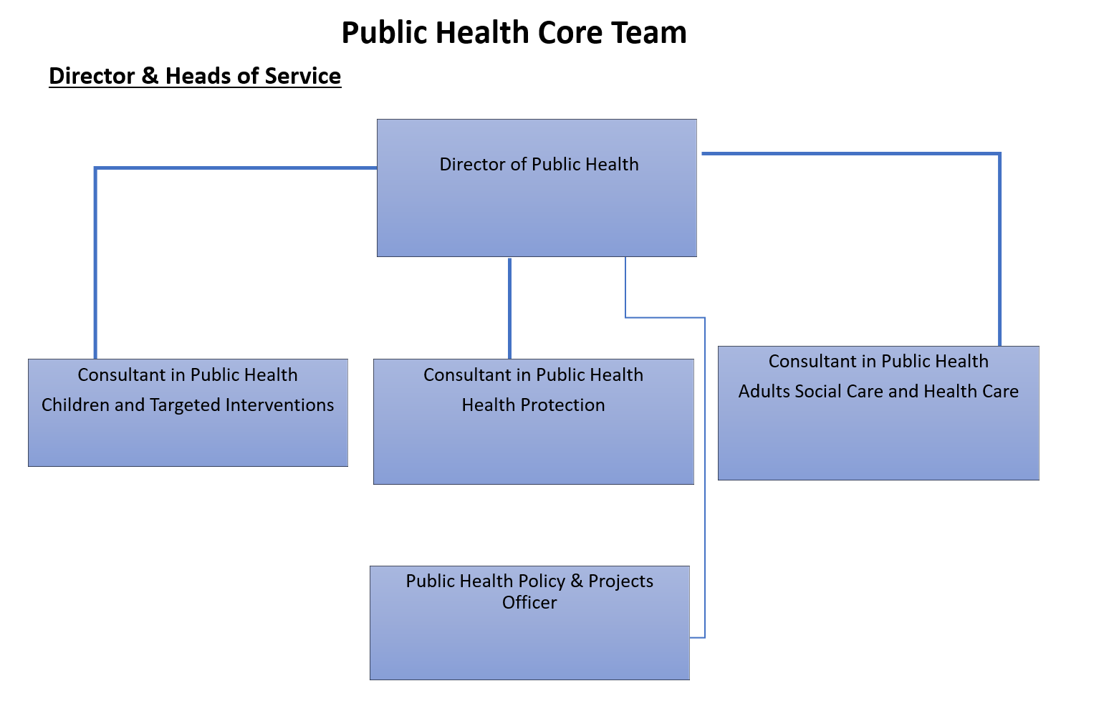

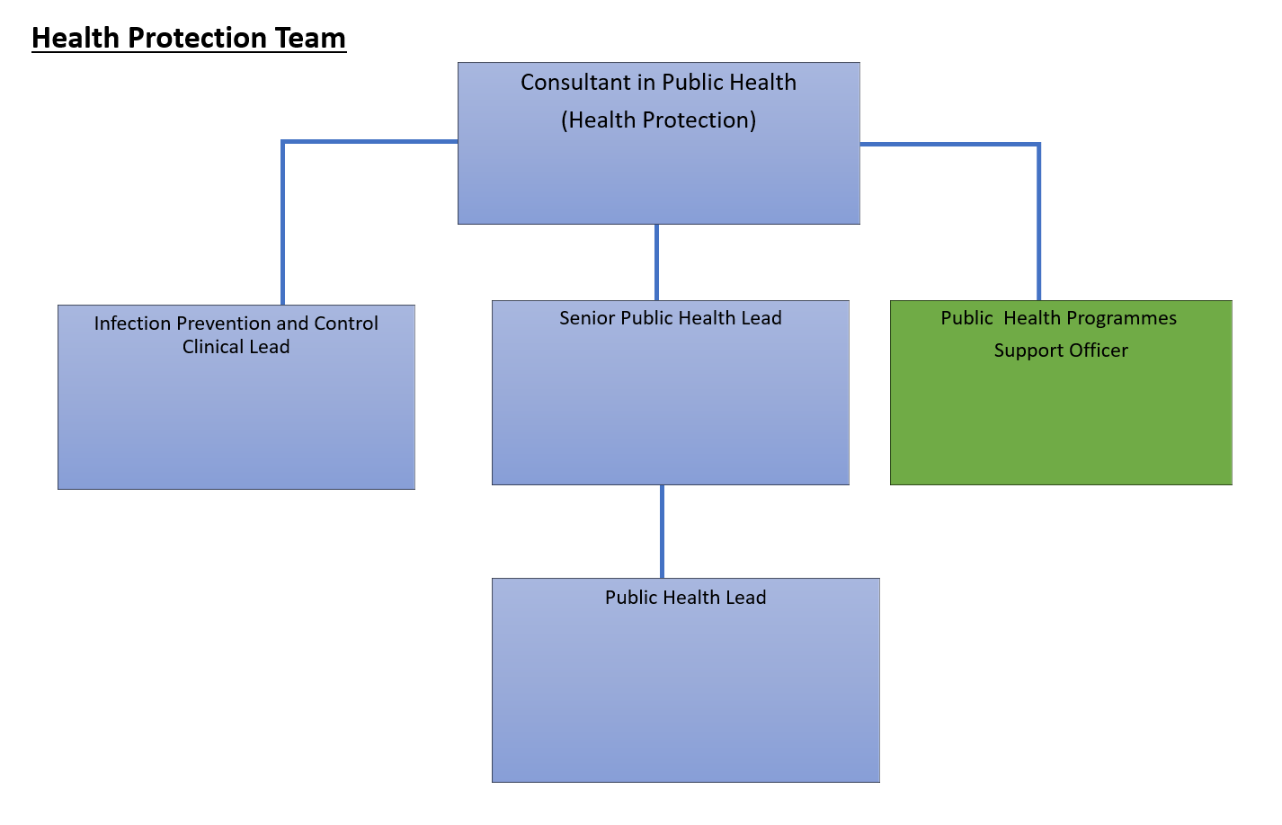
Person Specification

Job Title:  Public Health Programmes Support Officer | Grade:  SO1
Section:  Public Health | Directorate:  Adult Social Care and Public Health
Responsible to:  Consultant in Public Health - Health Protection | Responsible for:  N/A
Post Number/s: RWA7304 | Last Review Date: May 2021

Our Values and Behaviours

The values and behaviours we seek from our staff draw on the high standards of the two boroughs, and we prize these qualities in particular:

Being open. This means we share our views openly, honestly and in a thoughtful way. We encourage new ideas and ways of doing things. We appreciate and listen to feedback from each other.

Being supportive. This means we drive the success of the organisation by making sure that our colleagues are successful. We encourage others and take account of the challenges they face. We help each other to do our jobs.

Being positive. Being positive and helpful means we keep our goals in mind and look for ways to achieve them. We listen constructively and help others see opportunities and the way forward. We have a ‘can do’ attitude and are continuously looking for ways to help each other improve.

Person Specification Requirements | Assessed by  A  & I/ T/ C (see below for explanation)
Knowledge
Advanced knowledge of Microsoft Office, including Outlook, Word, Excel and PowerPoint. | A/I/T
Experience
Experience of working consistently as an administrator and project officer at a senior level. | A/I/T
Skills
Demonstrable project management skills. | A/I
The ability to work effectively and accurately to tight deadlines in a sometimes challenging environment and to manage multiple project deadlines. | A/I
Ability to organise and prioritise own work in an efficient and effective way, and to work with minimum supervision. | A/I
A high level of office and business management skills, diary management and the ability to organise meetings. | A/I/T
Be able to demonstrate a meticulous approach and an eye for detail. | A/I
The ability to communicate effectively and sensitively, orally and in writing on a wide range of detailed issues. | A/I/T
The ability to take and transcribe action points/minutes of meetings and draft non-standard correspondence. | A/I/T
Be able to collate information and maintain files and records accurately on computerised and manual recording systems. | A/I
Be able to work as part of a team and be able to deal confidently, tactfully, calmly and sensitively with a wide range of Officers and professionals at all levels inside and outside of the organisation. | A/I
Qualifications
Project management qualification or evidence of equivalent qualification and experience. | A/C
A – Application form / CV
I – Interview
T – Test – one or more of these areas may be assessed as part of the recruitment process
C – Certificate

These values and behaviours will be developed further as the SSA becomes established.

