Rutherford House School

Balham High Road

London

SW17 7BQ

Join Our Team

Class teachers required

October 2024 start

Welcome to Rutherford House School

Thank you for your interest in the position of Class Teacher (Maternity Cover) at RHS.

Opening in 2013, Rutherford House School was the first free school established by Bellevue Place

Education Trust. Our aim is to provide a broad, exciting education in a happy environment with a commitment to ensuring pupils achieve their full potential. Children are encouraged to learn independently and are treated as individuals celebrating their unique set of talents.

At Rutherford House School our philosophy is to promote excellence and outstanding progress in the basics- reading, writing and maths whilst sparking curiosity and instilling a lifelong love of learning and curiosity. We are a successful two-form entry school located in South London, Balham, routinely achieving well above national average by the end of KS2.

We are a creative school, looking for an inspirational, motivated and dynamic teacher with **Upper Key stage 2 experience (no ECTs)**  to join our committed and forward thinking team. This is a real opportunity for a forward thinking teacher to develop their teaching and leadership potential in a unique setting. We are looking to appoint someone with a positive outlook and a proactive attitude, ready to make a difference.

Our outstanding candidate will have the strong interpersonal skills to foster links between the school, home and the wider community.

**We are looking for qualified teachers who can evidence:**

•    Strong cross curriculum knowledge

•    A desire to raise achievement for all pupils

•    Resourcefulness and the ability to drive and embrace change

•    A commitment to our school vision and shared values

If you are ready for a new and exciting challenge, we will offer you:

* A commitment to well-being and work life balance
* Generous PPA and pupil conferencing time
* A strong commitment to the innovative use of technology to ensure efficient ways of working
* Excellent peer support from our outstanding, supportive and friendly team
* Supportive parents and a fantastic PTA
* A positive and innovative working environment
* Professional development and opportunities for middle leadership
* Opportunities for career progression and wider professional experiences in a Trust with a range of schools serving a variety of different communities

.

If you have the skills, experience and drive to be successful in this role, please download and complete the attached documents.

Application packs are available from [info@rutherfordhouseschool.co.uk](mailto:info@rutherfordhouseschool.co.uk) or can be downloaded from our school website at www.rutherfordhouseschool.co.uk

Our Values

At Rutherford House School we believe that the teaching of values helps children to understand how they should treat other people and how they should expect to be treated themselves which in turn will help them to make positive choices throughout their lives. It also encourages them to see learning a lifelong journey, as something they are involved in and not happening to them. Our aim is that pupils are happy, independent lifelong learners.



Our House Teams

Our Year 6 pupils have been working with senior leaders to develop the House Teams: Saphhire, Topaz, Ruby and Emerald. They have developed their own team chant and shields. Each pupil from Reception to Year 6 has been assigned to a team and opportunities to work collaboratively are built into each half term.

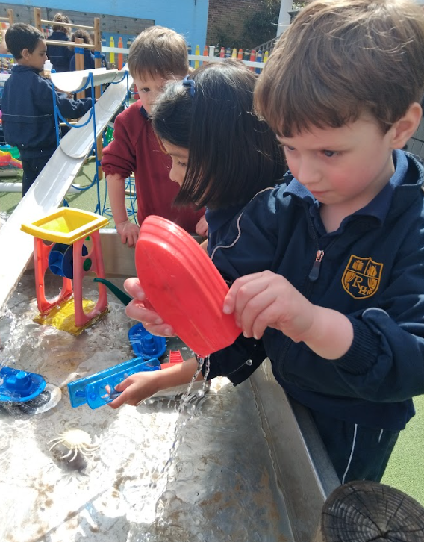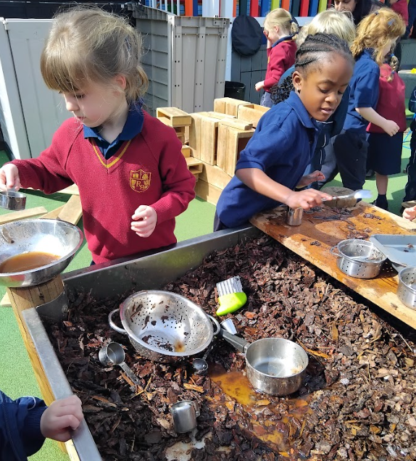

Job Description

Class Teacher (Maternity Cover) - Teachers’ Pay Scale

**Reporting to:** Headteacher, & Senior Leadership Team and Governors

This job description should be read in conjunction with the current School Teachers’ Pay and Conditions Document and the provisions of that document will apply to the post holder.

**Purpose:**

* To be a leader of learning who has high expectations of every child.
* To carry out the professional duties of a Class Teacher, with due regard to the requirements of the National Curriculum, to ensure high quality education for all our pupils
* Be able to provide a carefully structured and thorough education experience, which enables pupils to achieve their academic and personal potential and to develop skills appropriate to the world of work and life in the twenty first century.
* To encourage pupils to participate in an extensive range of sporting, cultural and enriching activities; to develop an understanding of our responsibilities and our duty to serve the local, national and global communities.

**Responsibilities:**

* The post holder is responsible to their line manager and to the Headteacher for his/her duties, responsibilities and teaching tasks.
* The post holder undertakes the teaching of the pupils in his/her class and the associated pastoral and administrative duties in respect of those pupils as well as the general responsibilities in the school as agreed with the Head.
* The post holder will interact on a professional level with all colleagues and establish and maintain good working relationships, which will promote the development and effective delivery of the school curriculum and maximise children’s achievement.
* The post holder will be responsible for the supervision of the work of support staff and any students who may be on teaching practice or work placement.
* The post holder will be responsible for the development and implementation of an engaging, accessible and relevant curriculum.
* The post holder will be responsible for the pastoral care and safeguarding of the children within their class or groups, ensuring that children’s safety, wellbeing and welfare are at the forefront of all they do.

**Professional Conduct**

* To fully support the aims and ethos of the school
* To set an excellent example to children, staff and parents in terms of presentation and personal conduct
* To relate positively to colleagues, establishing effective and professional working relationships
* To implement all current school policies and procedures
* To safeguard the health and safety of pupils at all times
* To carry out any other such duties which may be required from time to time to meet the needs of the school
* To have professionalism and understand the importance of confidentiality and behave appropriately including social media platforms

**Teaching and Learning**

* To have a thorough knowledge and understanding of the National Curriculum
* To plan and prepare programmes of work which meet the needs of the full range of children’s abilities in the class/group
* To identify clear objectives and expected outcomes for children’s learning, building upon their prior attainment, adopting a range of strategies to meet their different learning styles
* To set high expectations for behaviour, establishing positive relationships and a stimulating learning environment
* To provide effective teaching of whole classes, groups and individuals so that learning aims/objectives are met, momentum and challenge are maintained and best use is made of teaching time
* To use data effectively to identify pupils who are underachieving and, where necessary, create and implement effective plans of action to support those pupils and accelerate their progress
* To plan and prepare work using appropriate resources to make learning accessible to all pupils, including those with Special Educational Needs and children speaking English as an Additional Language
* To identify pupils who have special educational needs and work within the school SEND policy in order to give positive and targeted support and implement provision maps/ IEPs
* To use teaching strategies which engage pupils and stimulate an enjoyment of learning
* To demonstrate effective questioning and responses and promote pupil voice in lessons
* To select and make good use of learning resources, including ICT and computing, which enable objectives to be met
* To manage resources appropriately in order to enable children to develop skills necessary for independent learning
* To plan the work of teaching assistants/ support staff for whom they have responsibility, ensure colleagues are briefed effectively and ensure that activities undertaken promote achievement of pupils

**Assessment and Evaluation**

* To assess, record and report the development, progress and attainment of pupils in accordance with the schools’ assessment and evaluation procedures
* To evaluate how well learning objectives have been achieved and use this evaluation to inform future planning and teaching
* To mark and monitor pupils’ class and homework in line with school policies
* To participate in arrangements, as appropriate, for preparing pupils for national assessments, recording and reporting results as required and participating in arrangements for pupils’ supervision at such times

**Relationships with Parents and the Community**

* To communicate effectively with parents, both formally and informally, thereby encouraging active participation in the education of their children
* To prepare and present informative written reports to parents annually
* To liaise with agencies responsible for pupils’ welfare and attend meetings when necessary
* To deal sensitively with members of all communities represented locally

**Professional Development**

* To understand the need to take responsibility for personal professional development and keep up to date with research and developments in pedagogy and in the subjects taught
* To participate in further training and professional development as appropriate
* To participate in staff meetings which relate to the curriculum or organisation of the school
* To participate in arrangements within the agreed framework for appraisal
* To reflect upon feedback from colleagues, self-evaluate own teaching and participate in the school’s aims to share good practice and improve the quality of practice

**Subject Leadership (where appropriate)**

To undertake subject leadership in a curriculum or related area and:

* + - Demonstrate excellent knowledge and understanding of the subject
    - Understand how the subject relates to the curriculum as a whole, demonstrating the characteristics of high-quality provision.
    - Review and develop a comprehensive policy for the subject
    - Identify, through effective monitoring of your subject area, realistic and challenging targets for improvement and lead professional development to support and challenge staff.

Person Specification

|  |  |  |
| --- | --- | --- |
|  | Essential | Desirable |
| Qualifications | | |
| Educated to degree level | ✓ |  |
| Qualified teacher status | ✓ |  |
| Satisfactory DBS and safeguarding checks | ✓ |  |
| A willingness to undertake personal and professional development | ✓ |  |
|  |  |  |
| Experience | | |
| Proven ability as a class teacher | ✓ |  |
| Experience of working successfully as part of a team | ✓ |  |
| Teaching experience across different age ranges |  | ✓ |
| Upper Key Stage 2 experience (no ECTS) | ✓ |  |
| Professional Knowledge, understanding and skills | | |
| Have a good understanding of the National Early Years Curriculum and the National Curriculum | ✓ |  |
| Up to date knowledge and awareness of current issues in educational development in primary education | ✓ |  |
| Knowledge of effective teaching and learning strategies |  |  |
| Excellent understanding of how children learn | ✓ |  |
| Knowledge of effective strategies to include and meet the needs of all children including SEND, EAL and ability to adapt classroom practice to meet needs | ✓ |  |
| Ability to use and analyse assessment information to provide feedback, plan next steps and improve outcomes for pupils | ✓ |  |
| Have commitment towards safeguarding, child protection and looked after children | ✓ |  |
| Knowledge and use of effective behaviour management strategies | ✓ |  |
| Understand and have a commitment to the principles of equality, diversity and inclusion |  | ✓ |
| Good computing skills and the ability to use technology to enhance teaching |  | ✓ |
| Skills and Attributes | | |
| Establish and develop positive working relationships with parents, governors and community groups | ✓ |  |
| Demonstrate willingness to share good practice across the school |  | ✓ |
| Promote the school’s aims positively | ✓ |  |
| Be respectful and develop positive working relationships within the school team | ✓ |  |
| Have good working knowledge of Spanish |  | ✓ |
| Show a commitment to good attendance and excellent punctuality | ✓ |  |
| Create an engaging and stimulating learning environment | ✓ |  |
| Promote the school’s aims positively | ✓ |  |
| Personal Qualities | | |
| Passionate and motivated to teach children |  |  |
| Positive and creative thinker who sees challenges as opportunities and who is able to enthuse others. | ✓ |  |
| Reflective practitioner committed to personal development | ✓ |  |
| Strong interpersonal skills | ✓ |  |
| Organised and able to manage own workload | ✓ |  |
| Adaptable and reflective |  |  |
| High expectations of self and others | ✓ |  |
| Recognise the importance of confidentiality in school context |  |  |

This role falls within the category of regulated activity, therefore you will be required to have an enhanced DBS check and a barred list check. Should you receive any cautions or convictions whilst in our employment these must be reported immediately to your line manager.

The school is committed to safeguarding and promoting the welfare of children and young people and expects all staff and volunteers to share this commitment and work in accordance with our child protection policies and procedures.

The post holder’s responsibility for promoting and safeguarding the welfare of children and young persons for whom he/she is responsible, or with whom he/she comes into contact will be to adhere to and ensure compliance with the school’s policies at all times. If in the course of carrying out the duties of the post, the post holder becomes aware of any actual or potential risks to the safety or welfare of children in the school, he/she must report any concerns to the school’s Designated Safeguarding Officer or Deputy Safeguarding Officer.

ECTs are welcome to apply.

How to Apply

Please email your completed application form to [info@rutherfordhouseschool.co.uk](mailto:info@rutherfordhouseschool.co.uk)

Please put the position you are applying for in the subject line.

**Closing Date for applications: Monday 30th September 2024**

**Interview Dates: Thursday 3rd October & Friday 4th October 2024**

**Start date: Monday 21st October 2024**

We encourage interested applicants to read our website carefully <http://www.rutherfordhouseschool.co.uk/>. Visits are warmly encouraged.

*As part of BPET and Rutherford House’s commitment to safeguarding and promoting the welfare of children and young people, all employees employed within schools are required to undergo an enhanced DBS check.  Further details can be found on the Disclosure and Barring Services website*

[*https://www.gov.uk/disclosure-barring-service-check*](http://disclosure-barring-service-check)

*Rutherford House School welcomes a diverse population of both children and staff and committed to promoting and developing equality of opportunity in all its functions.*