Job Profile comprising Job Description and Person Specification
Job Description

Job Title:  Project Officer | Grade:  S02, career graded through to PO1 (to be evaluated)  Two years fixed term.
Section:  Partnerships Team (Strategic), Community and Partnerships | Directorate:  Chief Executive’s Group
Responsible to following manager:  Partnership Manager (Strategic) | Responsible for following staff:  N/A
Post Number/s:  1 | Last review date:  November 2020

Working for the Richmond/Wandsworth Shared Staffing Arrangement

This role is employed under the Shared Staffing Arrangement between Richmond and Wandsworth Councils. The overall purpose of the Shared Staffing Arrangement is to provide the highest quality of service at the lowest attainable cost.

Staff are expected to deliver high quality and responsive services wherever they are based, as well as having the ability to adapt to sometimes differing processes and expectations.

The Shared Staffing Arrangement aims to be at the forefront of innovation in local government and the organisation will invest in the development of its staff and ensure the opportunities for progression that only a large organisation can provide.

Job Purpose
To support the Customer and Partnerships division in the development and implementation of project work.

To undertake project work, manage discrete projects and to assist in the provision of advice and information to internal and external partners.

To guide and support funding applications, working across Council departments and with external partners

Specific Duties and Responsibilities

This role will support the delivery of a number of Customer and Partnerships initiatives and projects, including planning and the associated communications and engagement activity. The post will provide project management support and sometimes lead, to new initiatives, service development and funding applications. The work will include external funding application co-ordination, analysis of data and legislation, and recommendation for local or sub-regional implementation.

The post will be work within the Partnerships (Strategic) team but will be required to provide project support across the Customer and Partnerships, at times, working directly to the Community Engagement Manager or the Head of Community and Partnerships.

The nature of the work means that there will be meetings and events during office hours across SW London. The post holder will be also be expected to attend occasional events outside of normal working hours and at weekends when required.

Key Responsibilities

- Under the direction of the Partnership Manager (Strategic), to support project management work across the Customer and Partnerships division, at times coordinating the project. These projects can vary and will be dependent on the two councils’ current needs.

- Producing funding applications, drawing in input from council departments, on a wide range of topics of corporate and strategic importance to the organisation, under the guidance of the Partnership Manager.

- Producing reports and evaluations to support business systems across Communities and Partnerships.

- To develop and support models which will enable better community engagement, such as mapping community assets, identifying and supporting training needs, equipping community groups to build capacity from within and connecting groups with relevant networks, partners and funding streams.

- To analyse data, producing relevant information in a simple, clear written or graphical format. This could include using Excel. At times to present these findings and emerging projects to partners, senior officers and members, which is likely to include presenting your own informed recommendations.

- To analyse information, examples of which could include new legislation or good practice findings, and to produce recommendations for local application, taking into account the current political or financial climate.

- Providing project and business support to the Community Engagement and Partnerships Teams, including monitoring and evaluation.

- To support coordination of multi-borough project work, which could include business analysis, information dissemination or bid applications.

- To develop and deliver presentations, relating to your own work or on behalf of senior officers or elected Members.

- To be able to present confidently to audiences of varying size and online, at times including presenting data or new legislation. Using appropriate communication channels and materials, which could include mapping charts and using PowerPoint.

- To assist with management of procured contracts, including supporting procurement processes and supplying administrative and to the management of commissioned contracts.

- To produce briefing notes and reports for teams across the Customers and Partnerships division to advise senior officers or elected Members on a subject, seeking guidance and advice on the subject from officers across the organisation.

- To lead and ensure effective administrative support, including organising meetings, including booking venues, issuing invitations, drafting and distribution of agendas and papers, minute taking, and follow-up actions as agreed.

- To support the organisation of events such as seminars and conferences, working with internal staff and external partners. This can include investigating subjects for discussion; preparing written, online and presentation materials; suggesting invite list and issuing invitations, arranging audio-visual equipment or support, assessing delegates needs and arranging catering, arranging market place events to compliment a conference, producing promotional and post event literature, arranging interpreters and translations, welcoming guests and being a first point of contact for delegates at the event.

- Organise own workload and prioritise work tasks to meet deadlines and respond flexibly to changing needs and priorities.

- To be able to manage regular tasks alongside reactive, urgent work and prioritise tasks.

Progression to PO1

- Support the development of papers on a wide range of topics tailored to a variety of audiences including Director’s Board, Committee, Overview and Scrutiny papers, Richmond Partnership, South London Partnerships or Central London Forward meetings, as well as Leader’s briefings.

- On occasion, to represent the councils at external meetings or promotional events. Also, to build contacts with external partners.

- To be able to host discussion meetings or workshop events and develop the content and scope of the event.

- To be able to coordinate staff at a conference or similar event.

Generic Duties and Responsibilities

- To contribute to the continuous improvement of the services of the boroughs of Wandsworth and Richmond.

- To comply with relevant Codes of Practice, including the Code of Conduct and policies concerning data protection and health and safety.

- To adhere to security controls and requirements as mandated by the SSA’s policies, procedures and local risk assessments to maintain confidentiality, integrity, availability and legal compliance of information and systems.

- To promote equality, diversity, and inclusion, maintaining an awareness of the equality and diversity protocol/policy and working to create and maintain a safe, supportive and welcoming environment where all people are treated with dignity and their identity and culture are valued and respected.

- To understand both Councils’ duties and responsibilities for safeguarding children, young people and adults as they apply to the role within the council.

- The Shared Staffing Arrangement will keep its structures under continual review and as a result the post holder should expect to carry out any other reasonable duties within the overall function, commensurate with the level of the post.

Additional Information

- Attendance at evening meetings and at weekend events will occasionally be required, these may need to be in person, not virtually.

- Post holder will be expected to work flexibly across two locations (Wandsworth and Richmond)

- As at November 2020, the Partnerships Team is working from home, this position will be regularly reviewed. The post holder will need to be able to work remotely from the rest of the team, either from home or within the office, with regular online meetings. The nature of the role necessitates that there will be occasions when the post holder will need to attend the office.

- Will require work across more than one team with different project leads.

Team structure

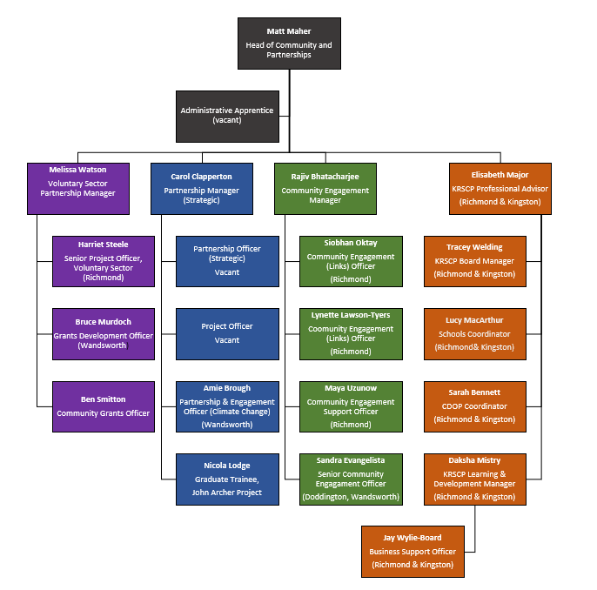

Person Specification

Job Title:  Project Officer | Grade:  S02, career graded through to PO1 (to be evaluated)  Two years fixed term.
Section:  Community and Partnerships | Directorate:  Chief Executive’s Group
Responsible to following manager:  Partnership Manager | Responsible for following staff:
Post Number/s:  1 | Last review date:  November 2020

Our Values and Behaviours

The values and behaviours we seek from our staff draw on the high standards of the two boroughs, and we prize these qualities in particular:

Being open. This means we share our views openly, honestly and in a thoughtful way. We encourage new ideas and ways of doing things. We appreciate and listen to feedback from each other.

Being supportive. This means we drive the success of the organisation by making sure that our colleagues are successful. We encourage others and take account of the challenges they face. We help each other to do our jobs.

Being positive. Being positive and helpful means we keep our goals in mind and look for ways to achieve them. We listen constructively and help others see opportunities and the way forward. We have a ‘can do’ attitude and are continuously looking for ways to help each other improve.

Person Specification Requirements | Assessed by  A & I/ T/ C (see below for explanation)
Experience
Experience of supporting and coordinating projects | A/I
Deliver agreed outcomes to demanding timescales | A/I
Experience of providing administrative support, including organising meetings, workshops and similar events – including booking venues, issuing invitations, drafting and distributing agendas and papers, minute taking and follow-up actions. | A/I
Negotiating, influencing and building constructive relationships with a range of key stakeholders such as residents, community-based organisations, colleagues, councillors and senior council staff and partner organisation staff. | A/I
Understanding and experience of desk-based research, Microsoft Office programmes, editing web content and social media platforms. | A / I
Understanding and experience of analysing complex information and presenting relevant facts to a local audience. | A/I
Knowledge and skills
An understanding of working with a political climate within or alongside a local authority. | A / I
Knowledge of, and the ability to use, spreadsheets including Excel, databases, email and MS Office functions. | A / I
Ability to produce concise reports, including to senior officers or members. | A/I
Ability to understand and interpret numerical data. | A/I
Ability to communicate effectively orally and in writing and work co-operatively with colleagues, members, outside agencies, community groups and the public | A / I
Ability to digitally engage with a range of stakeholders, using the most appropriate medium for the widest engagement. | A/I
Ability to set up and support online meetings in applications including MS Teams, Zoom and Skype. | A/I
An understanding of the procurement and commissioning processes within a local government setting or similar. | A / I
Ability to organise own workload, prioritise work tasks to meet deadlines and respond flexibly to frequently changing needs and priorities | A / I
Ability to work constructively as part of a team | A / I
Ability to demonstrate an understanding of the sensitive nature of a range of Council projects. | A / I
Ability to prepare presentations, including using Powerpoint, and developing high quality visuals for events. | A/I
Ability to confidently present a concept or proposal to a range of stakeholders, which could include senior officers, Members, partners or the public. | A/I
To have a flexible approach to working across differing teams and to differing managers. | A/I
Qualifications
Educated to Degree level or equivalent (desirable) demonstrating strong communication research and writing skills | A / C

A – Application form
I – Interview
T – Test
C - Certificate

